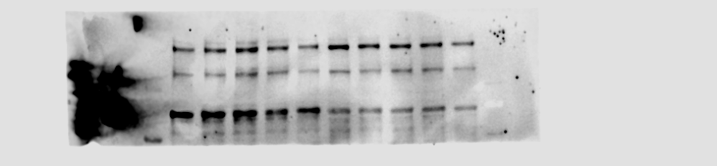
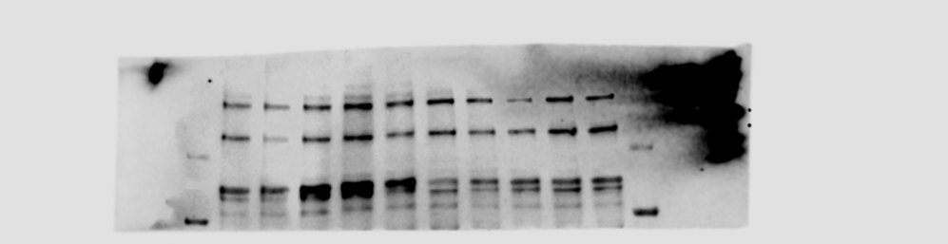
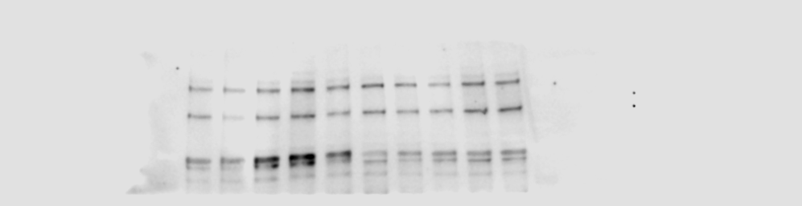
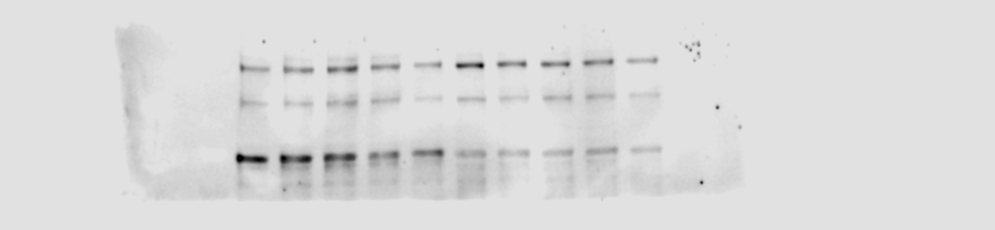
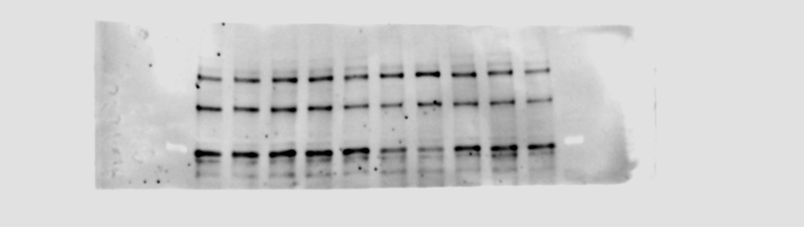
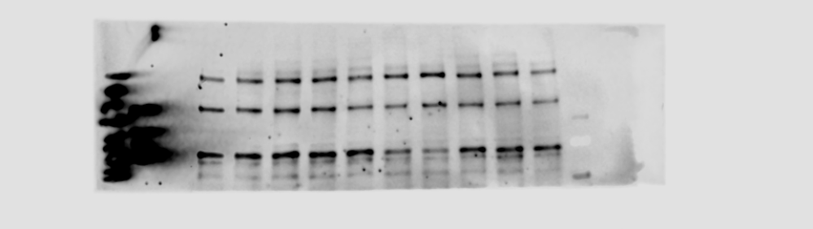
Additional file 2
Additional figure 2. Uncropped immunoblots of TLR3 blots. Chemiluminescence channel of C57Bl/6J blot (A), BALB/c blot (C) and C57Bl/6N blot (E). Chemiluminescence and 700 nm channel merge of C57Bl/6J blot (B), BALB/c blot (D) and C57Bl/6N (F), to visualize ladder. Ladder size is indicated.
F
A

B
C
D
E
100 kDa
50 kDa
70 kDa
100 kDa
50 kDa
70 kDa
100 kDa
50 kDa
70 kDa

