Additional file 5

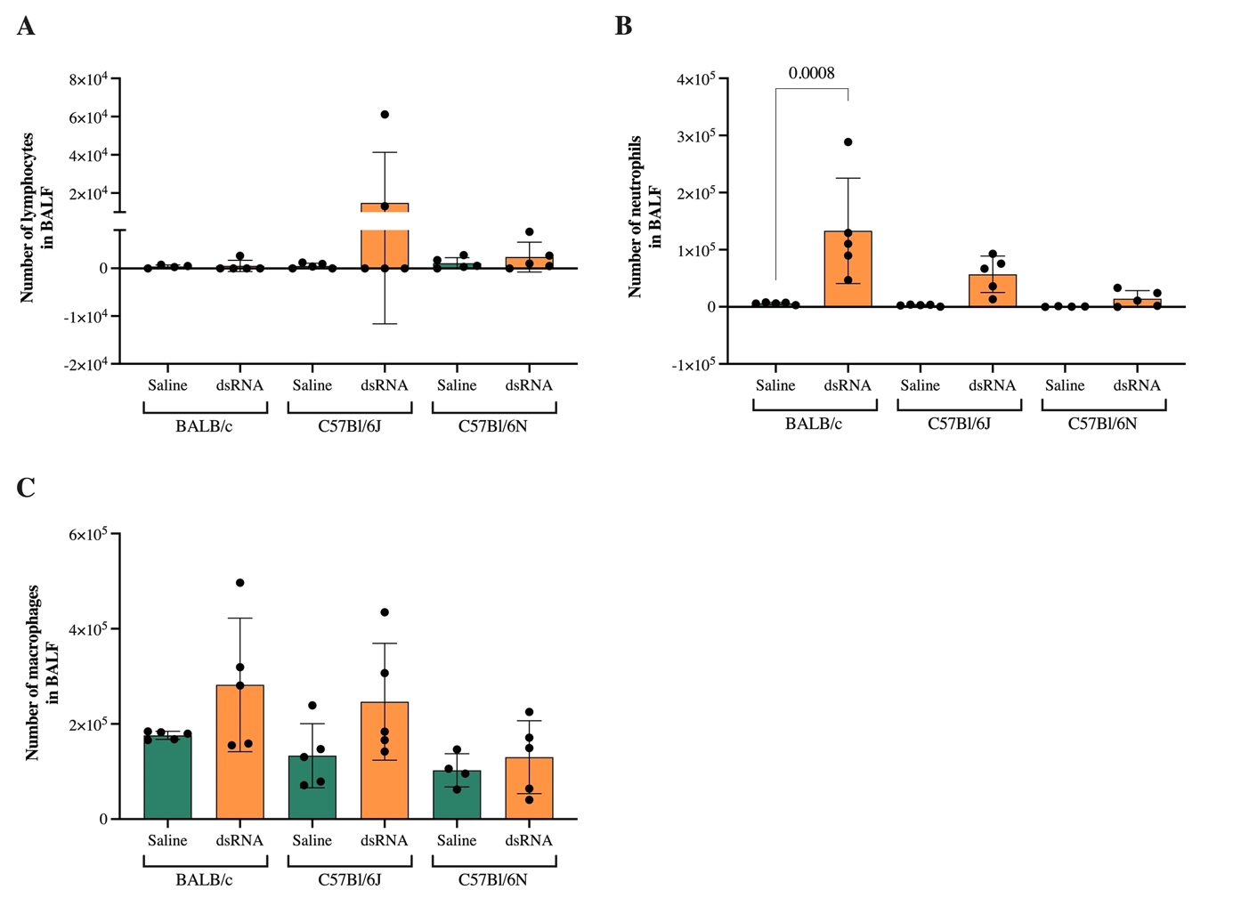
Additional figure 5. Effect of i.n. dsRNA administration on BALF cellular infiltration in mice. dsRNA (100 µg) or saline were i.n. administered to C57Bl/6J, C57Bl/6N or BALB/c mice once per day for three consecutive days, and the total number of lymphocytes (A), neutrophils (B) and macrophages (C) were determined in BALF using cytospin, differential cell counting and cell concentration measurements. Data are presented as mean ± SD. Differences between groups were tested using a 2way ANOVA with Tukey’s multiple comparisons test. P-values of <0.05 are indicted in the graphs, each data point represents one mouse from one experiment (n=4-5).

