Supplementary Materials

Supplementary Methods 1: Index Disease and Comorbidity ICD-9 and ICD-10 codes

Chronic Inflammatory Conditions
- Crohn’s Disease (CD): ICD-9=555.0-555.2, 555.9; ICD-10=K50.0, K50.1, K50.8, K50.9
- Ulcerative Colitis (UC): ICD-9=556.0-556.6, 556.8, 556.9; ICD-10=K51.0-K51.5, K51.8, K51.9
- Psoriasis (Ps)/Psoriatic Arthritis (PsA): ICD-9=696.0-696.5, 696.8; ICD-10=L40.0-L40.4, L40.8
- Rheumatoid Arthritis (RA): ICD-9=714.0-714.2, 714.30-714.33, 714.4; ICD-10=M05.0-M05.9
- Ankylosing Spondylitis (AS)/Spondyloarthritis (SpA): ICD-9=720.20-720.2, 720.8, 720.9; ICD-10=M45.0-M45.9
- Hidradenitis Suppurativa (HS): ICD-9=705.83; ICD-10=L73.2
- Uveitis (UV): ICD-9=364.00-364.05; ICD-10=H20.00-H20.05, H20.1

Comorbidities
- Hypertension (HTN): ICD-9 = 401.0, 401.1, 401.9, 403.00, 403.01, 403.10, 403.11, 403.90, 403.91; ICD-10 = I10, I11.0, I11.9, I12.0, I12.9
- Hyperlipidemia (HLD): ICD-9 = 272.4; ICD-10 = E78.0-E78.5
- Diabetes Mellitus: ICD-9 = 250.0-250.9; ICD-10 = E10 (Type 1, 84 sub-codes), E11 (Type II, 84 sub-codes)
- Congestive Heart Failure (CHF): ICD-9 = 428.0, 428.1, 428.20-428.23, 428.30-428.33, 428.40-428.43, 428.9; ICD-10 = I50.1-I50.4, I50.8, I50.9
- Coronary Artery Disease (CAD): ICD-9 = 410.0-410.9 (all .00-.02 only), 411.0, 411.1, 411.81, 411.89, 412, 414.00-414.07, 414.10-414.12, 414.19,414.2-414.4, 414.8, 414.9; ICD-10 = I20-I25
- Chronic Kidney Disease (CKD): ICD-9 = 585.1-585.1, 585.9; ICD-10 = N18.1-N18.6, N18.9
- Chronic Obstructive Pulmonary Disease (COPD): ICD-9 = 491-494; ICD-10 = J41-J44, J47
- HIV/AIDS: ICD-9 = 042; ICD-10 = B20
- *Lynch Syndrome: ICD-9 = 758.5 (Other conditions due to autosomal abnormalities); ICD-10 = Z15.02 (ovary), Z15.04 (endometrium), Z15.09 (genetic susceptibility to other malignant neoplasm)
- *Gardner Syndrome: ICD-9 = 758.5 (Other conditions due to autosomal abnormalities); ICD-10 = Z15.09(genetic susceptibility to other malignant neoplasm)
- *Li-Fraumeni Syndrome: ICD-9 = 758.5 (Other conditions due to autosomal abnormalities); ICD-10 = Z15.01 (breast), Z15.09 (genetic susceptibility to other malignant neoplasm)
- HPV: ICD-9 = 078.10-078.12, 078.19, 079.4; ICD-10 = B07.0, B07.8, B07.9
- EBV: ICD-9 = 075; ICD-10 = B27.90-B27.92, B27.99
- Hepatitis B (HBV): ICD-9 = 070.20-070.23, 070.30-070.33; ICD-10 = B16.0-B16.2, B16.9, B18.0, B18.1, B19.10, B19.11
- Hepatitis C (HCV): ICD-9 = 070.41, 070.44, 070.51, 070.54, 070.70, 070.71; ICD-10 = B17.10, B17.11, B18.2, B19.20, B19.21
- H. pylori: ICD-9 = 041.86; ICD-10 = B96.81

*comorbidity can only be identified by generic genetic abnormality ICD-9/10 code

Supplementary Methods 2: Urologic Malignancy ICD-9 and ICD-10 Codes.
ICD-9 Codes:
- Esophagus: 150
- Stomach: 151
- Intestine/colorectal: 152-154
- Liver: 155
- Pancreas: 157
- Lung: 162
- Melanoma: 172
- NMSC: 173
- Breast: 174
- Cervix: 180
- Uterus: 182
- Ovary: 183
- Prostate: 185
- Testis: 186
- Bladder: 188
- Kidney: 189
- Thyroid: 193
- Lymphoma: 200-201
- Leukemia: 204-205
- Corresponding in situ neoplasms: 230-234

ICD-10 Codes:
- Esophagus: C15
- Stomach: C16
- Intestine/colorectal: C17-C21
- Liver: C22
- Pancreas (C25)
- Lung: C34
- Melanoma: C43
- NMSC: C44
- Breast: C50
- Cervix: C53
- Uterus: C54
- Ovary: C56-C57
- Prostate: C61
- Testis: C62
- Kidney: C64-C65
- Bladder: C66-C67
- Thyroid: C73
- Lymphoma: C81-C84
- Leukemia: C91-C92
- Corresponding in situ neoplasms: D00-D09

Supplementary Figure 1: Sensitivity Analysis of Malignancy Risk by any TNF-I Exposure Including Patients with Missing Demographic Information
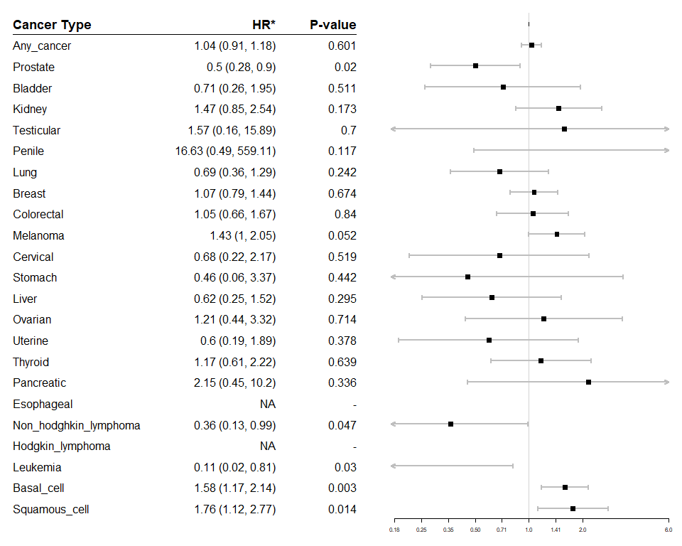

*HR = Hazard Ratio

Supplementary Figure 2: Sensitivity Analysis of TNF-I Malignancy Risk by Autoimmune Disease Including Patients with Missing Demographic Information

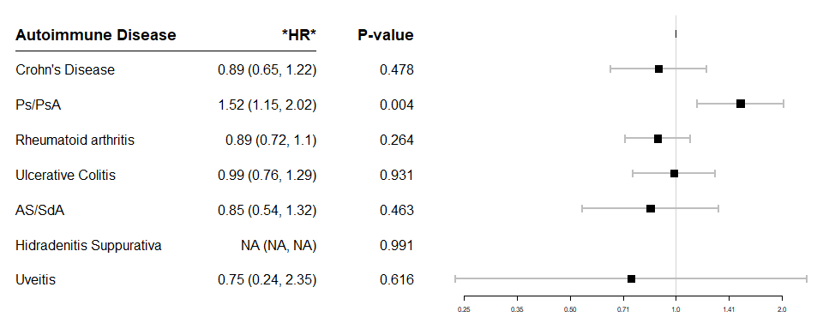
*HR = Hazard Ratio

Supplementary Figure 3: Sensitivity Analysis of Malignancy Risk by Individual TNF-I Exposure Including Patients with Missing Demographic Information

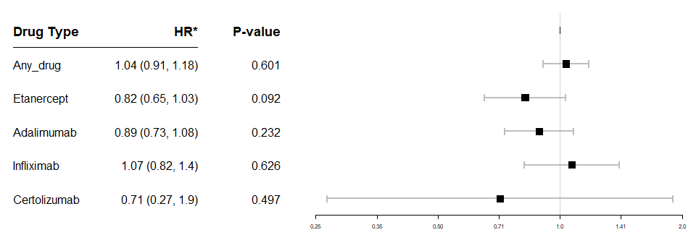
*HR = Hazard Ratio

Supplementary Table 1: Individual Malignancy Rates by TNF-I Exposure

 | TNF-I Exposed (N=12,941) | TNF-I Unexposed (N=37,402) | Total (N=50,343)
Any Cancer
Yes | 827 (6%) | 4,749 (13%) | 5,576 (11%)
No | 12,114 (94%) | 32,653 (87%) | 44,767 (89%)
Cancer Type
Basal Cell | 142 (1.1%) | 437 (1.2%) | 579 (1.2%)
Bladder | 20 (0.2%) | 124 (0.3%) | 144 (0.3%)
Breast | 144 (1.1%) | 1,016 (2.7%) | 1,160 (2.3%)
Cervical | 10 (<0.1%) | 112 (0.3%) | 122 (0.2%)
Colorectal | 45 (0.3%) | 421 (1.1%) | 466 (0.9%)
Esophageal | 0 (0%) | 26 (<0.1%) | 26 (<0.1%)
Hodgkin Lymphoma | 0 (0%) | 52 (0.1%) | 52 (0.1%)
Kidney | 39 (0.3%) | 184 (0.5%) | 223 (0.4%)
Leukemia | 24 (0.2%) | 179 (0.5%) | 203 (0.4%)
Liver | 25 (0.2%) | 157 (0.4%) | 182 (0.4%)
Lung | 50 (0.4%) | 314 (0.8%) | 364 (0.7%)
Melanoma | 102 (0.8%) | 382 (1.0%) | 484 (1.0%)
Non-Hodgkin Lymphoma | 46 (0.4%) | 183 (0.5%) | 229 (0.5%)
Ovarian | 8 (<0.1%) | 89 (0.2%) | 97 (0.2%)
Pancreatic | 13 (0.1%) | 0 (0%) | 13 (<0.1%)
Penile | 2 (<0.1%) | 0 (0%) | 2 (<0.1%)
Prostate | 49 (0.4%) | 545 (1.5%) | 594 (1.2%)
Squamous Cell | 56 (0.4%) | 183 (0.5%) | 239 (0.5%)
Stomach | 9 (<0.1%) | 35 (<0.1%) | 44 (<0.1%)
Testicular | 5 (<0.1%) | 0 (0%) | 5 (<0.1%)
Thyroid | 26 (0.2%) | 187 (0.5%) | 213 (0.4%)
Uterine | 12 (<0.1%) | 123 (0.3%) | 135 (0.3%)

