Characterization and applications of Nanobodies against human procalcitonin selected from a novel naive Nanobody phage display library
Junrong Yan¹, Pingyan Wang¹, Min Zhu¹, Guanghui Li¹, Ema Romão⁴, Sheng Xiong^{3*}, Yakun Wan^{1,2*}
¹The Key Laboratory of Developmental Genes and Human Disease, Ministry of Education, Institute of Life Sciences, Southeast University, Nanjing 210096, PR China
²Jiangsu Nanobody Engineering and Research Center, Nantong 226010, PR China
³Institute of Biomedicine & National Engineering Research Center of Genetic Medicine, College of Life Science and Technology, Jinan University, Guangzhou 510630, PR China.
⁴Laboratory of Cellular and Molecular Immunology, Vrije Universiteit Brussel, Faculty of Science, Pleinlaan 2, 1050 Brussels, Belgium

Corresponding author*:
Yakun Wan, PhD, Professor. Address: Sipailou No.2, Southeast University, Nanjing, PR China. Tel.: 86-25-83790967. Fax: 86-25-83790960. Email: ywansystemsbiology@gmail.com.
Sheng Xiong, PhD. Address: Room 730, 2nd Building of Sci & Tech, 601W Huangpu Ave, Guangzhou, PR China. Tel.:+86-20-85220504. Fax: +86-20-85220504. Email: xiongsheng@jnu.edu.cn.

Fig. S1
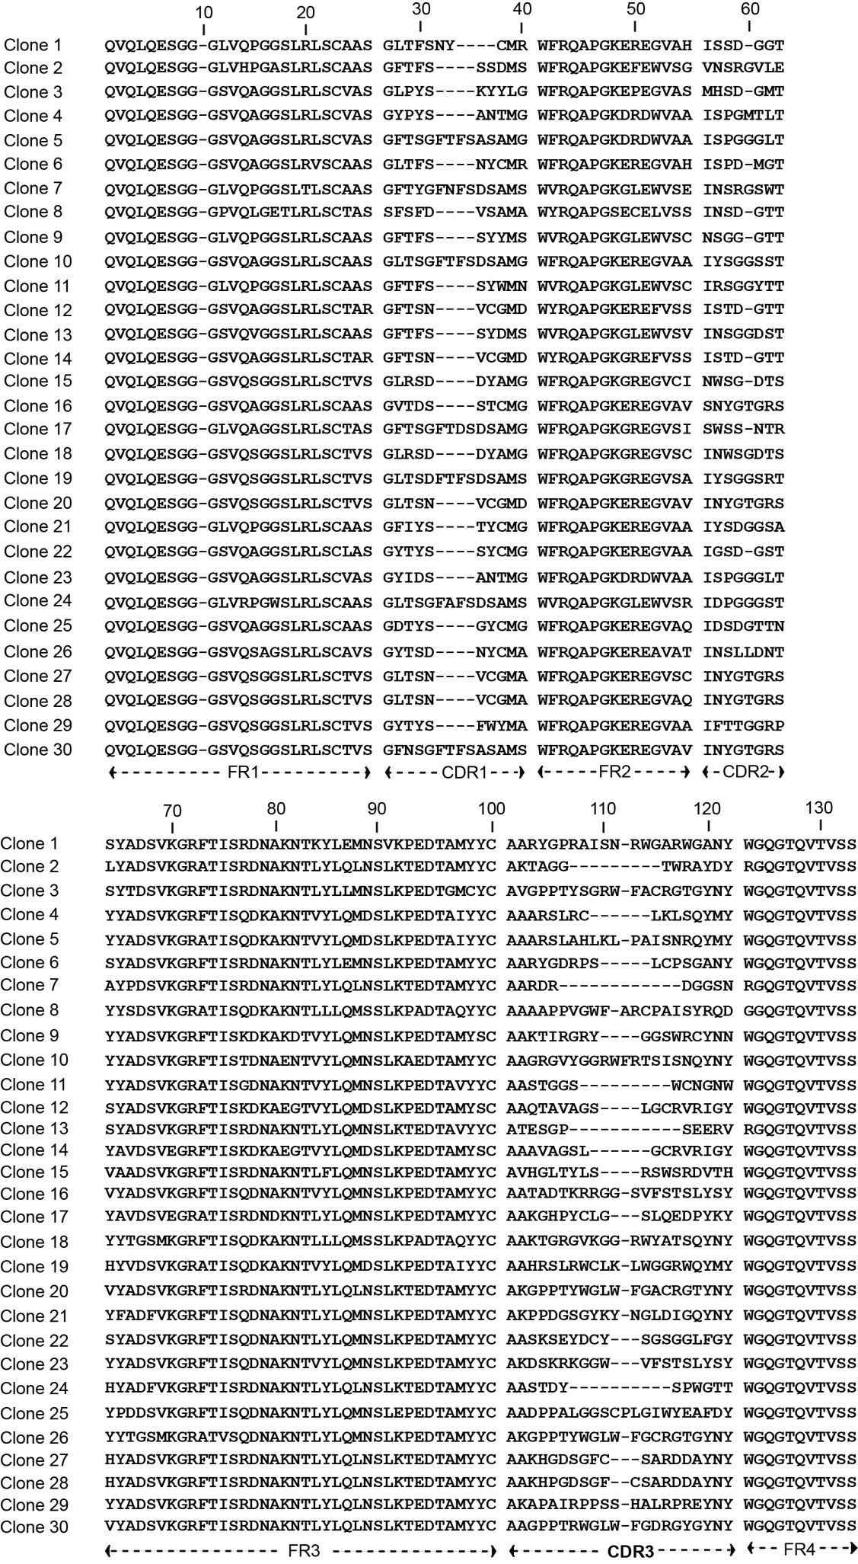
Fig. S2
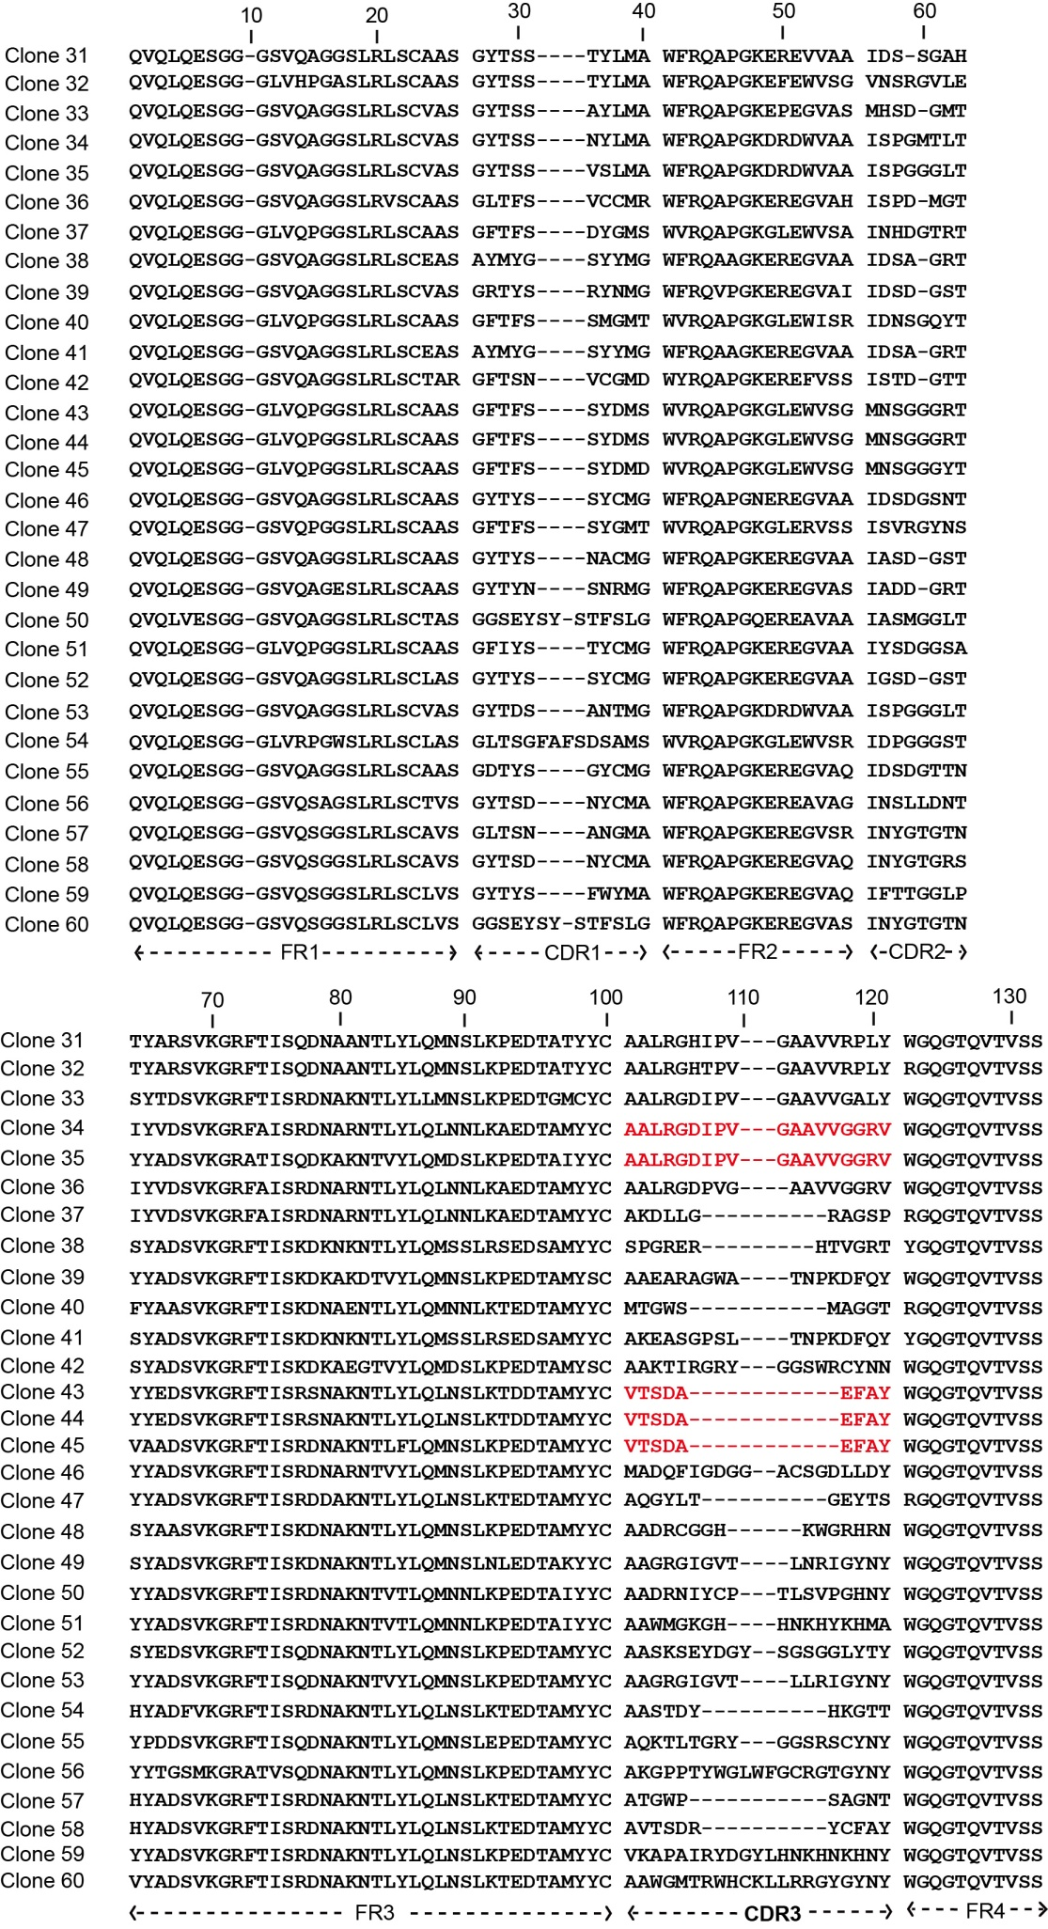
Fig. S3
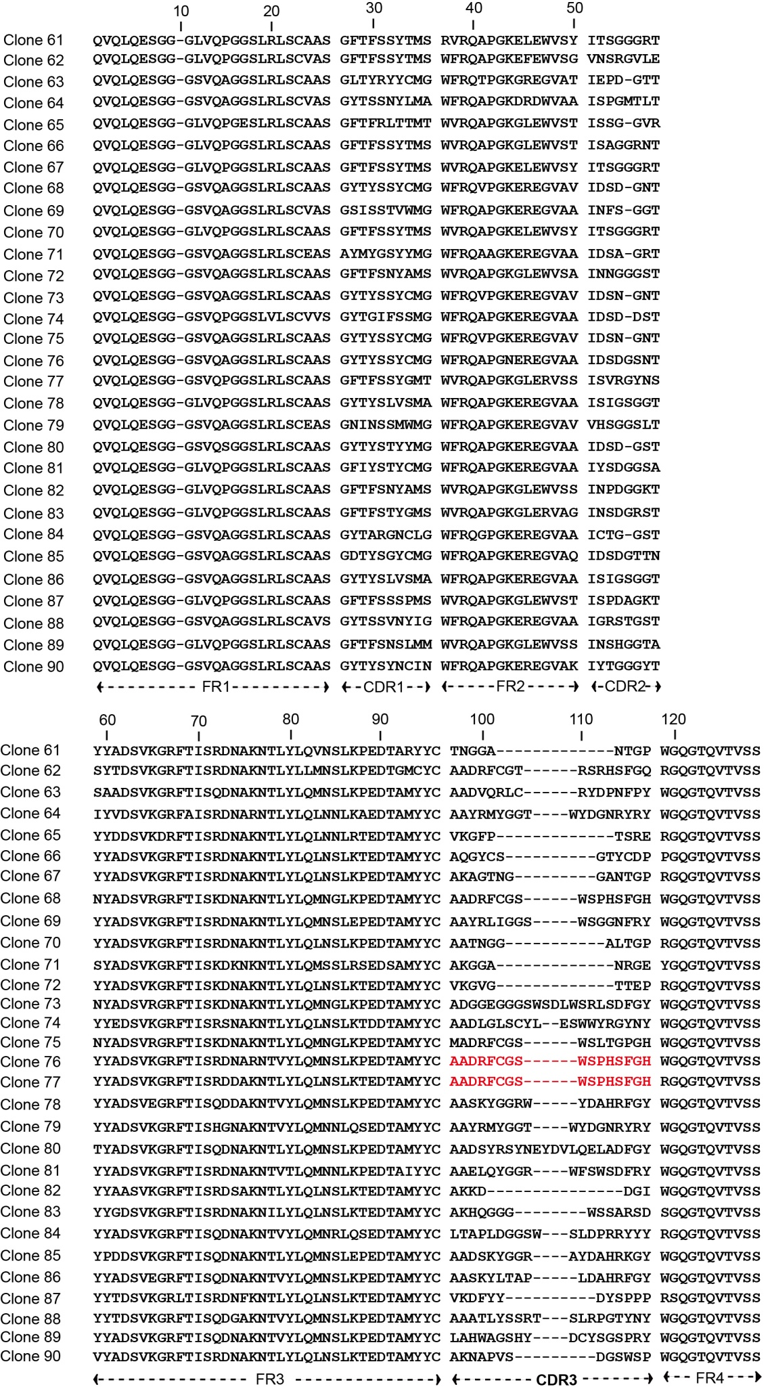
Fig. S4
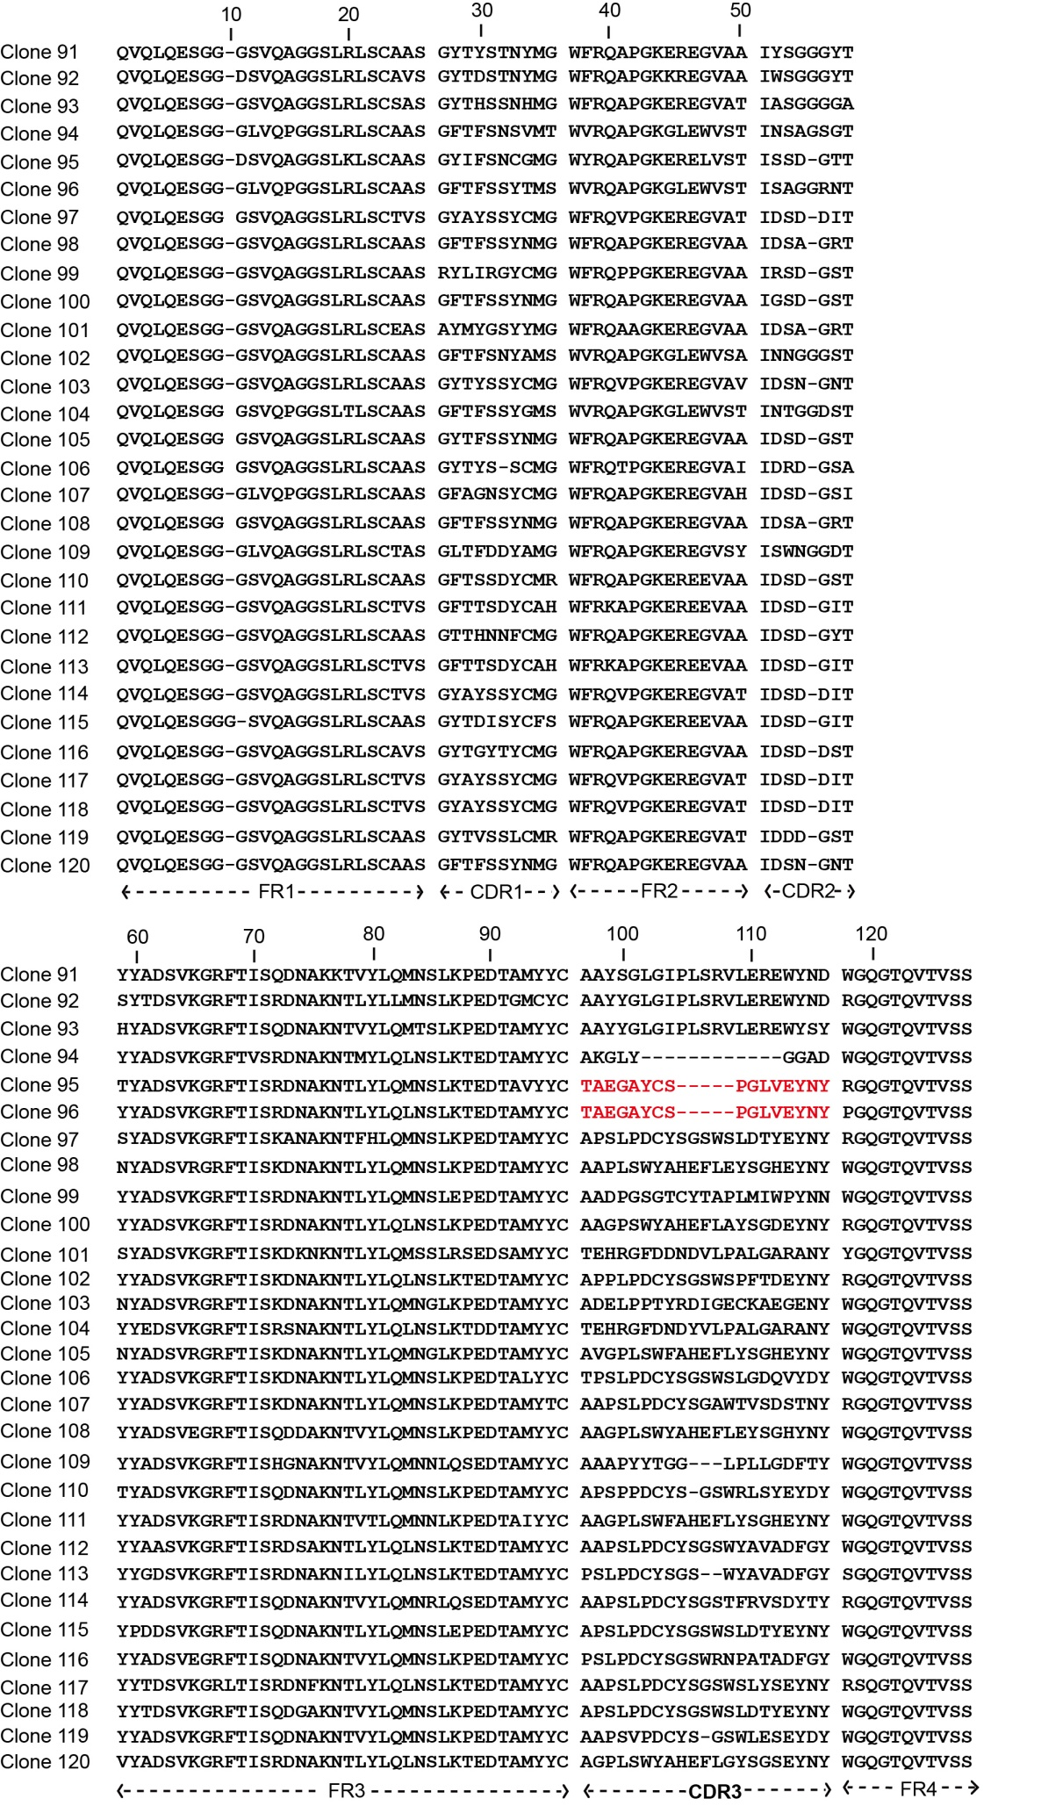
Fig. S5
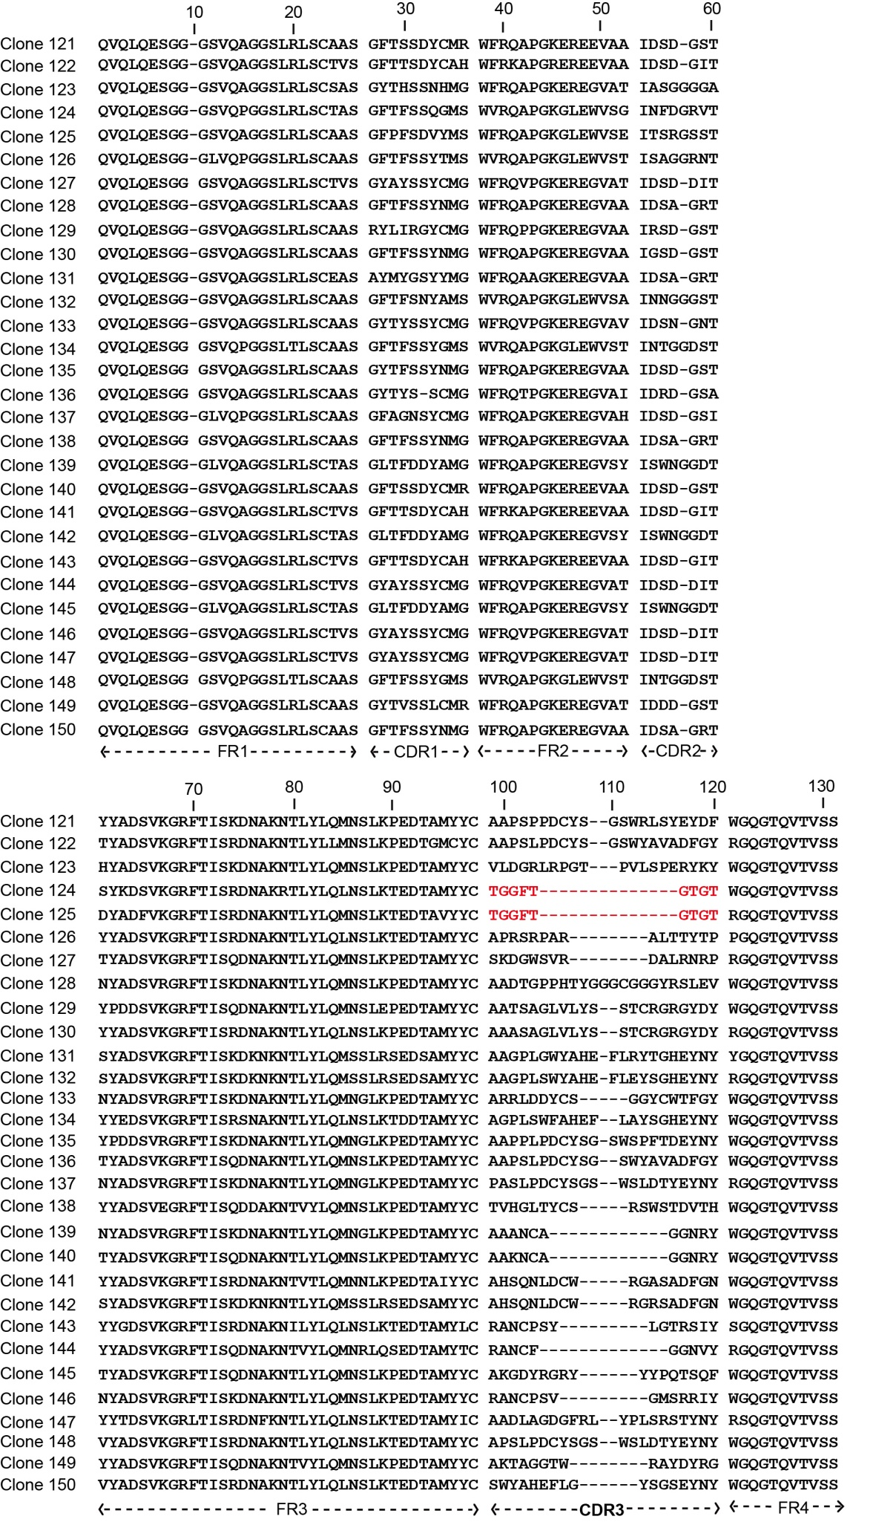
Fig. S6
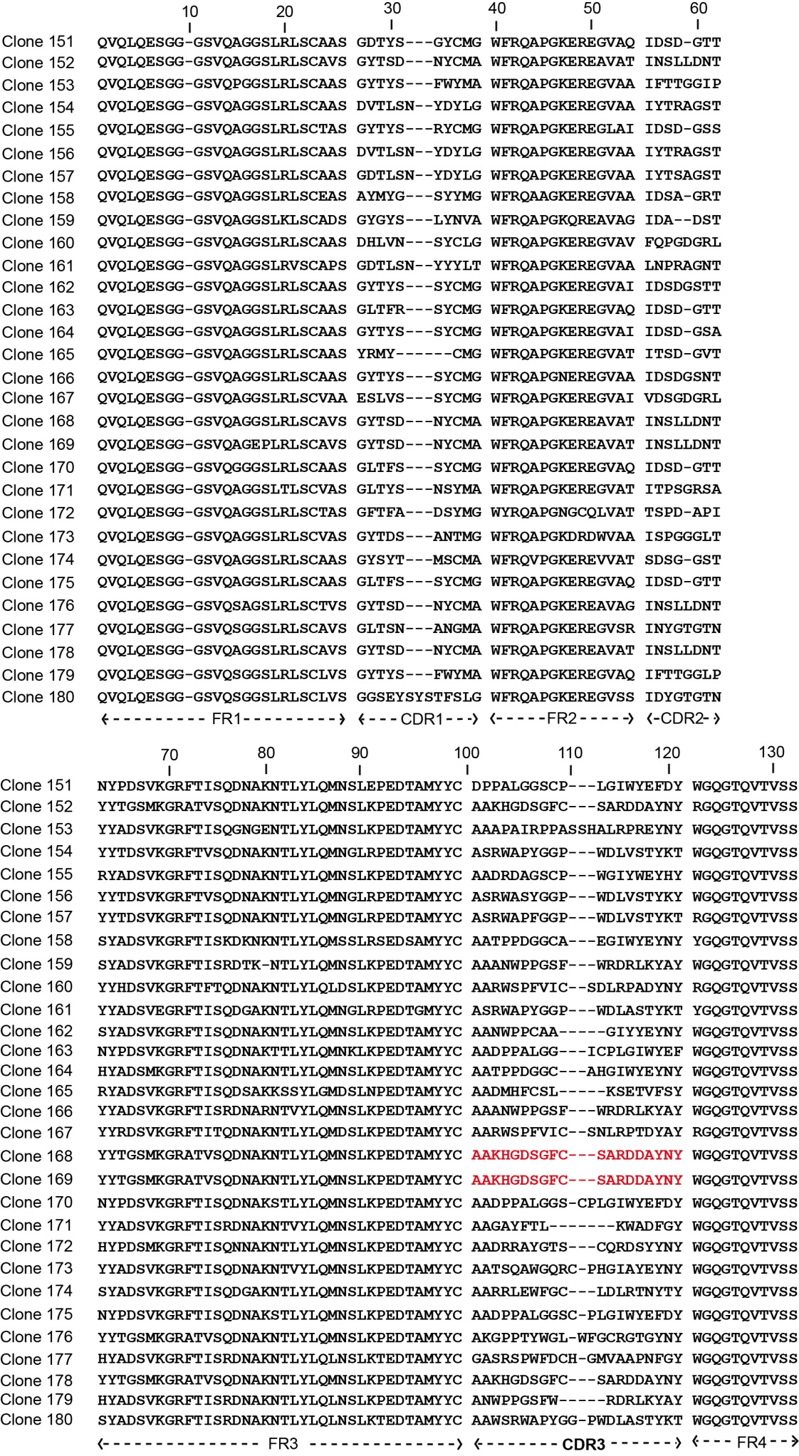
Fig. S7
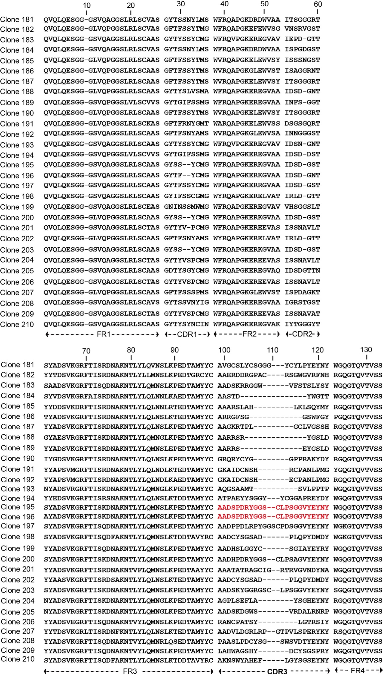
Fig. S8
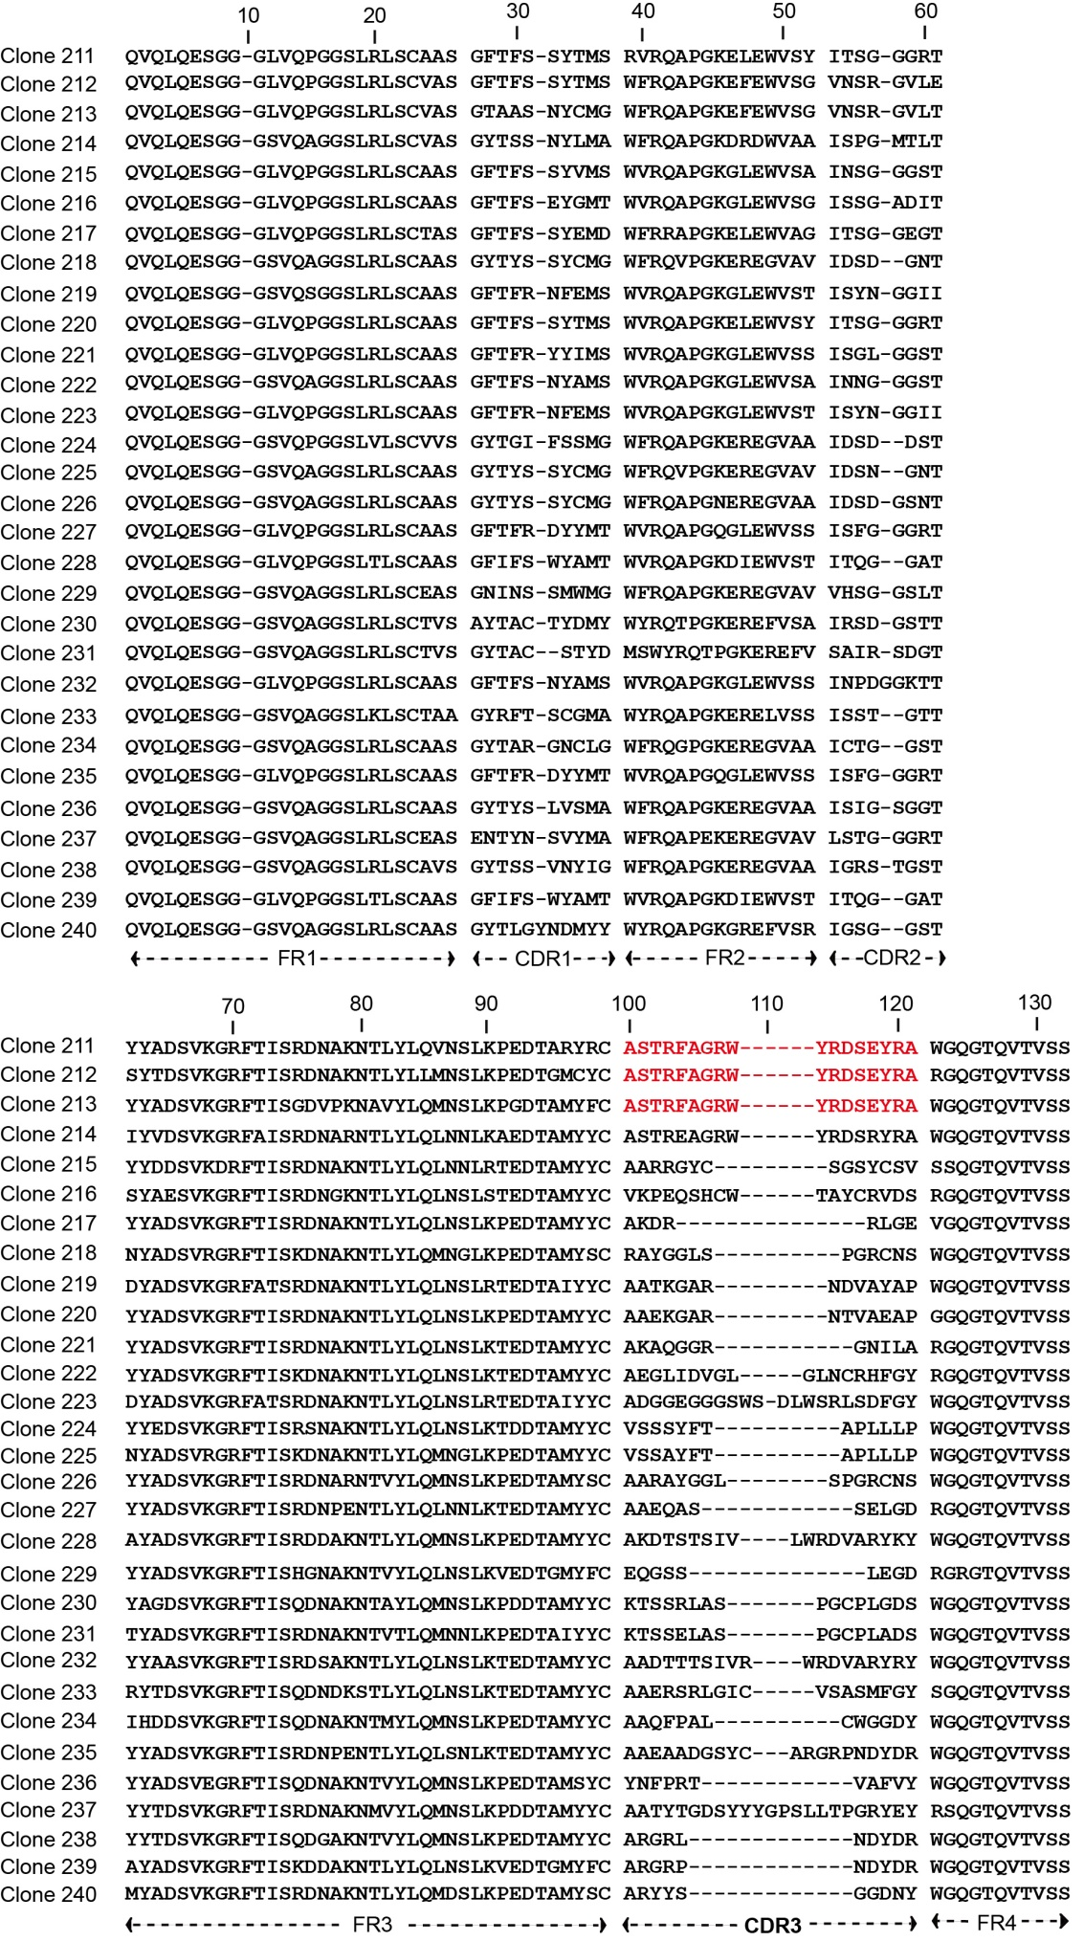
Fig. S9
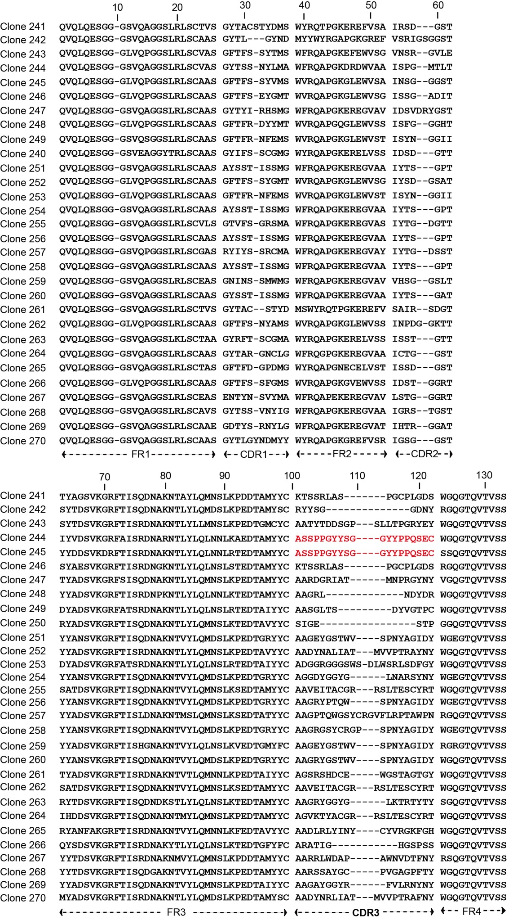
Fig. S10
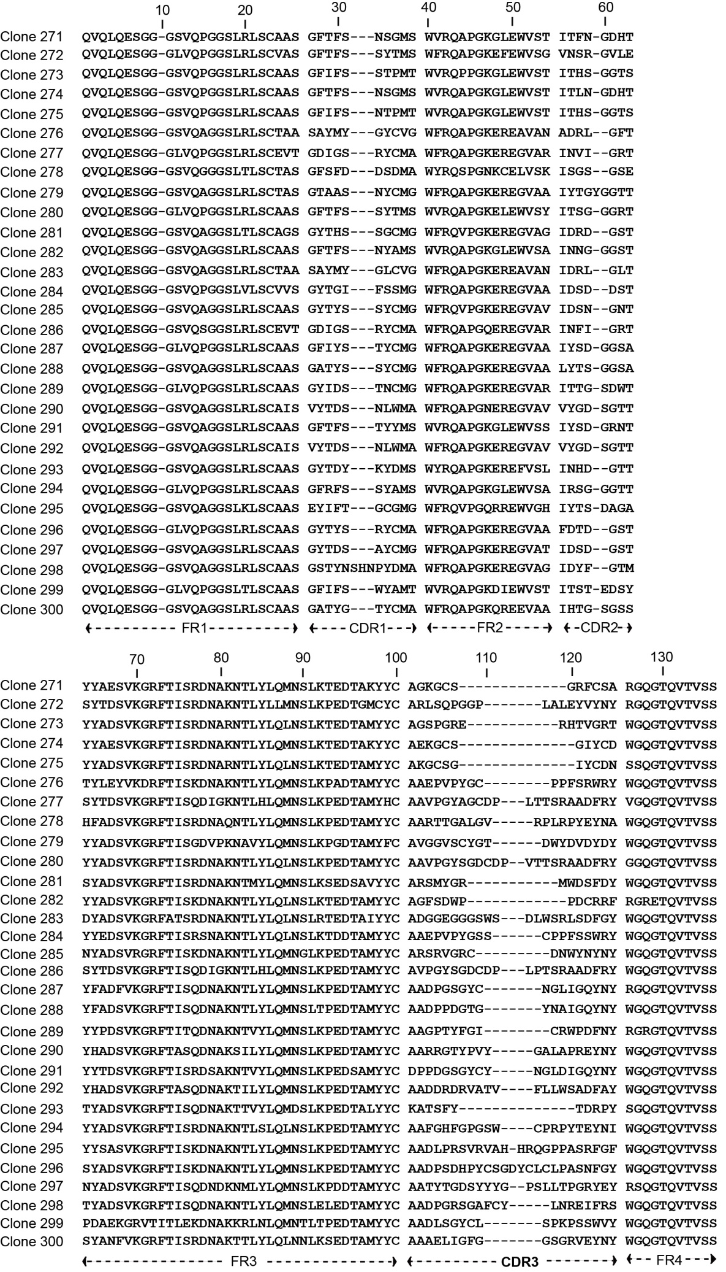
Fig. S1-S10. Diversity determination of the naïve library. 300 individual clones were randomly chosen for sequencing to determine the library diversity. Amino acids positions of the framework FRs and the three antigen-binding loops (CDR1, CDR2 and CDR3) are numbered according to the IMGT Scientific chart for the V-Domain and are indicated at bottom. Clones exhibited the same amino acids in CDR3 are colored in red in CDR3.

