LA-ICP-MS 2D imaging of gold distribution in the hippocampus and the hypothalamus
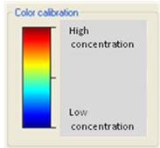
Figure S2 present LA-ICP-MS 2D imaging of gold distribution in the hippocampus and the hypothalamus, as representative regions of brain. The images obtained from a brain sample that was frozen and dissected into 25 μm thick slices after AuNPs abdominal injection.
Low Concentration
High Concentration
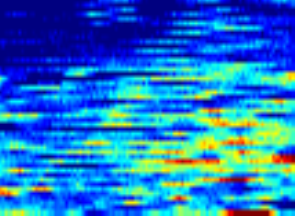  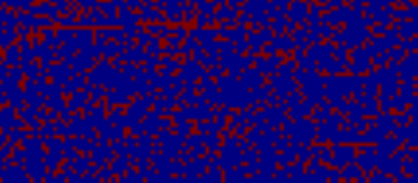  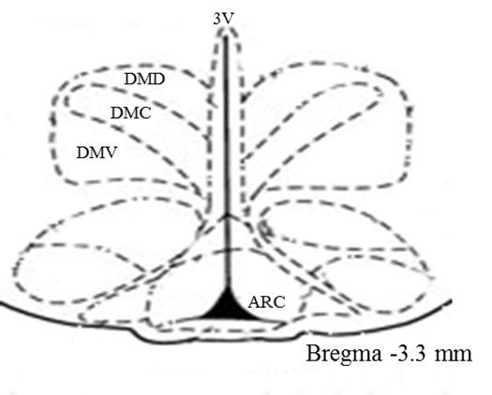  A  C  E | 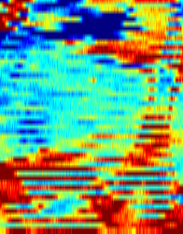  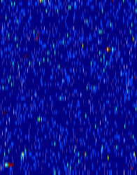  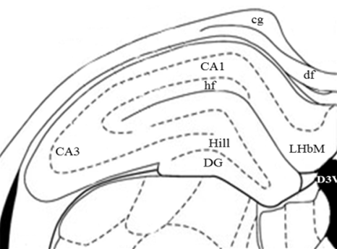  D  B  F

Figure S2: Qualitative LA-ICP-MS imaging of gold distribution in rat brain sections. (A) and (B) atlas drawings of the hypothalamus and hippocampus respectively [1]; (C) Carbon-13 distribution in the hypothalamus; (D) Carbon-13 distribution in the hippocampus; (E) Gold distribution in the hypothalamus; (F) Gold distribution in the hippocampus.

(1) Paxinos G, Watson C. The Rat Brain in Stereotaxic Coordinates: London, UK (1988).

