Figure S2 X-ray diffraction patterns of graphene oxide (A), pristine silver nanoparticles (B) and graphene oxide-silver nanocomposite (C)
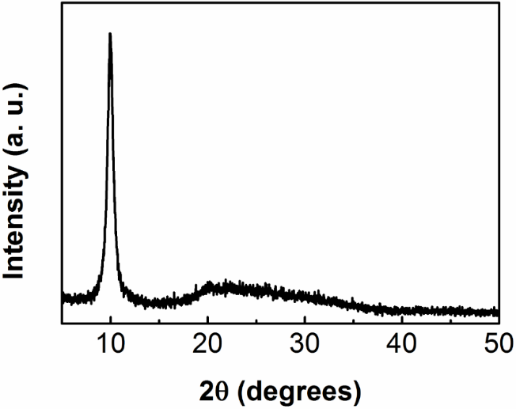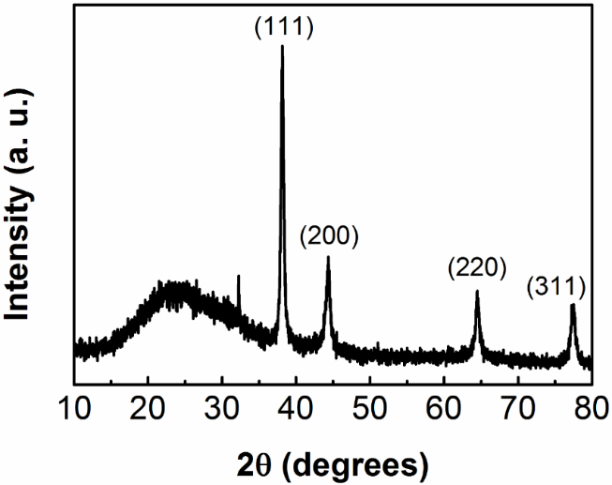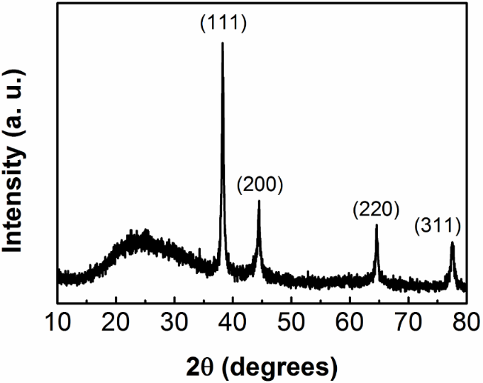
A
B
C
GO
AgNP
GOAg

