Figure S3. Photographs of graphene oxide dispersed in deionized water (DI), RPMI, and RPMI + 10% FBS during 48 h of incubation. Black arrows indicate precipitation of the nanomaterial.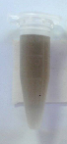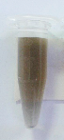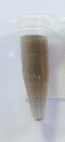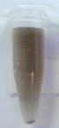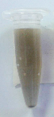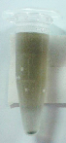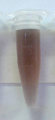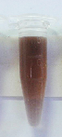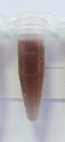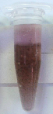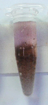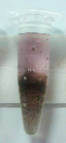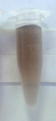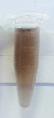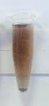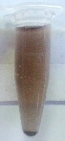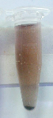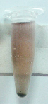
RPMI
0 h
1 h
3 h
6 h
12 h
24 h
GO
48 h
DI
RPMI +
FBS

