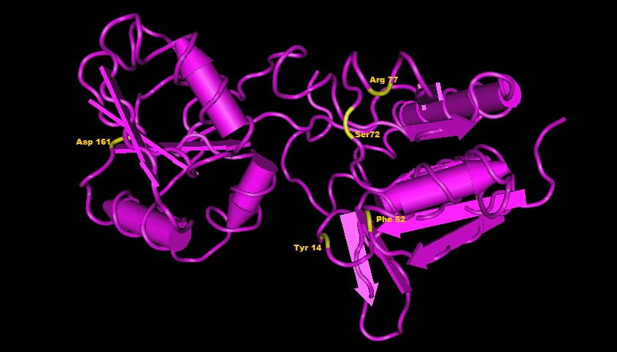

Additional file 2. Redesign of lysine-binding site for a wide physiological range of detection of lysine and an enhanced response. Predicted structures of different binding site variants in LAOBP. Mutated residues are shown in yellow: Y14A, R77L, F52A, S72A and D161I.

