Additional file 1:

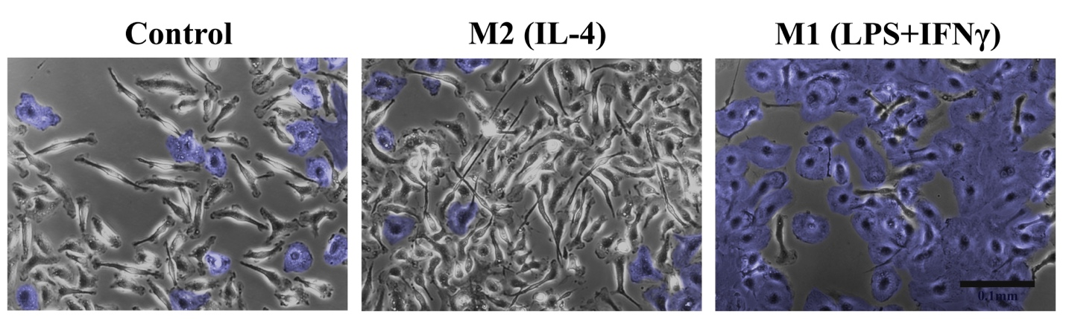

S1. The morphology of activated macrophages subsets. The control group did not receive any cytokine stimulation. Macrophages activated with IL-4 were polarized into the M2 stave, whereas macrophages receiving LPS and IFNγ were activated into the M1 state. M2 and control macrophages demonstrated a spindle-like morphology while M1 macrophages were more spread out and rounded in appearance (shaded in blue).

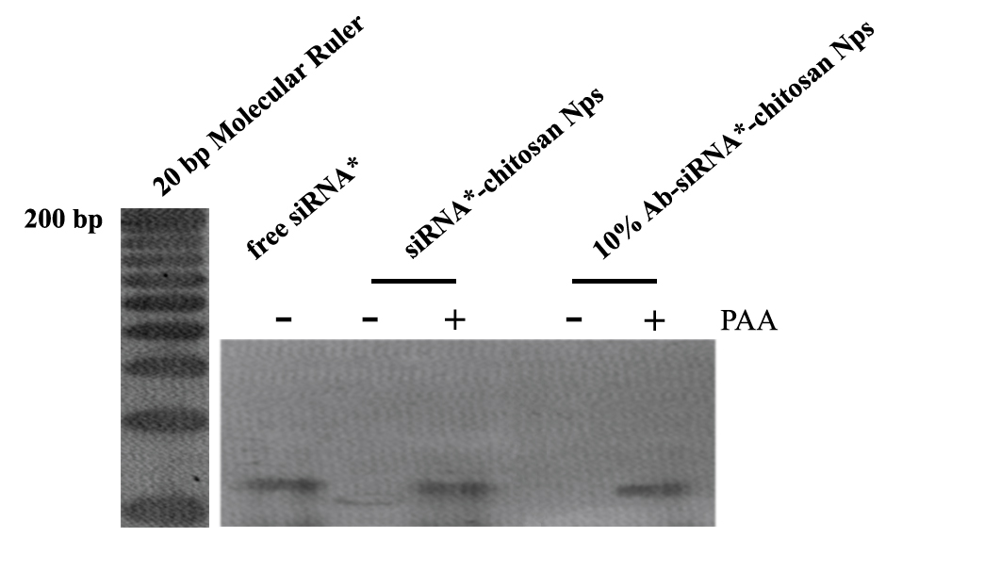
S2. Gel retardation assay indicating the integrity of chitosan nanoparticles. Poly(l-aspartic acid) (PAA) is a highly anionic polyelectrolyte that competitively binds to cationic chitosan, displacing siRNA.

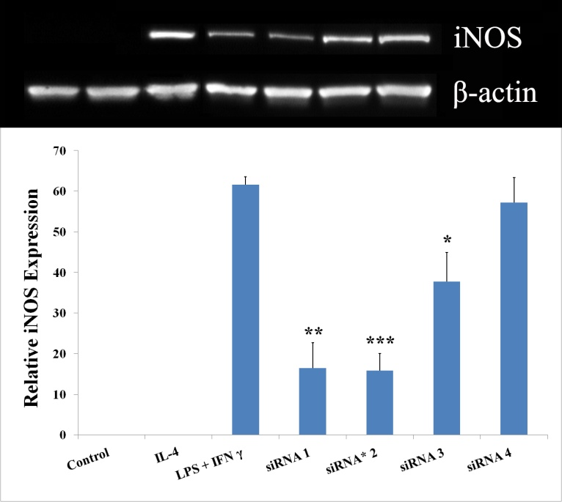
S3. Screening of four unique iNOS targeted siRNA sequences (siRNA1-siRNA4) to detect the silencing effects on iNOS mRNA expression using Western blotting techniques. **p< 0.01 and ***p<0.001 vs LPS+ IFNγ.

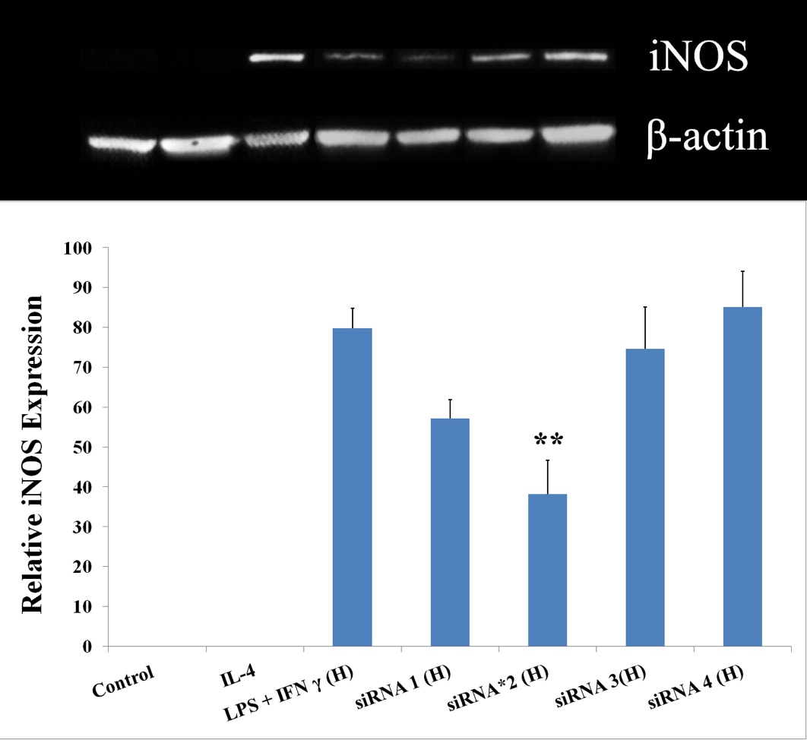
S4. Screening of four unique siRNA sequences to detect the silencing effects on iNOS mRNA expression when a high concentration of 1μg/ml LPS +200ng/ml IFNγ is applied to activate macrophages into the M1 state. **p< 0.01 vs LPS+ IFNγ.

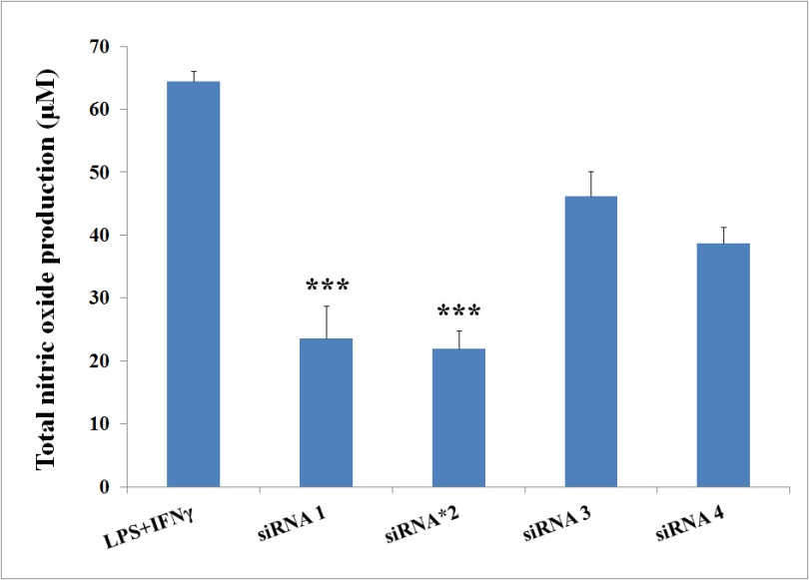
S5. Screening and comparison of nitric oxide secretion from BMDM with and without siRNA treatment. ***p<0.001 vs LPS+ IFNγ.

