Supplementary Materials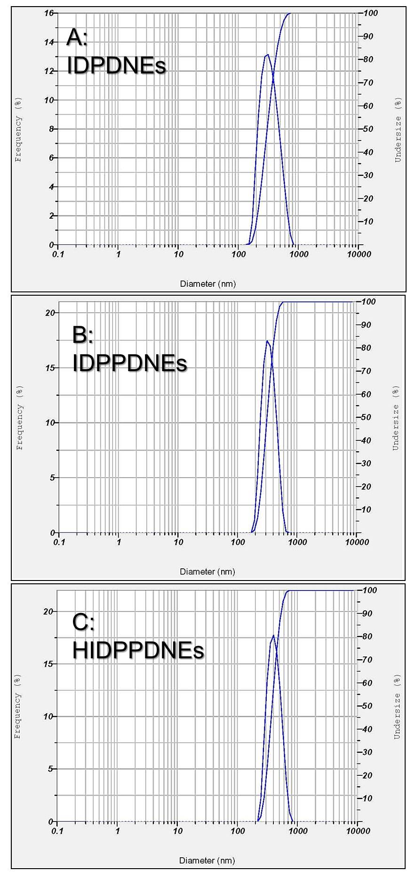
Fig. S1 Representative graphs of size distribution for IDPDNEs (A), IDPPDNEs (B), and HIDPPDNEs (C) measured by DLS technique.
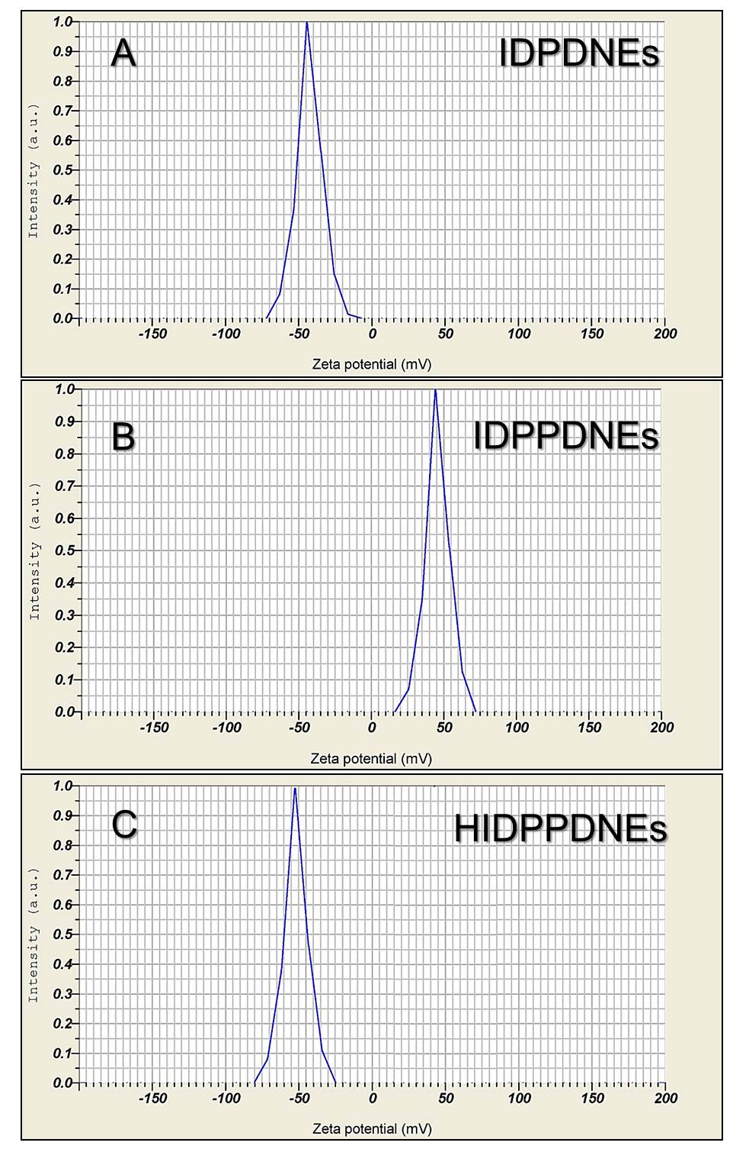
Fig. S2 Representative graphs of zeta potential (/surface charge) for IDPDNEs (A), IDPPDNEs (B), and HIDPPDNEs (C) measured by DLS technique.

