Supplementary Materials

Nanostructured Biosensor Using Bioluminescence Quenching technique for Non-invasive Detection of Glucose
Longyan Chen¹, Longyi Chen¹, Michelle Dotzert², Jamie Melling ², Jin Zhang¹*
¹ Department of Chemical and Biochemical Engineering, Western University, London, Ontario, Canada, N6A 5B9
² School of Kinesiology, Faculty of Health Sciences, University of Western Ontario, London, Ontario, Canada, N6A 5B9

S1. Quantitative analysis of the designed donor
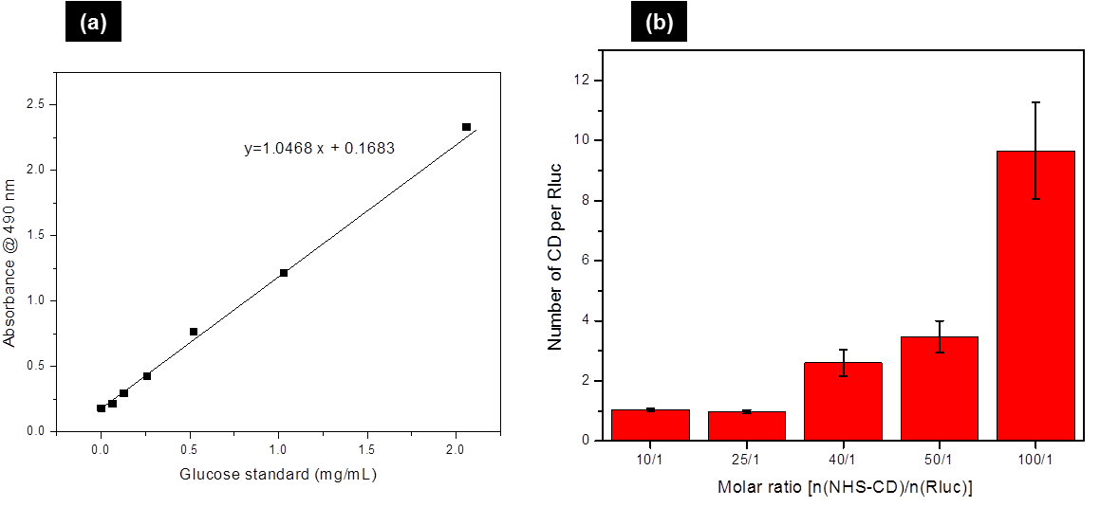
Figure S1. (a) Standard curve for sulfuric acid-phenol carbohydrate assay. (b) Calculated number of β-CD conjugated on Rluc after purification verse different molar ratios in the initial carbodiimide reactions.
The protein concentration was maintained to 30 μM in the reaction. The maximum number of β-CD conjugated onto one Rluc is estimated at 10; the molar ratio of NHS-β-CD to Rluc is 100:1.

S2. Evaluation of the specificity of the bioluminescent nanosensor

Figure S2. Response of bioluminescent nanosensors to common biological substances. The concentrations of all the substances are 50 µM.
Here the normalized bioluminescence is calculated by using the equation below;
Normalized bioluminescence = Relative bioluminescence intensity after adding a certain substance-relative bioluminescent intensity without any substance

