Gold nanoparticles stabilize peptide-drug-conjugates for sustained targeted drug delivery to cancer cells
Kalimuthu et al. Additional file 1

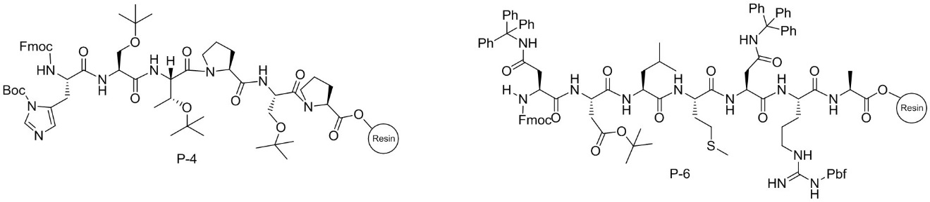
Figure S1. Structures of P4 and P6 peptides bound to 2-chlorotrityl resin

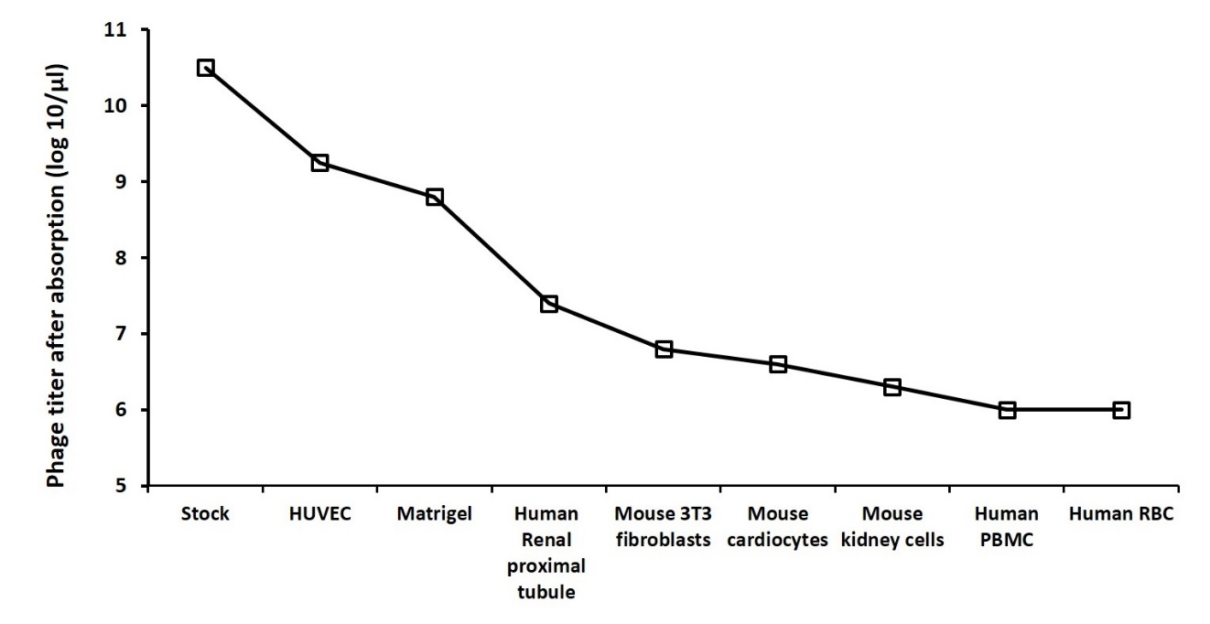
Figure S2:Decrease in Log₁₀ phage titer following sequential in vitro absorption of stock Ph.D 7 linear phage display library on a series of normal human and mouse cells and on matrigel. In each case, 1x10⁶log-phase cells were washed with PBS and re-suspended in 1ml of RPMI. 10 microliters of phage particles (2X10¹¹) were added 1 ml of cells and the mixture incubated for 1h at 37⁰C with gentle shaking. The mixture was then centrifuged at 1500 rpm and the supernatant containing the unbounded phage was collected. A small portion (3-5µl) was retained and titrated to determine the decrease in phage titer resulting from each absorption. The remainder was used for the next stage of negative panning. The library was similarly exposed to matrigel.
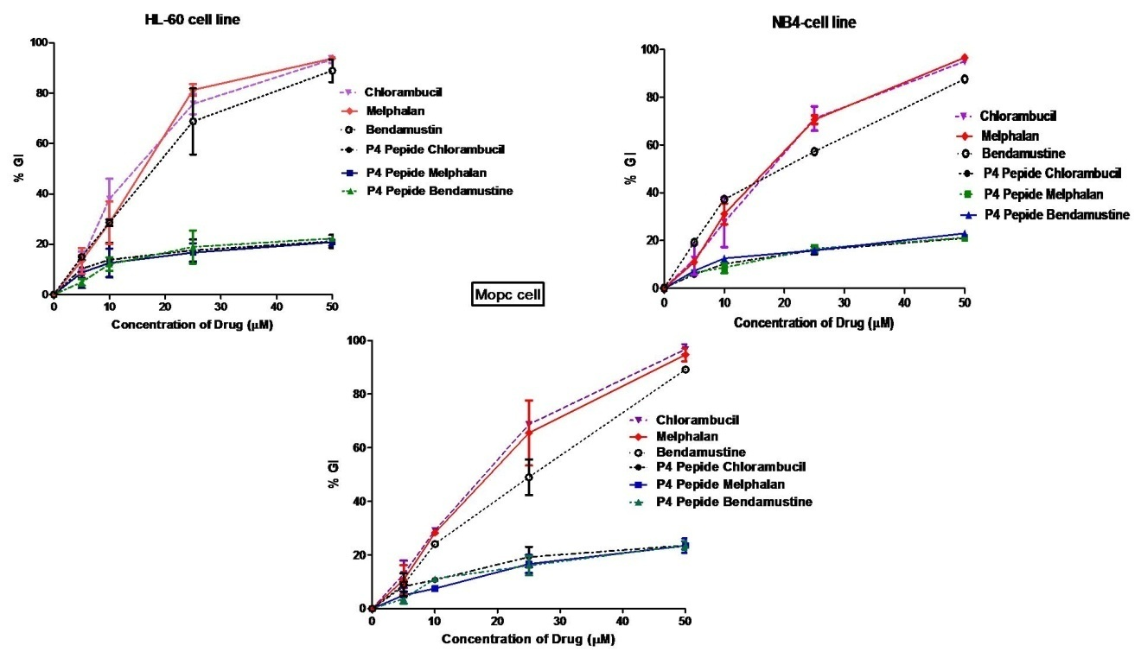
Figure S3: Cytotoxic effect of free drugs of P4-PDCs against off-target cells. The compounds were cultured with cells for 72 hrs after which cell growth was assessed using the XTT assay: Optical density (OD) was measured at 480 and 680 nm – the latter is the background absorbance. The difference between the 480 and 680 nm measurement was used to calculate the % growth inhibition (GI) in test wells compared with control cells exposed to medium alone. The results shown for each concentration point represent the mean ± standard error for independent experiments each conducted in triplicate

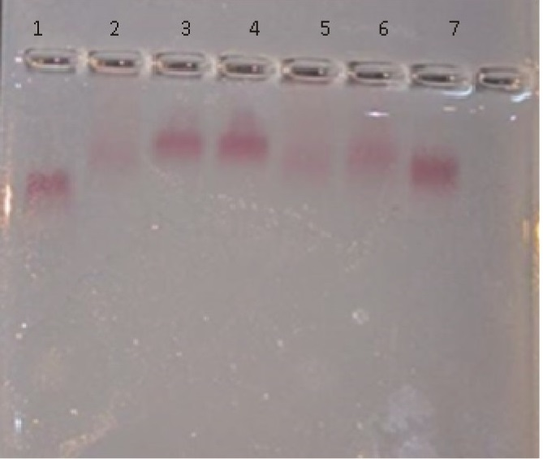
Figure S4: Electrophoretic mobility of AuNPs and PDC-AuNPs. Samples were electrophoresed in a 1.5% agarose gel in TAE running buffer. Lane 1: PEG-6000 AuNP; Lane 2: PEG-6000 AuNP-P4–Chlorambucil; Lane 3: PEG-6000 AuNP-P4–Melphalan; Lane 4: PEG-6000 AuNP P4-Bendamustine; Lane 5: PEG-6000 AuNP P6-Chlorambucil; Lane 6: PEG-6000 AuNP P6-Melphalan; Lane 7: PEG-6000 AuNP P6-Bendamustine

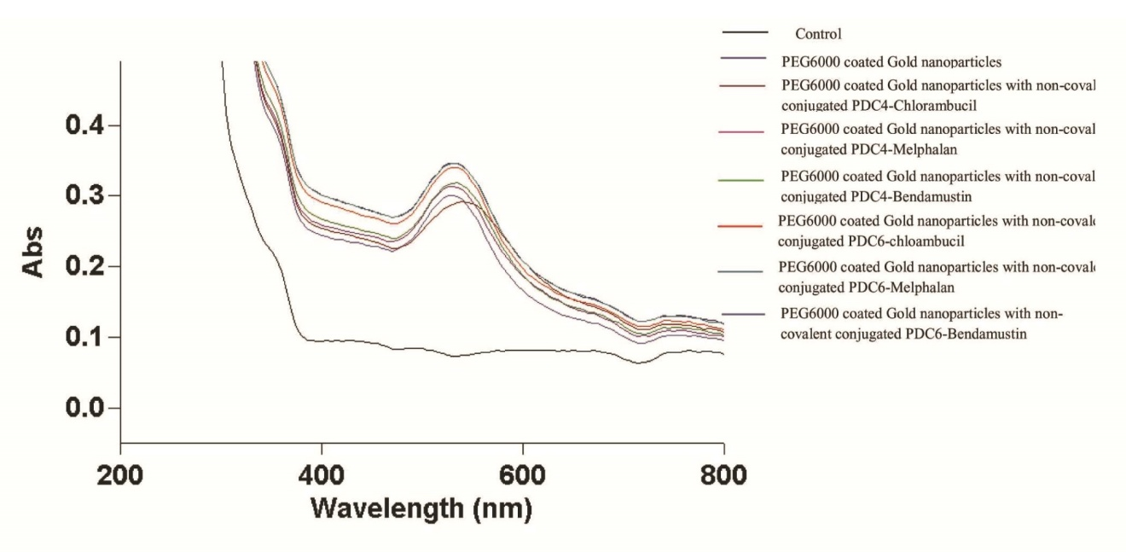
Figure S5
UV-VIS spectra in the range of 100-800nm of PEG-coated gold particles along and those non-covalently coated with peptide-drug-conjugates (PDCs). The PDCs were composed of either P4 or P6 peptides conjugated with wither Chlorambucil, Melphalan or Bendastumin. The major peak at 530nm showing PEG conjugation to the particles was not affected by additional attachment of the PDCs.

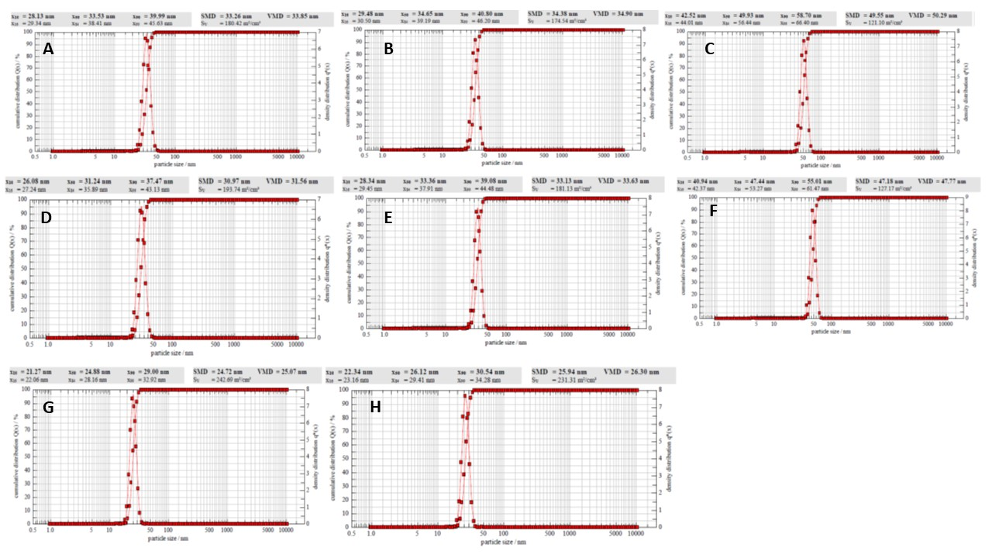
Figure S6 DLS size characterization of the PDC-PEG-AuNP
(A) PEG-6000 AuNP-P4–Chlorambucil;(B) PEG-6000 AuNP-P4–Melphalan; (C) PEG-6000 AuNP P4-Bendamustine; (D) PEG-6000 AuNP P6-Chlorambucil; (E) PEG-6000 AuNP P6-Melphalan; (F) PEG-6000 AuNP P6-Bendamustine; (H) AuNP; (G)PEG-6000 AuNP.

A
B
C
D
E
F

Figure S7. Elution time and Mass spectroscopy of P4 PDCs
(A) P4–Chlorambucil- Elution time (B) P4–Chlorambucil –Mass spectra (C) P4–Melphalan-- Elution time (D) P4–Melphalan- Mass spectra (E) P4-Bendamustine- Elution time (F) P4-Bendamustine- Mass spectra.

A
B
C
D
E
F

Figure S8 Elution time and Mass spectroscopy of P6 PDCs
(A) P6–Chlorambucil- Elution time (B) P6–Chlorambucil –Mass spectra (C) P6–Melphalan- Elution time (D) P6–Melphalan- Mass spectra (E) P6-Bendamustine- Elution time (F) P6-Bendamustine- Mass spectra.

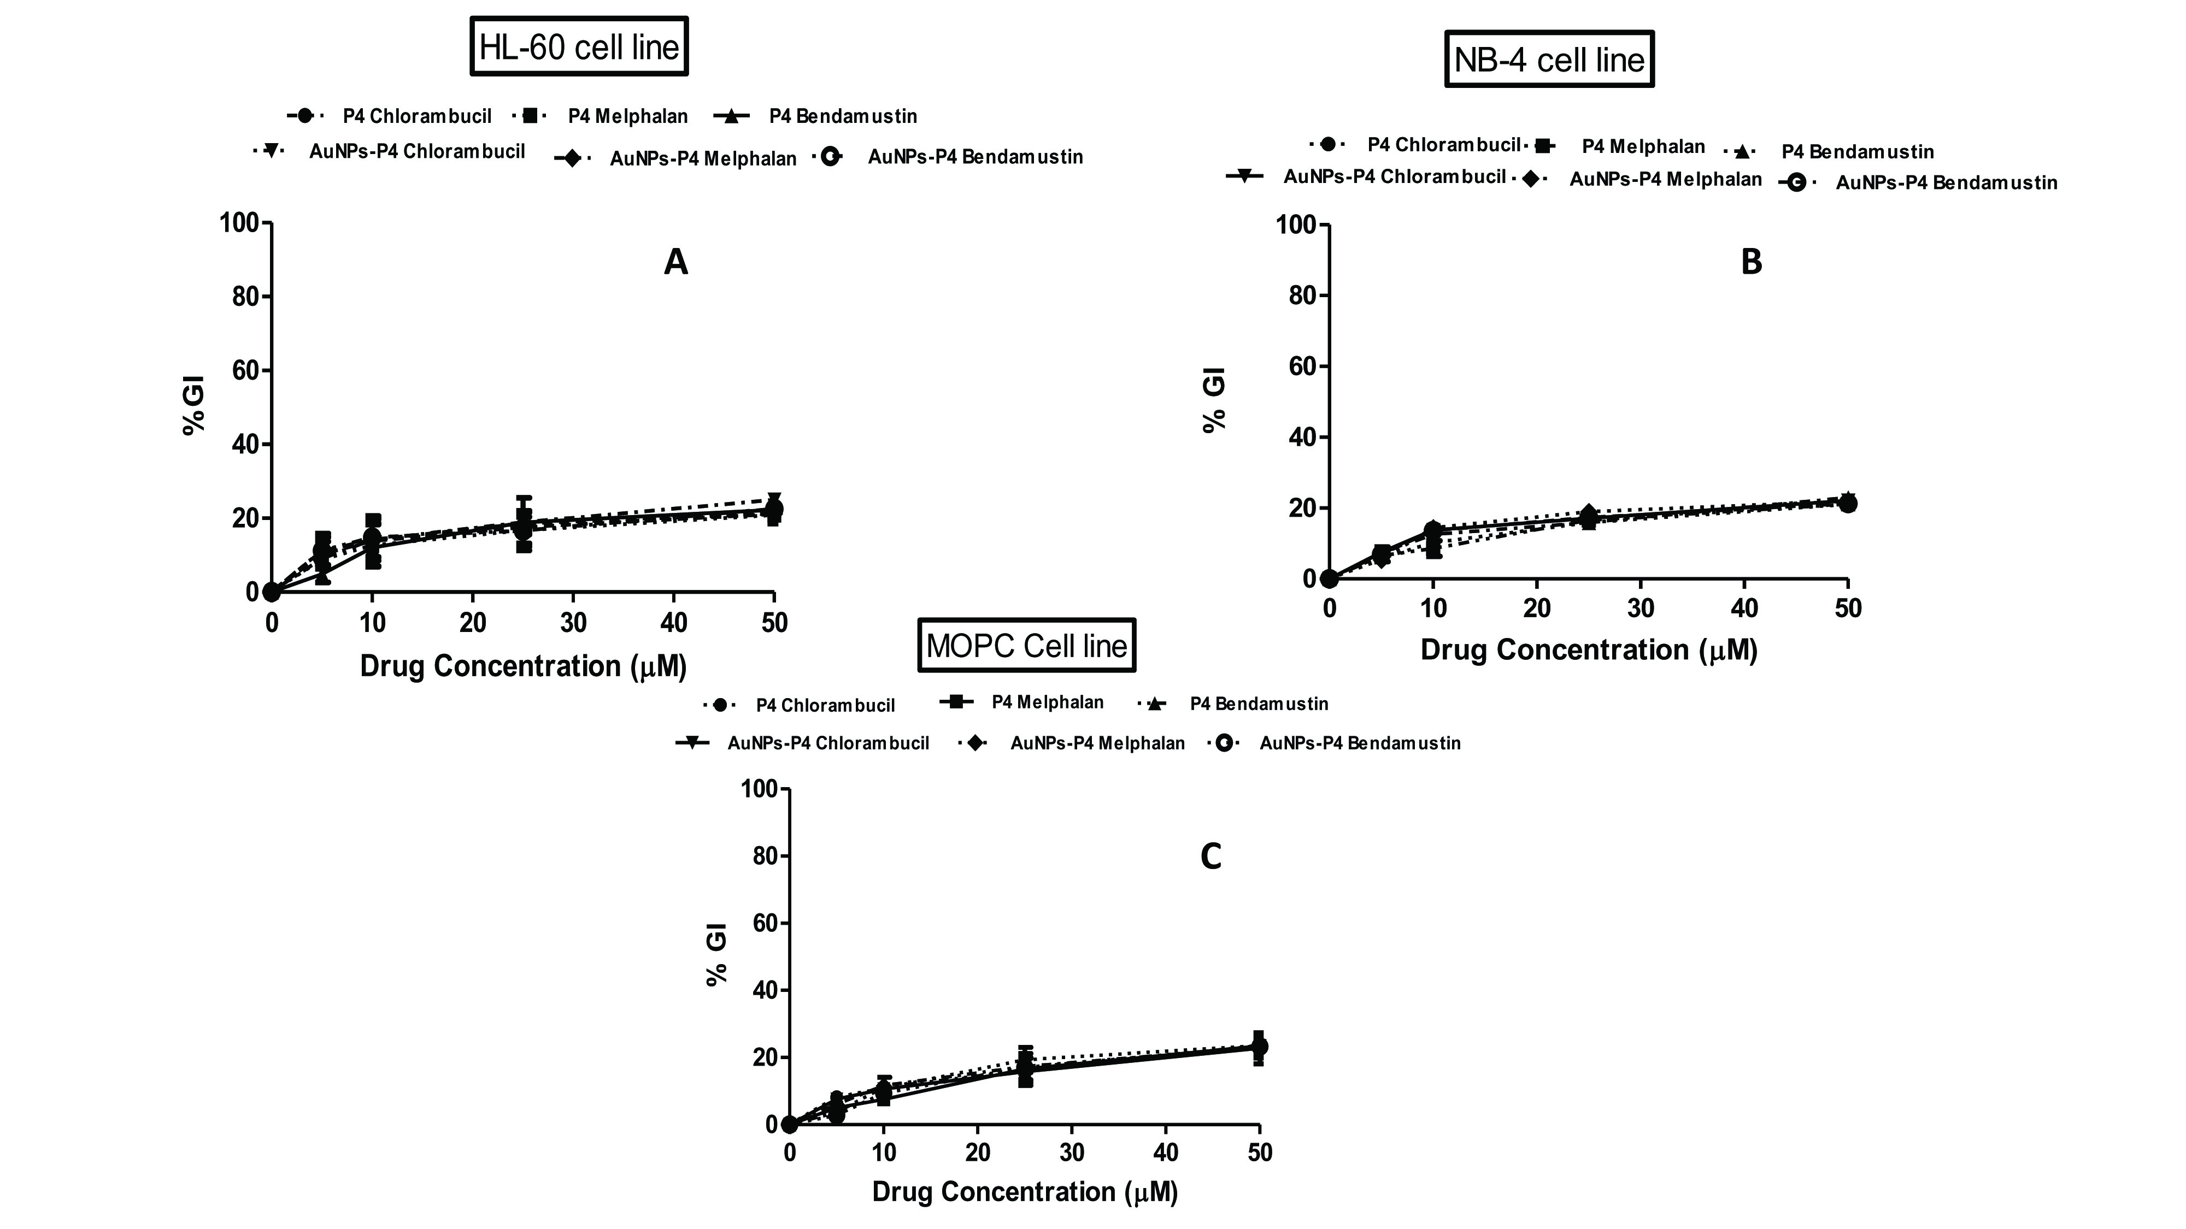

Figure S9 Cell growth Inhibition of Peptide drug conjugates and AuNPs –Peptide drug conjugates on off-target cells. P4-PDC or P4-PDC-PEG-AuNPs were cultured with (A) HL-60 cells ((B) NB-4 cells or (C) MOPC cells. At the end of 72 hr incubation, cell growth was assessed using the XTT assay: Optical density (OD) was measured at 480 and 680 nm – the latter is the background absorbance. The difference between the 480 and 680 nm measurement was used to calculate the % growth inhibition (GI) in test wells compared with control cells exposed to medium alone. The results shown for each concentration point represent the mean ± standard error for two independent experiments each conducted in triplicate.

Table S1: Calculated chemo- and bio-stabilityt½ values of PDCs and PDC-PEG-AuNPs
Material | Chemostability  (pH 7.4) | Biostability  (liver homogenate)
P4-Chlorambucil | 21.5 mins | 12.4 mins
P4-Melphalan | 24.6 mins | 10.6 mins
P4-Bendamustine | 19.3 mins | 15.4 mins
P4-Chlorambucil-PEG-AuNP | 21.0 hrs | 20.0 hrs
P4-Melphalan-PEG-AuNP | 22.0 hrs | 18.3 hrs
P4-Bendamustine-PEG-AuNP | 22.3 hrs | 18.3 hrs

