Supplemental online material
Impact of Nanoparticle Surface Functionalization on the Protein Corona and Cellular Uptake and Transport

Ashraf Abdelkhaliq^{1,2,3}, Meike van der Zande², Ans Punt², Richard Helsdinger², Sjef A. Boeren⁴, Jacques J.M. Vervoort⁴ and Hans Bouwmeester^{1,2 *}

¹ Division of Toxicology, Wageningen University, P.O. box 8000, 6700 EA, Wageningen , the Netherlands
² RIKILT - Wageningen Research, P.O. Box 230, 6700 AE, Wageningen, the Netherlands
³ Food Science and Technology Department, Faculty of Agriculture – Alexandria University,
Alexandria, Egypt
⁴ Laboratory of Biochemistry - Wageningen University, P.O. box 8128, 6700 ET, Wageningen , the Netherlands
* Corresponding author: email: hans.bouwmeester@wur.nl

Keywords: Nanoparticles, High throughput screening, cellular uptake, label-free LC/MS, quantitative proteomics

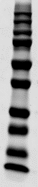
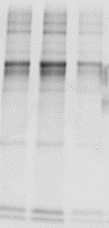


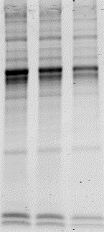
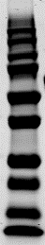
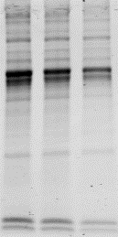
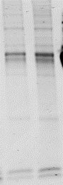
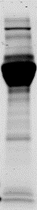
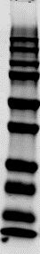
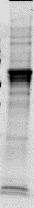
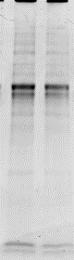
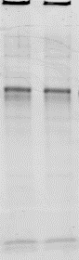

C)

F
A)
B)

F
D)

F
250
150
100
75
50
37
25
20
15
10
10min
20min
30min
60min
120min
DMEM⁺
10min
20min
30min
60min
120min
DMEM⁺
250
150
100
75
50
37
25
20
15
10
10 min
20 min
30 min
60 min
120 min
DMEM⁺+
250
150
100
75
50
37
25
20
15
10
10min
20min
30min
60min
120min
DMEM⁺
250
75
50
37
25
20
15
10
150
100
Figure S 1: SDS-PAGE showing the protein corona of PSNPs after 10, 20, 30, 60, 120 min incubation in DMEM⁺. A) 50nm (-SM), B) 50nm (-CM), C) 50nm (-CP), and D) 200nm (-CP). The amount of proteins at all-time points for each PSNP was adjusted to load the same amount. The molecular weights of the proteins in the standard ladder are given on the left side of each gel. DMEM⁺ is the medium control.

