Additional data
Table S1: Concentration of gold in the organs
µg/g  tissue | Chow-C | OB-C | OB-EAu | OB-LAu | OB-HAu
Fat | 0.22 ± 0.01 | 1.89 ± 0.49 | 36.91 ± 14.61 | 750 ± 187 | 10692 ± 2207‡
Liver | 0.42 ± 0.05 | 0.54 ± 0.14 | 14.83 ± 3.52 | 624 ± 311 | 3052 ± 1959*†
Spleen | 0.72 ± 0.30 | 0.69 ± 0.28 | 3.28 ± 0.65 | 21.41 ± 6.63 | 236.1 ± 113.6‡
Kidney | 0.16 ± 0.07 | 0.07 ± 0.01 | 0.16 ± 0.02 | 0.93 ± 0.17 | 2.73 ± 0.95‡
Heart | 0.01 ± 0.01 | 0.01 ± 0.00 | 0.06 ± 0.01 | 0.42 ± 0.13 | 2.64 ± 1.25‡
Brain | 0.12 ± 0.04 | 0.05 ± 0.01 | 0.08 ± 0.01 | 0.09 ± 0.01 | 0.28 ± 0.14†
Results are expressed as mean ± S.E.M. Data were analysed by one-way ANOVA followed by post hoc Bonferroni test.* P < 0.05 vs. Chow; † P < 0.05 vs. OB; ‡ P < 0.05 vs. all the other groups. n=3.

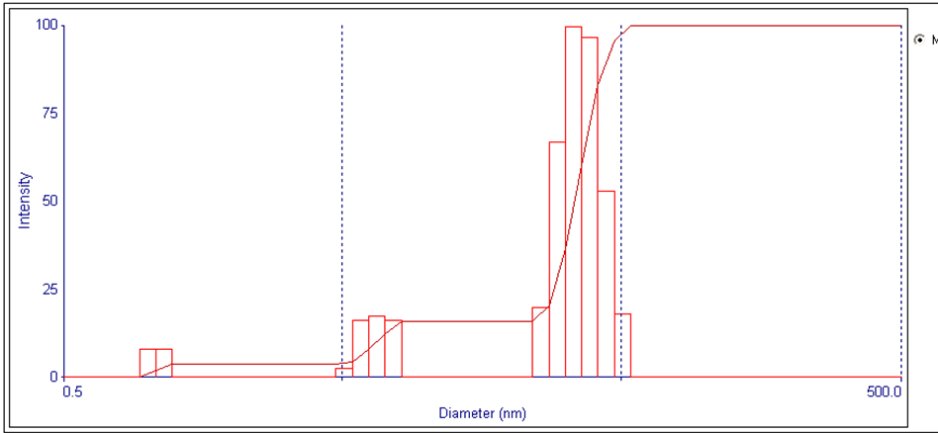
Figure S1
Dynamic light scattering measurement of as-synthesized AuNPs showing a narrow distribution of particle size between 20–30 nm and mean hydrodynamic diameter of 27.3±0.5 nm as determined by Brookhaven ZetaPALS.

Figure S2
UV-VIS absorption spectra showed a slight shift in surface plasmon resonance peaks for as-synthesized AuNPs in water from 520 nm to 518 nm for AuNPs resuspended in water after centrifuge purification at 5000 rpm, 4°C for 30 mins to remove excess citrate capping ions.
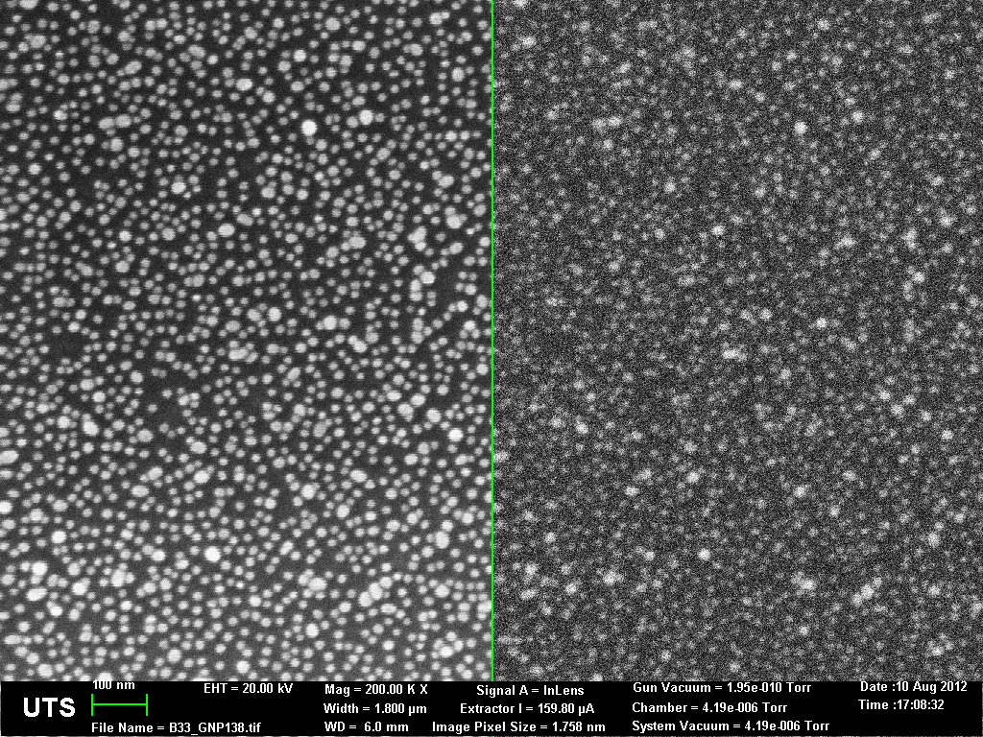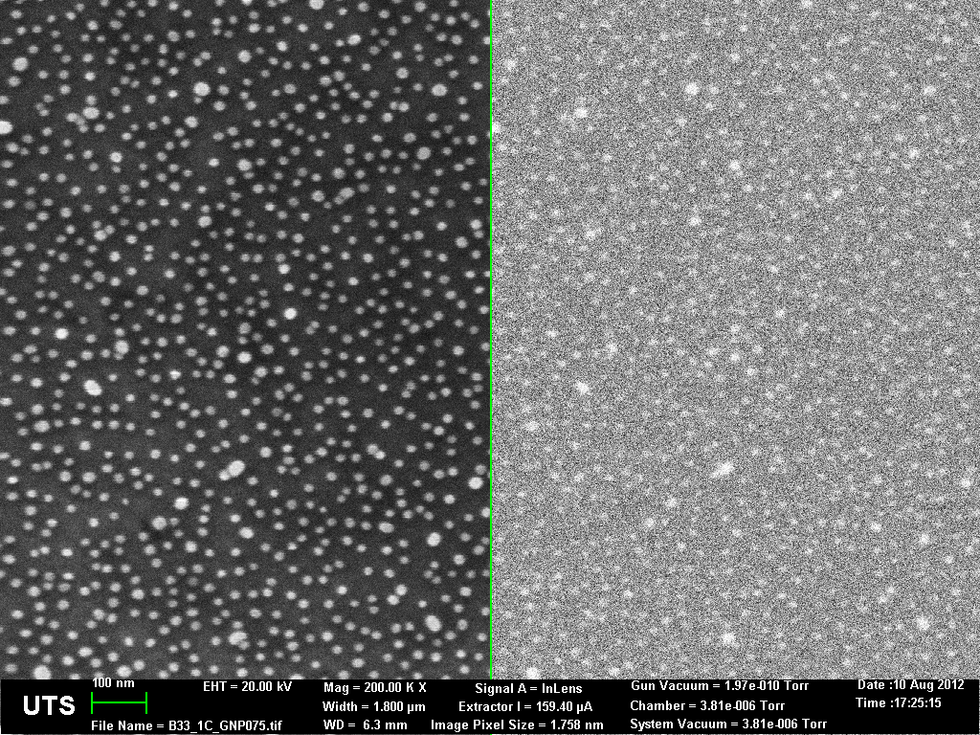
(A)
(B)
Figure S3
Representative brightfield mode (left panel) and electron backscatter diffraction mode (right panel) HR-SEM images at 200,000x magnification of as synthesized AuNPs immobilized on SiO₂ wafer using functional silane before (A) and after centrifuge-purified (B) dispersed in water. More than 60–100 particles were manually measured for particle core size estimation. Scale bar = 100 nm.

Figure S4. Effects of HFD and AuNP treatment on body weight in male mice. Body weight (B) in Chow (□ solid blue line), OB ( solid red line), OB-EAu ( dotted green line), OB-LAu ( dotted purple line), and OB-HAu ( dotted orange line). Results are expressed as mean ± S.E.M. Data were analysed by one-way ANOVA followed by post hoc Bonferroni test. γ P < 0.05 Chow vs. OB-EAu & OB-LAu; * P < 0.05 Chow vs. all other groups; λ P < 0.05 Chow vs. OB-LAu; ϕ P < 0.05 Chow vs. OB-HAu; ‡ P < 0.05 OB vs. OB-EAu & OB-LAu; τ P < 0.05 Chow vs. OB & OB-EAu; ξ P < 0.05 OB vs. OB-EAu & OB-HAu; ε P < 0.05 OB vs. OB-EAu; ζ P < 0.05 OB vs. OB-LAu; n=13–16.

Figure S5. Effect of HFD and AuNP treatment on glucose metabolism. Blood glucose levels during intraperitoneal glucose tolerance test (IPGTT) in Chow (□ solid blue line), OB ( solid red line), OB-EAu ( dotted green line), OB-LAu ( dotted purple line), and OB-HAu ( dotted orange line) mice at week 14. Results are expressed as mean ± S.E.M. Data was analysed by one-way ANOVA with repeat measures followed by post hoc Bonferroni test. ‡ P< 0.05 Chow vs. all other 4 groups at 15min; γ P< 0.05 OB vs. all other 4 groups at 30mins; δ P< 0.05, Chow vs. OB & OB-HAu, OB vs. OB-EAu & OB-LAu at 60mins; θ P< 0.05, Chow vs. OB & OB-HAu, OB vs. OB-LAu at 90mins.

