ADDITIONAL FILE 1

Magnetic targeting of adoptively transferred tumour-specific nanoparticle-loaded CD8⁺ T cells does not improve their tumour infiltration in a mouse model of cancer but promotes the retention of these cells in tumour-draining lymph nodes

Laura Sanz-Ortegaª, Yadileiny Portillaª, Sonia Pérez-Yagüeª, Domingo F. Barber^{a,*}

ªDepartment of Immunology and Oncology, and NanoBiomedicine Initiative, Centro Nacional de Biotecnología (CNB)-CSIC, Darwin 3, Cantoblanco, 28049 Madrid, Spain
*Address correspondence to dfbarber@cnb.csic.es

SUPPLEMENTARY FIGURES
Fig. S1. Phenotyping of blood obtained from the transgenic mouse strain OT-I. Representative graphs, obtained using FlowJo software, showing presence of Vα2 in CD8⁺ cells within the population of mature T cells (CD90.2⁺). The upper panel shows the results obtained in a transgenic mouse while the lower panel displays the results in a mouse that has lost the transgene. Shaded grey histogram: isotype control; blue line: corresponding antibody.

Fig. S2. OT-I CD8⁺ T cell purification and expansion. Representative graphs obtained using FlowJo software from the different populations at (A) day 0, after spleen and LN processing, and at (B) day 5, following activation with the OVA₂₅₇₋₂₆₄ peptide and subsequent IL-2 expansion. The percentage of CD8⁺ cells and their activation profile were analysed using the surface markers CD69 and CD25. Shaded grey histogram: isotype control; blue line: corresponding antibody. (C) Representative graphs of the culture, at day 5, in the absence of the different stimuli (OVA₂₅₇₋₂₆₄ or IL-2).

Fig. S3. Analysis of CD8⁺Vα2/Vβ5⁺ T cell infiltration in the tumour-draining and distal LNs and in spleens. Gating strategy followed for the analysis of the percentage of CD8⁺ Vα2 / Vβ5⁺ T cells present in the tumour-draining and distal LNs and in spleens.

Fig. S4. CD8⁺Vα2/Vβ5⁺ T cell infiltration of a distal LN in the different treatment groups. (A) Representative dot plots showing the percentage of Vα2/Vβ5⁺ cells within the living CD3⁺CD8⁺ cell population. (B) Percentage of CD8⁺ Vα2/Vβ5⁺ T cells within living CD45⁺ cells in a distal LN for the different treatment groups. (C) Percentage of CD8⁺ Vα2/Vβ5⁺ CD69⁺, CD25⁺, and CD69⁺CD25⁺ T cells in a distal LN for the different treatment groups. (D) Percentage of CD8⁺ Vα2/Vβ5⁺ IFN-γ⁺ T cells in a distal LN for the different treatment groups. The results shown (mean ± SD) correspond to 4 or 5 mice / group, * p <0.05, ** p <0.01, *** p <0.001.

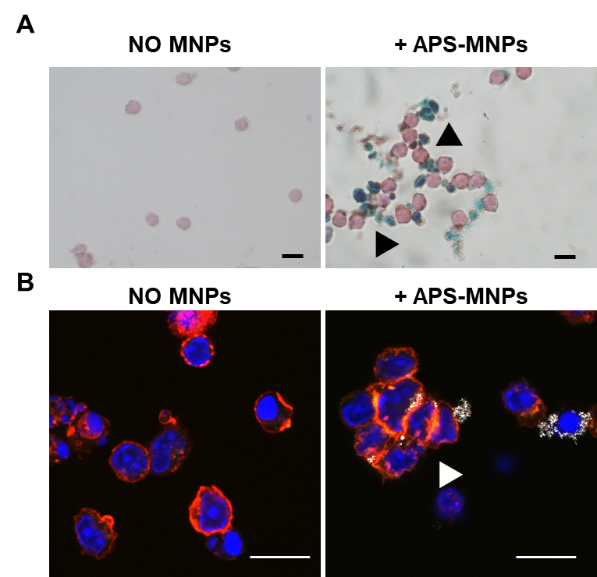
Fig. S5. Cell aggregation after MNP treatment. Representative images, showing cell aggregation due to MNP presence after 2 hour treatment, acquired using (A) Prussian blue staining and neutral red counterstain of OT-I CD8⁺ T cells after association with the MNPs (scale = 10 μm) or (B) confocal microscopy of the OT-I CD8⁺ T cells after treatment with APS-MNPs (cell membrane (red), MNPs (grey), and core (blue)) (scale = 10 μm). The arrows indicate the cell aggregation.

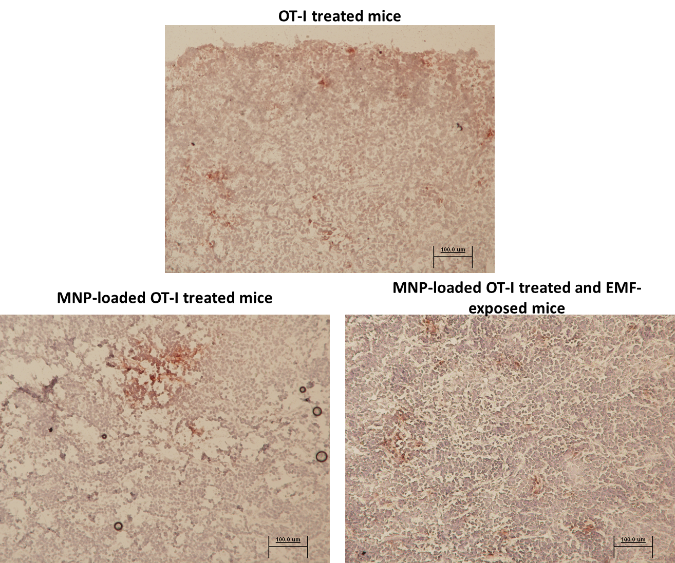
Fig. S6. Immunohistochemical analysis of CD8⁺ T cell infiltration in tumours. Immunohistochemical analysis of CD8⁺ T cell infiltration in the tumours from mice transferred with OT-I cells, MNP-loaded OT-I cells and MNP-loaded OT-I cells together with EMF-exposition. Representative images are shown (×10).

SUPPLEMENTARY METHODS
Immunohistochemistry
Tumours were removed and frozen in tissue-freezing medium (Jung). Immunohistochemical analyses were performed as previously described [1]. Briefly, sections were fixed, endogenous peroxidase was blocked, and slides incubated with anti-mouse CD8 primary antibody (YTS169.4, 1/100; abcam), followed by rat Histofine Simple Stain kits (Nichirei Biosciences), and finally stained with AEC+ substrate chromogen solution (Dako) and hematoxylin-counterstained.

[1] Spada R, Rojas JM, Pérez-Yagüe S, Mulens V, Cannata-Ortiz P, Bragado R and Barber DF: NKG2D ligand overexpression in lupus nephritis correlates with increased NK cell activity and differentiation in kidneys but not in the periphery. J Leukoc Biol 2015 Mar; 97(3): 583–598.

