Additional file
Ultrasmall nanostructured drug based pH-sensitive liposome for effective treatment of drug-resistant tumor
Yanyan Li¹, Yongxia Zhai¹, Wei Liu², Kaixiang Zhang^{2,3,4*}, Junjie Liu^{2,3,4*}, Jinjin Shi^{2,3,4*} and Zhenzhong Zhang^{2,3,4}
¹ Department of Pharmacy, the Fifth Affiliated Hospital of Zhengzhou University, Kangfu Road, Zhengzhou 450052, China
²School of Pharmaceutical Sciences, Zhengzhou University, Zhengzhou, PR China.
³Collaborative Innovation Center of New Drug Research and Safety Evaluation, Henan Province, PR China.
⁴Key laboratory of Targeting Therapy and Diagnosis for Critical Diseases, Henan Province, PR China.
*Correspondent author: Dr. Kaixiang Zhang, Dr. Junjie Liu and Dr. Jinjin Shi
Tel: 86-371-67781910
Fax: 86-371-67781908
E-mail:zhangkx@zzu.edu.cn, liujunjie@zzu.edu.cn and shijinyxy@zzu.edu.cn
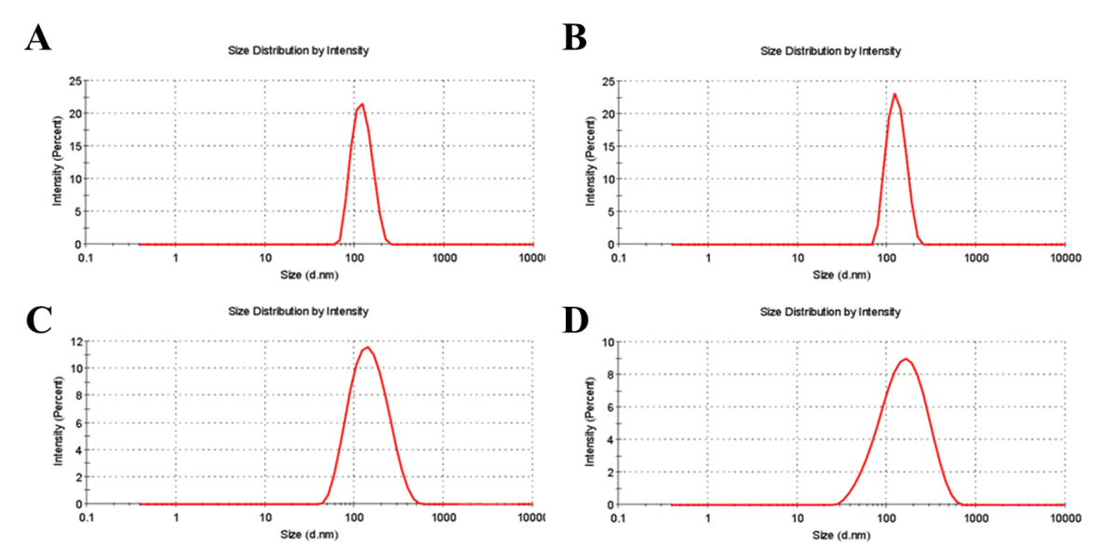
Additional file 1. Size distributions of liposome (A), DOX@liposome (B), TD@liposome (C) and LNSD (D).

