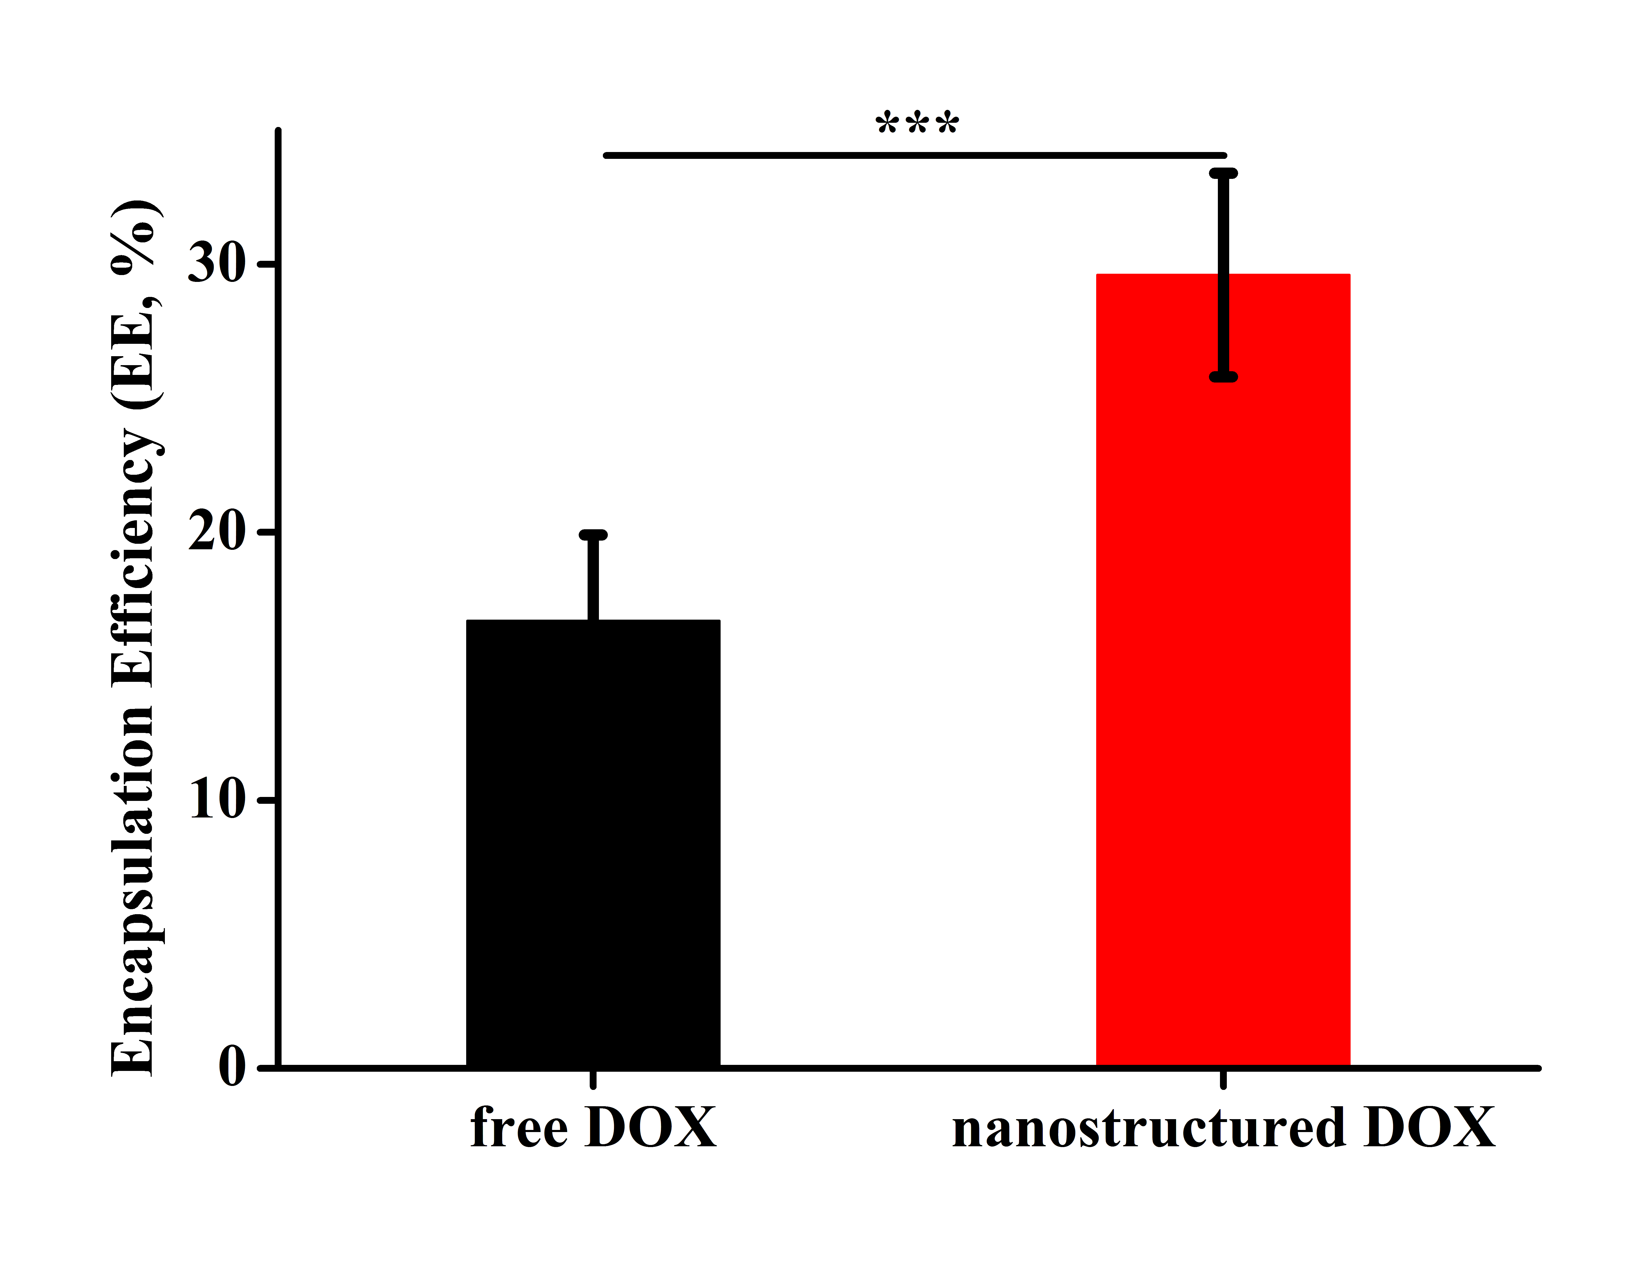
Additional file 2. Encapsulation efficiency of DOX@liposome (free DOX strategy) and LNSD (nanostructured DOX strategy) (n=6). Data presented are means ± SD. ***, p<0.01.

