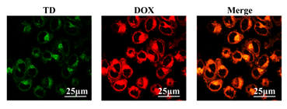
Additional file 5. Representative CLSM images of cells treated with DOX/TD@liposome for 4h. Scale bar: 25 μm.

