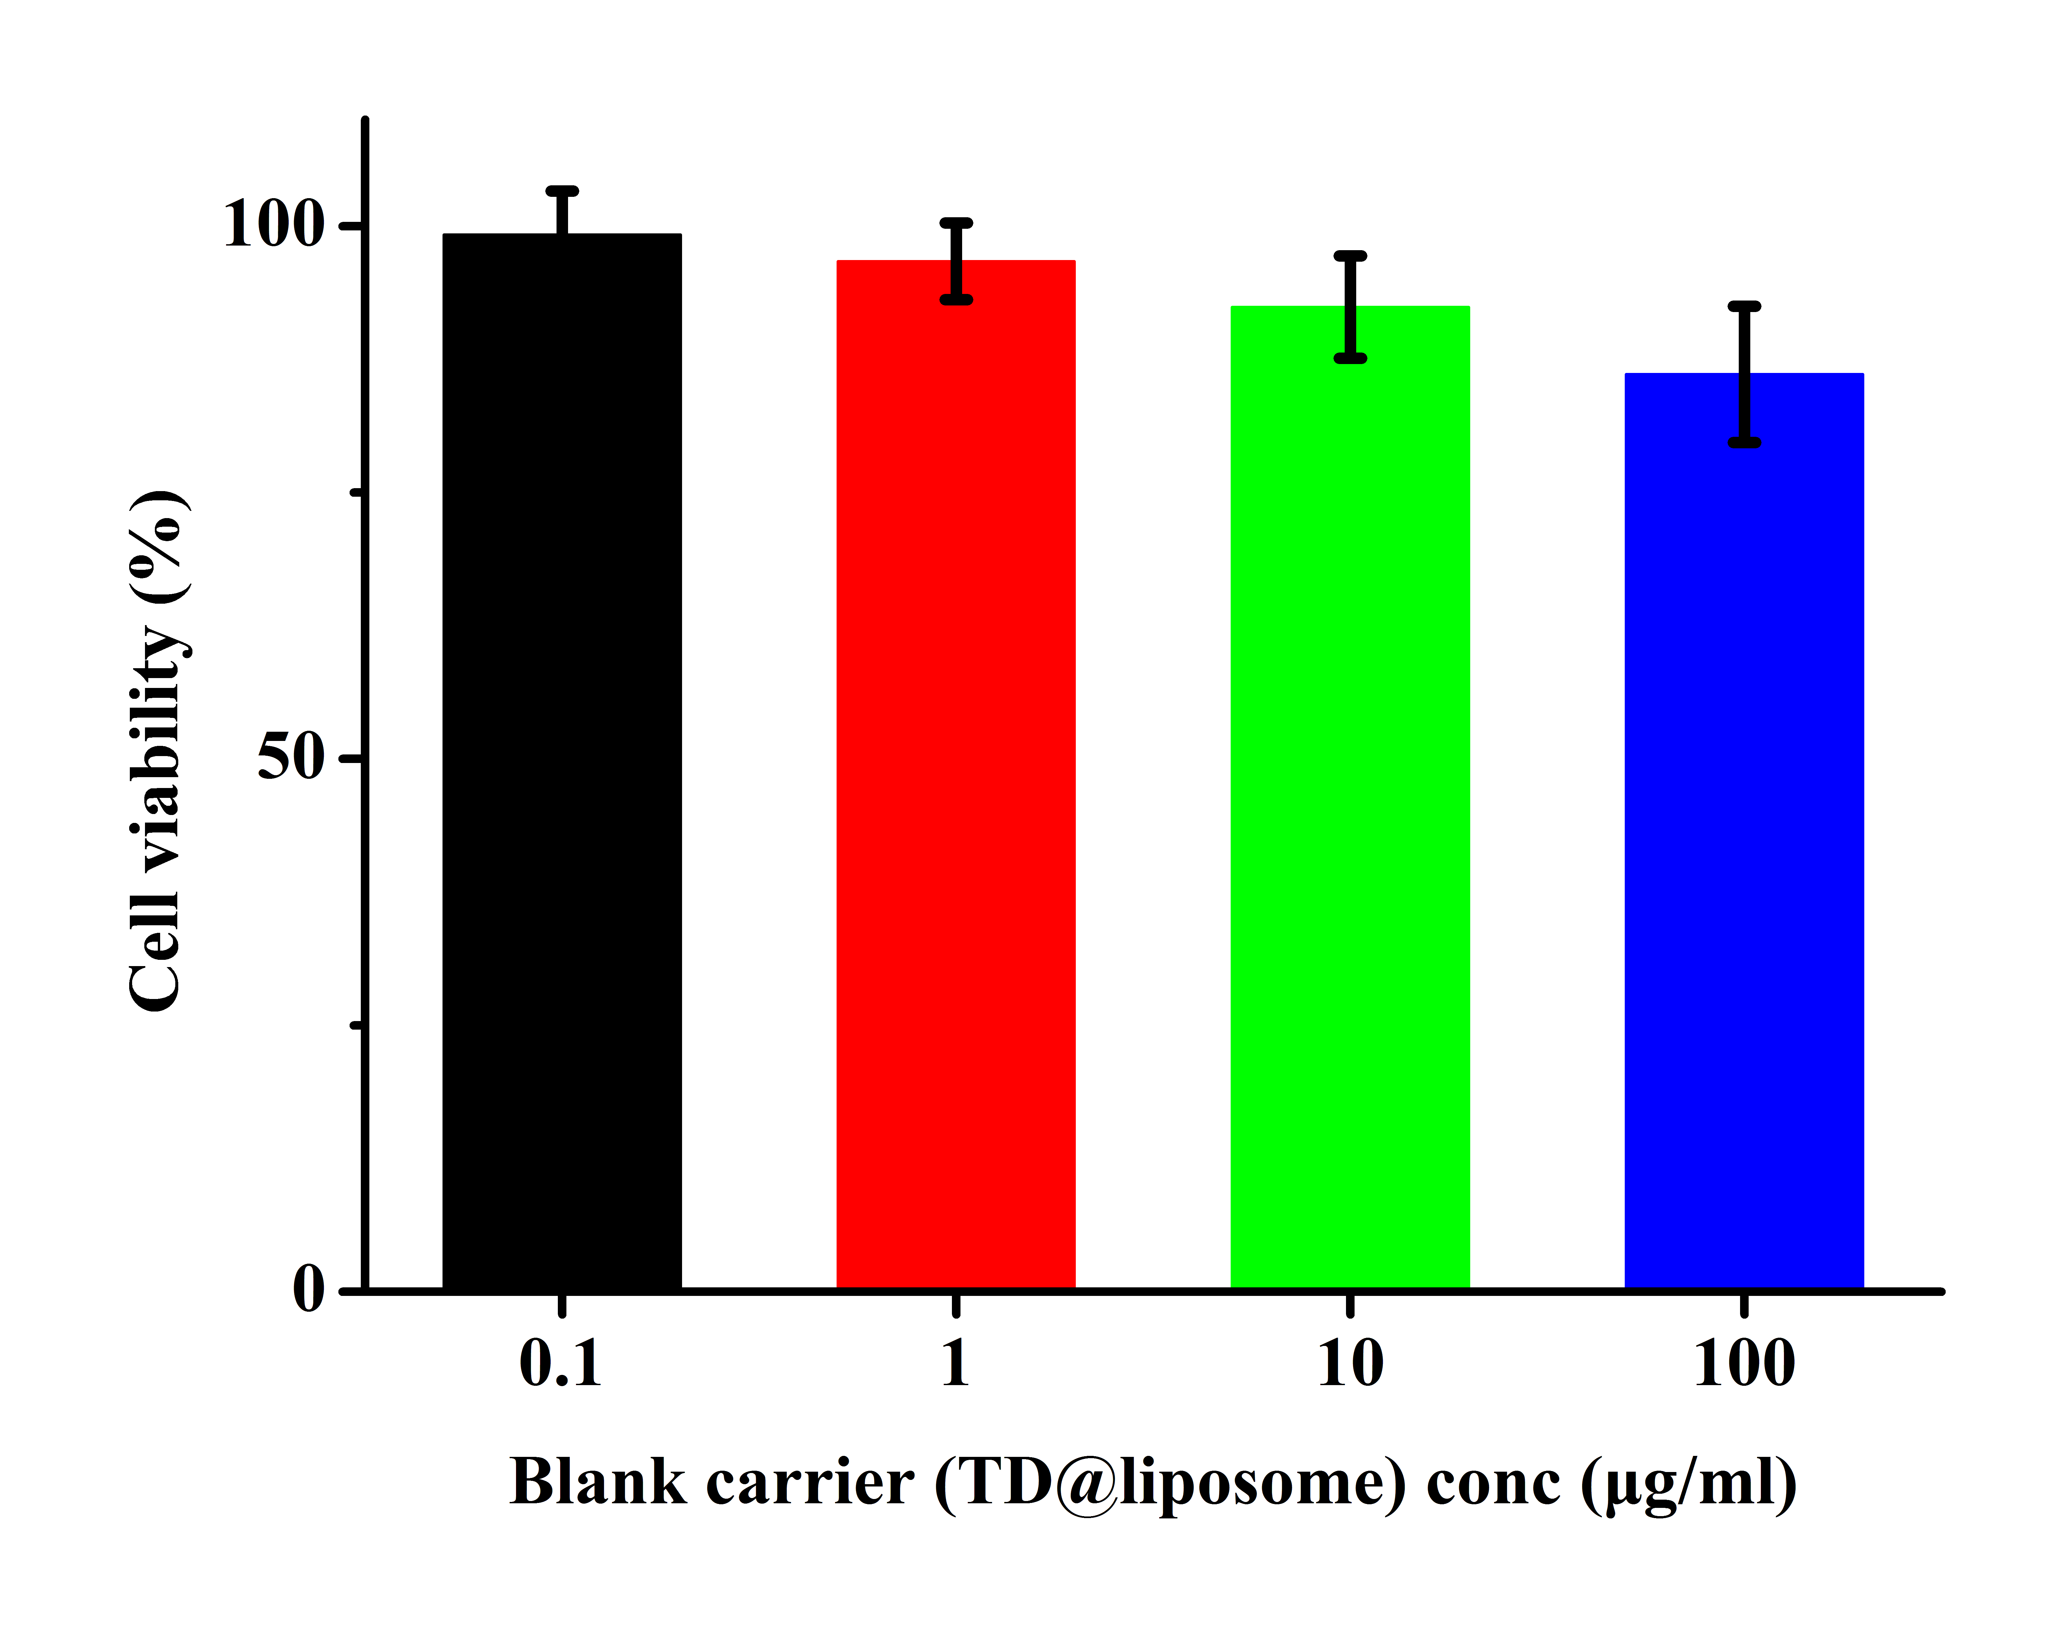
Additional file 6. Cell viability of MCF-7/ADR cells treated with different concentrations of blank carrier (TD@liposome, n=6).

