Additional information

Ultrasensitive haptoglobin biomarker detection based on amplified chemiluminescence of magnetite nanoparticles

Narsingh R. Nirala¹, Yifat Harel², Jean-Paul Lellouche², Giorgi Shtenberg^{1*}
¹ Institute of Agricultural Engineering, ARO, the Volcani Center, Bet Dagan 50250, Israel
² Department of Chemistry, Nanomaterials Research Center, Institute of Nanotechnology & Advanced Materials (BINA), Bar-Ilan University, Ramat-Gan 5290002, Israel

*Corresponding author: giorgi@agri.gov.il

Table S1. Peak area comparison of amide bonds vs. Fe-O for the different MNPs modifications obtained by ATR-FTIR
Sample | Peak Area |  | Ratio ($\frac{υ_{(amide I and II)}}{υ_{(Fe-O)}}$)
Sample | υ_{(amide I and II)}ª | υ_{(Fe-O)}^{b} | Ratio ($\frac{υ_{(amide I and II)}}{υ_{(Fe-O)}}$)
MNPs | 2.16 | 6.17 | 0.35
G-MNPs | 3.92 | 2.33 | 1.68
Hb-MNPs | 3.55 | 0.65 | 5.46
ª 1474-1709 cm⁻¹.
^{b} 479-603 cm⁻¹.

Table S2. MNPs size distribution obtained by DLS
Sample |  | Averaged diameter  (nm)
MNPs |  | 211±6
G-MNPs |  | 469±31
Hb-MNPs |  | 535±173
Data are reported as mean ± SD (n = 3).

Table S3. Hb binding efficiency to MNPs surface
Hb  (µg mL⁻¹) |  | Added Hb  (µg) | Washed Hb ª  (µg) | Immobilized Hb ^{b}  (µg)
1 |  | 0.2 | N/A * | N/A
10 |  | 2 | 1.4±0.4 | 0.6±0.4
100 |  | 20 | 13.6±1.4 | 6.4±1.4
ª Quantified by the Bradford dye-binding method.
^{b} Immobilized Hb content per 0.49 mg magnetite.
* Below linear quantification range.
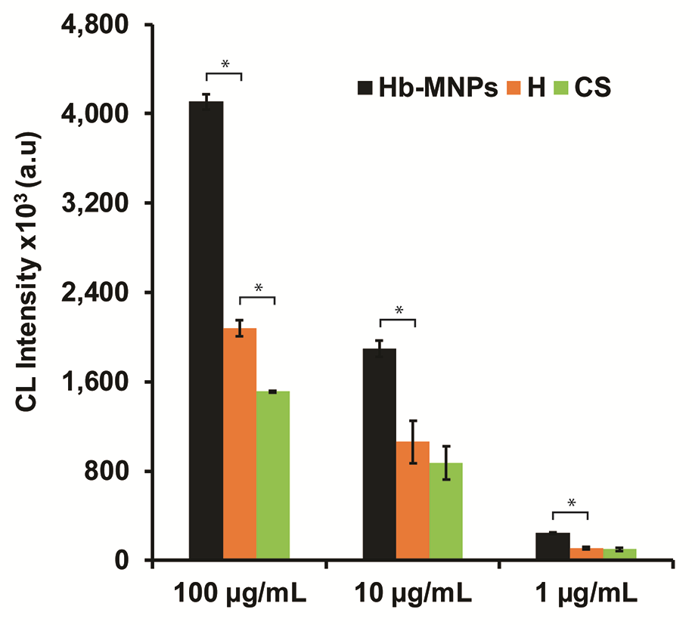
Figure S1. CL values of the magnetic bioassay for three concentrations of Hb catalyst (1, 10, and 100 µg mL⁻¹) within dissimilar milk samples qualities: healthy (H), cattle sick (CS, representing clinical mastitis) and in buffer (Hb-MNPs used as a positive control). Data are reported as mean ± SD (n ≥ 3). * Statistically different (t-test, p<0.05).
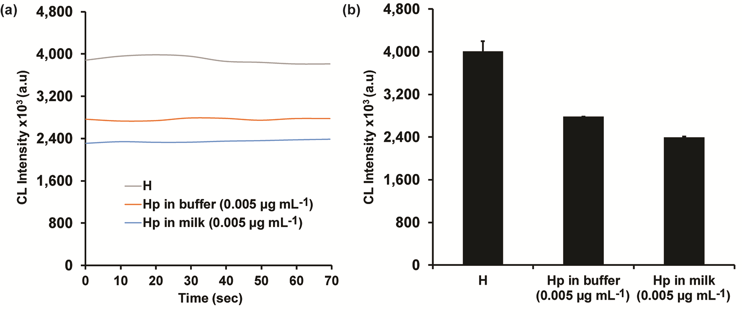
Figure S2. (a) CL signal stability of the Hb-MNPs bioassay within healthy milk sample (H) used for blocking (insignificant Hp content) and spiked Hp (0.005 µg mL⁻¹) in buffer and milk, respectively; (b) The corresponding averaged CL data. Data are reported as mean ± SD (n ≥ 3).
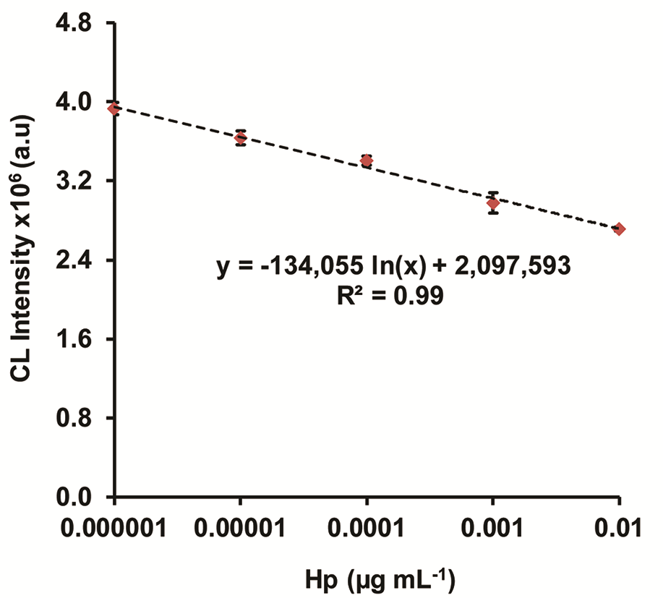
Figure S3. Calibration curve of the CL bioassay for standard Hp concentrations based on Hb-MNPs in buffer.

Table S4. Hp concentrations in spiked buffer and milk samples using Hb-MNPs CL emission system in comparison to bovine ELISA
Spiked Hp  (µg mL⁻¹) | Hp Hb-MNPS  (µg mL⁻¹) | Hp ELISA  (µg mL⁻¹) |  |  | CL  Recovery  (%) | ELISA  Recovery  (%) | Deviation  (%) ^{b}
0.0050 in buffer | 0.0060±0.0002 ª | 0.0046±0.0002 |  |  | 120 | 92 | 130
0.0050 in milk | 0.0069±0.0008 | 0.0052±0.0002 |  |  | 138 | 104 | 133
ª Calculated based on calibration curve in buffer conditions (milk-free assay, Figure S3).
^{b} Recovery of Hp output obtained by CL emission system with respect to bovine ELISA.

