Norepinephrine Transporter-Derived Homing Peptides Enable Rapid Endocytosis of Drug Delivery Nanovehicles into Neuroblastoma Cells
Yazan Haddad^{1,2}, Marketa Charousova^{1,2}, Hana Zivotska^{1,2}, Zbynek Splichal^{1,2}, Miguel Angel Merlos Rodrigo^{1,2}, Hana Michalkova^{1,2}, Sona Krizkova^{1,2}, Barbora Tesarova^{1,2}, Petr Vitek³, Kamila Stokowa-Soltys⁴, David Hynek^{1,2}, Lukas Richtera^{1,2}, Vedran Milosavljevic^{1,2}, Simona Dostalova^{1,2*}, Zbynek Heger ^{1,2*}

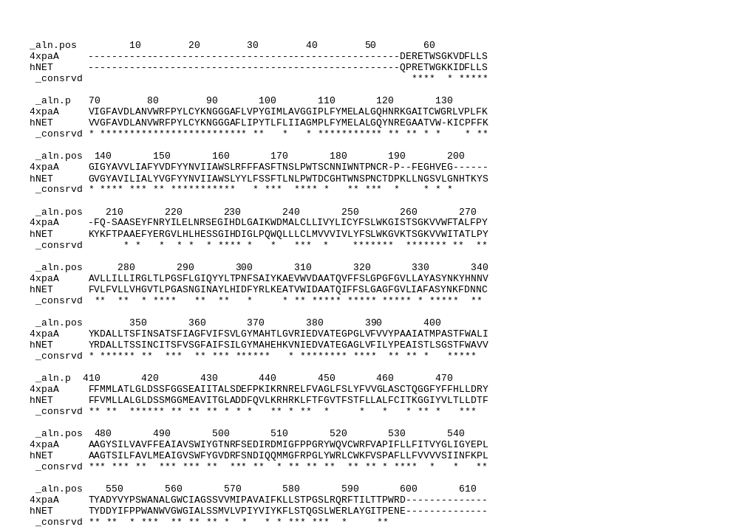
Figure S1. Alignment of hNET sequence (P23975) and dDAT crystal structure (PDB ID: 4XPA) using Modeller.

Table S1. Summary of manual refinement and quality control of homology models hNET-M and hNET-S.
 | hNET-M model |  | hNET-S model
Refinement
Phi/Psi changes | K201, L584 |  | G217, V532, L584
Rotamers superposed to dDAT | 163_{mt}, L146_{tt}, P188_{cg exo}, K201_{tptp}, E212_{mt-10}, V282_{t}, T283_{p}, K303_{mttt}, K334_{mttt}, I349_{mt}, L398_{mt}, T450_{m}, L455_{tp}, E488_{mt-10}, L515_{mt}, L530_{tp}, P542_{cg exo}, K576_{tttp}, L584_{pp}, L588_{tp}, P594_{cg exo} |  | D75_{p-10}, L100_{mt}, F101_{m-85}, L146_{tp}, L169_{tt}, N170_{p30}, N192_{m120}, N292_{t-20}, D378_{m-20}, L398_{pp}, D418_{p-10}, V498_{m}, D499_{p-10}, N503_{t-20}, Q507_{tt}, V524_{t}, V532_{m}, V533_{p}, F540_{t80}, K576_{tttp}
Rotamers superposed to hSERT | K61_{tttt}, T99_{p}, I103_{mt}, C131_{m}, L163_{tp}, S165_{m}, Y214_{t80}, V218_{p}, Q236_{mp0}, L237_{mt}, V256_{m}, V276_{t}, V279_{t}, L302_{tp}, E304_{mm-40}, I315_{tp}, F329_{m-30}, C351_{m}, V356_{m}, I389_{m}, E393_{tt}, V449_{p}, V468_{t}, R518_{ttp85}, Y572_{t80}, I592_{pp} |  | T99_{p}, I130_{mm}, Y161_{t80}, Y162_{m-85}, S165_{m}, Y214_{t80}, V218_{p}, Q236_{mp0}, M242_{ttt}, V247_{p}, T268_{p}, L302_{tp}, E304_{mm-40}, I309_{mt}, I315_{tp}, V356_{m}, S357_{m}, E393_{tt}, V449_{p}, R518_{ttp85}, Y572_{t80}
Quality | Before | After | Before | After
Clashscore | 87.7 (0th percentile) | 27.18 (18th percentile) | 4.51 (95th percentile) | 7.56 (84th percentile)
Poor rotamers | 6 (1.31%) | 2 (0.48%) | 5 (1.09%) | 3 (0.71%)
Ramachandran outliers | 2 (0.37%) | 0 (0.00%) | 1 (0.18%) | 0 (0.00%)
C-beta outliers | 4 (0.8%) | 7 (1.41%) | 3 (0.6%) | 9 (1.81%)
MolProbity score | 2.54 (45th percentile) | 2.15 (67th percentile) | 1.42 (97th percentile) | 1.6 (92nd percentile)

Table S2. Summary of ClustPro geometric docking.
ClustPro Docking | A | B | C | D
Ligand | GASNGINAYL | GASNGINAYL | SLWERLAYGI | SLWERLAYGI
Receptor | hNET-M | hNET-S | hNET-M | hNET-S
Clusters | 9 | 8 | 9 | 9
Order among clusters | 2nd | 2nd | 1st | 2nd
Models in chosen cluster | 236/1000 | 213/1000 | 427/1000 | 266/1000
Median score | -733.9 | -735.0 | -881.7 | -803.8

Table S3. Summary of Haddock solvated docking.
Haddock Solvated docking | A | B | C | D
Ligand | GASNGINAYL | GASNGINAYL | SLWERLAYGI | SLWERLAYGI
Receptor | hNET-M | hNET-S | hNET-M | hNET-S
Interacting residue in ligand | G1 | G1 | S1 | S1
Interacting residue in receptor | D473 | D473 | E382 | E382
Total number of Clusters | 2 | 7 | 1 | 2
Order among Clusters | 1st | 1st | 1st | 1st | 2nd
Haddock score | -95.9 ± 6.3 | -72.0 ± 3.3 | -84.9 ± 2.9 | -80.1 ± 6.7 | -25.6 ± 6.0
Cluster size/total | 190/198 | 15/184 | 200/200 | 194/199 | 5/199
RMSD from the overall lowest-energy structure | 0.4 ± 0.2 | 0.4 ± 0.2 | 0.4 ± 0.2 | 0.4 ± 0.2 | 1.7 ± 0.1
Van der Waals energy | -31.4 ± 2.9 | -34.9 ± 6.8 | -35.5 ± 3.7 | 41.6 ± 3.8 | -19.4 ± 1.1
Electrostatic energy | -292.3 ± 23.2 | -253.3 ± 39.9 | -228.9 ± 39.5 | -260.5 ± 22.0 | -82.9 ± 19.9
Desolvation energy | -6.1 ± 9.2 | 13.6 ± 6.0 | -3.6 ± 3.2 | 13.6 ± 4.6 | 10.4 ± 8.0
Restraints violation energy | 0.0 ± 0.0 | 0.0 ± 0.0 | 0.0 ± 0.0 | 0.0 ± 0.0 | 0.0 ± 0.0
Buried surface area | 1162.8 ± 61.1 | 1198.5 ± 106.7 | 1184 ± 6.4 | 1402.8 ± 60.6 | 746.5 ± 122.8
Z-score | -1.0 | -1.8 | 0.0 | -1.0 | 1.0

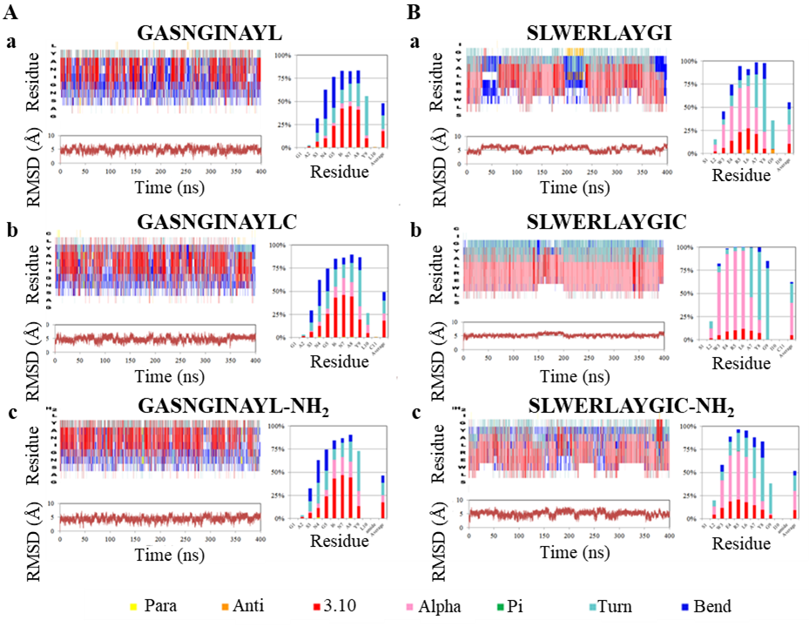
Figure S2. Generalized Born implicit-water molecular dynamics simulations (400 ns) at physiological pH 7.4 of homing peptides variants GASNGINAYL(Cys/-NH₂) (A, a-c) and SLWERLAYGIC(Cys/-NH₂) (B, a-c). Left panels show time evolution of peptide secondary structures and Root-mean square-deviations (RMSD, Å), whereas right panels show percentage of secondary structure distribution among residues and average in the last column.
Table S4. Full list of genes deregulated in SH-SY5Y cells after incubation with GASNGINAYLC peptide. The list contains genes, which were up- or down-regulated in three independent analyzes (n = 3). Shown are only the genes with fold ratio >1.5 or <0.5.
Up-regulation
Gene | Symbol | NCBI database | FR* | SD (n = 3)
Reticulocalbin 1 | RCN1 | NM_002901 | 18.15 | 3.451
ARP2 actin-related protein 2 homolog | ACTR2 | NM_001005386 | 2.53 | 0.201
Scavenger receptor cysteine-rich type 1 protein M160 | M160 | NM_174941 | 2.51 | 0.075
KH-type splicing regulatory protein | KHSRP | NM_003685 | 2.25 | 0.497
Mitogen-activated protein kinase 14 | MAPK14 | NM_139013 | 2.22 | 0.026
RAD21 homolog | RAD21 | NM_006265 | 1.98 | 0.018
Adipose differentiation-related protein | ADFP | NM_001122 | 1.82 | 0.064
Thymidine kinase 1 | TK1 | NM_003258 | 1.78 | 0.220
S-adenosylhomocysteine hydrolase | AHCY | NM_000687 | 1.68 | 0.288
Dystonin | DST | NM_183380 | 1.66 | 0.045
SRY (sex determining region Y)-box 4 | SOX4 | NM_003107 | 1.61 | 0.229
Solute carrier family 25, member 6 | SLC25A4 | NM_001151 | 1.61 | 0.426
Creatine kinase brain | CKB | NM_001823 | 1.61 | 0.004
Protein kinase C | PRKCQ | NM_006257 | 1.54 | 0.137
Choline kinase alpha | CHKA | NM_001277 | 1.52 | 0.147
Down-regulation
Gene | Symbol | NCBI database | FR* | SD (n = 3)
Hepsin (transmembrane protease, serine 1) | HPN | NM_002151 | 0.56 | 0.018
Proline 4-hydroxylase | P4HB | NM_000918 | 0.55 | 0.064
Zinc finger protein 36, C3H type, homolog | ZFP36 | NM_003407 | 0.54 | 0.220
V-erb-b2 erythroblastic leukemia viral oncogene homolog 3 | ERBB3 | NM_001005915 | 0.50 | 0.288
Fc fragment of IgG, low affinity IIIa, receptor (CD16a) | FCGR3A | NM_000570 | 0.42 | 0.045
Thymidylate synthetase | TYMS | NM_001071 | 0.41 | 0.029
Ubiquitin-conjugating enzyme E2C | UBE2C | NM_181800 | 0.23 | 0.041
Retinol binding protein 4, plasma | RBP4 | NM_006744 | 0.11 | 0.198
ST7 overlapping transcript 2 | ST7 | NM_021908 | 0.09 | 0.419
*FR, fold ratio.

Table S5. Full list of genes deregulated in SH-SY5Y cells after incubation with SLWERLAYGIC peptide. The list contains genes, which were up- or down-regulated in three independent analyzes (n = 3). Shown are only the genes with fold ratio >1.5 or <0.5.
Up-regulation
Gene | Symbol | NCBI database | FR* | SD (n = 3)
ARP2 actin-related protein 2 homolog | ACTR2 | NM_001005386 | 8.23 | 1.224
Reticulocalbin 1 | RCN1 | NM_002901 | 3.10 | 0.411
Mitogen-activated protein kinase 14 | MAPK14 | NM_139013 | 2.73 | 0.064
Choline phosphotransferase 1 | CHPT1 | NM_020244 | 1.96 | 0.029
KH-type splicing regulatory protein | KHSRP | NM_003685 | 2.25 | 0.497
FXYD domain containing ion transport regulator 5 | FXYD5 | NM_014164 | 1.76 | 0.132
Melanoma cell adhesion molecule | MCAM | NM_006500 | 1.74 | 0.091
Trefoil factor 3 | TFF3 | NM_003226 | 1.72 | 0.147
Alpha-2-macroglobulin | A2M | NM_000014 | 1.71 | 0.236
Thymidine kinase 1 | TK1 | NM_003258 | 1.62 | 0.066
Creatine kinase brain | CKB | NM_001823 | 1.54 | 0.198
Dystonin | DST | NM_183380 | 1.53 | 0.044
LUC7-like | LUC7L | NM_018032 | 1.52 | 0.011
F-box protein 31 | FBXO31 | NM_024735 | 1.51 | 0.411
S-adenosylhomocysteine hydrolase | AHCY | NM_000687 | 1.50 | 0.206
Down-regulation
Gene | Symbol | NCBI database | FR* | SD (n = 3)
V-erb-b2 erythroblastic leukemia viral oncogene homolog 3 | ERBB3 | NM_001005915 | 0.59 | 0.061
Paternally expressed 3 | PEG3 |  | 0.58 | 0.018
Stanniocalcin 1 | STC1 |  | 0.58 | 0.155
Mitogen-activated protein kinase 12 | MAPK12 |  | 0.55 | 0.220
Spondin 2, extracellular matrix protein | SPON2 |  | 0.52 | 0.068
MLF1 interacting protein | MLF1IP |  | 0.51 | 0.470
Dynactin | DCTN4 |  | 0.44 | 0.081
ST7 overlapping transcript 2 | ST7 |  | 0.14 | 0.110
*FR, fold ratio.

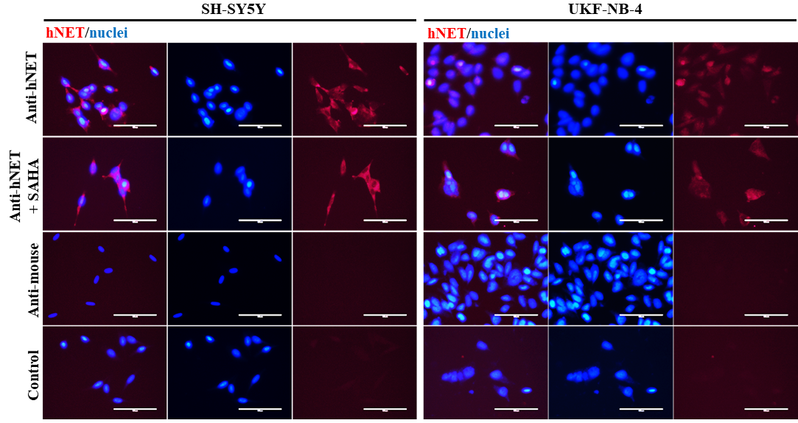
Figure S3. hNET (red) immunofluorescence in wild type neuroblastoma cells and after 24-h treatment with SAHA, cell autofluorescence and fluorescence after incubation with anti-mouse fluorescent secondary antibody. Hoechst 33342 (blue) was used to counterstain nuclei. Scale bar 50 µm.

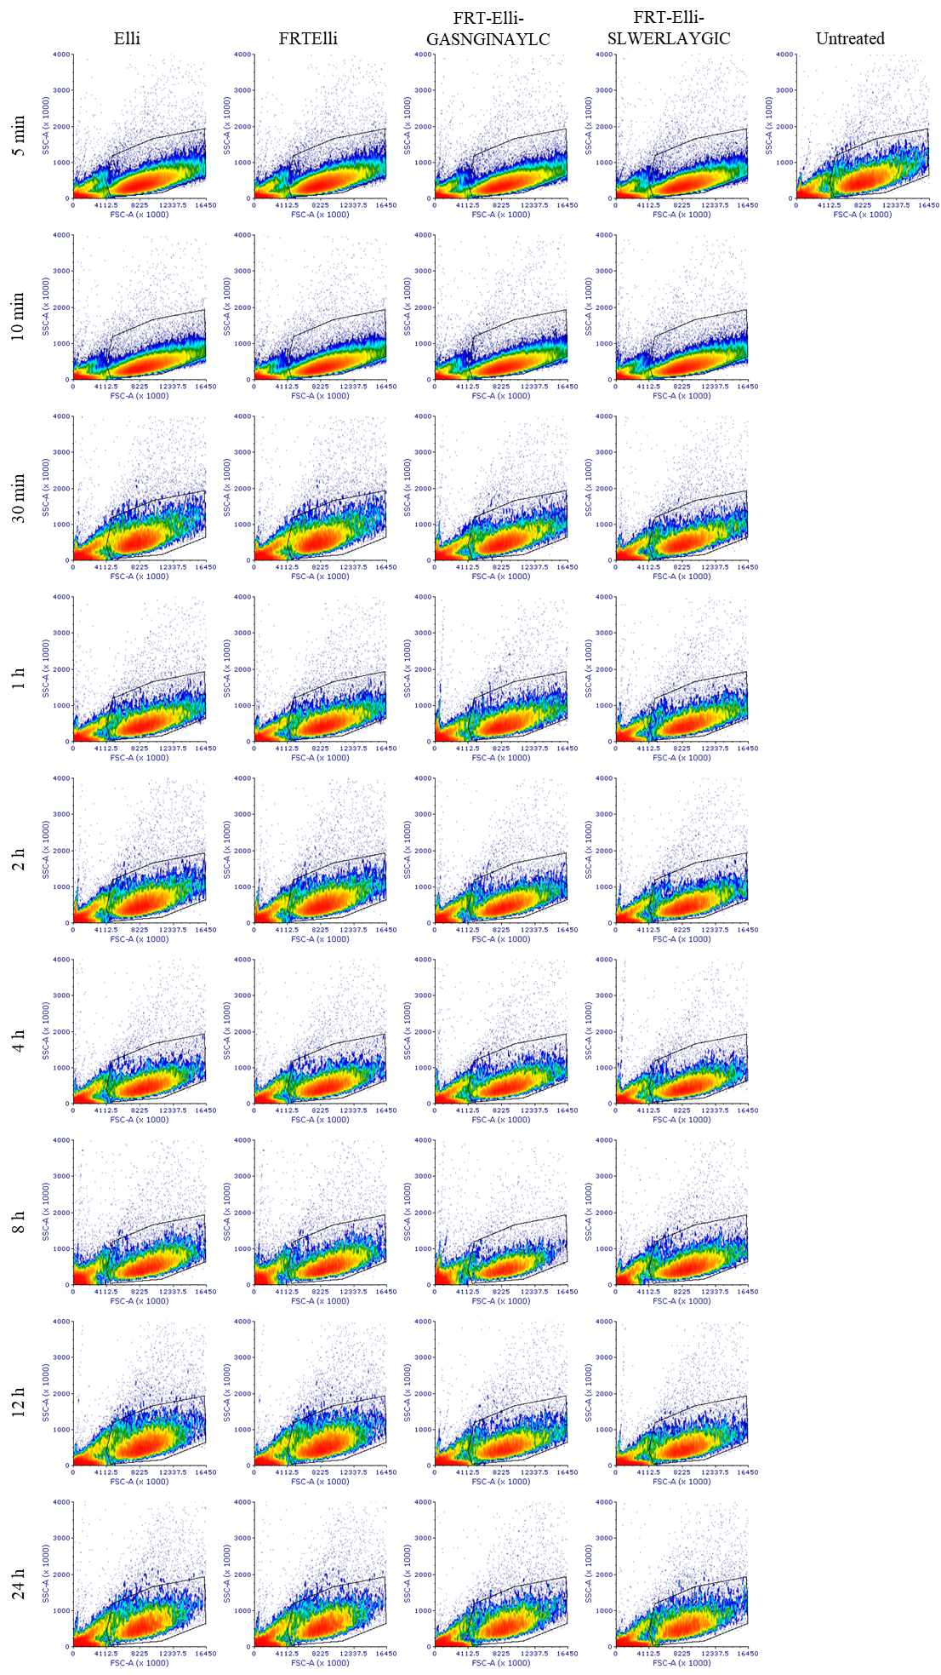
Figure S4. Scatter plots showing the gating of cells on forward vs. side scatter for the measurement of uptake kinetics of hNET-homing nanovehicles encapsulating Elli.

Table S6. List of primers employed for qPCR analysis of SLC6A2, SLC6A3 and SLC6A4 expression.
Full name/Function | Gene |  | Primer (5´-3´) | Product size  (nt)
Solute carrier family 6 member 2 | SLC6A2 | F | CTGTATCACCAGCTTCGTCTC | 111
Norepinephrine transporter | SLC6A2 | R | ACTAGGCCAGCTCCTTCT | 111
Solute carrier family 6 member 3 | SLC6A3 | F | TCAGGGAAGGTGGTATGGAT | 108
Dopamine transporter | SLC6A3 | R | GTATGCTCTGATGCCGTCTATG | 108
Solute carrier family 6 member 4 | SLC6A4 | F | CCCTCTGTTTCTCCTGTTCATC | 114
Serotonine transporter | SLC6A4 | R | GTTCCTATGCAGTAACCCAAGA | 114
Hypoxanthine phosphoribosyltransferase 1 | HPRT1 | F | TGGCGTCGTGATTAGTGATG | 128
Generation of purine nucleotides (reference gene) | HPRT1 | R | GACGTTCAGTCCTGTCCATAAT | 128

