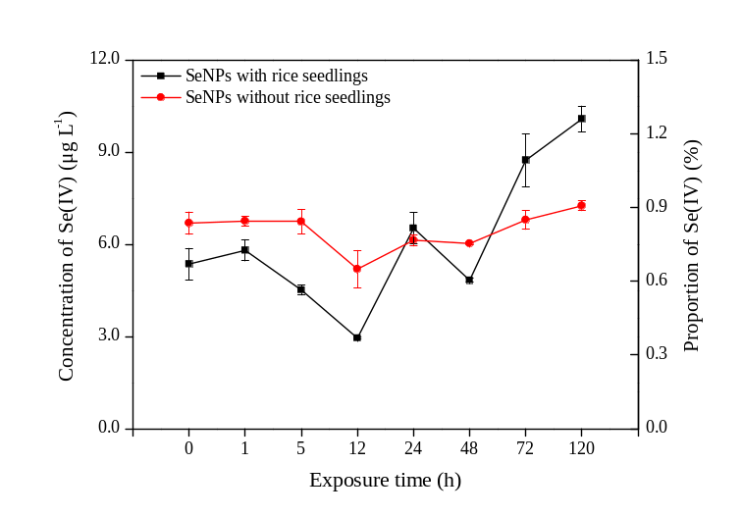
Figure S1. Concentration and proportion of Se(IV) in the culture solution during the exposure period. Data presented as mean ± SE (n = 3).

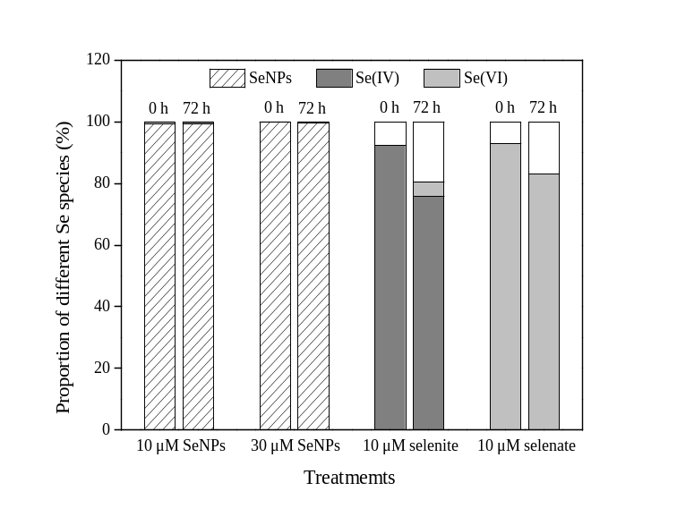
Figure S2. Proportion of different Se species in the culture solution under the different Se treatments during the exposure period.

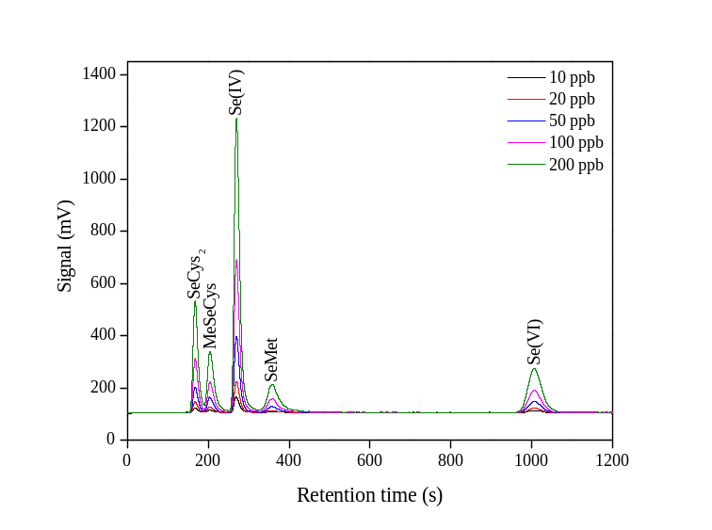
Figure S3. Chromatogram of five standard selenocompounds through HPLC-UV-HG-AFS. SeCys₂, selenocystine; MeSeCys, Se-methyl-selenocysteine; Se(IV), selenite; SeMet, selenomethionine; Se(VI), selenate.

