Additional file
Multifunctional TPP-PEG-biotin self-assembled nanoparticle drug delivery-based combination therapeutic approach for co-targeting of GRP78 and lysosome
Baskaran Purushothaman, Jeongmin Lee, Sera Hong, and Joon Myong Song*

College of Pharmacy, Seoul National University, Seoul 08826, South Korea

* Corresponding author:
E-mail: jmsong@snu.ac.kr (Joon Myong Song)

Figure S1. Intracellular drug release
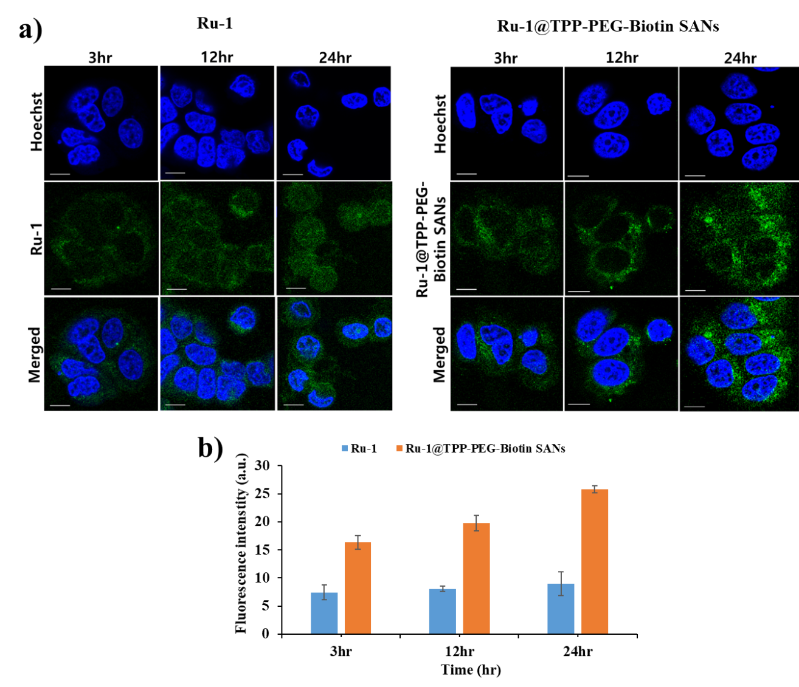
Figure S1. The intracellular Ru-1 release study of Ru-1@TPP-PEG-Biotin SANs was assessed by confocal fluorescence microscopy. (a) Confocal fluorescence images of free Ru-1 and Ru-1loaded TPP-PEG-Biotin SANs. (b) The quantitative analysis for the fluorescent intensity of Ru-1 release was measured using the software MetavueTM.

