Additional Information
ROS-triggered self-accelerating drug release nanosystem with charge conversion for enhanced cancer therapy
Xinyi Zhang¹, Tiantian Zhu², Yaxin Miao³, Lu Zhou³, Weifang Zhang¹*.
1.Department of Pharmacy/Respiratory Diseases, The Second Affiliated Hospital of Nanchang University, Nanchang 330006, China.
2.Teaching and Research Office of Clinical Pharmacology, College of Pharmacy, Xinxiang Medical University, Xinxiang, 453003, China.
3.Medical College of Nanchang University，Nanchang, 330031，China.
*Corresponding to Weifang Zhang, e-mail: zhaweifang@163.com, Tel.: +86-0791-86303184.
Figure S1. ¹H-NMR spectra of PEG-b-PLL(Z) and PEG-b-PLL.
PEG-b-PLL(Z) (¹H NMR; 500 MHz, CDCl₃, ppm): 1.20-1.90 (-CH₂CH₂CH₂-CH-), 3.10 (-CH₂-NH-), 3.66 (-CH₂CH₂-O-), 3.86 (-CH-NH-), 5.00 (-CH₂-C₆H₅), 7.26-7.44 (-C₆H₅). PEG-b-PLL (¹H NMR; 500 MHz, D₂O, ppm): 1.32-1.70 (-CH₂CH₂CH₂-CH-), 2.93 (-CH₂-NH₂), 3.63 (-CH₂CH₂-O-), 4.23 (-CH-NH-).
Figure S2. ¹H-NMR spectra of N-(tert-Butoxycarbonyl)-L-methionine (D(Boc)) and methoxyl poly(ethylene glycol)-block-Poly(L-lysine)-graft- methionine (Boc) (PLM(Boc)).
D(Boc) (¹H NMR; 500 MHz, DMSO-d₆, ppm): 1.39 ((CH₃)₃C-O-), 1.85-1.90 (-CH₂-CH-), 2.04 (CH₃-S-), 2.54 (-CH₂-S-), 4.03 (-CH-NH-). PLM(Boc) (¹H NMR; 500 MHz, DMSO-d₆, ppm): 1.38 ((CH₃)₃C-O-), 2.04 (CH₃-S-), 3.52 (-CH₂CH₂-O-).
Figure S3. ¹H-NMR spectra of PPT/D(Boc) and PPD(DMA).
PPT/D(Boc) (¹H NMR; 500 MHz, DMSO-d₆, ppm): 0.82 (CH₃- from α-TOS); 1.30-1.40 ((CH₃)₃C-O- from methionine and CH₃- from α-TOS); 1.87 broad (CH₂- from chromanol ring); 1.9-2.1 (CH₃- from chromanol ring and CH₃-S- from methionine); 2.7 (h, -CH₂- from α-TOS); 3.01 (i, -CH₂- from α-TOS); 3.4-3.6 (-CH₂CH₂-O- from mPEG). PPD(DMA) (¹H NMR; 500 MHz, DMSO-d₆, ppm): 1.20-1.90 (-CH₂CH₂CH₂-CH-from mPEG); 1.90 (CH₃- from DMA); 2.02 (CH₃-S- from methionine); 3.52 (-CH₂CH₂-O- from mPEG).
Figure S4. ¹H-NMR spectra of PPT/D(SA) in DMSO-d6.
Figure S5. ¹H-NMR spectra of methionine treated with H₂O₂ for 0, 4 and 12 h in D₂O.

Figure S6. Ex vivo representative fluorescence imaging (a) and quantitative analysis (b) of various organs, including tumor tissue, from mice treated with saline, PPT/D(SA)@DOX and PPT/D(DMA)@DOX.

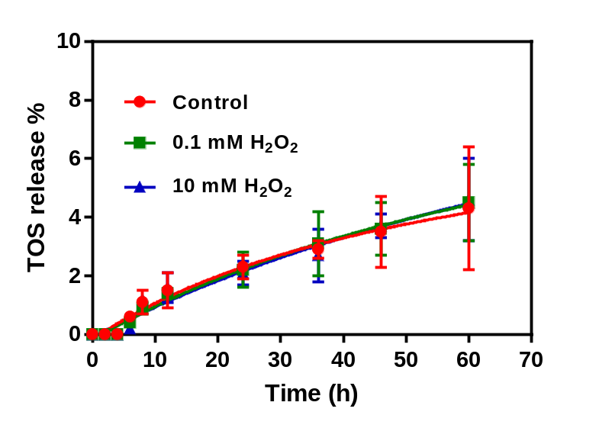
Figure S7 Cumulative release of TOS from PPT/D(DMA)@DOX micelles at pH 7.4 after treatment with 0.1 and 10 mM of H₂O₂.

