Enhanced Antitumor Effects of Follicle-stimulating Hormone Receptor-mediated Hexokinase-2 Depletion on Ovarian Cancer Mediated by a Shift in Glucose Metabolism

Meng Zhang^{1†}, Qiyu Liu^{1†}, Mingxing Zhang¹, Cong Cao², Xiaoxia Liu¹, Mengyu Zhang¹, Guiling Li¹, Congjian Xu^{1,3*} and Xiaoyan Zhang^{1*}

¹ Obstetrics and Gynecology Hospital, Fudan University, Shanghai 200011, China
² School of Materials Science & Engineering, Zhejiang Sci-Tech University, Hangzhou 310018, China
³ Shanghai Key Laboratory of Female Reproductive Endocrine Related Diseases, Shanghai 200011, China

† Meng Zhang and Qiyu Liu equally contributed to this work
* Correspondence: zhxy@fudan.edu.cn; xucongjian@fudan.edu.cn

Supplementary Information
Table S1. DLS size and Zeta Potential of Nanoparticles with Different N/P Ratios
 | N/P ratio | DLS size(nm) | PDI value | zeta potential  (mV)
PEG-PEI -shHK2 | 10 | 326.7±41.05 | 0.411±0.047 | 31.4±1.67
PEG-PEI -shHK2 | 15 | 265.4±32.51 | 0.401±0.035 | 33.2±2.32
PEG-PEI -shHK2 | 20 | 167.1±39.88 | 0.426±0.082 | 32.5±3.75
PEG-PEI -shHK2 | 25 | 125.7±42.35 | 0.423±0.049 | 42.3±2.27
PEG-PEI -shHK2 | 30 | 116.8±5.56 | 0.395±0.097 | 41.2±2.65
FSH-PEG-PEI -shHK2 | 10 | 379.7±63.99 | 0.540±0.065 | -17.0±1.33
FSH-PEG-PEI -shHK2 | 15 | 293.3±12.77 | 0.409±0.010 | -17.0±1.33
FSH-PEG-PEI -shHK2 | 20 | 237.1±11.43 | 0.389±0.074 | -24.5±2.84
FSH-PEG-PEI -shHK2 | 25 | 152.4±20.15 | 0.489±0.013 | -26.7±2.61
FSH-PEG-PEI -shHK2 | 30 | 139.5±39.45 | 0.465±0.084 | -19.5±1.36
D-FSH-PEG-PEI -shHK2 | 10 | 392.1±46.58 | 0.496±0.078 | -19.6±1.65
D-FSH-PEG-PEI -shHK2 | 15 | 318.5±28.56 | 0.356±0.023 | -21.7±1.84
D-FSH-PEG-PEI -shHK2 | 20 | 250.3±30.21 | 0.373±0.046 | -22.1±1.97
D-FSH-PEG-PEI -shHK2 | 25 | 163.4±26.45 | 0.324±0.037 | -29.4±1.67
D-FSH-PEG-PEI -shHK2 | 30 | 142.5±46.58 | 0.381±0.094 | -20.5±2.25

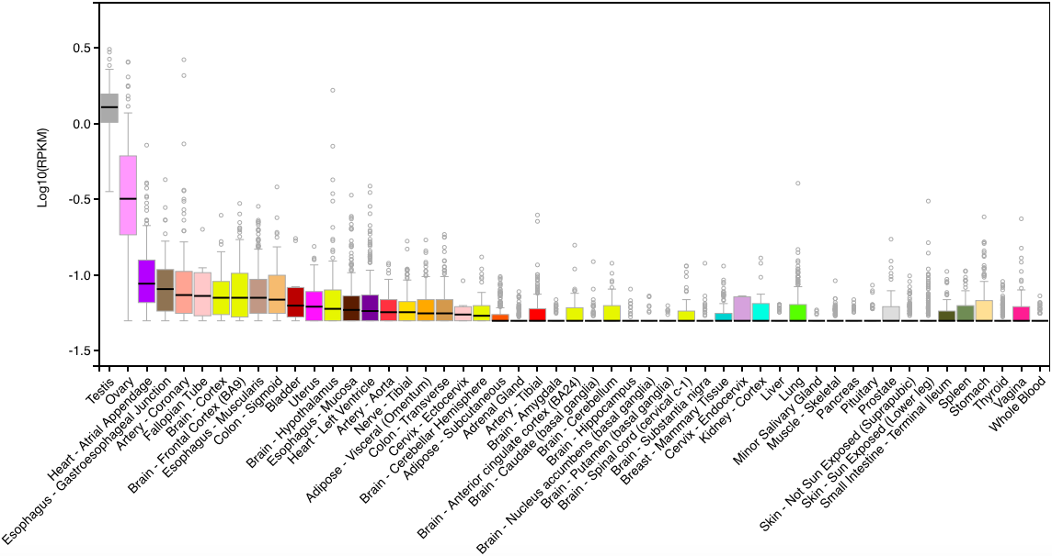
Figure S1. Relative FSHR mRNA expression in human normal tissues. (https://gtexportal.org/home/gene/FSHR)

Figure S2. FTIR of FSH (A), DFSH (B), PEG (C), PEI (D), FSH-PEG (E) and DFSH-PEG (F).

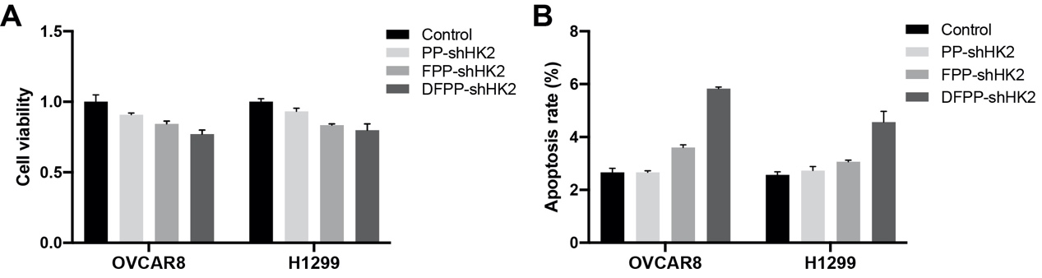
Figure S3. In vitro effects of HK2 shRNA-loaded nanoparticles on different cancer cell lines. (A) Cell viability according to a CCK-8 assay. (B) Cell apoptosis according to flow cytometry.

Figure S4. In vitro effects of scramble shRNA-loaded nanoparticles on A2780 and A2780CP cells. A2780 and A2780CP cells were treated with scramble shRNA-loaded nanoparticles at a plasmid-equivalent concentration of 1.0 μg/ml. (A) Cell viability according to a CCK-8 assay. (B) Cell apoptosis according to flow cytometry.

