LRP1-mediated pH-sensitive polymersomes facilitate combination therapy of glioblastoma in vitro and in vivo
Chen He¹, Zhiyuan Zhang², Yinan Ding¹, Kangli Xue¹, Xihui Wang¹, Rui Yang³, Yanli An¹, Dongfang Liu¹, Chunmei Hu⁴* and Qiusha Tang¹*

¹Medical School of Southeast University, 87 Dingjiaqiao Road, Nanjing, China.
²Department of Neurosurgery, Nanjing Jinling hospital, Nanjing University , Nanjing, China.
³Research Institute for Reproductive Health and Genetic Diseases, The Affiliated Wuxi Maternity and Child Health Care Hospital of Nanjing Medical University, Wuxi , China.
⁴Department of Tuberculosis, the Second Affiliated Hospital of Southeast University (the second hospital of Nanjing), Nanjing, China

*Correspondence:
Chunmei Hu and Qiusha Tang
Department of Tuberculosis, the Second Affiliated Hospital of Southeast University (the second hospital of Nanjing), Nanjing, China
Medical School of Southeast University, 87 Dingjiaqiao Road, Nanjing, China.
hcm200702@163.com, panyixi-tqs@163.com

Fig. S1. Characterization of AuNPs, AuNPs-NH_{2.} TEM images of AuNPs (a-1) and AuNPs-NH₂ (a-2). Size distribution and size in water of AuNPs (b-1) and AuNPs-NH₂ (b-2). c Zeta-potentials of AuNPs and AuNPs-NH₂. d Spectrophotometer results of AuNPs and AuNPs-NH₂. e In vitro toxicity evaluation of U87-MG cells after co-incubation with AuNPs-NH₂ for 24 h by Cell Counting Kit-8 (CCK-8) method. f Dynamic light scattering (DLS) size measurements of AuNPs-NH₂ in PBS for varied time durations (0 ~ 29 days).

Fig. S2. Characterization of Au-DOX. IC50 of DOX (a) and AuNPs combined with radiotherapy of 6Gy (b). c TEM image of Au-DOX. d Spectrophotometer results of AuNPs , AuNPs-NH2 and Au-DOX. e FT-IR spectrum of Au-DOX. f Size distribution and size in water of Au-DOX

Fig. S3. Characterization of PCL-PEOz- maleimide. a XPS spectra of PCL-PEOz- maleimide. b ¹HNMR spectrum of the polymer.

Fig. S4. Photographs of blank polymersomes (a-1) and cargo-loaded polymersomes (a-2). TEM images of blank polymersomes (b-1) and cargo-loading polymersomes (b-2).c In vitro toxicity evaluation of U87-MG cells after co-incubation with PO and ANG-PO for 24 h by Cell Counting Kit-8 (CCK-8) method.

Fig. S5. The particle number of polymersomes was measured using NTA. The original sample was diluted 250 times before testing. The particle number of original sample was yielded a value of 6×10¹¹ particles/mL after calculation.
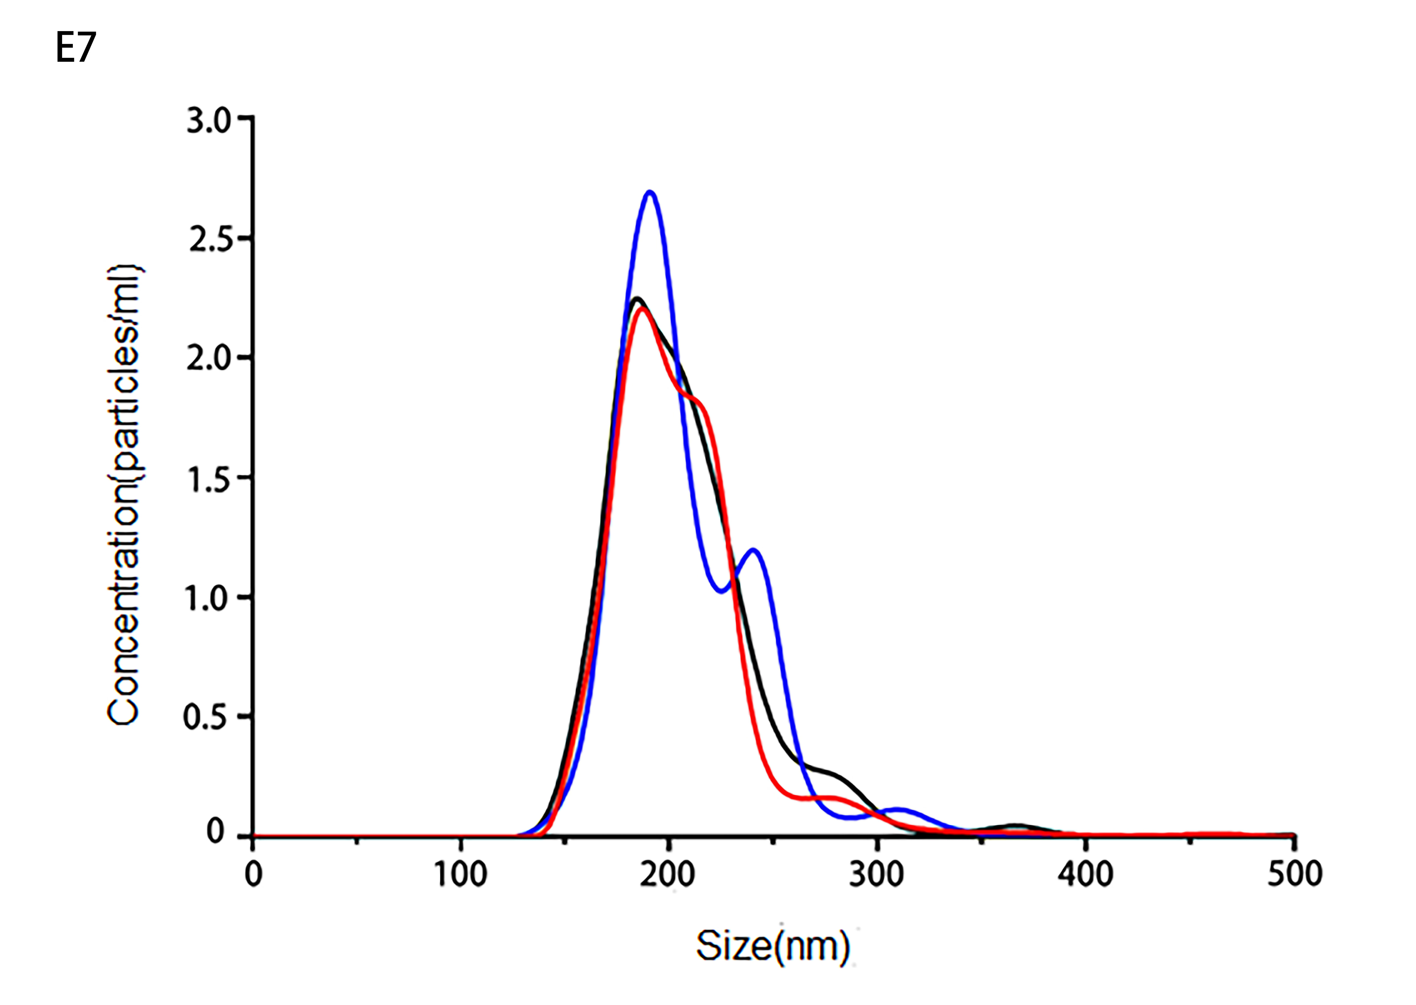
Stats: Mean +/- Standard Error:
Mean: 216.8 +/- 3.2 nm
Concentration (Upgrade): 2.40e+09 +/- 1.12e+08 particles/ml

Fig. S6. Identification of primary astrocytes (a-1) and cerebral microvascular endothelial cells (a-2) by flow cytometry. b Expression levels of LRP1 on cell lines of U87-MG, BMECs, and normal astrocyte determined by Western blot. c Quantitative analysis of LRP1 protein levels. Data are presented as the mean plus or minus the standard deviation (SD), and n=3 for each group,**P<0.01,***P<0.001.
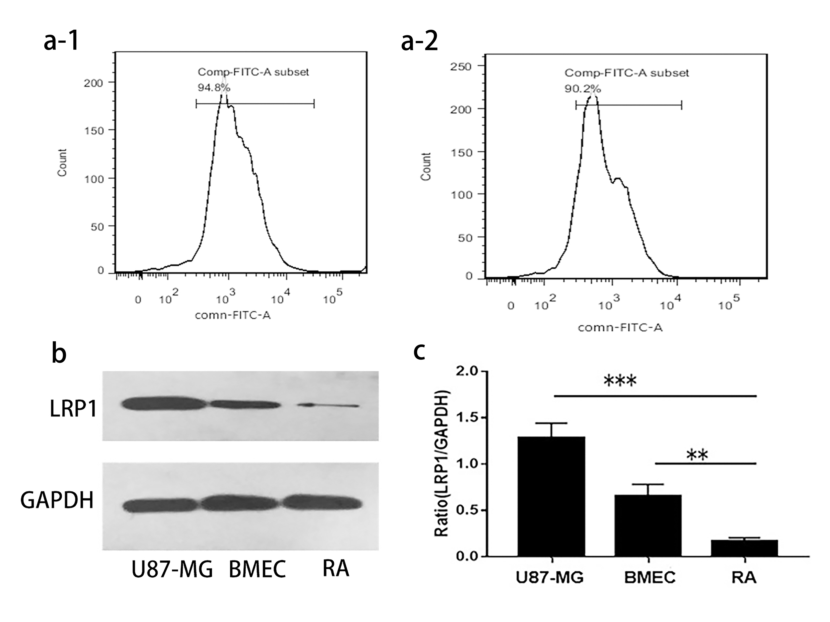

Fig. S7. Confocal analysis of the U87 cells treated with Au-DOX@PO for 6 hours.
