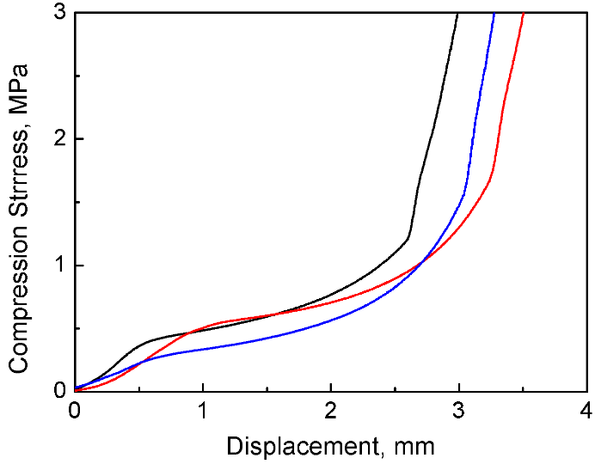
Figure. S1. Compression properties of CePO₄/CS/GO scaffolds (n=3).

