Additional file 1.

Triazine-cored Polymeric Vectors for Antisense Oligonucleotide Delivery in vitro and in vivo

Mingxing Wang*, Bo Wu, Jason D Tucker, Sapana N Shah, Peijuan Lu, Qilong Lu

McColl⁻Lockwood Laboratory for Muscular Dystrophy Research, Carolinas Medical Center, 1000 Blythe Blvd. Charlotte, NC 28231, USA

Phone: 1-704-355-5588; Fax: 1-704-355-1679; Email: mingxing.wang@atriumhealth.org

Synthesis and characterization of Triazine-cored amphiphilic polymers (TAPs)
The synthesis and characterization of TAPs have been reported in our previous study.³⁰ The structure and code of Jeffamine M series and LPEI were given in Figure S1, and the code abbreviations and corresponding compositions of the TAP polymers are presented in Table S1.

Figure S1. Structure illustration of substituents A (Jeffamine M ) and B (LPEI).

Table S1. Polymer code abbreviations and corresponding compositions
Code | Composition | Code | Composition | Code | Composition | Code | Composition
1A₄1B₁ | M2070-Cy(Cl)-PEI 0.8k | 1A₃1B₁ | M2005-Cy(Cl)-PEI 0.8k | 1A₂1B₁ | M1000-Cy(Cl)-PEI 0.8k | 1A₁1B₁ | M600-Cy(Cl)-PEI 0.8k
1A₄1B₂ | M2070-Cy(Cl)-PEI 1.2k | 1A₃1B₂ | M2005-Cy(Cl)-PEI 1.2k | 1A₂1B₂ | M1000-Cy(Cl)-PEI 1.2k | 1A₁1B₂ | M600-Cy(Cl)-PEI 1.2k
1A₄1B₃ | M2070-Cy(Cl)-PEI 2.0k | 1A₃1B₃ | M2005-Cy(Cl)-PEI 2.0k | 1A₂1B₃ | M1000-Cy(Cl)-PEI 2.0k | 1A₁1B₃ | M600-Cy(Cl)-PEI 2.0k
1A₄2B₁ | M2070-Cy-2PEI 0.8k | 1A₃2B₁ | M2005-Cy-2PEI 0.8k | 1A₂2B₁ | M1000-Cy-2PEI 0.8k | 1A₁2B₁ | M600-Cy-2PEI 0.8k
1A₄2B₂ | M2070-Cy-2PEI 1.2k | 1A₃2B₂ | M2005-Cy-2PEI 1.2k | 1A₂2B₂ | M1000-Cy-2PEI 1.2k | 1A₁2B₂ | M600-Cy-2PEI 1.2k
1A₄2B₃ | M2070-Cy-2PEI 2.0k | 1A₃2B₃ | M2005-Cy-2PEI 2.0k | 1A₂2B₃ | M1000-Cy-2PEI 2.0k | 1A₁2B₃ | M600-Cy-2PEI 2.0k
2A₄1B₁ | 2M2070-Cy-PEI 0.8k | 2A₃1B₁ | 2M2005-Cy-PEI 0.8k | 2A₂1B₁ | 2M1000-Cy-PEI 0.8k | 2A₁1B₁ | 2M600-Cy-PEI 0.8k
2A₄1B₂ | 2M2070-Cy-PEI 1.2k | 2A₃1B₂ | 2M2005-Cy-PEI 1.2k | 2A₂1B₂ | 2M1000-Cy-PEI 1.2k | 2A₁1B₂ | 2M600-Cy-PEI 1.2k
2A₄1B₃ | 2M2070-Cy-PEI 2.0k | 2A₃1B₃ | 2M2005-Cy-PEI 2.0k | 2A₂1B₃ | 2M1000-Cy-PEI 2.0k | 2A₁1B₃ | 2M600-Cy-PEI 2.0k

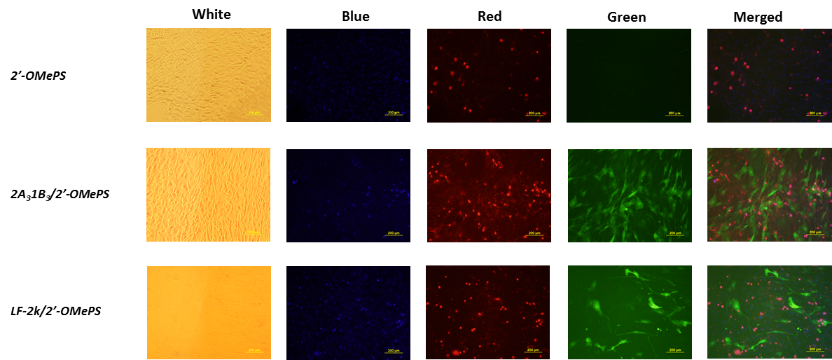

Figure S2. Comparison of transduction and cytotoxicity between TAP (10 µg) and LF-2k (4 µg) mediated 2′-OMePSE50 (2 µg) stained by Propidium iodide (PI, red) and Hoechst 33342 (blue) after six-day delivery (original magnification, x200; scale bar: 500 µm).

