Supporting Information for
Administration route governs the therapeutic efficacy, biodistribution and macrophage targeting of anti-inflammatory nanoparticles in the lung

Lu Wang^{1,†,#}, Yafei Rao^{1,#}, Xiali Liu^{1,#}, Liya Sun², Jiameng Gong², Huasheng Zhang³, Lei Shen³, Aihua Bao^{1,*}, Hong Yang^{2,4,*}
¹ Department of Pulmonary and Critical Care Medicine, Shanghai General Hospital, Shanghai Jiao Tong University School of Medicine, Shanghai 201620, China
² School of Biomedical Engineering, Tianjin Medical University, Tianjin 300070, China
³ Shanghai Institute of Immunology, Shanghai Jiaotong University School of Medicine, Shanghai 200025, China
⁴ The Province and Ministry Co-Sponsored Collaborative Innovation Center for Medical Epigenetics, Tianjin Medical University, Tianjin 300070, China
#These authors contribute equally to the work.
†Current address: Department of Critical Care Medicine, Zhongda Hospital, School of Medicine, Southeast University, Nanjing 210009, China
*Corresponding author: Professor Hong Yang; Dr. Aihua Bao
Email: hongyang@tmu.edu.cn; hongyang36@gmail.com; aihuabao312@126.com
List of Supplementary Figures

Figure S1. The biodistribution of PEGylated-GNPs in the lung, liver and spleen in healthy mice through i.t. instillation at 24 h post administration. N = 5 mice per group, ns: not significant.

Figure S2. In vivo distribution of P12 in different organs at 4 h and 24 h after P12 treatment (i.t.). The amount of gold in the main organs was quantified by ICP-MS. N ≥ 3 mice per group.

Figure S3. In vivo distribution of P12 in different organs after LPS pre-treatment for 2 h. The organs were collected 4 h after P12 treatment. The amount of gold in the main organs was quantified by ICP-MS. N = 5 mice per group.

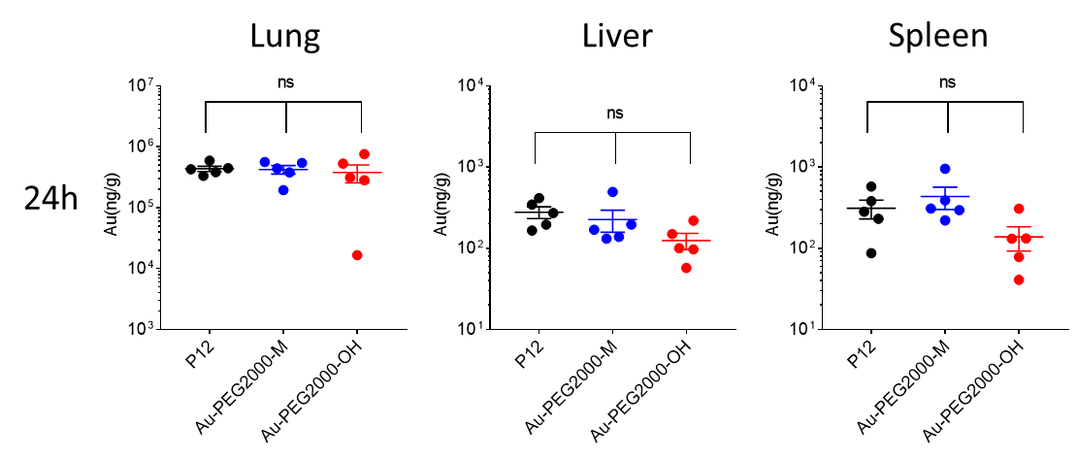

Figure S1. The biodistribution of PEGylated-GNPs in the lung, liver and spleen in healthy mice through i.t. instillation at 24 h post administration. N = 5 mice per group, ns: not significant.

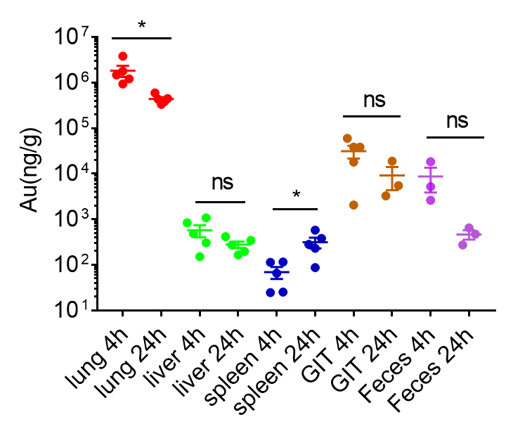
Figure S2. In vivo distribution of P12 in different organs at 4 h and 24 h after P12 treatment (i.t.). The amount of gold in the main organs was quantified by ICP-MS. N ≥ 3 mice per group.

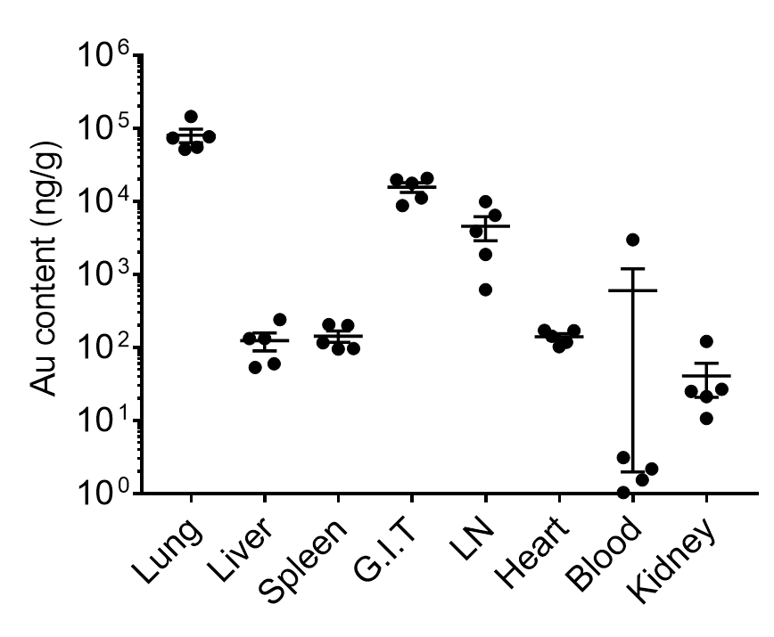
Figure S3. In vivo distribution of P12 in different organs after LPS pre-treatment for 2 h. The organs were collected 4 h after P12 treatment. The amount of gold in the main organs was quantified by ICP-MS. N = 5 mice per group.

