[Supplementary Material]
Au-Ag Assembled on Silica Nanoprobes for Visual Semi-Quantitative Detection of Prostate-Specific Antigen

Hyung-Mo Kim,¹ Jaehi Kim,¹ Jaehyun An,¹ Sungje Bock,¹ Xuan-Hung Pham,¹ Kim-Hung Huynh,¹ Yoonsik Choi,² Eunil Hahm,¹ Hobeom Song,³ Jung-Won Kim,³ Won-Yeop Rho,⁴ Dae Hong Jeong,^{2*} Ho-Young Lee,⁵* Sangchul Lee⁶* and Bong-Hyun Jun¹*

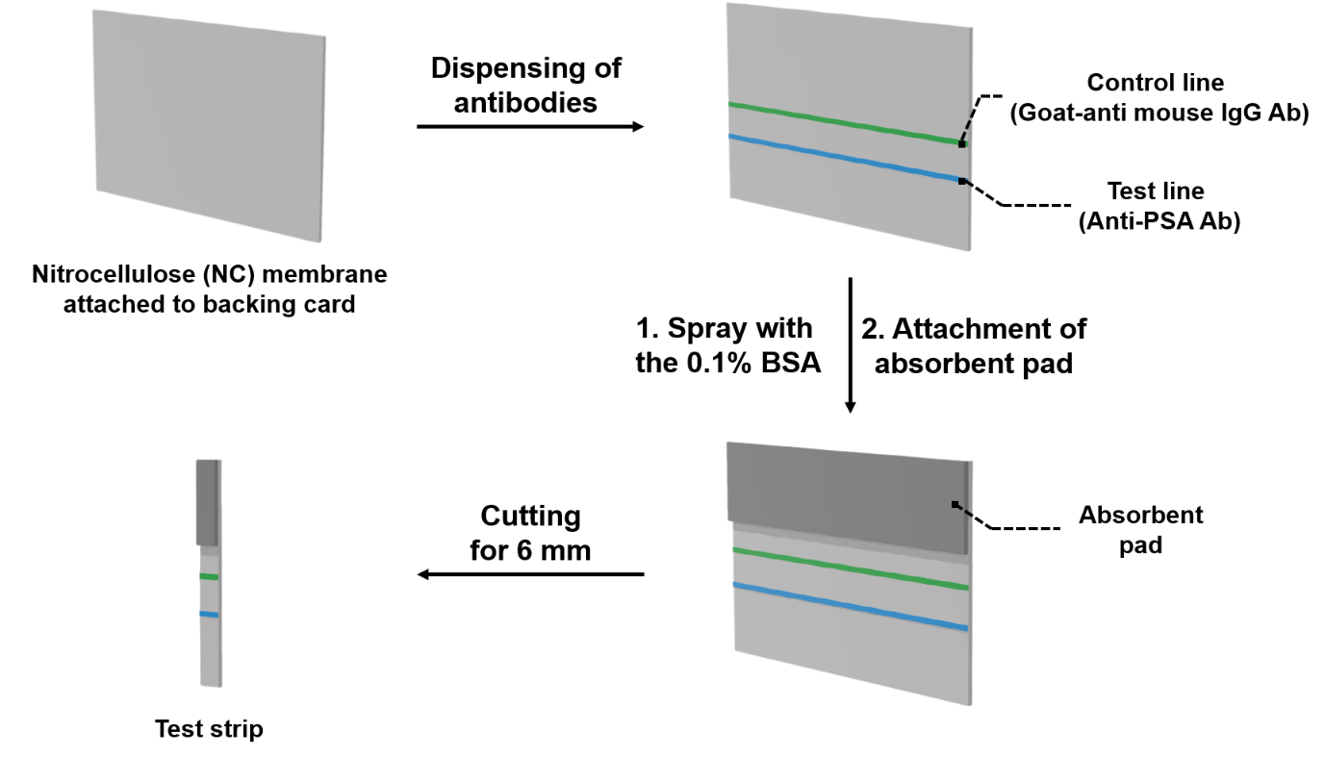
Fig. S1. Schematic illustration of the preparation of test strip.

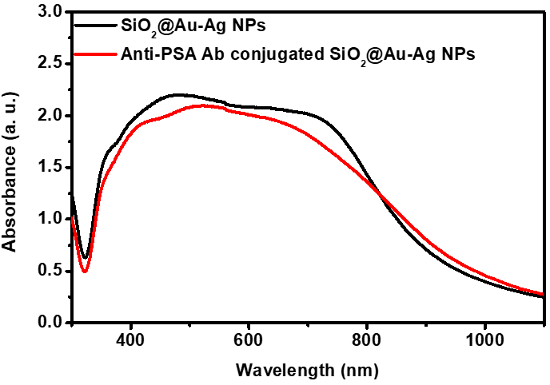
Fig S2. UV-vis absorption spectra of SiO₂@Au-Ag NPs and anti-PSA conjugated SiO₂@Au-Ag NPs.

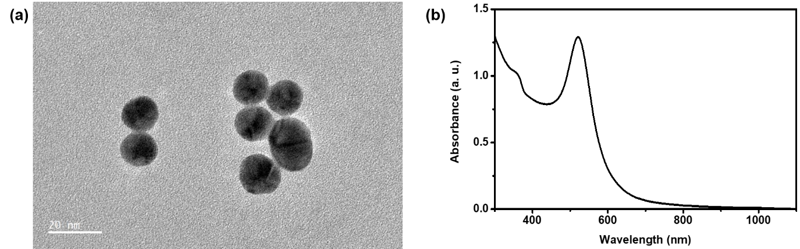
Fig. S3. Characterization of colloid AuNPs. (a) Transmission electron microscopy (TEM) image. (b) UV-vis extinction spectra.

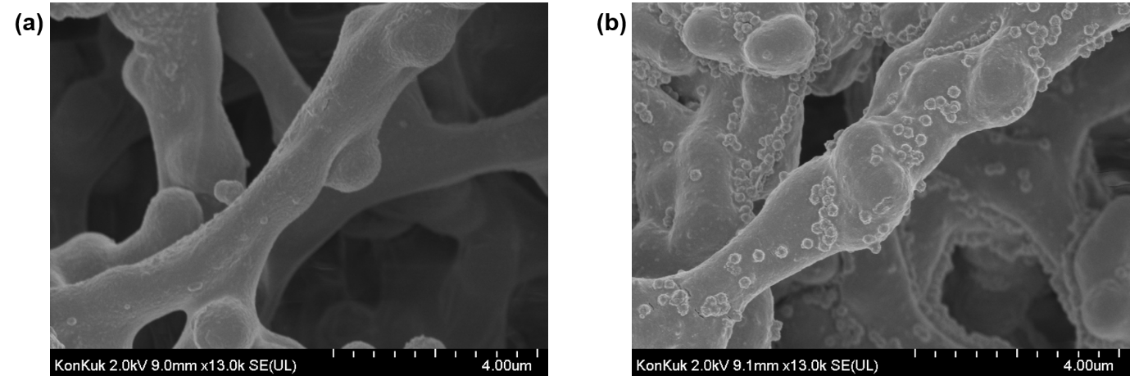
Fig. S4. Scanning electron microscope (SEM) images of the test line on the test strip. (a) the test line on the test strip with PSA 0 ng/mL, (b) the test line on the test strip with PSA 300.00 ng/mL.

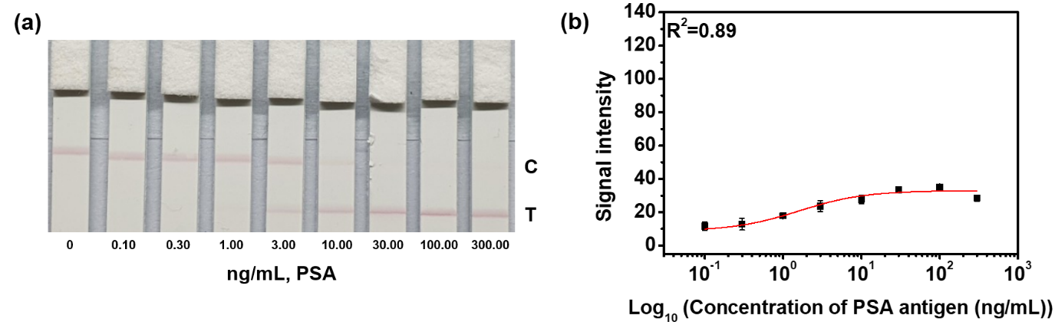
Fig. S5. Detection of various concentrations of PSA using colloid AuNPs as a signal reporter in LFIA. (a) Color images and (b) measurement of signal intensity. Error bars represent the standard deviations of the means for three batches of analyte measurements.
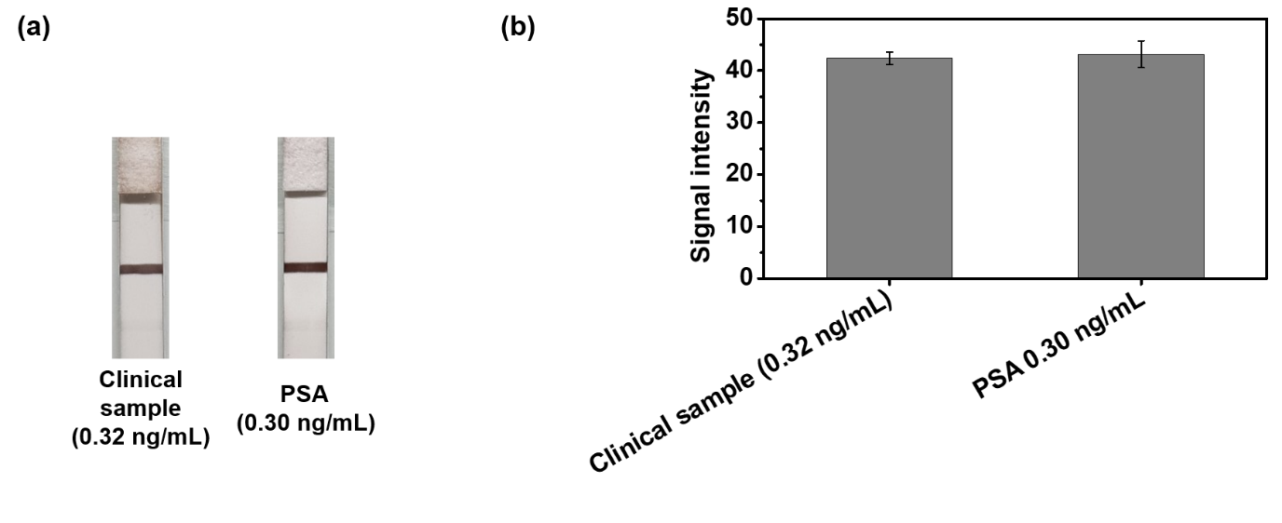
Fig. S6. Application of clinical samples (0.32 ng/mL PSA) with SiO₂@Au-Ag NPs as a signal reporter by comparison of test strips detecting 0.3 ng/mL PSA in LFIA. (a) Color images and (b) measurement of signal intensity. Error bars represent the standard deviations of the means for three batches of analyte measurements.

