Supplementary information

Mitochondria-targeting graphene oxide nanocomposites for fluorescence imaging-guided synergistic phototherapy of drug-resistant osteosarcoma

Wei-Nan Zeng ^{1,2}, Qiu-Ping Yu ³, Duan Wang ¹, Jun-Li Liu ², Qing-Jun Yang ^{2, *}, Zong-Ke Zhou ^{1, *}, Yi-Ping Zeng ^{2, *}

¹ Department of Orthopedics, West China Hospital/West China School of Medicine, Sichuan University, Chengdu, 610041, China
² Department of Orthopedics, Chongqing General Hospital, University of Chinese Academy of Sciences, Chongqing, 400014, China.
³ Health Management Center, West China Hospital/West China School of Medicine, Sichuan University, Chengdu, 610041, China
*Corresponding author.
E-mail address: zongkehx@163.com (Z.K. Zhou); qingjunyang_cgh@163.com (Q.J. Yang); zyp860625@126.com (Y.P. Zeng)

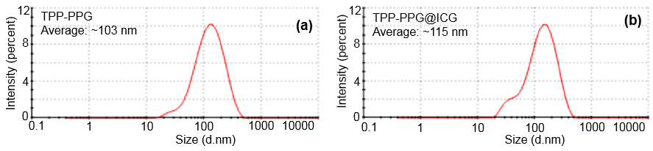
Fig. S1. The DLS analysis of the TPP-PPG and TPP-PPG@ICG
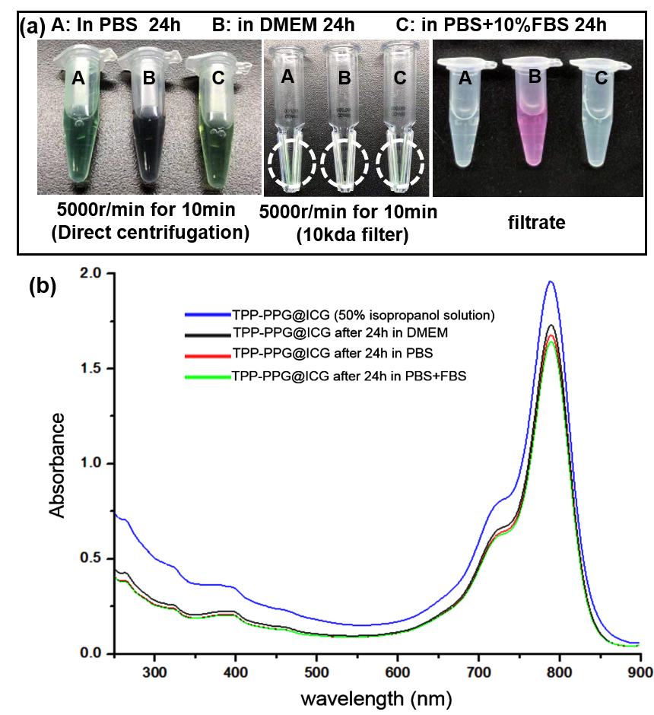
Fig. S2. (a) The stabilities of TPP-PPG@ICG in PBS (A), in DMEM(B) and in PBS+10% FBS (C), no precipitation was observed after centrifugation at 8000 rpm min⁻¹ for 10 min. The pictures of the ultrafiltration tube and the filtrate after centrifugation at 5000 rpm min⁻¹ for 10min. (b) The UV−vis absorption spectra of the TPP-PPG@ICG incubation 24h with 50% isopropanol, PBS, DMEM and PBS+10% FBS after the appropriate cleaning procedures performed.

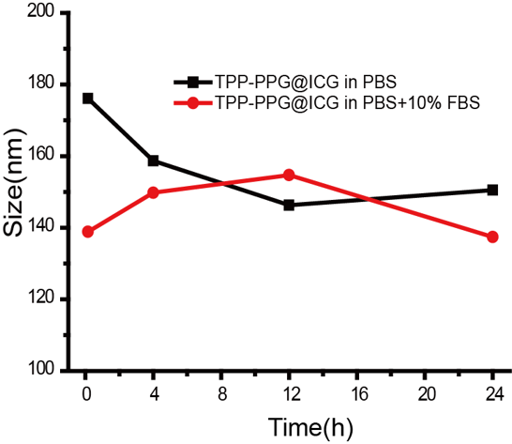
Fig. S3. The DLS change curve of TPP-PPG@ICG in PBS or PBS + 10% FBS.

Fig. S4. The effect of weight ratio of ICG and TPP-PPG on the ICG loading efficiency.

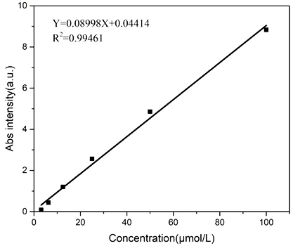
Fig. S5. The calibration curve of ICG in PBS with absorption at 790 nm.

Fig. S6. The MG63/Dox cells showed resistance to Dox.

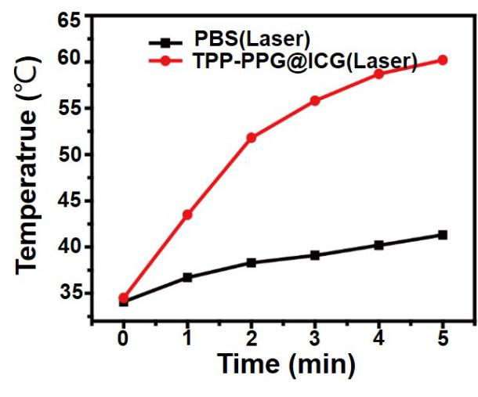
Fig. S7. The temperature variation of tumors after laser exposure.

Fig. S8. TUNEL staining of tumor sections of control group, TPP-PPG@ICG+No laser group and TPP-PPG+laser. group

Fig. S9. Negligible injury to the heart, the liver, the spleen, the lungs, and the kidneys after treatment with the TPP-PPG@ICG.

Table 1 Comparison between PBS and TPP-PPG@ICG groups of treatment on whole blood cell count.
Group | WBC (10^9/L) | RBC (10^12/L) | HGB (g/L) | HCT (%) | MCV (FL) | MCH (pg) | MCHC (g/L) | PLT (10^9/L)
PBS | 5.116± 0.567 | 9.596± 0.370 | 159± 5.34 | 51.56± 0.937 | 51.36± 1.379 | 17.72± 0.828 | 338.6± 10.41 | 415± 15.03
TPP-PPG@ICG | 5.592± 0.472 | 10.356± 0.298 | 156.6± 5.94 | 54.38± 1.642 | 50.96± 3.111 | 18.54± 1.026 | 341.2± 13.24 | 421.4± 23.09
Values are mean±SEM

Table 2 Comparison between PBS and TPP-PPG@ICG groups of treatment on liver function and kidney function indicators
Group | ALT (IU/L) | ALP (IU/L) | AST(IU/L) | CREA(μmol/L) | BUN (mmol/L)
PBS | 55.68±5.634 | 143.24±8.452 | 155.6±13.212 | 47.28±3.237 | 8.735±0.392
TPP-PPG@ICG | 46.68±6.247 | 153.65±7.425 | 143.2±10.256 | 52.76±2.832 | 7.478±0.582
Values are mean±SEM

