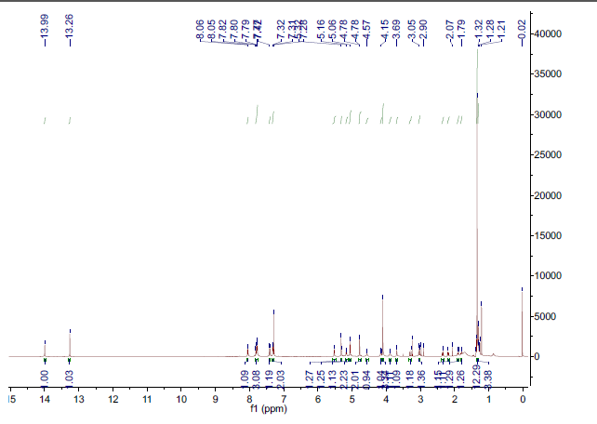
Figure S1 ¹H NMR spectrum of pB-DOX in CDCl₃. δppm: 13.99 (s, 1H), 13.26 (s, 1H), 8.05 (d, J = 7.7 Hz, 1H), 7.81 (d, J = 8.2 Hz, 1H), 7.78 (d, J = 8.0 Hz, 2H), 7.41 (d, J = 8.4 Hz, 1H), 7.32 (d, J = 7.6 Hz, 2H), 5.52 (d, J = 3.9 Hz, 1H), 5.31 (s, 1H), 5.17 (d, J = 8.4 Hz, 1H), 5.06 (s, 2H), 4.78 (d, J = 2.2 Hz, 2H), 4.19–4.13 (m, 1H), 4.10 (s, 3H), 3.94–3.85 (m, 1H), 3.69 (s, 1H), 3.27–3.32 (m, 1H), 2.90–2.98 (m, 1H), 2.35 (dd, J = 14.7, 2.3 Hz, 1H), 2.19 (dd, J = 14.7, 4.0 Hz, 1H), 1.92–1.88 (m, 1H), 1.81 (dd, J = 13.2, 4.1 Hz, 1H), 1.34 (s, 12H), 1.31 (d, J = 6.6 Hz, 3H).

Table S1 Characteristics of Lipo/pB-DOX, Lipo/ICG, and Lipo/pB-DOX/ICG.
 | Diameter (nm) | EE_{(pB-DOX)}  % | EE_{(ICG)}  % | LC_{(pB-DOX)}  % | LC_{(ICG)}  %
Lipo/pB-DOX/ICG | 170.5 ± 4.1 | 55.5 ± 3.2 | 75.0 ± 2.4 | 3.9 ± 0.6 | 1.8 ± 0.3
Lipo/pB-DOX | 141.4 ± 5.5 | 58.3 ± 3.2 | - | 4.2 ± 0.6 | -
Lipo/ICG | 143.5 ± 4.3 | - | 84.0 ± 2.4 | - | 6.0 ± 0.3

Figure S2 Size and morphology of Lipo/pB-DOX a and Lipo/ICG b measured using a Malvern Zetasizer Nano Series instrument and TEM. Scale bar for TEM is 100 nm.

Figure S3 pB-DOX and ICG release from the nanoliposomes in PBS with acidic pH (5.5).

Figure S4 The degradation of DPBF over time at 407 nm under continuous 808 nm laser radiation (1.0 W/cm², 300 s) for free ICG (15 μg/mL).

Figure S5 UV-vise-NIR spectra of free ICG a, Lipo/ICG b, and Lipo/pB-DOX/ICG c at different time points under 808 nm laser irradiation (1.0 W/cm², 3 min).

Figure S6 Fluorescence images of intracellular ROS generation of PBS and Lipo/pB-DOX with laser (1.0 W/cm²) for different time periods (0, 1 and 2 min) inside MDA-MB-231 cells. The scale bar is 100 μm.

Figure S7 a FL intensities and FL images of Lipo/pB-DOX/ICG with different concentrations of ICG. b PA signals and PA images of Lipo/pB-DOX/ICG with different concentrations of ICG.

Figure S8 Representative histological images of liver, spleen, lung and kidney samples from the treated mice. (n = 5 per group).

