Additional File 1

Supplementary Information for
Nanoconjugates to enhance PDT-mediated cancer immunotherapy by targeting the indoleamine-2,3-dioxygenase pathway

Xueyuan Yang¹, Weizhong Zhang¹, Wen Jiang¹, Anil Kumar¹, Shiyi Zhou¹, Zhengwei Cao¹, Shuyue Zhan¹, Wei Yang¹, Rui Liu,¹ Yong Teng,² Jin Xie^{1,*}
¹ Department of Chemistry, University of Georgia, Athens, GA 30602, USA
² Department of Hematology and Medical Oncology, Winship Cancer Institute, Emory University School of Medicine, Atlanta, GA, 30322, USA

Scheme S1: Schematic illustration to show the preparation of PPF NPs.

Figure S1: ¹H-NMR spectrum of PLGA-b-PEG.

Figure S2: Schematic illustration to show the preparation of NLG919@PLGA NPs.

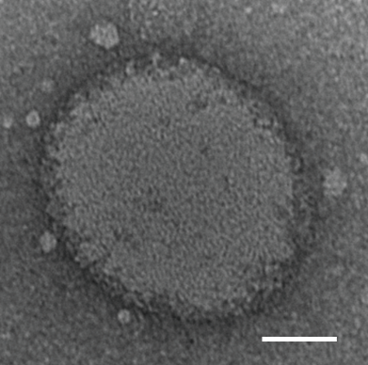
Figure S3: TEM image of PPF NPs. Scale bar, 50 nm.

Figure S4: Cytotoxicity, measured with B16F10 cells by MTT assays. Cells were incubated with ZnF₁₆Pc@FRT or PPF NPs for 4 h and then irradiated by a 671-nm laser (0.1 W/cm2 for 200 s). MTT assays were conducted 12 h later. *, p < 0.05; **, p < 0.01; ns, no significant difference.

Figure S5: Relative tumor volume after live cell re-challenge. B16F10-tumor bearing mice surviving the initial ZnF₁₆Pc@FRT+IR or PPF+IR treatments were inoculated with live B16F10 cancer cells to opposite flank of the mice on Day 69. The animals were monitored for another 90 days. All animals in the PPF+IR group remained alive and tumor-free throughout the study.

Figure S6: Animal survival throughout the experiment, including the re-challenge study.

Figure S7: a,b) Central (a) and effector (b) memory T cells abundance, based on flow cytometry analysis of spleen tissues taken from animals treated with PPF+IR. *p < 0.05, **p < 0.01; n=3. Spleen tissues from naïve animals were tested as a comparison.

Figure S8: Absorbance spectra of ZnF₁₆Pc, NLG919, and PLGA-b-PEG in DMSO.

