Additional file 1
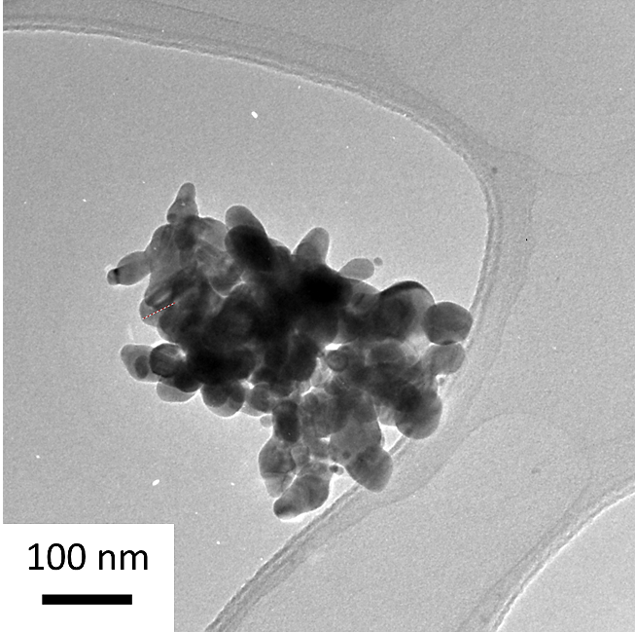
- ENM Characterisation
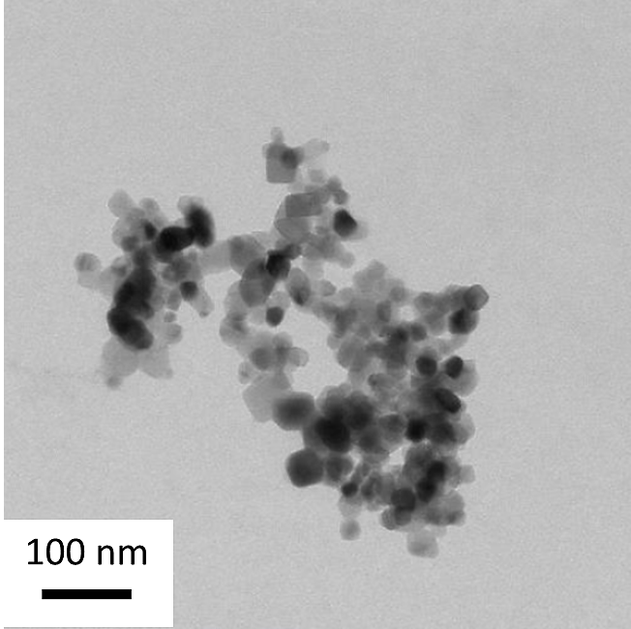
B
A
NM-105
Sigma-576832

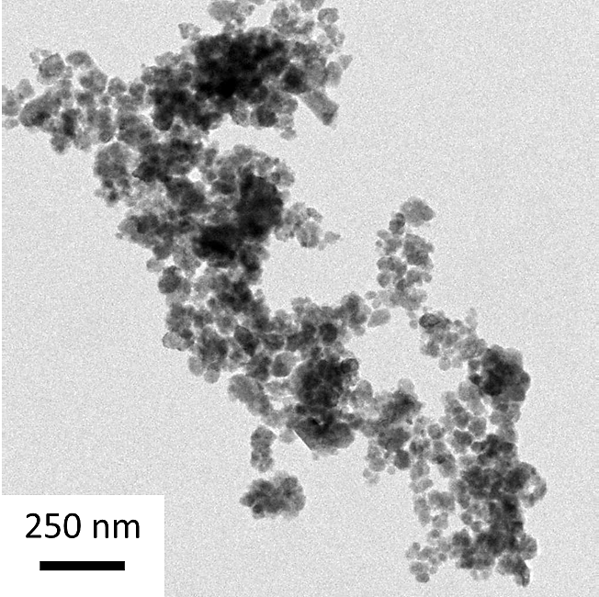
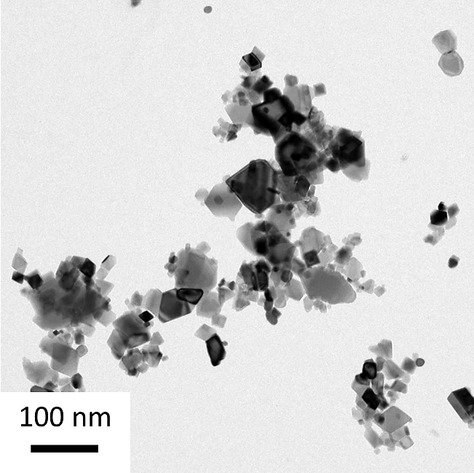
D
C
NM-220
NM-212

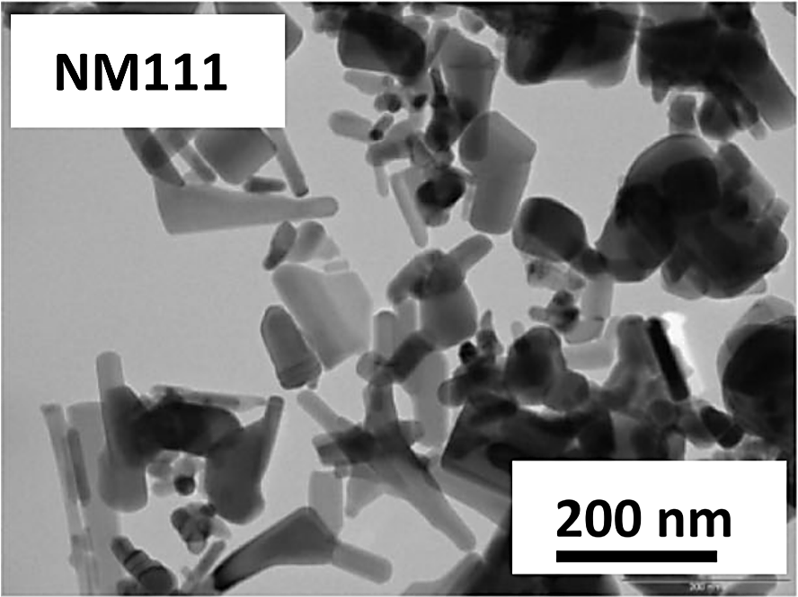
E

Figure S1: TEM micrographs of the ENM listed in Table 1: (A) TiO₂ NM-105 (B) Ag Sigma (C) BaSO₄ NM-220 (D) CeO₂ NM-212 and (E) ZnO NM-111. Image (A), (B), (C) and (D) reproduced from Keller et al. (2020) (DOI: 10.1080/17435390.2020.1836281) and image (E) reproduced from Yin et al. (2015) (DOI 10.1007/s11051-014-2851-y).

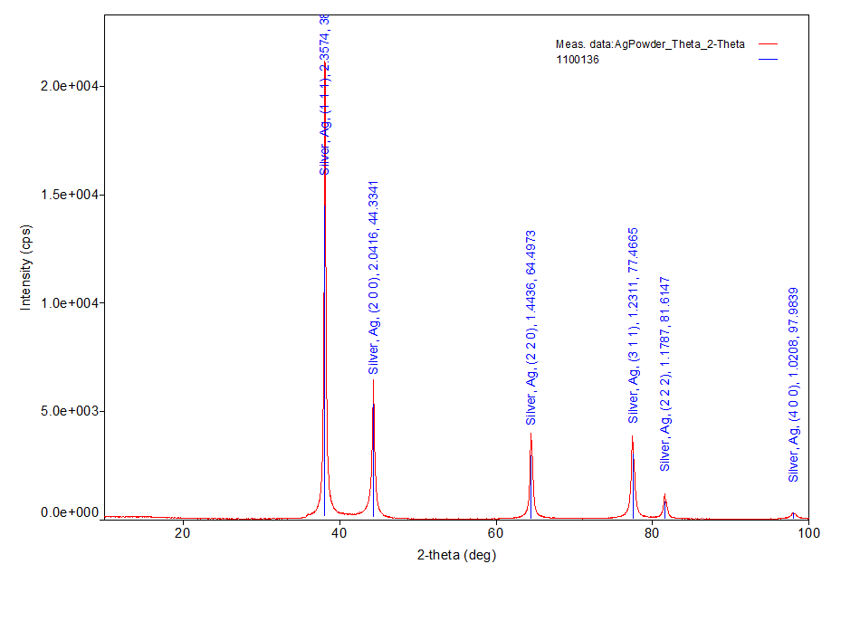
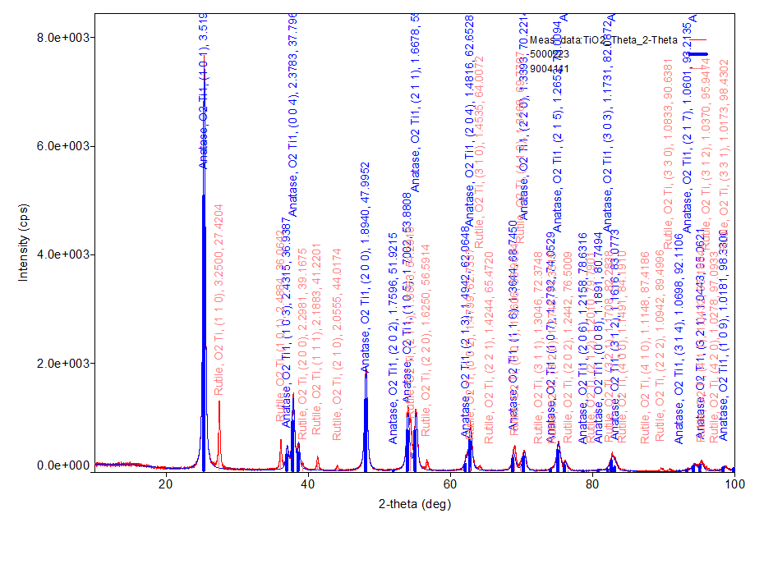
B. Ag Sigma-576832
- TiO₂ NM-105
C. ZnO NM-111

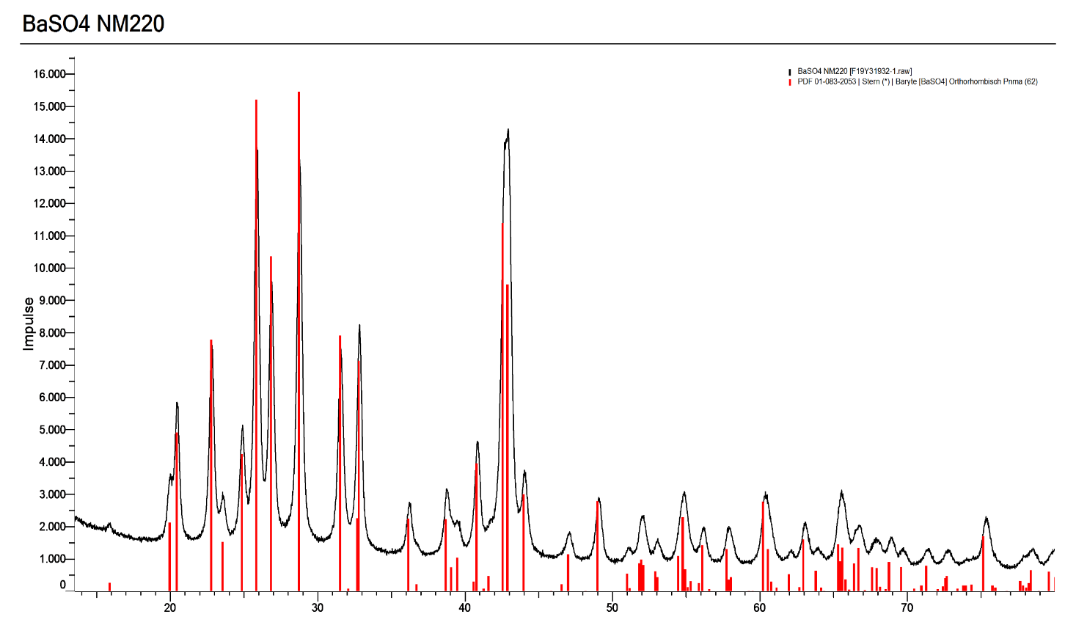
D.

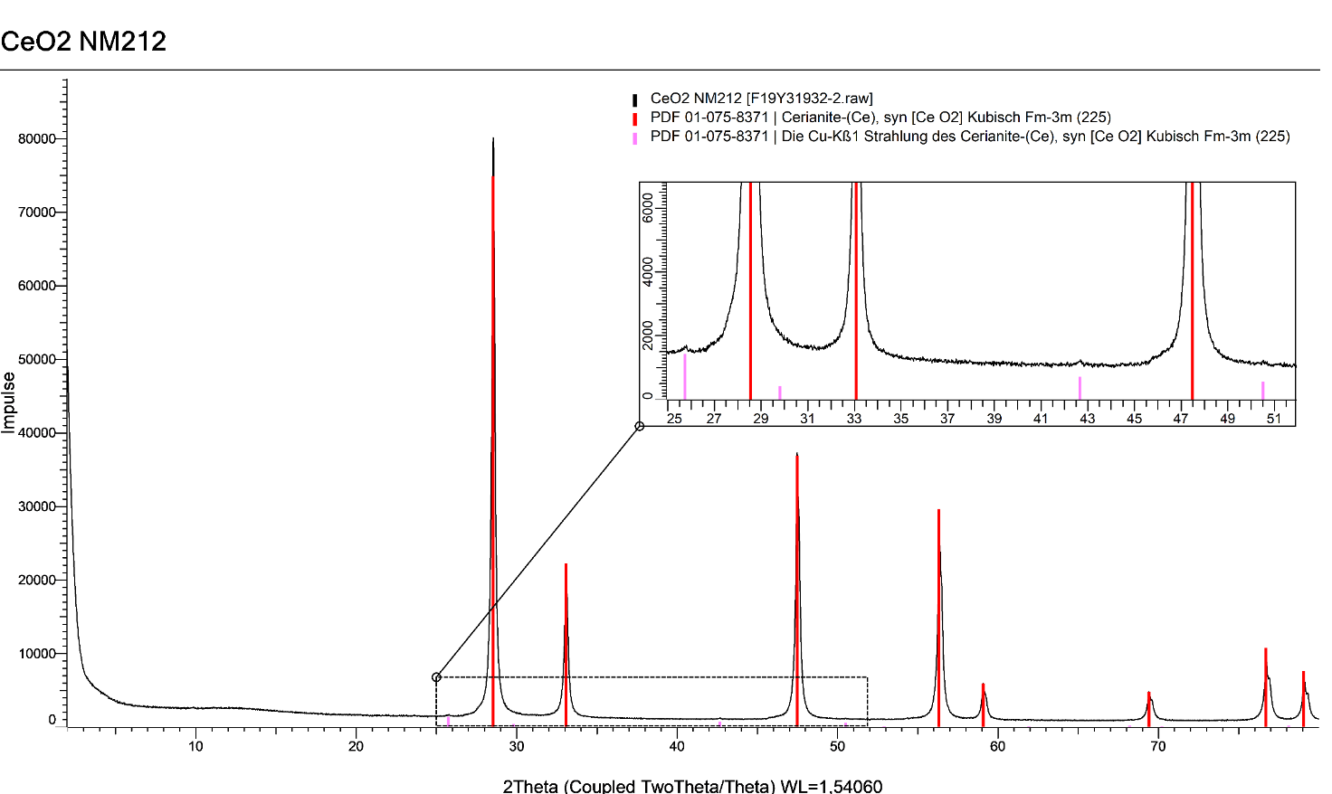
E.

Figure S2: A series of XRD patterns for the five ENMs listed in Table 1, (A) TiO₂ (NM-105), (B) Ag (Sigma 576832), (C) ZnO (NM-111), (D) BaSO₄ (NM-220) and (E) CeO₂ (NM-212). These graphs illustrate the crystalline phases for each material as summarised in Table 1.

NM-105 O 1s C 1s Ti 2p
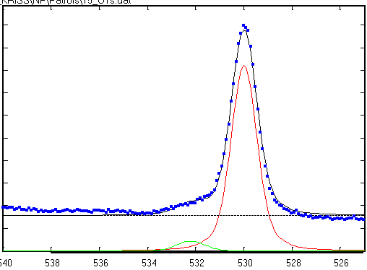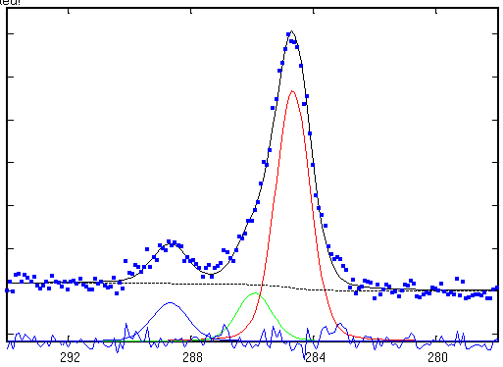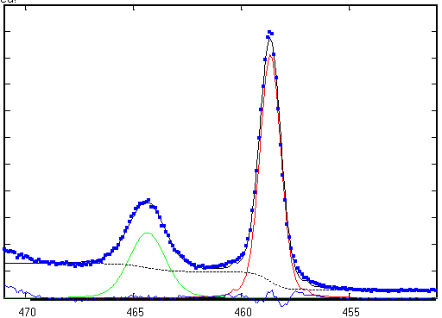
NM-111 Zn 2p_{3/2} O 1s C 1s
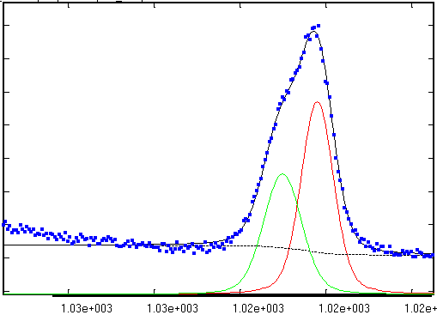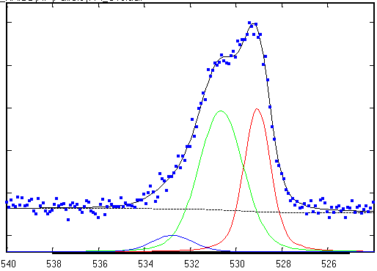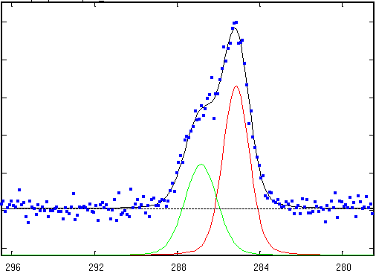
Ag Sigma 576832 Ag 4d C 1s O 1s
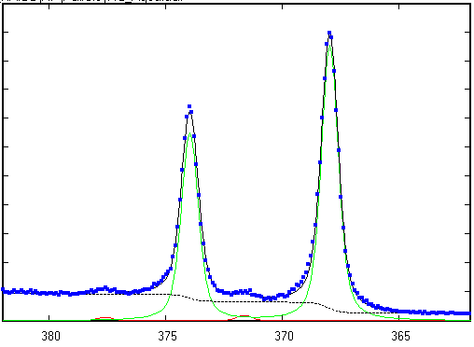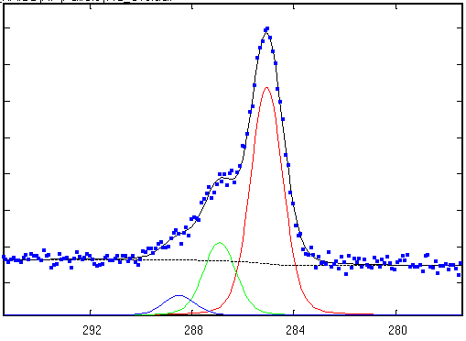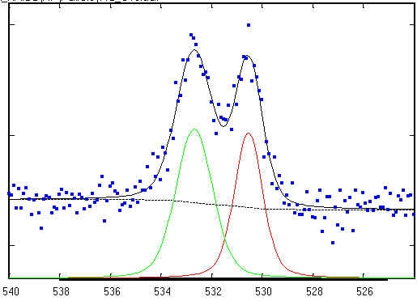
NM-220 O 1s S 2p Ba 3d_{5/2}
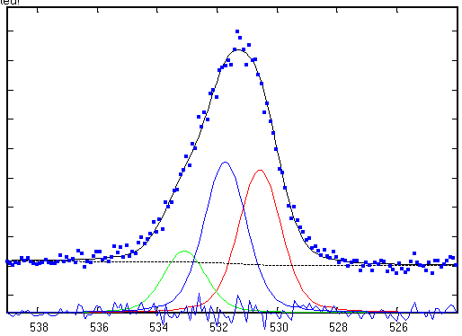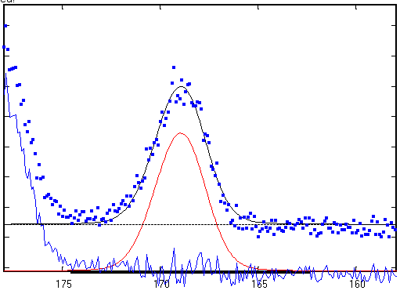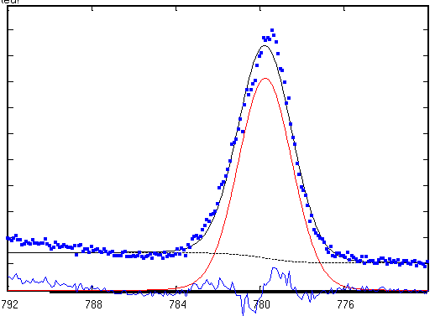
NM-212 (q) Ce 3d (r) O 1s
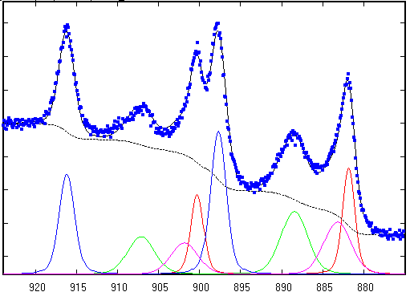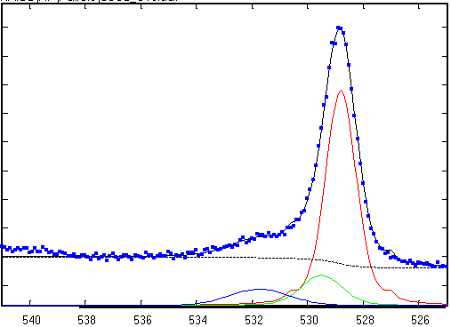

Figure S3: A series of XPS core level curves for the five ENMs included in this study and summarized in Table 1: TiO₂ (NM-105), ZnO (NM-111), Ag (Sigma 576832), BaSO₄ (NM-220) and CeO₂ (NM-212). Each curve is fitted by Lorentzian-Gaussian convoluted functions to determine the chemical composition.
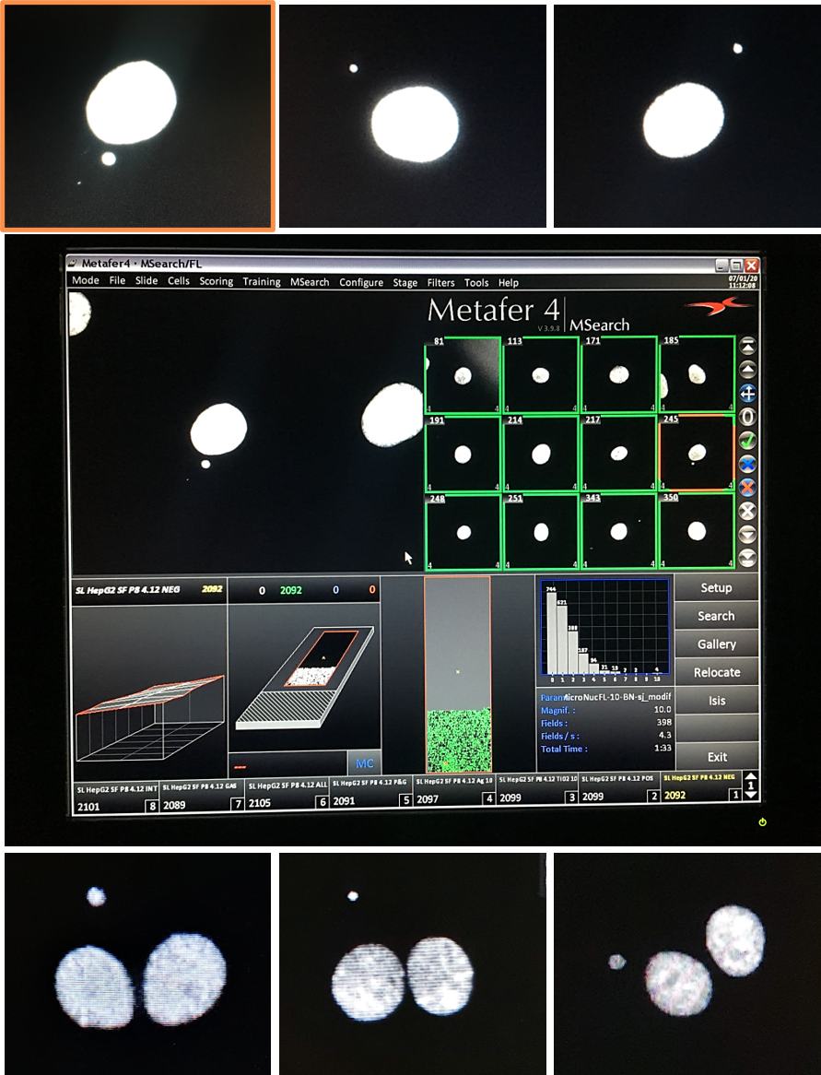
- Micronucleus Assay
A
B
C
D
F
E
G
D

Figure S4: Representative images of micronuclei generated by automated scoring of HepG2 cells using a Metafer MetaSystem 3.9.8. (A) illustrates an enlarged image of a micronucleus shown in the scoring gallery pictured in (D), and highlighted with an orange outline. Representative images of micronuclei found within the HepG2 mononucleate (B, C) and binucleate (E – G) cell populations following prolonged and acute ENM exposures respectively.

