Additional file 1 (Supplementary Figure)

Qi Wang^{1†}, Yong Wang^{1†}, Siwen Liu¹, Xuan Sha¹, Xiaoxi Song¹, Yue Dai¹, Mingming Zhao¹, Lulu Cai¹, Kai Xu^{1,2*}, Jingjing Li^{1,2*}ID

*Correspondence: qingchao0124@163.com ; xkpaper@163.com
†Qi Wang and Yong Wang contributed equally to this work
¹ School of Medical Imaging, Xuzhou Medical University, Xuzhou 221006, China
²Department of Radiology, Affiliated Hospital of Xuzhou Medical University, Xuzhou 221004, China
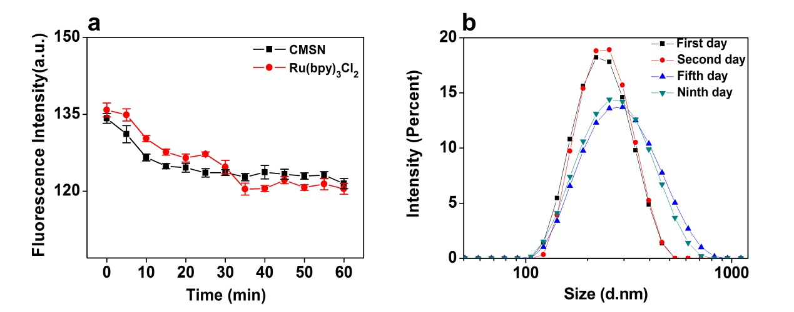
Fig. S1 a The fluorescence intensity values of Ru(bpy)₃Cl₂ and CMSN at various time points under the UV lamp. b The hydrated particle size of CMSN@Anti. (The mean particle sizes of NPs were 225.3 nm, 231.6 nm, 267.8 nm and 255.4 nm respectively).

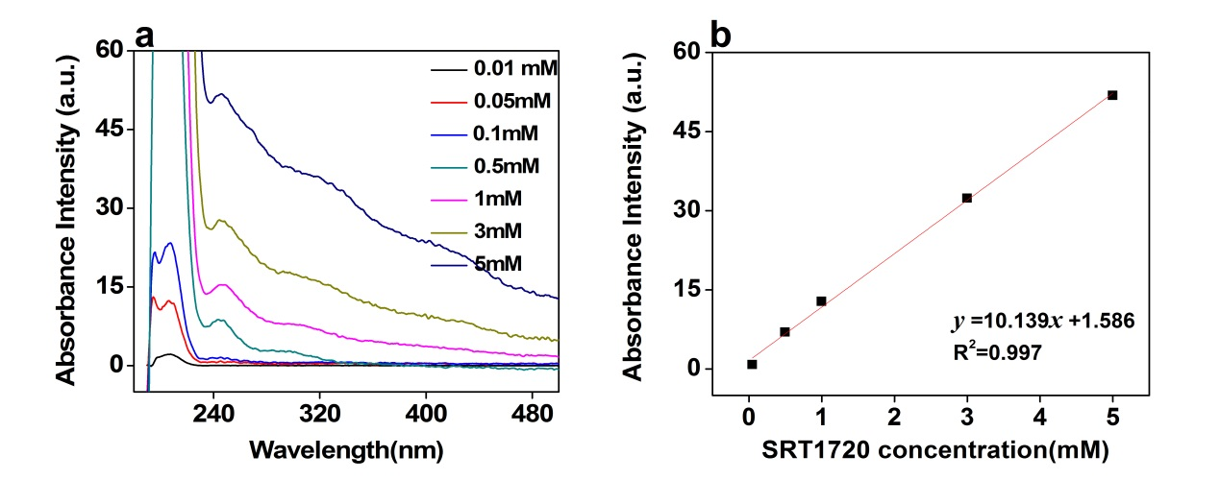
Fig. S2 a The UV-vis absorption spectra of SRT1720 at different concentrations. b The corresponding linear regression equation.

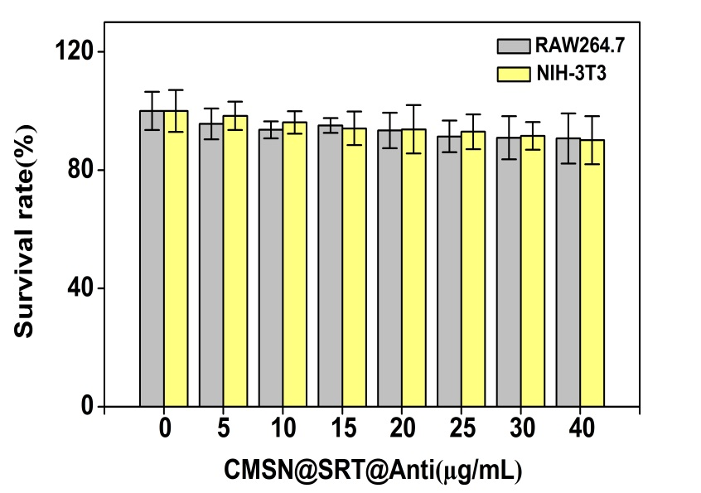
Fig. S3 Toxicity test of CMSN@SRT@Anti to RAW264.7 or NIH-3T3 cells (F_{RAW264.7} = 1.679, P = 0.142 ＞ 0.05; F_{NIH-3T3} = 1.737, P = 0.128 ＞ 0.05).
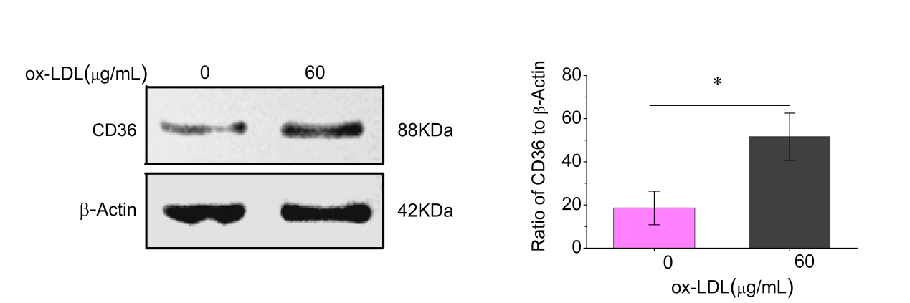
Fig. S4 Representative blots and quantification of protein levels of CD36 to the β-actin levels before and after ox-LDL treatment.（*p< 0.05）

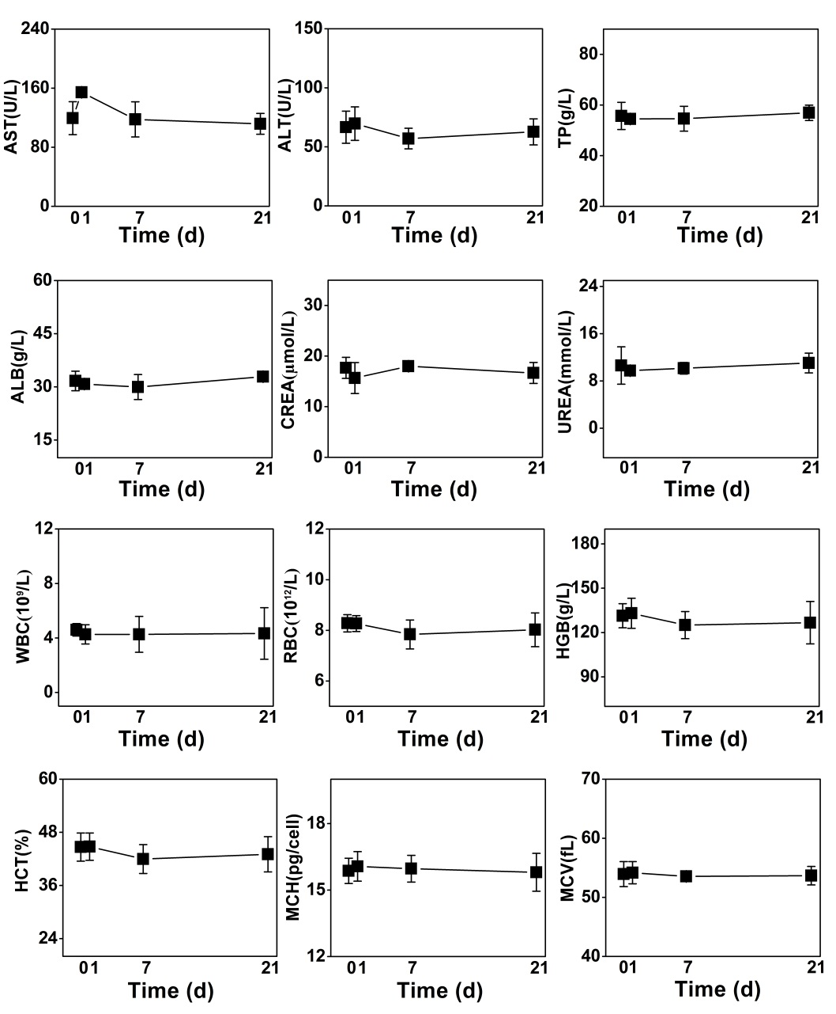
Fig. S5 Blood index analysis of Kunming mice before and after CMSN@SRT@Anti intervention. ALT (P=0.624), TP (P=0.972), ALB (P=0.504), CREA (P=0.577), UREA (P=0.849), WBC (P=0.984), RBC (P=0.664), HGB (P=0.775), HCT (P=0.707), MCH (P=0.965), MCV (P=0.963), P values are all greater than 0.05.
Compared with AST _{0d} group, P(AST _{1d})= 0.023＜0.05, P (AST _{7d})= 0.448>0.05, P (AST _{21d})= 0.313>0.05.

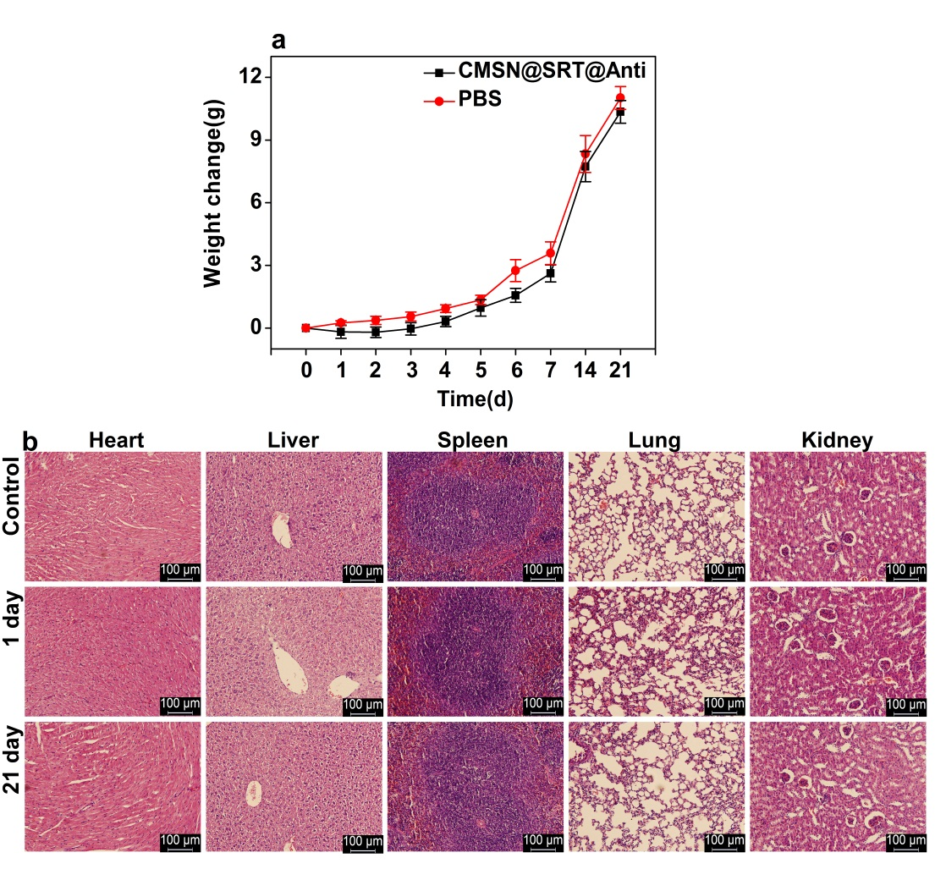
Fig. S6 Toxicity test of CMSN@SRT@Anti on Kunming mice. a The body weight of Kunming mice injected intraperitoneally with NMs or PBS changed with time. b Pathological section of major organs in Kunming mice (H&E, Scale bar: 100 μm).

Tab. S1 EE and LE of CMSN@SRT@Anti at different concentrations of SRT1720
SRT1720 (mM) | Loading Efficiences (%) | Encapsulation Efficiences (%)
0.5 | 185) | 83±8
1 | 24±1 | 63±3
3 | 42±2 | 47±4
5 | 53±1 | 44±2

Tab. S2 Relative fluorescence intensity of liver and cholecyst of Kunming mice at each time point after intraperitoneal injection of CMSN@SRT@Anti determined by Tanon Image softerware.
Tissue | 0 h | 0.5 h | 1 h | 2 h | 4 h | 6 h | 12 h | 24 h
Liver | 32.8 | 89.4 | 128.5 | 139.6 | 128.5 | 105.1 | 103.4 | 30.5
Cholecyst | 27.9 | 34.7 | 159.5 | 176.8 | 240 | 195.1 | 143.6 | 33.4

