Supporting Information

An In Situ Tissue Engineering Scaffold with Growth Factors Combining Angiogenesis and Osteoimmunomodulatory Functions for Advanced Periodontal Bone Regeneration

Tian Ding, Wenyan Kang, Jianhua Li, Lu Yu, Shaohua Ge*

Department of Periodontology & Biomaterials, School and Hospital of Stomatology, Cheeloo College of Medicine, Shandong University & Shandong Provincial Key Laboratory of Oral Tissue Regeneration & Shandong Engineering Laboratory for Dental Materials and Oral Tissue Regeneration, Jinan 250012, China

* Corresponding authors: E-mail address: shaohuage@sdu.edu.cn (S. Ge)

Table S1. Primer sequences for qRT-PCR.
Genes | Primers sequences
TNF-α | 5’- CAGGCGGTGCCTATGTCTC -3’
TNF-α | 5’- CGATCACCCCGAAGTTCAGTAG -3’
IL-1β | 5’- TGCCACCTTTTGACAGTGATG -3’
IL-1β | 5’- TGATGTGCTGCTGCGAGATT -3’
iNOS | 5’- CTCACTGTGGCTGTGGTCACCTA -3’
iNOS | 5’- GGGTCTTCGGGCTTCAGGTTA -3’
IL-10 | 5′-GCCAGAGCCACATGCTCCTA-3′
IL-10 | 5′-GATAAGGCTTGGCAACCCAAGTAA-3′
Arg-I | 5’- TGTCCCTAATGACAGCTCCTT -3’
Arg-I | 5’- GCATCCACCCAAATGACACAT -3’
TGF-β | 5’- CTAAGGCTCGCCAGTCCCC -3’
TGF-β | 5’- TGCGTTGTTGCGGTCCAC -3’
GADPH | 5’- TGACCACAGTCCATGCCATC -3’
GADPH | 5’- GACGGACACATTGGGGGTAG -3’

Table S2. Primer sequences for qRT-PCR.
Genes | Primers sequences
ALP | 5’- ATGGGATGGGTGTCTCCACA -3’
ALP | 5’- CCACGAAGGGGAACTTGTC -3’
Runx2 | 5’- TCCACACCATTAGGGACCATC -3’
Runx2 | 5’- TGCTAATGCTTCGTGTTTCCA -3’
OCN | 5’- TCACACTCCTCGCCCTATT -3’
OCN | 5’- GATGTGGTCAGCCAACTCG -3’
OPN | 5′- TCCTAGCCCCACAGACCCTT -3′
OPN | 5′- CACACTATCACCTCGGCCAT -3′
GADPH | 5’- TGACCACAGTCCATGCCATC -3’
GADPH | 5’- GACGGACACATTGGGGGTAG -3’

Table S3. Primer sequences for qRT-PCR.
Genes | Primers sequences
CD31 | 5’- AAGCTGCCGGTTCTTAAATCC -3’
CD31 | 5’- AACTTGGTGGAAGGAGGGTATG -3’
VEGF | 5’- CACAGTGGCCGACACCTAAA -3’
VEGF | 5’- TCTGACCATGTTGGCCAGACT -3’
SCF | 5’- GACCTTGTGGAGTGCGTGAA -3’
SCF | 5’- CTGGGTTCTGGGCTCTTGAAT -3’
PLGF | 5′- TTGTCTGCTGGGAACGGCTCGT -3′
PLGF | 5′- CCGGCACACAGTGCAGATTCT -3′
GADPH | 5’- TGACCACAGTCCATGCCATC -3’
GADPH | 5’- GACGGACACATTGGGGGTAG -3’

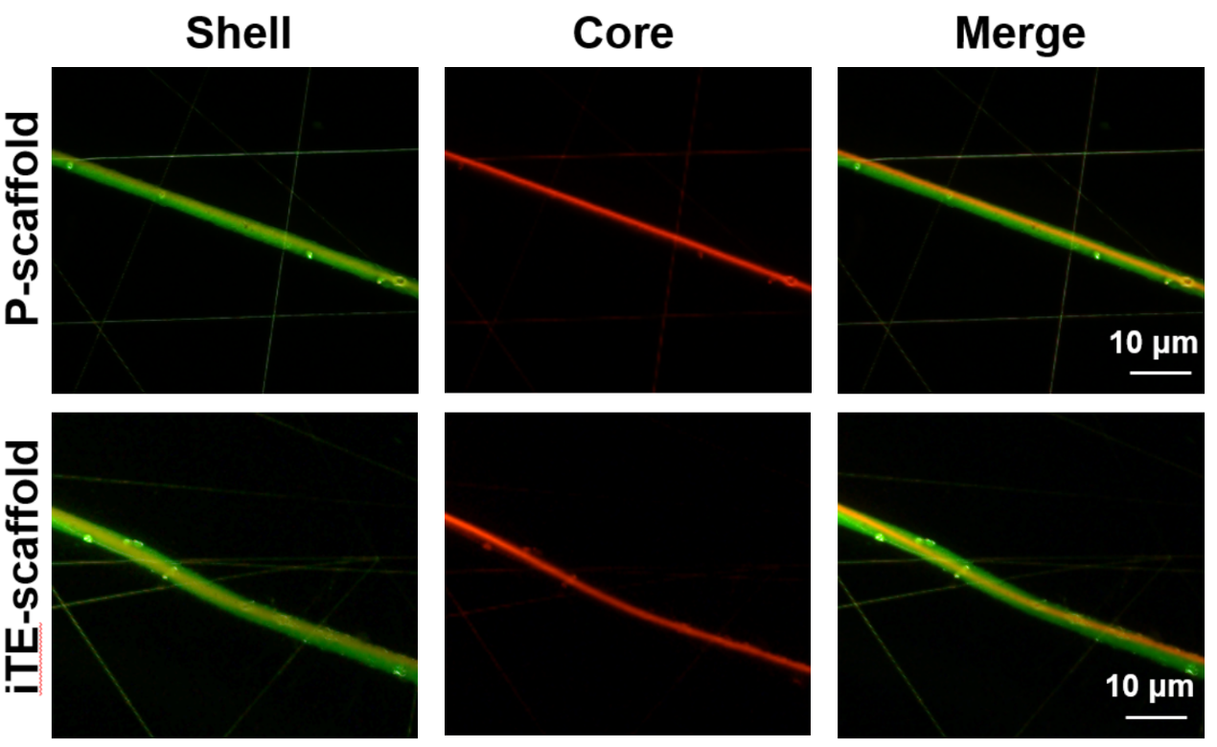
Fig. S1. Fluorescence microscopy images of the fibrous scaffolds after fluorescent staining. The PLLA core is indicated in red, while PLGA shell in green. Scale bar: 10 μm.

Fig. S2. Water contact angle of different fibrous membranes. *P < 0.05

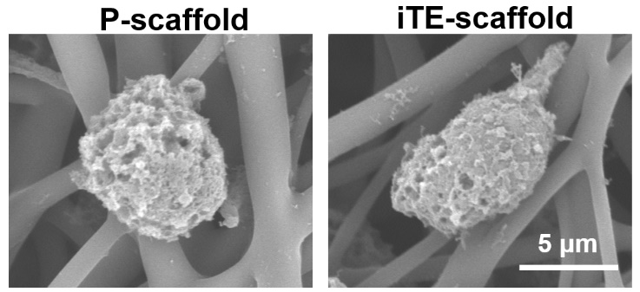
Fig. S3. SEM images of macrophages cultured on P-scaffold and iTE-scaffold for 24 h.

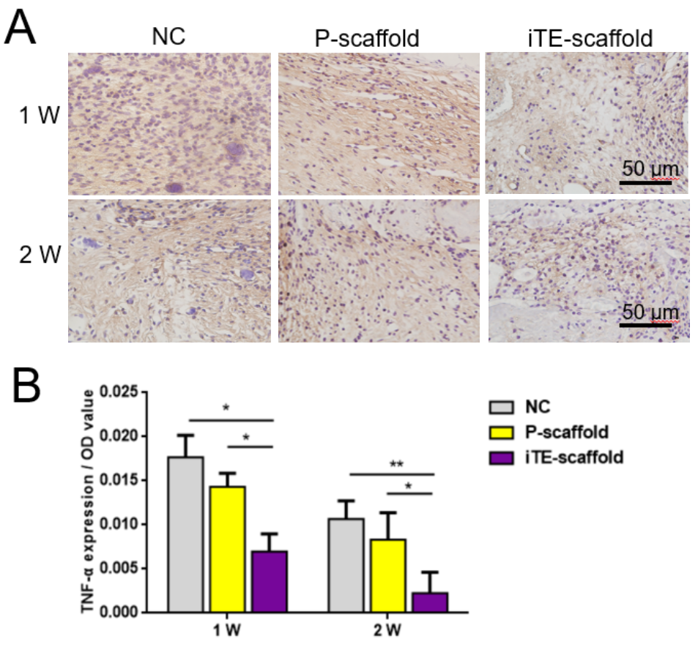
Fig. S4. Immunohistochemistry analysis of TNF-α expression in all groups. (A) Immunohistochemical staining of TNF-α(brown) at week 1 and 2 post-operation. Scale bar: 50 μm. (B) Quantitative analysis of TNF-αexpression at week 1 and 2 post-operation. *P < 0.05 and **P < 0.01.

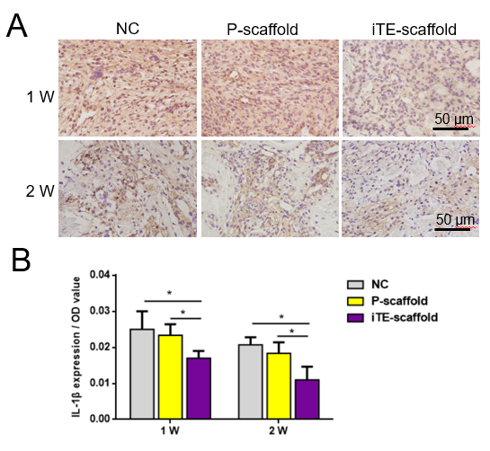
Fig. S5. Immunohistochemistry analysis of IL-1β expression in all groups. (A) Immunohistochemical staining of IL-1β (brown) at week 1 and 2 post-operation. Scale bar: 50 μm. (B) Quantitative analysis of IL-1β expression at week 1 and 2 post-operation. *P < 0.05.

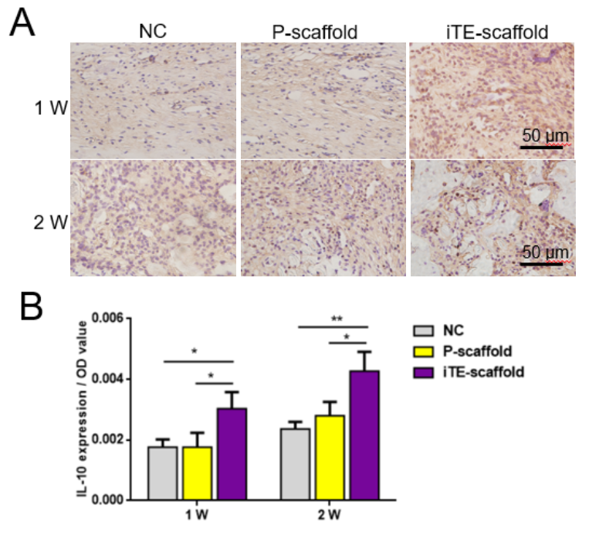
Fig. S6. Immunohistochemistry analysis of IL-10 expression in all groups. (A) Immunohistochemical staining of IL-10 (brown) at week 1 and 2 post-operation. Scale bar: 50 μm. (B) Quantitative analysis of IL-10 expression at week 1 and 2 post-operation. *P < 0.05 and **P < 0.01.

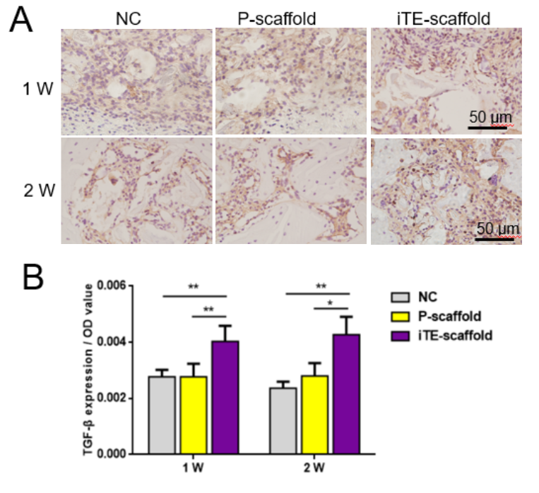 Fig. S7. Immunohistochemistry analysis of TGF-β expression in all groups. (A) Immunohistochemical staining of TGF-β (brown) at week 1 and 2 post-operation. Scale bar: 50 μm. (B) Quantitative analysis of TGF-β expression at week 1 and 2 post-operation. *P < 0.05 and **P < 0.01.

