Figure S1. The identification of hBM-MSC. a The verification of the adherence ability to plastic culture vessels of hBM-MSCs. Scale bar=500 μm. b The verification of the tri-lineage differentiation ability of adipogenesis, osteogenesis, as well as chondrogenesis of hBM-MSC by Oli Red O staining, Alizarin Red Staining and Alcian Blue Staining respectively. Scale bars = 100 μm, 200 μm, and 200 μm respectively. c The percentage of hBM-MSC specific surface markers CD34, CD45, CD73, CD90, CD105 positive cells by flow cytometry. Abbreviations: hBM-MSC: human bone marrow derived mesenchymal stem cells.
Figure S2. Exo-181b inhibited the inflammatory response by enhancing M2 polarization macrophages of BMDMs in vitro. a-b Representative images of the percentage of CCR7 and CD206 positive cells verified by flow cytometry analysis. c-d The quantitative flow cytometry analysis of the percentage of CCR7 and CD206 positive cells (*p<0.05). Abbreviations: CCR7: Cxc Chemokine Receptor 7.
Figure S3. The inhibition of PRKCD enhanced M2 polarization of BMDMs of Exo-181b. a BMDMs were first treated with Ti and then treated with Exo-181bi NC+si-PRKCD NC, Exo-181bi NC+si-PRKCD, Exo-181bi +si-PRKCD NC and Exo-181bi +si-PRKCD respectively for 24 h. a-b The representative images of the percentage of CCR7 and CD206 positive cells verified by flow cytometry analysis. c-d The quantitative analysis of the percentage of CCR7 and CD206 positive cells by flow cytometry analysis (*p<0.05).

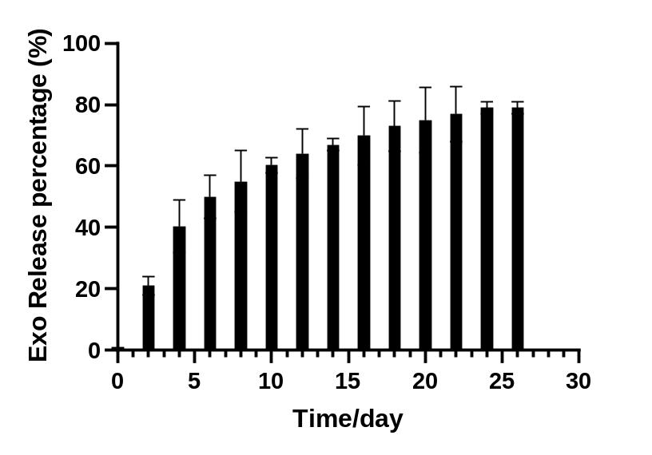
Figure S4. The sustained release profile of Exo by hydrogel
Figure S5. Exo-181b have no direct improvement on the proliferation, migration and osteogenic differentiation of hBM-MSCs in vitro. a The detection of proliferation of hBM-MSCs incubated with CM by CCK-8 assay for 1, 3 and 7 days. b Cell migration ability of hBM-MSCs incubated with CM by transwell assay. Scale bar=100μm. ALP staining on day 14 and ARS on day 21 for the evaluation of osteogenic differentiation of hBM-MSCs. Scale bar=200μm. c Relative mRNA expression of qRT-PCR analysis for ALP, RUNX2, OCN of hBM-MSCs treated with CM. (*p<0.05). Abbreviations: ALP: alkaline phosphatase; ARS: alizarin red staining; RUNX2: Runt-related transcription factor 2; OCN: osteocalcin; VEGF: vascular endothelial growth factor; BMP-2: bone morphogenetic protein-2; CM: conditioned medium.
Figure S6. The microCT analysis of the in vivo experiment. Statistical analysis of a TV and b BV by the acquired MicroCT data for each group after 12 weeks. (*p< 0.05).TV: total volume; BV: bone volume;

Table. S1 Primer sequences used in qRT-PCR
Gene | Primers
RUNX2 | F: 5' TGGTTACTGTCATGGCGGGTA 3'
RUNX2 | R: 5' TCTCAGATCGTTGAACCTTGCTA 3'
OCN | F: 5' CACTCCTCGCCCTATTGGC 3'
OCN | R: 5' CCCTCCTGCTTGGACACAAAG 3'
ALP | F: 5' ACTGGTACTCAGACAACGAGAT 3'
ALP | R: 5' ACGTCAATGTCCCTGATGTTATG 3'
CD206 | F: 5' TACTTGGACGGATAGATGGAGG 3'
CD206 | R: 5' CATAGAAAGGAATCCACGCAGT 3'
CCR7 | F: 5' GGTGGCTCTCCTTGTCATTTTC 3'
CCR7 | R: 5' AGGTTGAGCAGGTAGGTATCCG 3'
Arg-1 | F: 5' AACACTCCCCTGACAACCA 3'
iNOS  VEGF  BMP-2  18S  miR-181b  RNU6 | R: 5' CATCACCTTGCCAATCCC 3'  F: 5' ATGTCCGAAGCAAACATCAC 3'  R: 5' TAATGTCCAGGAAGTAGGTG 3'  F: 5' AGGAGTACCCCGACGAGATAGA 3'  R: 5' CACATCTGCTGTGCTGTAGGAA 3'  F: 5' AACGAGAAAAGCGTCAAGCC  R: 5' AGGTGCCACGATCCAGTCAT  F: 5' GGACAGGATTGACAGATTGATAG-3'  R: 5' CTCGTTCGTTTATCGGAATTAAC-3'  RT:5'GTCGTATCCAGTGCAGGGTCCGAGGTATTCGCACTGGATACGACACCCAC --3'  F: 5' GCGAACATTCATTGCTGTCG 3'  R: 5' AGTGCAGGGTCCGAGGTATT 3'  F: 5' GCT TCG GCA GCA CAT AT 3'  R: 5' ATT TGC GTG TCA TCC TTG 3'
Abbreviations: RT: reverse transcriptional; F:forward; R:reverse

