Additional file 1:
Figure S1
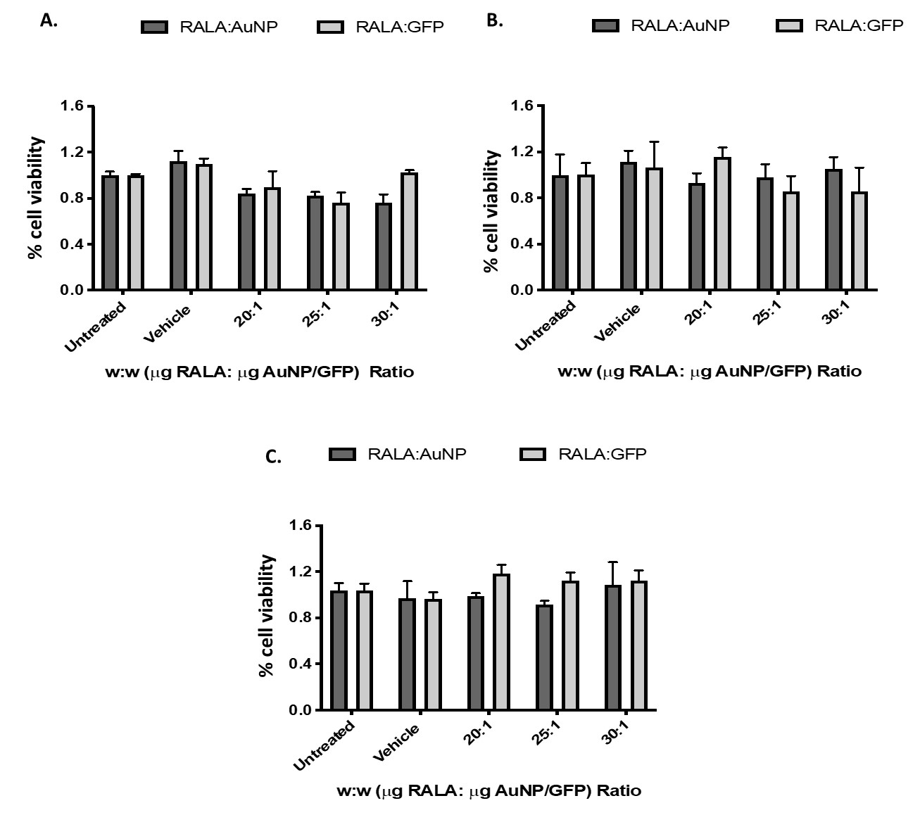

Figure S2
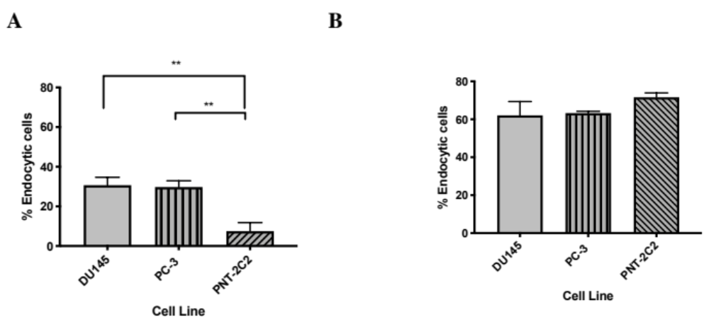

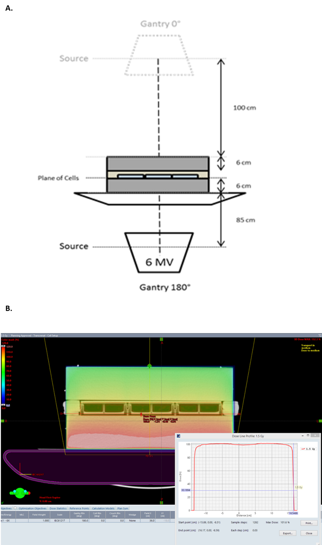
Figure S3

Figure S4
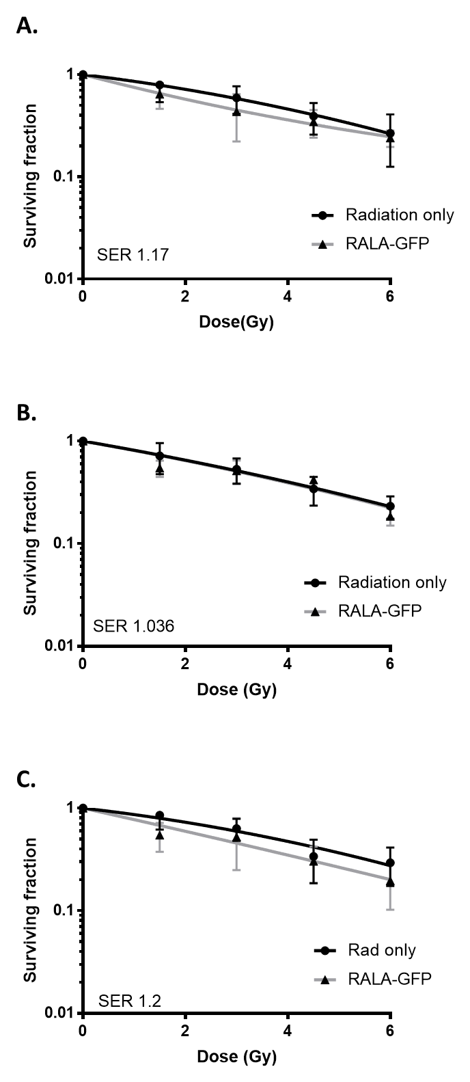

Figure S5
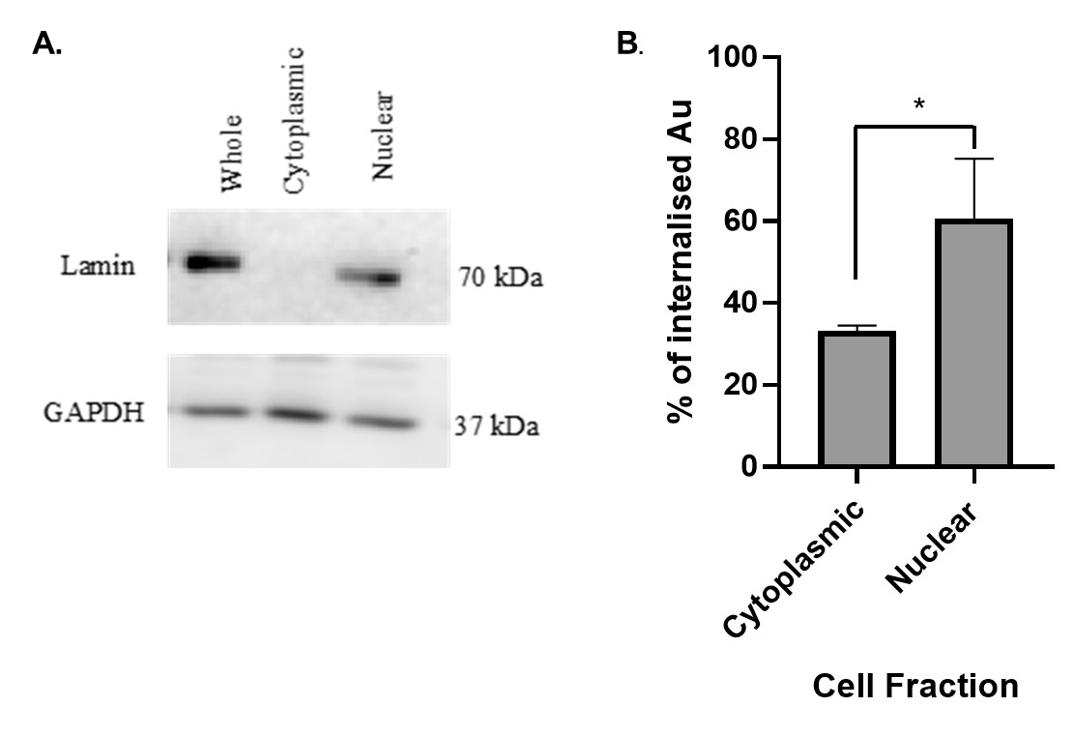

Table S1.

 | Z-Average (nm) | PDI | Zeta Potential (mV)
Citrate-AuNP | 15.3 ± 0.8 | 0.3 ± 0.01 | -23.7 ± 3.8
5 µg RALA: 1µg AuNP | 1868.8 ± 67.3 | 0.37 ± 0.02 | -3.6 ± 3.5
10 µg RALA: 1µg AuNP | 3137± 567.9 | 0.34± 0.05 | 5.1± 8.1
15 µg RALA: 1µg AuNP | 1653.7± 108.4 | 0.37± 0.01 | 10.6± 2.3
20 µg RALA: 1µg AuNP | 107.7± 14.3 | 0.49± 0.05 | 16.7± 4.5
25 µg RALA: 1µg AuNP | 107.9± 12.4 | 0.48± 0.06 | 17.8± 2.8
30 µg RALA: 1µg AuNP | 103.1± 12.4 | 0.52± 0.03 | 21.5± 2.2

Table S2.

Treatment Group | Doubling Time (Days)
Untreated | 3.3 +/- 0.64
Citrate-AuNP (1 µg ) | 5 +/- 0.503
RALA-AuNP (25 µg RALA: 1 µg ) | 4.2 +/- 0.79
Radiation (8 Gy) | 8.3 +/- 3.8
Citrate-AuNP + Radiation (8 Gy) | 10.02 +/- 2.52
RALA-AuNP+ Radiation (8 Gy) | Not Reached

