Table S1. Surface areas, pore diameter and pore volume of HPDA nanoparticles.

Sample S_{BET}ªm²/g |  | BJH Pore Diameter (nm) |  | Pore volume (cm³/g)
HPDA 39.1667 |  | 27.2621 | 0.252455
ª Surface area.

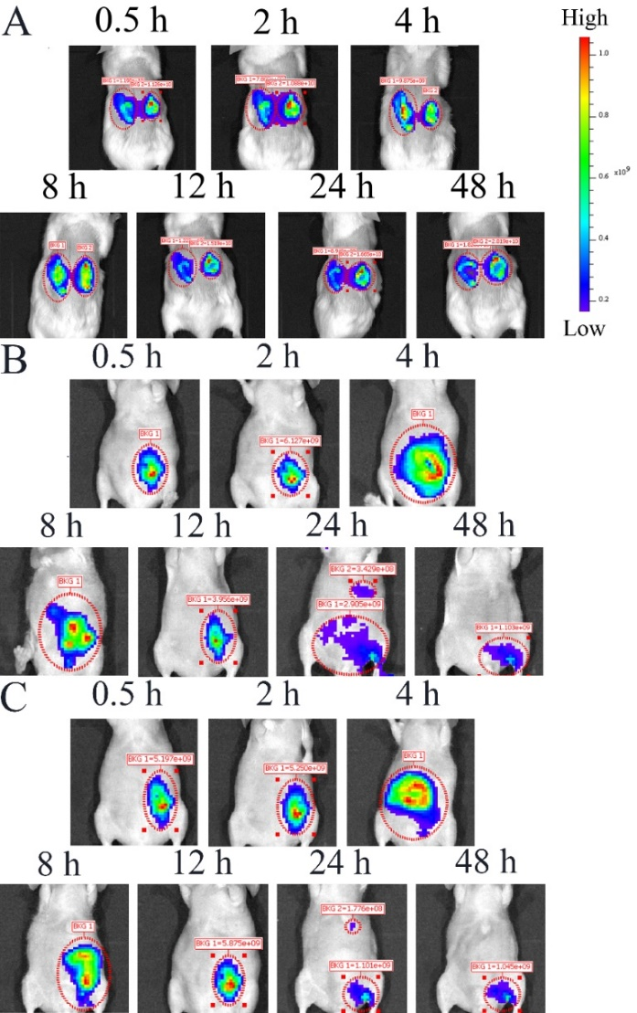

Table S1. Surface areas, pore diameter and pore volume of HPDA nanoparticles. Figure S1. Biodistribution and clearance of HPDA and HPDAlR.
A. In vivo fluorescence imaging of Kunming mice smeared with HPDA and HPDAlR by recording ICG fluorescence at indicated time (0.5, 2, 4, 8, 12, 24, 48 h).
B. In vivo fluorescence imaging of nude mice intraperitoneal injected with HPDA by recording ICG fluorescence at indicated time (0.5, 2, 4, 8, 12, 24, 48 h).
C. In vivo fluorescence imaging of nude mice intraperitoneal injected with HPDAlR by recording ICG fluorescence at indicated time (0.5, 2, 4, 8, 12, 24, 48 h).

