Supporting Information
Multifunctional silica nanocomposites prime tumoricidal immunity for efficient cancer immunotherapy
Linnan Yang^{1 4 #}, Feng Li^{1 #}, Yongsheng Cao³, Qiang Liu¹, Guoxin Jing¹, Jintong Niu¹, Feiyue Sun¹, Yechang Qian²*, Shilong Wang¹*, Ang Li¹*
¹ Research Center for Translational Medicine at East Hospital, School of Life Science and Technology, Tongji University, Shanghai, P. R. China.
² Department of Respiratory Disease, Baoshan District Hospital of Integrated Traditional Chinese and Western Medicine, Shanghai, P. R. China.
³ The Second Department of Urology, Anhui Provincial Children's Hospital, Hefei, P. R. China.
⁴ Central Laboratory, First Affiliated Hospital, Anhui Medical University, Hefei, P. R. China.
#These authors contribute equally to this paper
*Corresponding Author:
Ang Li: liang@tongji.edu.cn
Shilong Wang: wsl@tongji.edu.cn
Yechang Qian: qianyechang@163.com

Fig. S1 TEM image of DMSN-PEI treated by GSH solution (10⁻² M) for 24 h.
Fig. S2 Zeta potentials of (A) DMSN, (B) DMSN-NH2, (C) DMSN-ss-COOH, (D) DMSN-PEI, (E) Histograms of Zeta potential values.
Fig. S3 (A) N2 adsorption/desorption isotherm (B) pore size distribution curve.

Fig. S4 miRNA release from DMSN-PEI@125a in GSH-enriched environment.
Fig. S5 Body weight of mice weight during the experimental period.
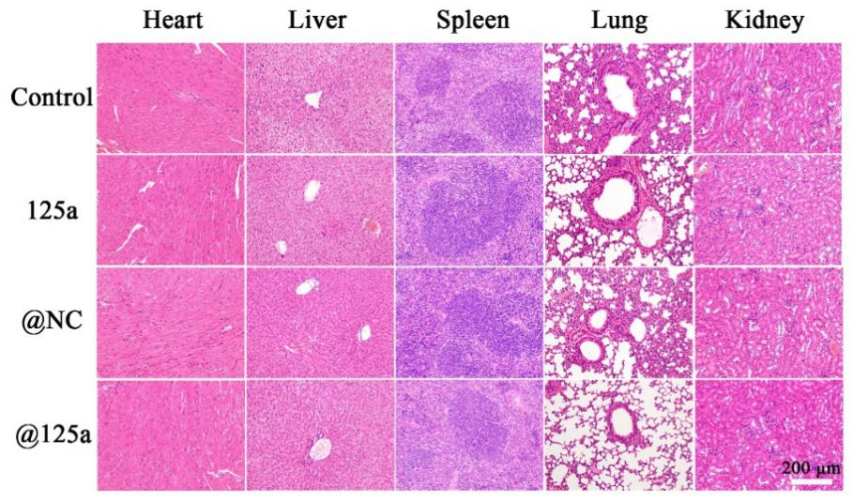
Fig. S6 HE staining of major mice organs (hearts, livers, spleens, lungs, and kidneys). at the end of the experiment. Bar = 200 μm

Table S1 q-PCR primer in the experiment (for mouse)
Gene | Forward Primer | Reverse Primer
GAPDH | GTGTTCCTACCCCCAATGTGT | ATTGTCATACCAGGAAATGAGCTT
Arg-1 | CTCCAAGCCAAAGTCCTTAGAG | AGGAGCTGTCATTAGGGACATC
TGF-β | TGCTGCTTTCTCCCTCAACCT | CACTGCTTCCCGAATGTCTGA
Msr-2 | TGCCTCTGTGCTTGCTGC | CCACTGTCACCGCGTCTT
TNF-α | CCCTCACACTCAGATCATCTTCT | GCTACGACGTGGGCTACAG
IL-1β | CCAAAAGATGAAGGGCTGCT | TCATCAGGACAGCCCAGGTC
iNOS | ATCTTTGCCACCAAGATGGCCTGG | TTCCTGTGCTGTGCTACAGTTCCG
STAT3 | AGGAGTCTAACAACGGCAGCCT | GTGGTACACCTCAGTCTCGAAG
Caspase-3 | GGAGTCTGACTGGAAAGCCGAA | CTTCTGGCAAGCCATCTCCTCA
Caspase-9 | GCTGTGTCAAGTTTGCCTACCC | CCAGAATGCCATCCAAGGTCTC
HMGB-1 | CCAAGAAGTGCTCAGAGAGGTG | GTCCTTGAACTTCTTTTTGGTCTC
CRT | AAAGGACCCTGATGCTGCCAAG | TCAGGGATGTGCTCTGGCTTGT
S100-A8 | CTACTGAGTGTCCTCAGTTTGTGCAG | CCATCGCAAGGAACTCCTCGAAG
S100-A9 | GCGCAGCATAACCACCATCATCG | GCCAACTGTGCTTCCACCATTTG

Table S2 the specific surface area and pore volume
Sample | BET surface area (m²/g) | Pore volume (cm³/g)
DMSN | 483.2105 | 1.4536
DMSN-NH₂ | 312.4709 | 1.2172
DMSN-COOH | 290.8651 | 1.0052
DMSN-PEI | 243.2834 | 0.9888

Table S3 liver or kidney parameters analysis of serum
 | Index | Ref range | Control | 125a | @NC | @125a
Liver parameter | ALT (U/L) | 42-74 | 46.442 | 50.246 | 53.485 | 67.008
Liver parameter | AST (U/L) | 51-122 | 92.115 | 107.421 | 91.145 | 98.216
Kidney parameter | CREA (μmol/L) | 8.8-13.2 | 9.357 | 9.907 | 10.011 | 11.069
Kidney parameter | UA (mmol/L) | 0.1-0.7 | 0.508 | 0.631 | 0.657 | 0.665

