Additional file for

Nano delivery of simvastatin targets liver sinusoidal endothelial cells to remodel tumor microenvironment for hepatocellular carcinoma

Zhuo Yu^{1,2}, Jianfeng Guo^{1,3}, Yun Liu¹, Menglin Wang¹, Zhengsheng Liu¹, Yueqiu Gao²*, Leaf Huang¹*
¹Division of Pharmacoengineering and Molecular Pharmaceutics, Eshelman School of Pharmacy, University of North Carolina, Chapel Hill, NC, 27599, USA.
²Department of Liver Disease, Shuguang Hospital, Affiliated to Shanghai University of Traditional Chinese Medicine, Shanghai 201203, China.
³School of Pharmaceutical Sciences, Jilin University, Changchun 130021, China.
*Correspondence authors: Leaf Huang (leafh@email.unc.edu);
Yueqiu Gao (gaoyueqiu@shutcm.edu.cn)

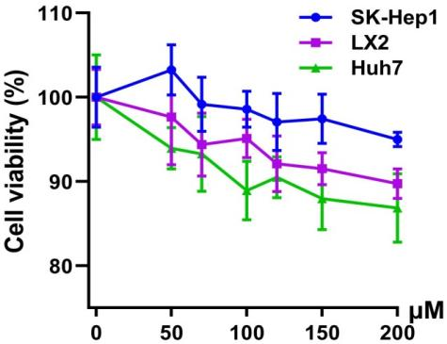

Figure S1. Simvastatin shows no obvious cytotoxicity. Cytotoxicity study of SK-Hep1, LX2 and Huh7 cells treated with simvastatin at different concentrations (n = 3).
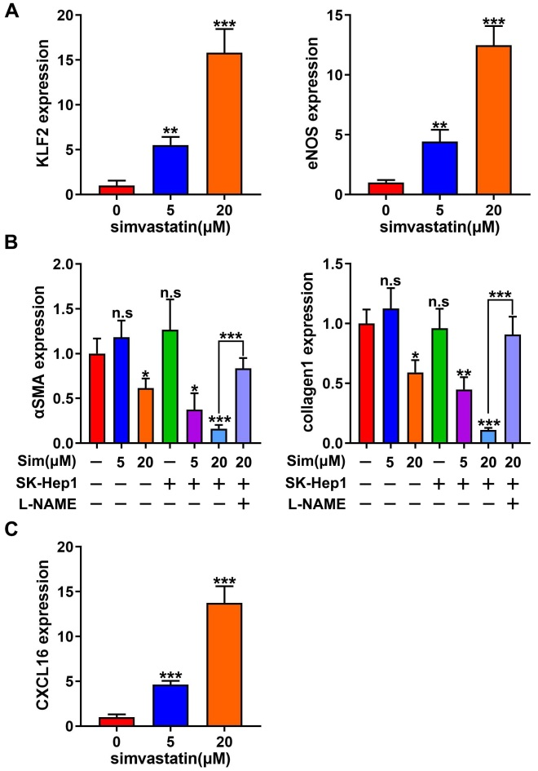
Figure S2. Simvastatin inhibits the activity of HSC via LSEC. (A) The expression of KLF2 and eNOS was quantified in SK-Hep1 cells treated with indicated concentration of simvastatin for 24 h (n=3). (B) The expression of α-SMA and collagen1 was quantified in LPS-activated LX2 treated with the supernatant of SK-Hep1 upon different doses of simvastatin treatment with or without L-NAME (n=3). (C) The expression of CXCL16 was quantified in SK-Hep1 cells treated with the indicated concentrations of simvastatin for 24 h (n=3). **p < 0.01, ***p < 0.001.

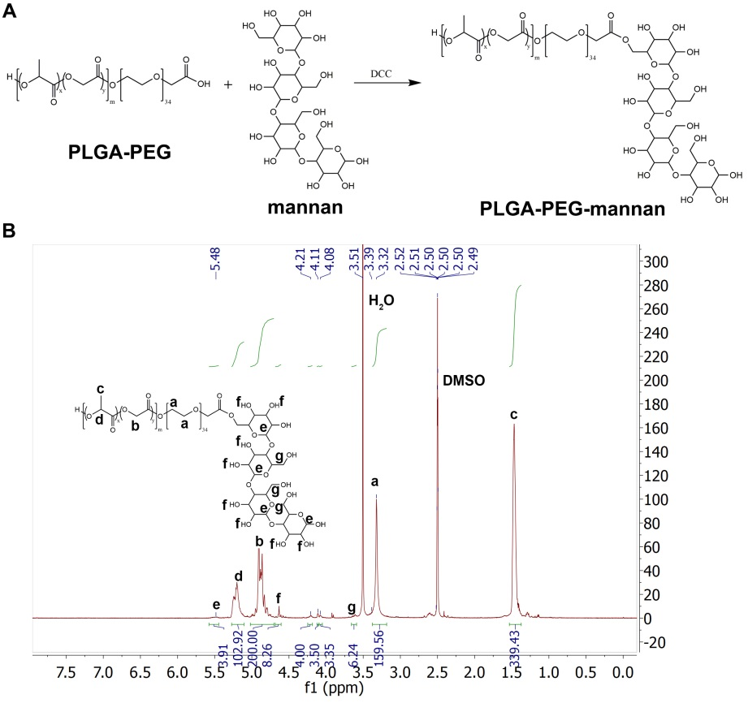

Figure S3. Synthesis of the LSEC-targeting PLGA-PEG. (A) The synthesis process of PLGA-PEG-mannan. (B) ¹H-NMR spectra of the synthesized particles PLGA-PEG-mannan. Comparing the integrated area of peak g (mannan protons) and peak a (protons in PEG), the ratio of mannose to PEG is approximately 4.5.

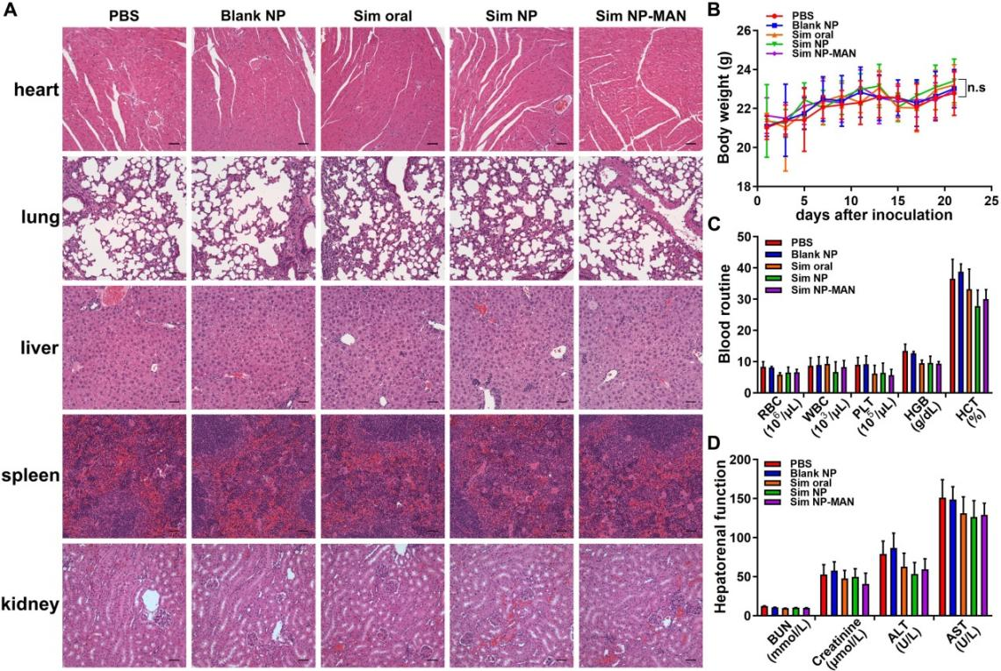
Figure S4. Simvastatin NPs show no obvious toxicity in mice. (A) HE staining of major organs from mice with various treatments. Scale bar stands for 50 μm. (B) Body weight changes during treatment. (C) Mice blood routine test and (D) Hepatorenal function test after treatment (n=5). n.s. = not significant.
Table S1. Antibody list
Antibody | Company | Catalog | Application
Anti-KLF2 | Abcam | ab194486 | WB
Anti-eNOS | Abcam | ab199956 | WB
Anti-Collagen1 | Abcam | ab6308 | WB
Anti-GAPDH | Abcam | ab181602 | WB
Anti-CXCL16 | Abcam | ab101404 | WB
Anti-α-SMA | Abcam | ab7817 | IF, IHC, WB
Anti-CD31 | Abcam | ab28364 | IF, IHC
Anti-CXCL16 | Bioss antibodies | bs-1441R | IF
Anti-LYVE1  (Alexa Fluor® 488-conjugated) | eBioscience | 53044380 | IF
CD1d-tetramer (PE-conjugated) | Proimmune | - | FC
Anti-CXCR6 (FITC-conjugated) | BioLegend | 151107 | FC
Anti-CD69 (APC-conjugated) | BioLegend | 104513 | FC
Anti-IFNγ (APC-conjugated) | BioLegend | 505809 | FC
Anti-PDL1 (APC-conjugated) | BioLegend | 124311 | FC
Table S2. Gene Primer list for real-time PCR
Primer |  | Sequence
Mus musculus | Klf2 | F: 5’-GAGCCTATCTTGCCGTCCTTT-3’’
Mus musculus | Klf2 | R: 5’-CACGTTGTTTAGGTCCTCATCC-3’
Mus musculus | Nos3 | F: 5’-GGCTGGGTTTAGGGCTGTG-3’
Mus musculus | Nos3 | R: 5’-CTGAGGGTGTCGTAGGTGATG-3’
Mus musculus | Gapdh | F: 5’-TGGCCTTCCGTGTTCCTAC-3’
Mus musculus | Gapdh | R: 5’-GAGTTGCTGTTGAAGTCGCA-3’
Human sapiens | KLF2 | F: 5’-CTACACCAAGAGTTCGCATCTG-3’
Human sapiens | KLF2 | R: 5’-CCGTGTGCTTTCGGTAGTG-3’
Human sapiens | NOS3 | F: 5’-TGATGGCGAAGCGAGTGAAG-3’
Human sapiens | NOS3 | R: 5’-ACTCATCCATACACAGGACCC-3’
Human sapiens | ACTA2 | F:5’-CTATGAGGGCTATGCCTTGCC-3’
Human sapiens | ACTA2 | R:5’-GCTCAGCAGTAGTAACGAAGGA-3’
Human sapiens | COL1 | F:5’-GAGGGCCAAGACGAAGACATC-3’
Human sapiens | COL1 | R:5’-CAGATCACGTCATCGCACAAC-3’
Human sapiens | CXCL16 | F:5’-GACATGCTTACTCGGGGATTG-3’
Human sapiens | CXCL16 | R:5’-GGACAGTGATCCTACTGGGAG-3’
Human sapiens | GAPDH | F:5’-GGAGCGAGATCCCTCCAAAAT-3’
Human sapiens | GAPDH | R:5’-GGCTGTTGTCATACTTCTCATGG-3’

Table S3. Cytokine Primer list for real-time PCR
Primer (mouse) | Applied Biosystems/Ref
CXCL16 | Mm00469712_m1
TGFβ | Mm01298616_m1
CXCL9 | Mm00434946_m1
IL-6 | Mm00446190_m1
IFN-γ | Mm01168134_m1
TNFα | Mm00443260_g1
GAPDH | Mm99999915_g1

