Additional file 1
3D hanging spheroid plate for high-throughput CAR T cell cytotoxicity assay
Zhenzhong Chen¹⁺, Seokgyu Han¹⁺, Arleen Sanny², Dorothy Leung-Kwan Chan², Danny van Noort^{3,4}, Wanyoung Lim⁵, Andy Hee-Meng Tan^{2,*}, and Sungsu Park^{1,5,6,*}

¹School of Mechanical Engineering, Sungkyunkwan University (SKKU), Suwon 16419, Korea
²Bioprocessing Technology Institute (BTI), Agency for Science, Technology and Research (A*STAR), Singapore 138668, Singapore
³Centro de Investigación en Bioingeniería, Universidad de Ingenieria y Tecnologia - UTEC, Lima 04, Peru
⁴Biotechnology, Linköping University, SE-581 83 Linköping, Sweden
⁵Department of Biomedical Engineering, Sungkyunkwan University (SKKU), Suwon 16419, Korea
⁶Institute of Quantum Biophysics (IQB), Sungkyunkwan University (SKKU), Suwon 16419, Korea
⁺ These authors contributed equally to this work.

*Corresponding authors: A. Tan, Bioprocessing Technology Institute (BTI), Agency for Science, Technology and Research (A*STAR), Singapore. Tel: +65-6-407-0937. E-mail: andy_tan@bti.a-star.edu.sg/S. Park, School of Mechanical Engineering, Sungkyunkwan University (SKKU), Suwon 16419, Korea. Tel: +82-31-290-7431. E-mail: nanopark@skku.edu.

Fig. S1. Generation of human epidermal growth factor receptor 2 (HER2)-chimeric antigen receptor (CAR) T cells. (A) Schematic diagram showing HER2-CAR structure. (B) Frequency of HER2-CAR T cells as assessed using flow cytometry. Data in (B) are representative of three independent experiments: HTM, hinge and transmembrane region.

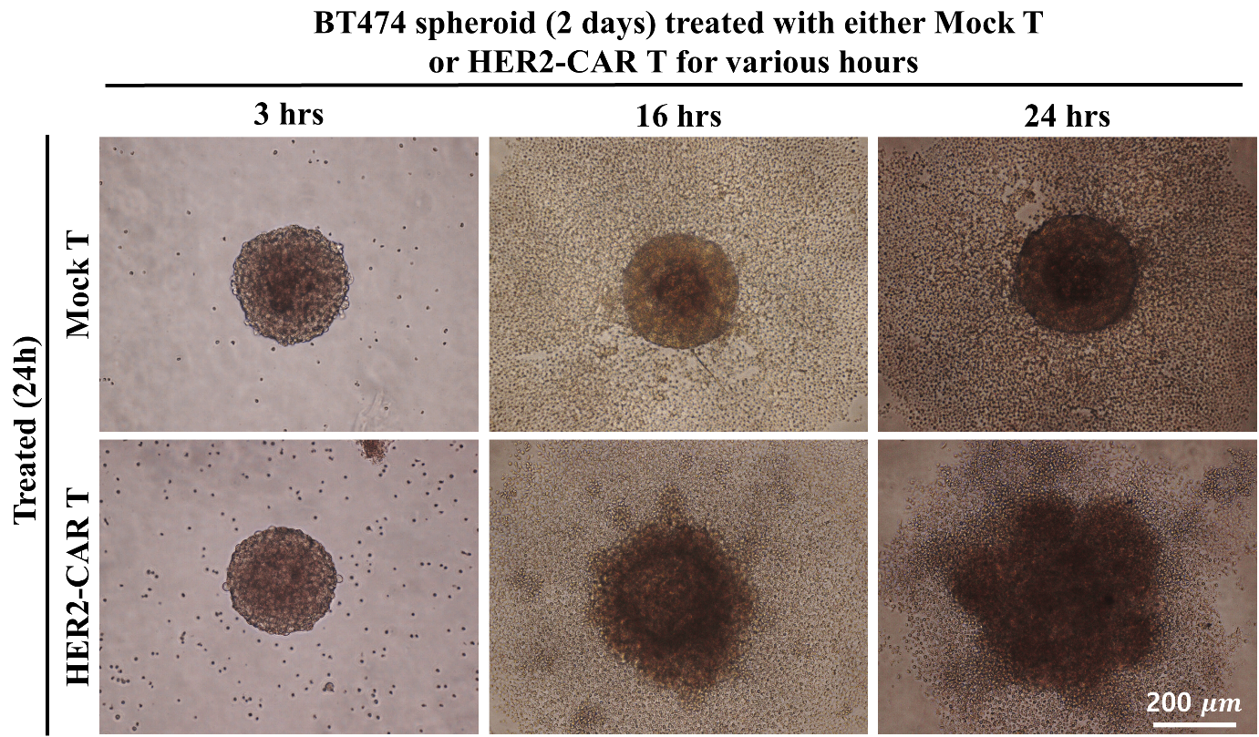

Fig. S2. Treatment of BT474 spheroids with either mock T or HER2-CAR T cells. The ratio of BT474 spheroids to either mock T or HER2-CAR T cells was 1:4 in agarose-coated wells, and the treatment duration was 3, 16, and 24 hrs.
.

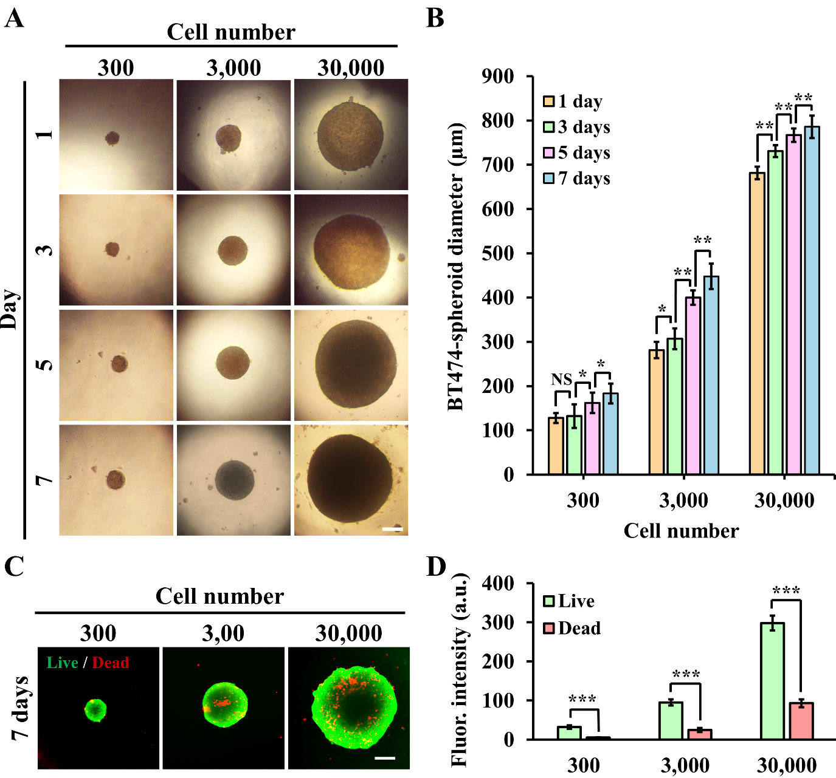
Fig. S3. Formation of BT474 spheroids on the 3DHSP. (A) Micrographs of BT474 spheroids with different cell numbers (300, 3,000, and 30,000) on the 3DHSP for 1, 3, 5, and 7 d. (B) Spheroid diameter changing with time. (C) Representative images of BT474 spheroids cultured on the 3DHSP for 7 d showing the live (green) and dead (red) cells. (D) Green and red fluorescence intensity of spheroids cultured on the 3DHSP for 7 d. Scale bar: 200 µm. Student’s t-test: * p< 0.05, ** p< 0.01, *** p< 0.001; NS, not significant.

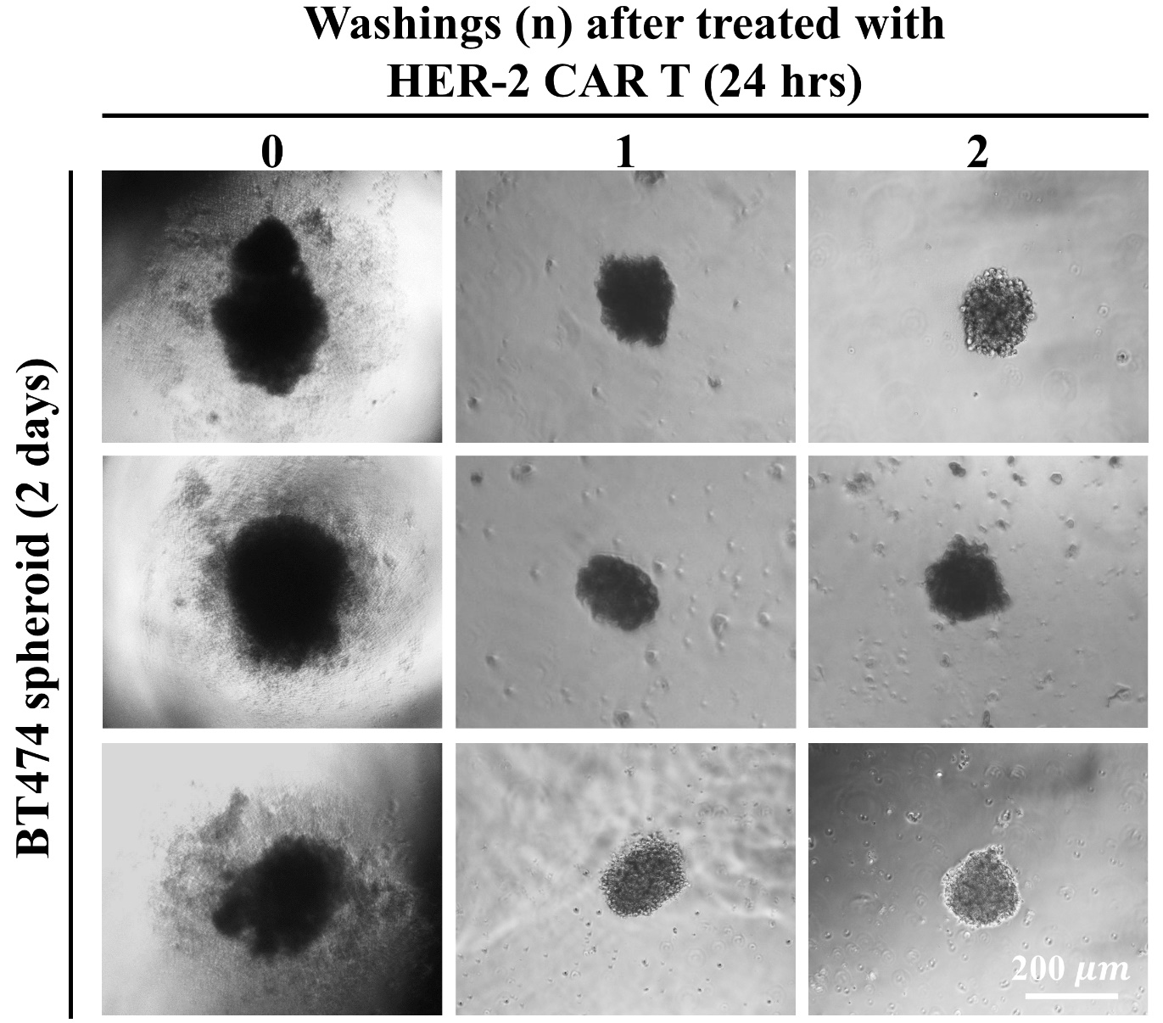
Fig. S4. Image of the treated BT474 spheroids with and without either one or two repeated washings. Scale bar: 200 µm.
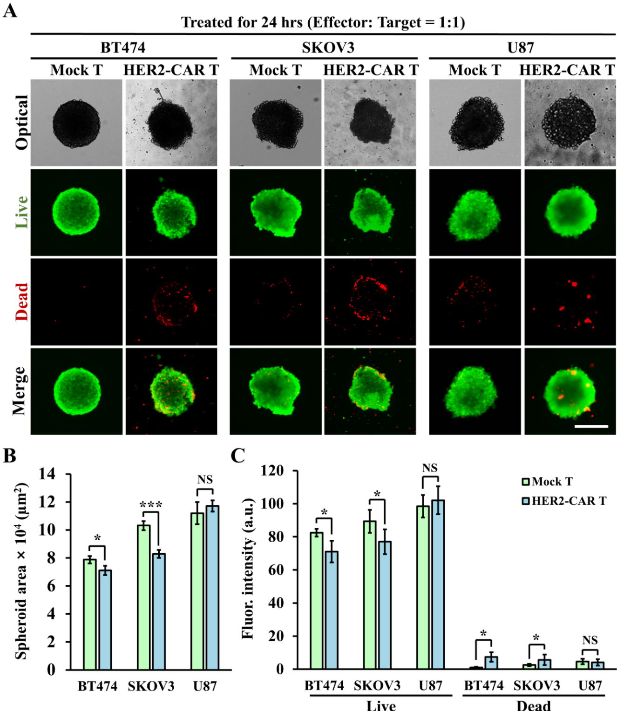
Fig. S5. Treatment of spheroids with either the mock or HER2-CAR T cells. The ratio of the spheroids and either the mock or HER2-CAR T cells was 1:1 in the 3DHSP, and the treatment duration was 24 hrs. (A) Optical and fluorescent images of the treated spheroids of BT474, SKOV3, and U87 cells stained with calcein-AM (green) and ethidium homodimer-1 (red). (B) Area and green and red fluorescence intensity (C) of the treated spheroids. Scale bar: 200 µm. Student’s t-test: * p< 0.05, *** p< 0.001; NS, not significant.
Fig. S6. Cytotoxicity of mock T and HER2-CAR T cells against luciferase-expressing cells co-cultured in 2D. The effector (BT474, SKOV3, and U87 cells) to target ratio was 4:1 (unless otherwise stated), and the cytotoxicity was assessed by the luminescence of surviving tumor cells 24 hrs later. Data are the mean ± standard deviation (SD) of three technical replicates for each condition and representative of one experiment.

