Supporting information

Mn dopped Prussian Blue nanoparticles for T₁/T₂ MR imaging, PA imaging and Fenton reaction enhanced mild temperature photothermal therapy of tumor

Quan Tao,Genghan He, Sheng Ye, Di Zhang, Zhide Zhang, Li Qi, Ruiyuan Liu

Content

Table S1. The doping ratios of Mn in final MnPB NPs products.

Figure S1. (A) The XRD of MnPB NPs. (B) The DLS of MnPB NPs. (C) The zeta potential of MnPB NPs. (D) The UV-vis absorption of MnPB NPs with different concentration. (E) The mass extinction coefficient of MnPB NPs

Figure S2. (A) The stable average diameter and PDI of Mn PB NPs changes with time. (B) The size of Mn PB NPs in water with different pH. (C) The stability of Mn PB NPs in H2O, FBS, and DMEM.

Figure S3. (A) The heating and cool cycle of MnPB NPs. (B) The IR imaging of MnPB NPs under 808 nm laser irradiation. (C) Time constant for heat transfer of MnPB NPs. (D) Time constant for heat transfer of water.

Figure S4. UV-vis absorption of different experimental groups to test the Fenton reaction.

 | FeCl₂  (M) | MnCl₂  (M) | K₃[Fe(CN)₆]  (M) | Mn/(Mn+Fe) | Mn/MnPb NPs
PB | 0.05 | 0 | 0.05 | 0 | 0
MnPB NPs | 0.05 | 0.05 | 0.05 | 10.73% | 5.37%
Table S1. The doping ratios of Mn in final MnPB NPs products.
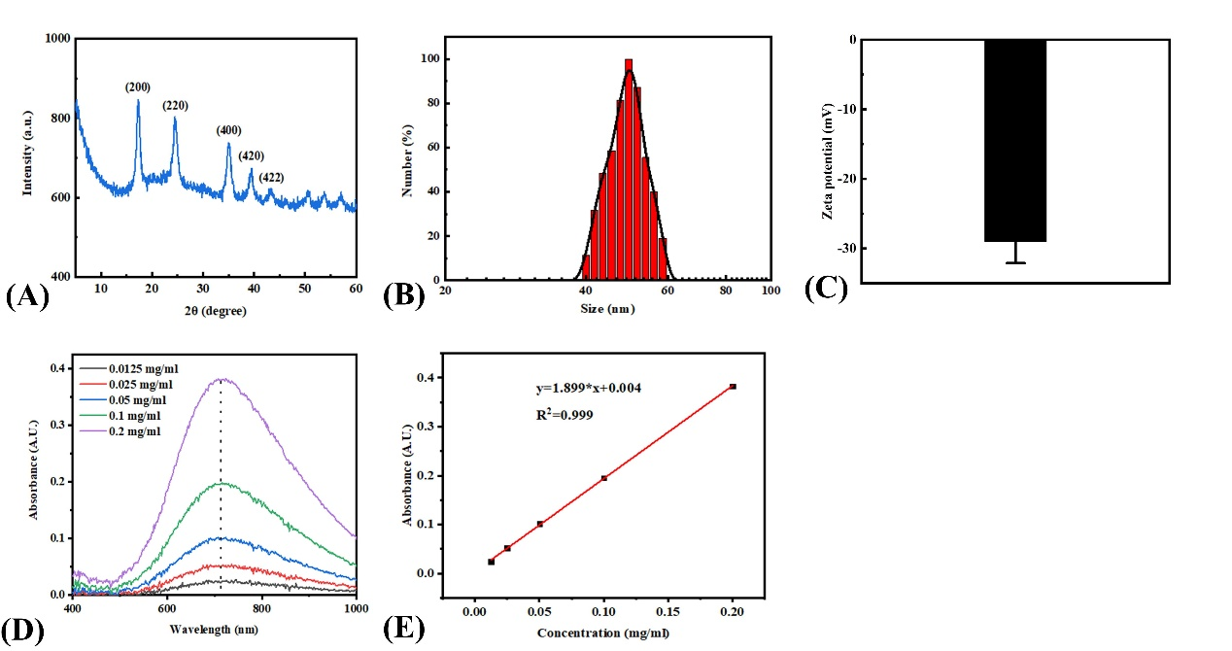
Figure S1 (A) The XRD of MnPB NPs. (B) The DLS of MnPB NPs. (C) The zeta potential of MnPB NPs. (D) The UV-vis absorption of MnPB NPs with different concentration. (E) The mass extinction coefficient of MnPB NPs

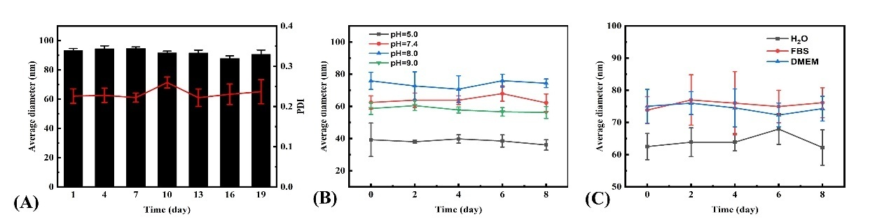
Figure S2 (A) The stable average diameter and PDI of Mn PB NPs changes with time. (B) The size of Mn PB NPs in water with different pH. (C) The stability of Mn PB NPs in H2O, FBS, and DMEM.

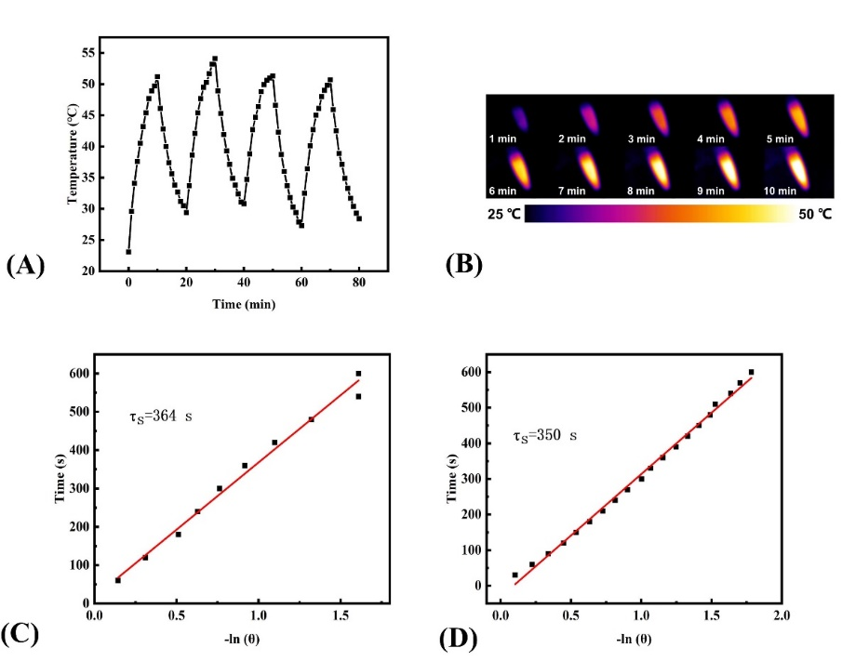
Figure S3. (A) The heating and cool cycle of MnPB NPs. (B) The IR imaging of MnPB NPs under 808 nm laser irradiation. (C) Time constant for heat transfer of MnPB NPs. (D) Time constant for heat transfer of water.

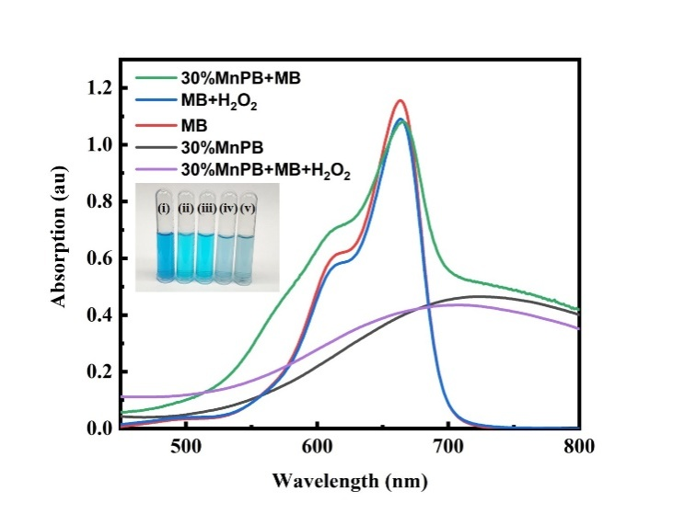
Figure S4. UV-vis absorption of different experimental groups to test the Fenton reaction.

