Supporting Information

Biodegradable MoSe₂-PVP with multi-enzyme activity ameliorates acute pancreatitis
Pei Xie,^{a,1} Liying Zhang,^{b,1} Hui Shen,^{a,1} Hang Wu,ª Jiulong Zhao,^{a,}* Shige Wang, ^{b} and Lianghao Hu ^{a,}*

Figure S1. (a) SEM of MoSe₂-PVP NPs. (b) Histogram of diameter distribution of MoSe₂-PVP NPs. Dynamic light scattering and Tyndall photographs of MoSe₂-PVP NPs in (c) DMEM, (d) saline, and (e) H₂O.

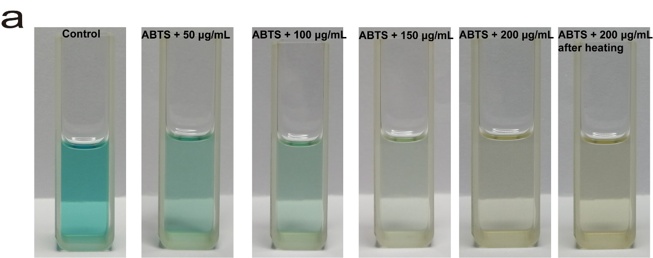
Figure S2. (a) The photographs of scavenging ability of MoSe₂-PVP NPs for ABTS⁺.

Figure S3. (a) Absorbance of the reaction of H₂O₂ in the presence of MoSe₂-PVP NPs (200 μg/mL) with time; (b) Kinetic change at 650 nm of POD-like of MoSe₂-PVP NPs. (c) Kinetic changes at 340 nm of GPx-like of MoSe₂-PVP NPs.

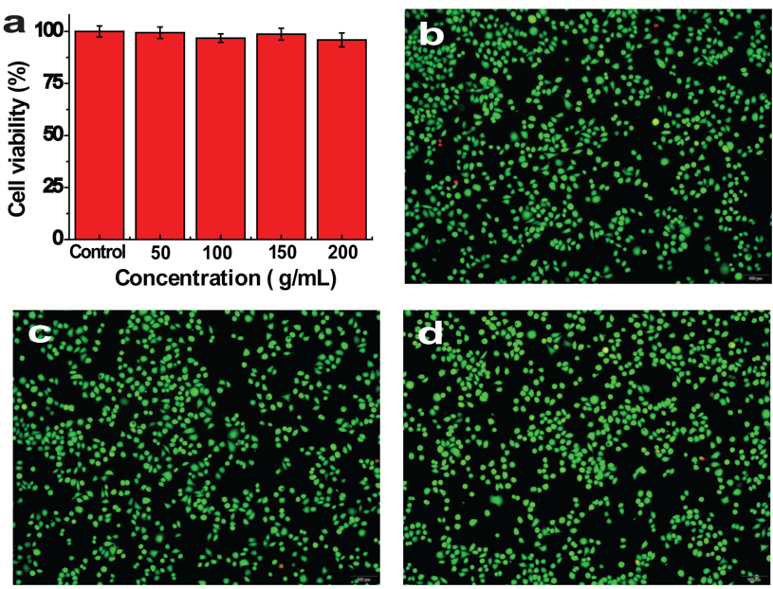
Figure S4. The safety of MoSe₂-PVP NPs in vitro. (a) Cells viabilities of 266-6 cells after cultured with different concentrations of MoSe₂-PVP NPs. (b) The photographs of Live/Dead staining corresponding to (a), b: control, c: 50 μg/mL, d: 100 μg/mL. Representative graphics are shown, n = 3 independent experiments.

Figure S5. (a-i) Hematological test results of mice after the injection with MoSe₂-PVP NPs.

