The Sustained PGE₂ Release Matrix Improves Neovascularization and Skeletal Muscle Regeneration in a Hindlimb Ischemia Model
Haoyan Huang, Shang Chen, Hui Cheng, Jiasong Cao, Jun Zhang, Yuqiao Chang, Xiaohong Shen, Zhikun Guo, Zhibo Han, Guoqiang Hua, Zhong-Chao Han, Nadia Benkirane-Jessel, Ying Chang, Zongjin Li

Supplemental Table 1. The sequences of human primers.
Transcription | Primer sequences
CASPASE-3 | Forward: TGCATACTCCACAGCACCTG  Reverse: TCTGTTGCCACCTTTCGGTT
CASPASE-9 | Forward: GCAAGCAGCAAAGTTGTCGA  Reverse: GGACTCACGGCAGAAGTTCA
BAX | Forward: AAGGTGCCGGAACTGATCAG  Reverse: AAAGTAGGAGAGGAGGCCGT
BAD | Forward: AGAGTTTGAGCCGAGTGAGC  Reverse: ATGATGGCTGCTGCTGGTT
GAPDH | Forward: GGAGCGAGATCCCTCCAAAAT  Reverse: GGCTGTTGTCATACTTCTCATGG

Supplemental Table 2. The sequences of mouse primers.
Transcription | Primer sequences
MyoD1 | Forward: CCACTCCGGGACATAGACTTG  Reverse: AAAAGCGCAGGTCTGGTGAG

Supplementary Figures & Legends
Supplementary Fig. 1 The PGE₂ matrix promoted HUVECs proliferation in optimal concentration. (A) Representative images showed the proliferation (Ki-67, red) of HUVECs treated with different concentrations of the PGE₂ matrix. (B) Quantification of Ki-67 immunostaining of HUVECs. (C) The CCK-8 assay showed the proliferation of HUVECs with different concentrations of PGE₂ matrix. Data are expressed as the mean ± SD. Scale bar 100 μm. The experiments were performed in triplicate.
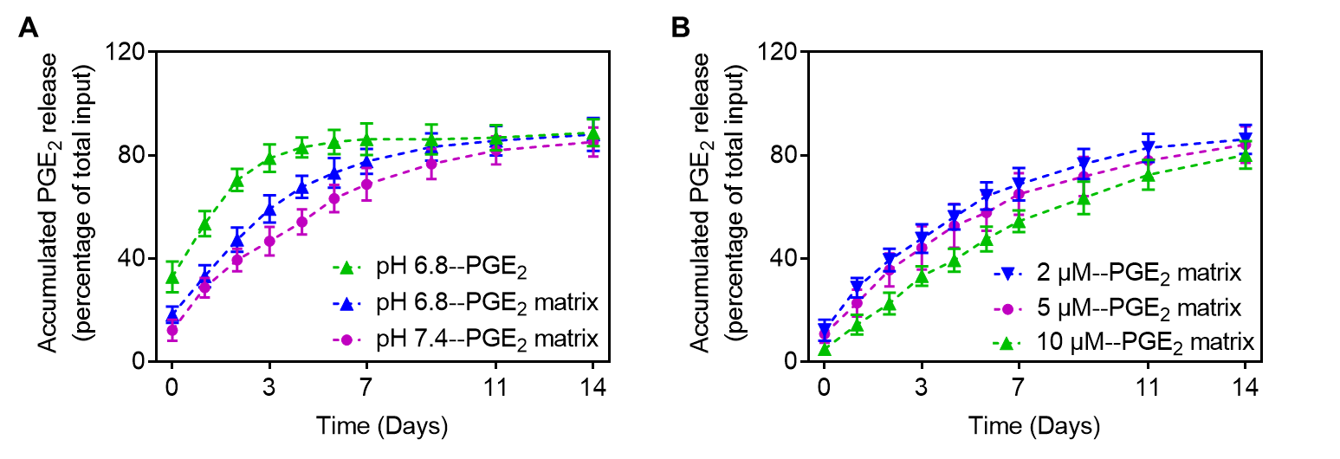
Supplementary Fig. 2 PGE₂ release kinetics from the PGE₂ matrix. (A) The PGE₂ release profiles from PGE₂ matrix with different concentrations. (B) The PGE₂ release profiles from PGE₂ matrix under different pH conditions.

Supplementary Fig. 3 The time course of MyoD1 in ischemic muscle tissues treated with the PGE₂ matrix. (A) Representative images of immunohistochemical staining of MyoD1in muscle tissue from different groups on day 14. Scale bar, 100 μm. (B) Quantification of MyoD1 immunostaining in injured muscles. (C) Gene expression of MyoD1 in muscle tissue of different groups on day 14. Data are expressed as the mean ± SD. n = 5, *P < 0.05 versus PGE₂ group; #P < 0.05 versus control group. Hindlimb ischemia mice injected with collagen as a control group.
Supplementary Fig. 4 PGE₂ matrix ameliorated tissue injury in ischemic hindlimbs. (A) (A) Measurement of the muscle fiber area of damaged muscle tissues. (B) Quantification of CD45 immunostaining in injured muscles. (C) Quantification of the area of fibrosis. Data are expressed as the mean ± SD. n = 5, *P < 0.05 versus the PGE₂ group; #P < 0.05 versus the control group. Hindlimb ischemia mice injected with collagen as a control group.
Supplementary Fig. 5 PGE₂ matrix inhibited inflammatory responses and prevented apoptosis in vivo. (A) Representative immunofluorescent images of F4/80 expression in muscle tissue from different groups at day14. Red: F4/80; Blue: DAPI. Scale bar, 100 μm. (B) Quantification of F4/80 immunostaining in injured muscles. (C) Immunohistochemical staining of cleaved caspase-3 on day14 after hindlimb ischemia. Scale bar, 50 μm. (D) Quantification of cleaved caspase-3 immunostaining in injured muscles. Data are expressed as the mean ± SD. n = 5, *P < 0.05 versus PGE₂ group; #P < 0.05 versus control group. Hindlimb ischemia mice injected with collagen as a control group.

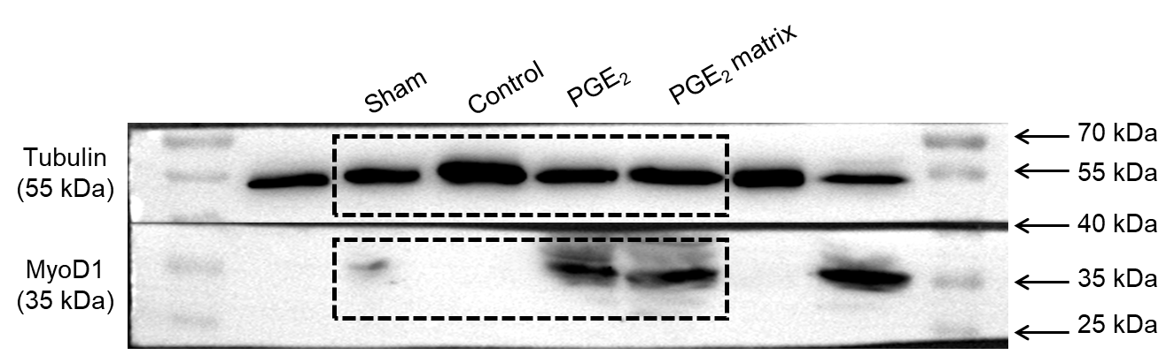
Supplementary Fig. 6 Images of the uncropped immunoblots shown in Fig. 7D. Boxes indicate cropped regions.

