Additional file 1 for
Curcumin primed ADMSCs derived small extracellular vesicle exert enhanced protective effects on osteoarthritis by inhibiting oxidative stress and chondrocyte apoptosis

Chen Xu^{1,*}, Zanjing Zhai^{1,*}, Hua Ying¹, Lin Lu², Jun Zhang^{1,#}, Yiming Zeng^{1,#}

¹ Shanghai Key Laboratory of Orthopedic Implants, Department of Orthopedics, Ninth People’s Hospital, Shanghai Jiao Tong University School of Medicine, Shanghai 200011, China.
² Department of Plastic and Reconstructive Surgery, Shanghai Ninth People's Hospital, Shanghai Jiao Tong University School of Medicine, Shanghai 200011, China.

*Chen Xu and Zanjing Zhai contributed equally to this work.

#Correspondence authors:
Yiming Zeng, xyhz29@163.com;
Jun Zhang, jeferry717717@163.com.

Figure S1. In vitro release profile of free curcumin and sEV-CUR in PBS for 24 hours.

Figure S2. Average particle diameter of sEV and sEV-CUR.

Figure S3. Detection of the fluorescent signal of DiI clusters in chondrocytes.

Figure S4. Immunofluorescence staining of cleaved caspase3 in vitro.
(a) Representative immunofluorescence images of cleaved caspase3 in each group, scale bar: 50 μm; (b) Statistical evaluation of fluorescent positive after EdU staining (n = 3). *P < 0.05, **P < 0.01, ***P < 0.001.

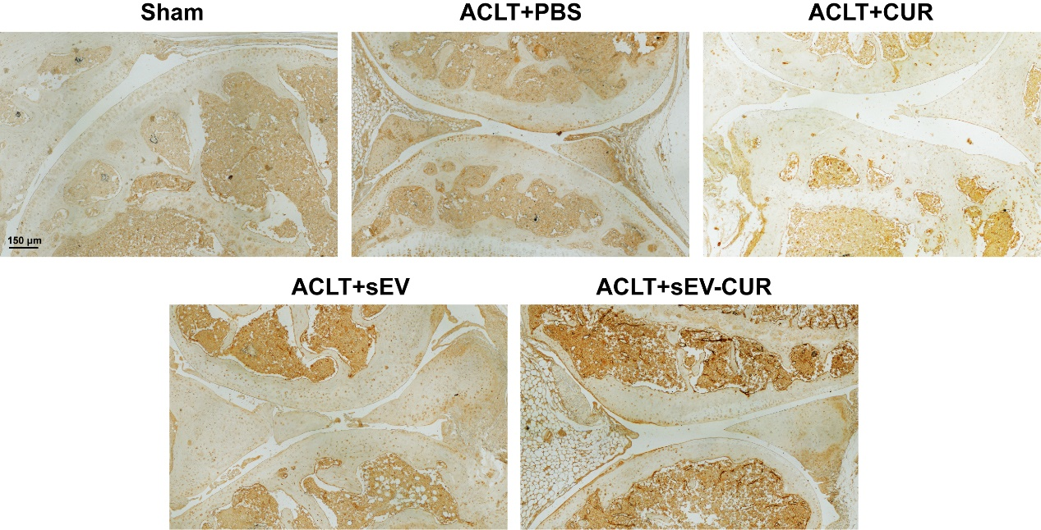

Figure S5. Immunohistochemistry staining of cleaved caspase3 in vivo.

Figure S6. The effect of sEV-CUR on mechanical sensitivity in ACLT-induced mice.
Mechanical sensitivity in each group was measured and analyzed at 2 weeks (a) and 4 weeks (b) after ACLT surgery (n = 6). WT, withdrawal threshold. NS, not significant, *P < 0.05, ***P < 0.001.

