Supplementary Material

High relaxivity Gd³⁺-based organic nanoparticles for efficient magnetic resonance angiography

Zhuang Liu^{1†}, Menglong Zhao^{2†}, Han Wang^{3†}, Zi Fu^{1,3}, Hongbo Gao⁴, Weijun Peng¹, Dalong Ni^{3*}, Wei Tang^{1*}, Yajia Gu^{1*}

¹ Department of Radiology, Fudan University Shanghai Cancer Center, Department of Oncology, Shanghai Medical College, Fudan University, Shanghai, 200032, China

² Department of Radiology, Zhongshan Hospital, Fudan University and Shanghai Institute of Medical Imaging, Shanghai, 200032, China

³ Department of Orthopaedics, Shanghai Key Laboratory for Prevention and Treatment of Bone and Joint Diseases, Shanghai Institute of Traumatology and Orthopaedics, Ruijin Hospital, Shanghai Jiao Tong University School of Medicine, Shanghai 200025, China

⁴ Department of Radiation Oncology, Huadong Hospital Affiliated to Fudan University, Shanghai 200040, China

†Zhuang Liu, Menglong Zhao and Han Wang contributed equally to this work.
*Corresponding: ndl12353@rjh.com.cn; tangwei105@163.com; cjr.guyajia@vip.163.com

Supplementary Material
In vivo toxicity experiments
All animal studies were conducted with the approval and according to the recommendations established by the administrative committee of laboratory animals of Fudan University. Healthy male BALB/c mice (4 weeks) were purchased from Shanghai SLAC Laboratory Animal Co. Ltd and maintained in a specific pathogen-free (SPF) environment during the experiments. Sixteen BALB/c mice were randomly divided into four groups (n = 4) and intravenously administered with GPT NPs at elevated doses (0, 5, 10, 20 mg kg⁻¹). During the 30 days, the body weight of mice was measured every other day. Hematological and histological analyses were performed on the 30th day after intravenous injection. Liver function indexes were measured by the serum levels of alanine aminotransferase (ALT), aspartate aminotransferase (AST), alkaline phosphatase (ALP). Kidney function indexes were measured by the serum levels of blood urea nitrogen (BUN) and creatinine (CR). Hematological white blood cells analyses were measured by the serum levels of white blood cells (WBC), lymphocyte (LYM), monocyte (MON), and granulocyte (GRAN). Hematological platelets analyses were measured by the serum levels of platelets count (PLT), mean platelets volume (MPV), platelets ratio (PCT), and platelet-large cell rate (P-LCR). Hemoglobin and red blood cells analyses were measured by the serum levels of red blood cells (RBC), hemoglobin (HGB), hematocrit (HCT), mean corpuscular volume (MCV), mean corpuscular hemoglobin (MCH), mean corpuscular hemoglobin concentration (MCHC), red blood cell volume distribution width (RDW) and red blood cell volume distribution width standard deviation (RDW-SD).

Supplementary Figures
Characterization of Gd-chelated PEG-TCPP nanoparticles (GPT NPs)

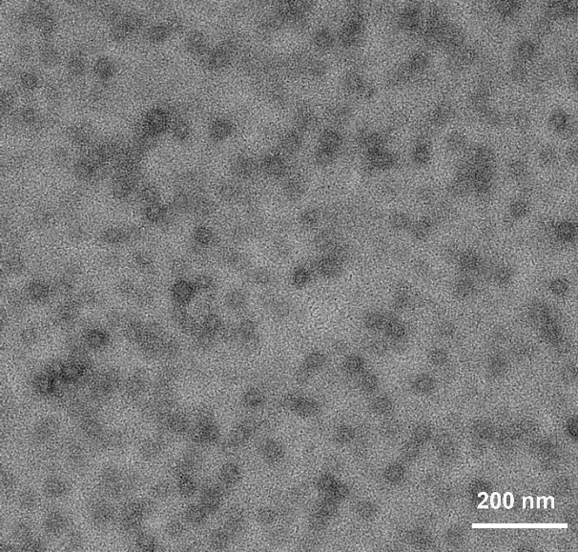
Fig. S1 Negative-staining TEM image of the GPT NPs.

Fig. S2 Fourier Transform Infrared (FTIR) spectroscopy of the GPT NPs.

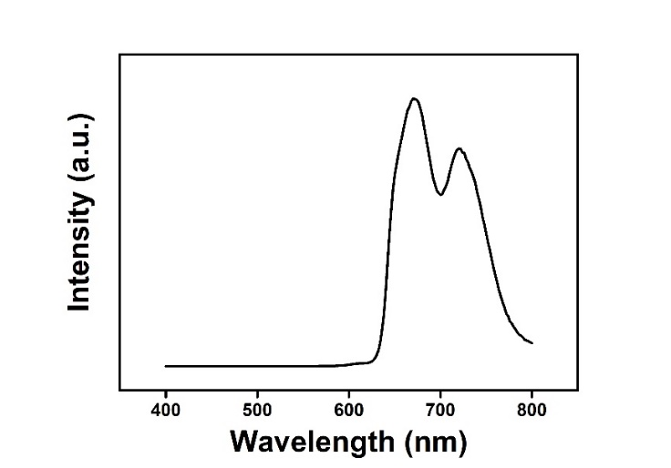
Fig. S3 Fluorescence spectroscopy of GPT NPs.

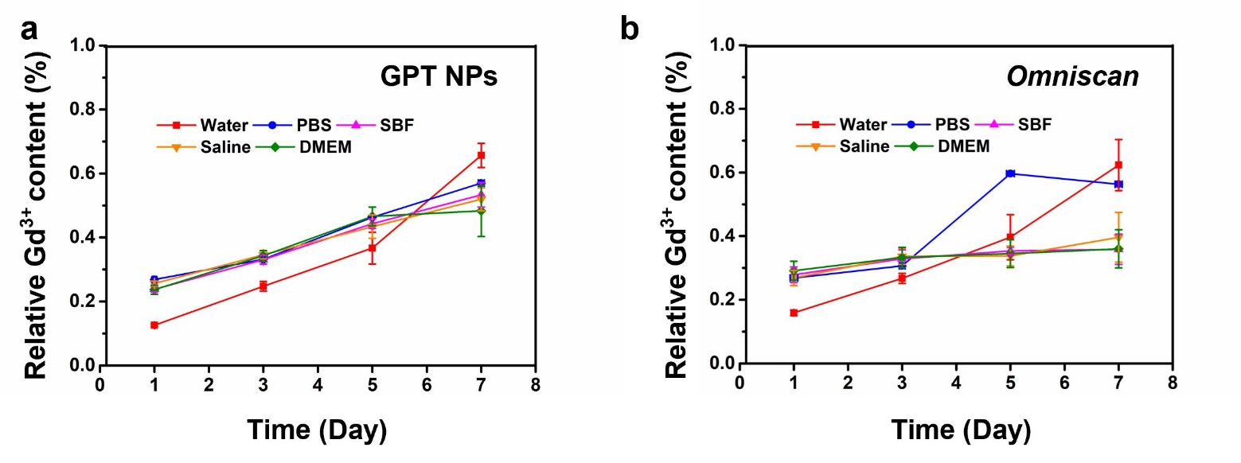
Fig. S4 The free Gd³⁺ leakage from GPT NPs and Omniscan at different time points in different buffer solutions (Water, PBS, SBF, Saline, and DMEM).

Blood circulation curve of GPT NPs

Fig. S5 Blood circulation curve of GPT NPs by measuring the Gd concentration in blood of health rats at different time points intervals post i.v. injection (n = 3). The half-time (T_{1/2}) is calculated to be approximately 6.007 h.

The free Gd³⁺ leakage from GPT NPs

Fig. S6 The free Gd³⁺ leakage from GPT NPs by measuring the Gd concentration in blood of health rats at varied time intervals.

MR performance in vivo

Fig. S7 Coronal section of T₁-weighted MRA images of PANC-1 tumor-bearing mice before and after intravenous GPT NPs (upper) and Omniscan (down) at given time points. The tumor sites were marked by red and yellow arrows.

Fig. S8 T₁-weighted MRI-signal intensities of tumor site with the prolonging of duration after the intravenous administration of GPT NPs and Omniscan.

Biocompatibility and biosafety

Fig. S9 a Relative viabilities of PDEC cells and PANC-1 cancer cells after incubation with GPT NPs at elevated concentrations (0, 0.125, 0.25, 0.5, 1 mM) for 24 h. b Relative viabilities of PDEC cells after incubation with GPT NPs at elevated concentrations (0, 0.125, 0.25, 0.5, 1 mM) for 24 h and 48 h. Error bars were based on the standard deviations (SD).

Fig. S10 a Relative viabilities of PDEC cells and PANC-1 cancer cells after incubation with Omniscan at elevated concentrations (0, 0.125, 0.25, 0.5, 1 mM) for 24 h. b Relative viabilities of PDEC cells after incubation with Omniscan at elevated concentrations (0, 0.125, 0.25, 0.5, 1 mM) for 24 h and 48 h. Error bars were based on the standard deviations (SD).

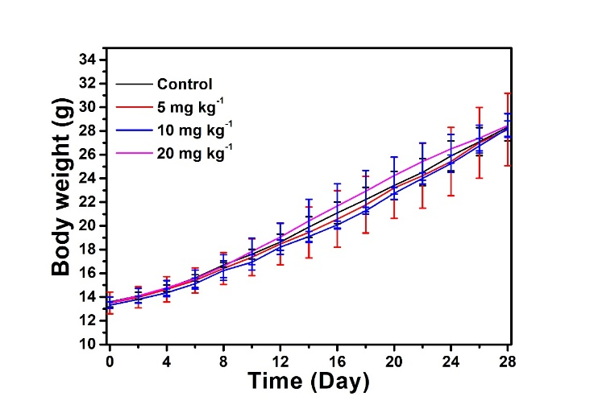
Fig. S11 Time-dependent body-weight changing profiles of BALB/c mice within 30 days after intravenous administration of GPT NPs at elevated doses (0, 5, 10, and 20 mg kg⁻¹).

Fig. S12 Liver function indexes (by measuring the serum levels of ALT, AST, and ALP) of BALB/c mice after single intravenous injection of GPT NPs at elevated doses (0, 5, 10, and 20 mg kg⁻¹) for 30 days feeding.

Fig. S13 Kidney function indexes (by measuring the serum levels of BUN and CR) of BALB/c mice after single intravenous injection of GPT NPs at elevated doses (0, 5, 10, and 20 mg kg⁻¹) for 30 days feeding.

Fig. S14 Hematological white blood cells analyses (by measuring the serum levels of WBC, LYM, MON, and GRAN) of BALB/c mice after single intravenous injection of GPT NPs at elevated doses (0, 5, 10, and 20 mg kg⁻¹) for 30 days feeding.
Fig. S15 Hematological platelets analyses (by measuring the serum levels of PLT, MPV, PCT, and P-LCR) of BALB/c mice after single intravenous injection of GPT NPs at elevated doses (0, 5, 10, and 20 mg kg⁻¹) for 30 days feeding.

Fig. S16 Hematological hemoglobin and red blood cells analyses (by measuring the serum levels of RBC, HGB, HCT, and MCV) of BALB/c mice after single intravenous injection of GPT NPs at elevated doses (0, 5, 10, and 20 mg kg⁻¹) for 30 days feeding.

Fig. S17 Hematological red blood cells analyses (by measuring the serum levels of MCH, MCHC, RDW-SD, and RDW) of BALB/c mice after single intravenous injection of GPT NPs at elevated doses (0, 5, 10, and 20 mg kg⁻¹) for 30 days feeding.

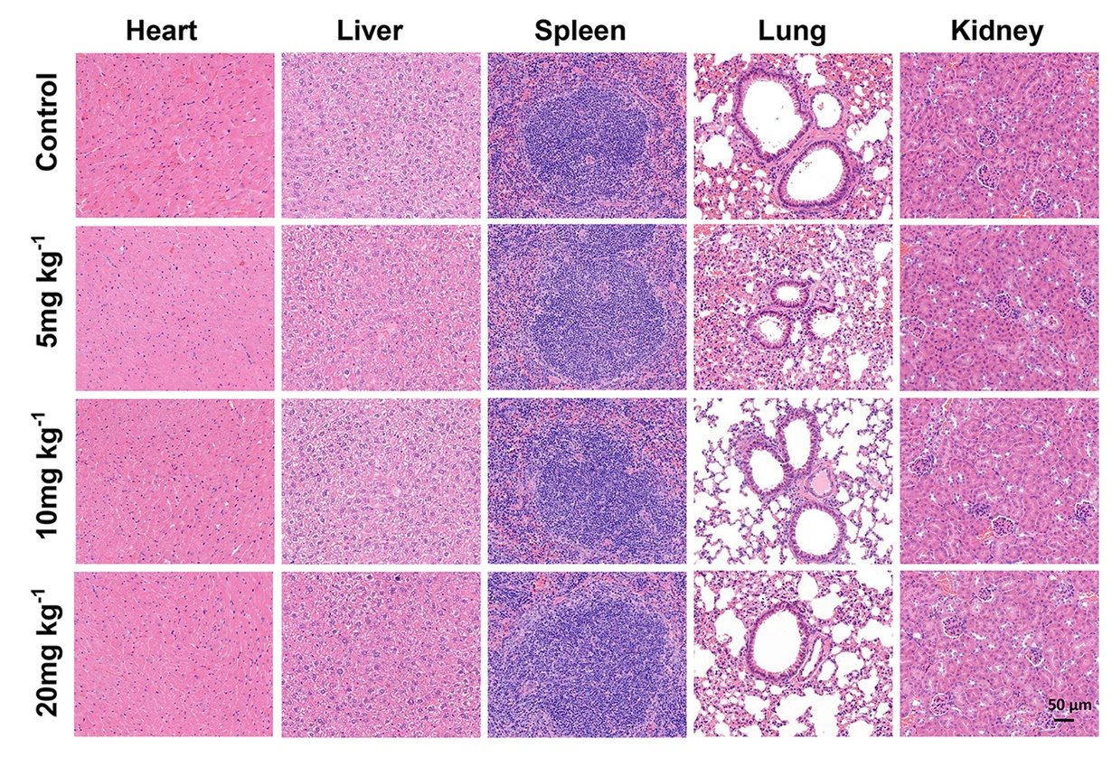

Fig. S18 H&E-stained tissues sections from BALB/c mice to monitor the histological changes in the heart, liver, spleen, lung, and kidney at 30th days after a single intravenous injection of GPT NPs (0, 5, 10, and 20 mg kg⁻¹). All images share the same scale bar of 50 μm.

