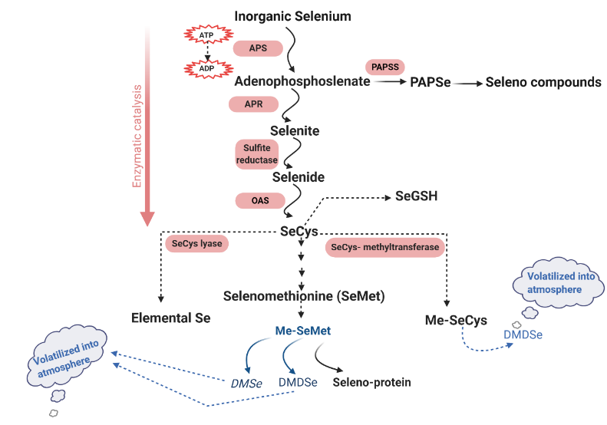
Fig. S1. Selenium pathway in plants.

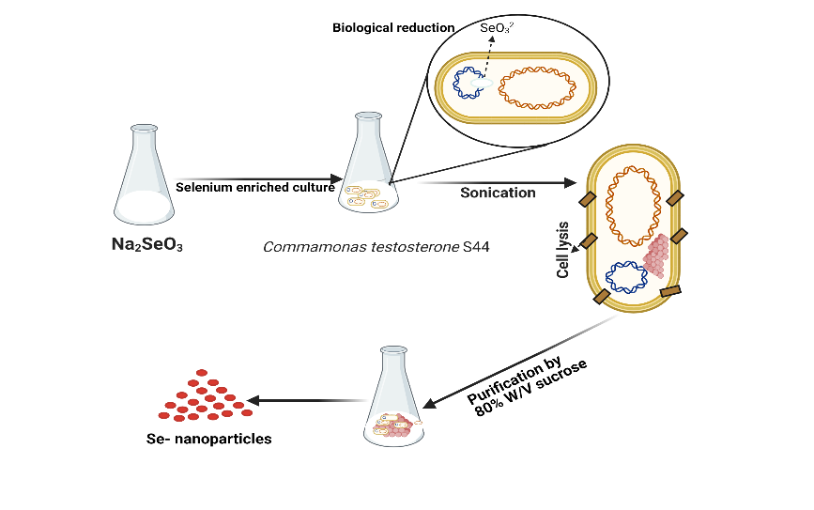
Fig. S2. Preparation and purification of nano selenium (SeNPs).

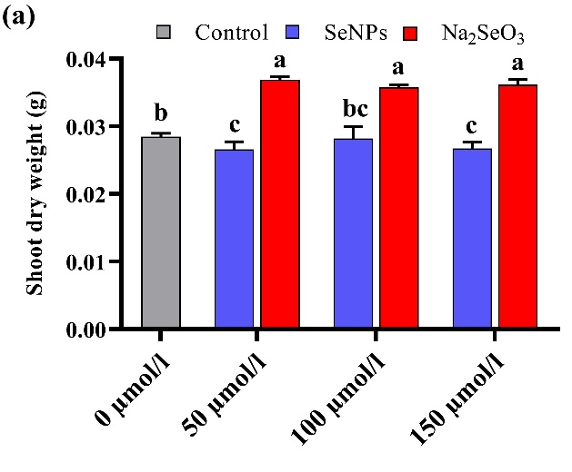 | 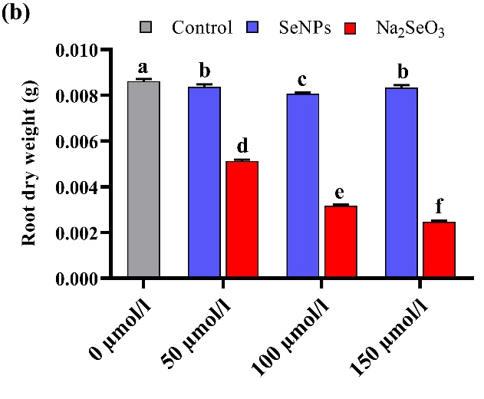
Fig. S3. Effect of different concentrations of SeNPs and Na₂SeO₃ (0, 50, 100 and 150 µmol/L) on (a) shoot dry weight (g) and (b) root dry weight (g) on rapeseed seedlings. Bars represent ± SE of three replicates. The difference in letters indicates significant differences at (P < 0.05) using Duncan's multiple range tests.

Fig. S4. (a): Heat map, and A Pearson’s correlation of (b): SeNPs and (c) Se (IV) showing the effects of different doses of SeNPs and Se (IV) (0, 50, 100, and 150 µmol/L) on the morphophysiological parameters in the seedling of rapeseed. Color scale corresponds to the logarithmic transformation of measured values (higher levels are shown in blue, lower levels in red and intermediate levels in dark colors for both blue/red). FG%: final germination percentage; GR: germination rate; VI (I): vigor index I; VI (II): vigor index II; ShL: shoot length; RL: root length; ShFW: shoot fresh weight; RFW: root fresh weight; ShDW: shoot dry weight; RDW: root dry weight; Chl a: chlorophyll a; Chl b: chlorophyll b; TC: total chlorophyll; C: carotenoid contents; TSS: total soluble sugar; TP: total protein; MDA: Lipid peroxidation; P: proline content; SOD: super oxidase dismutase activity; POD: peroxidase activity; CAT: catalase activity; APX: ascorbate peroxidase and GR: glutathione reductase.

Fig. S5. Impacts of selenium treatments on (a) shoot dry weight (g), and (b) root dry weight (g) on Yangyou 9 under two concentrations of salt stress during the early seedling stage. Bars represent ± SE of three replicates. The different letters indicate significant differences at (P < 0.05) using Duncan's multiple range tests.

Shoot dry weight was increased by 36.21 and 33.98% in NaCl treatment under 150 and 200 mM, respectively. However, under 150 µmol L⁻¹, bioSeNPs increased the shoot dry weight by 0.15% (150 mM) and 1.29% (200 mM), while Se (IV) improved it by 4.20% (150 mM) over the NaCl (Fig. S5a). Root dry weight was decreased by 43.52 and 58.90% in NaCl treatment under 150 and 200 mM, respectively. 150 µmol L⁻¹ of Se decreased the root dry weight by 6.04 and 68.64% (150 mM), 1.93 and 65.77% (200 mM) under bioSeNPs and Se (IV), respectively versus seedling treated with NaCl alone (Fig. S5b).

Table S1. Sequences of primers used in this study
No. | Abbreviation | Gene name | F | R
Antioxidant related genes
1 | SOD | Superoxide dismutase | ACGGTGTGACCACTGTGACT | GCACCGTGTTGTTTACCATC
2 | POD | Peroxidase | ATGTTTCGTGCGTCTCTGTC | TACGAGGGTCC- GATCTTAGC
3 | CAT | Catalase | TCGCCATGCTGAGAAGTATC | TCTCCAGGCTCCTTGAAGTT
4 | APX | Ascorbate peroxidase | ATGAGGTTTGA CGGTGAGC | CAGCATGGGAGATGGTAGG
5 | GR | Glutathione reductase | AAGCTGGAGCTGTGAAGGTT | AGACAGTGTTCGCAAAGCAG
1 | E3-MUL1 | E3 ubiquitin-protein ligase MUL1 | TGCTGGCATCCTTGGCTTTGC | TGCGCTGGTCTCTGCTCGAC
2 | CTP | CTP synthase (glutamine metabolic process) | TGATGAGAGACACCGGCACAGA | CCATACGACGCCCAGTCCCA
3 | LBD16 | LOB domain-containing protein 16 | CGTCAGCCGCCGAAGGTACT | GCTCTGTGGCGAGACCGGAT
4 | SULT1A | Aryl sulfotransferase | CCAGCTCAAGAGACTTGCGGAGT | GGCTACGCAGGGAGCAGAGC
5 | SOX | Sulfite oxidase | TGGTCCTCAAGGAGACCGCAA | CCCGCCCACCTCCAGAAACC
6 | Aat | Aspartate aminotransferase | AGGCCACTGCTGAGCTGCTT | AGCCGCTGCTAACCGCAGTG
7 | GST-12 | glutathione S-transferase 12 | GCCTGGCCGTCCAAGCTTTC | CCATCCTCCCGGCGTCATCC
8 | Trx1 | Thioredoxin 1 | GCAGACATCGACGAATGCCCTGA | GCCAAAGACGATCACGGAGCCT
9 | E2 | ubiquitin-conjugating enzyme E2 | TGGTCCCAACGATGAGTCTCCTG | TCTCACACACCGGCTCACCT
10 | ABCC1 | ATP-binding cassette, subfamily B (MDR/TAP), member 1 | TGCGTGGTACGGAAGCAGGT | GCCGTCCCTAGAGAAAGGCCACT
11 | E3-RNF13 | E3 ubiquitin-protein ligase RNF13 | CGTCGCCGTCGCAGAGATCA | CAGGCGACGCATTGCTCGGA
12 | PRt5 | 26S proteasome regulatory subunit T5 | ACAGGGAAGTGCAGCGGACTA | ACGCATCAGTGCTGGGTCCAA
13 | APR | Adenylyl sulfate reductase | TTGAGGCGTGCGCTCAAGGG | CAGCTCCGCCGTCCAAACCT
14 | Sulfur1;2 | Sulfate transporter 1;2 (high-affinity) | AATCGGACCCGTCGCTGTGG | ACGTGGCGGTGAAGGCAAGT
15 | PLR1 | pyridoxine 4-dehydrogenase | ACCGCAAACTACGCGCCTCT | TGACTCCAACAGCTCGAACTAGCC
16 | metB (CγS) | cystathionine gamma-synthase | TGTGGCCCACTGAAGGTGGT | AGGTACGCTGCGTTCGGGTT
17 | metE (MET) | 5-methyltetrahydropteroyl-triglutamate-homocysteine methyltransferase | CCACCGCTATGCTCGGTGCT | CCATGGCTGGAACAGAGGCGTT
18 | metC (CBL) | cystathionine beta-lyase | TGGGAATCCTACACGGGATGCAC | AGCAGCAAGAGCAGCCATTCCA
19 | CYSK | cysteine synthase A | GGGAAACACTGGCCTCGGGAT | CCGCTCCTAGCGCGCGTAAA
20 | SL | selenocysteine lyase | TGTGGAGGGACTGCACCCAA | GCGCAGTGGTGTCCTGACCT
21 | GST-U4 | glutathione S-transferase tau 4 | TCGGCGGCAAGACAATCGGA | TTCCCAAGCCCGAGCTACGC
22 | PAPSS | 3′-phosphoadenosine 5′-phosphosulfate synthase | ATCCGCGCCGGACTCATCTC | GCTTCTTCTCCCGCCGTCGT
23 | CYSE | serine O-acetyltransferase | CCGACGTCGAGCAAGAACCCA | TGTTCGCCAAAGCGGAGTCCA
24 | VHA-a2 | V-type H+-transporting ATPase subunit I | TGCCGTGATGCCTCTTGCAGT | TGCGGGTACCATGCCACACA
25 | AtGoLS3 | galactinol synthase 3 | TCGCCGGGAACGGTGACTAC | GGTGATCCACCGGCACGTCT
26 | XET | xyloglucan: xyloglucosyl transferase | GCGACGTCAACGTGGCTTGG | GGTGAGAGTAAGAAGCTGGCCGTT
27 | SUlT1a | Aryl sulfotransferase | CCAGCTCAAGAGACTTGCGGAGT | GGCTACGCAGGGAGCAGAGC
28 | ABCC2 | ATP-binding cassette, subfamily C (CFTR/MRP), member 2 | TGGAGTTCGGGTGGCTGTCC | ATCAACACCGGCGTGCTCCA
29 | TUB | tubulin beta | CCAGCTCGAGCGCATCAACG | GGGCGGAAGGTCTGACCGTAG
30 | Actin | Actin | TTGGGATGGACCAGAAGG | TCAGGAGCAATACGGAGC

