Novel approach to enhance Bradyrhizobium diazoefficiens nodulation through continuous induction of ROS by manganese ferrite nanomaterials in soybean

Jun Ma ¹, Yi Zhou ¹, Jiaying Li ¹, Zhiyong Song^{2*} and Heyou Han ^{1, 2*}

¹State Key Laboratory of Agricultural Microbiology, College of Life Science and Technology, Huazhong Agricultural University, No. 1Shizishan Street, Hongshan District, Wuhan, Hubei 430070, China.
²State Key Laboratory of Agricultural Microbiology, College of Science, Huazhong Agricultural University, No. 1 Shizishan Street, Hongshan District, Wuhan, Hubei 430070, China.
* Corresponding authors :
E-mail addresses: songzhiyong@mail.hzau.edu.cn
E-mail addresses: hyhan@mail.hzau.edu.cn

Material Characterization.
MF-NPs (Purity: 99.5%, APS: 40 nm) and M-NPs (Purity: 99.9%, APS: 50 nm,) were purchased from Shanghai Bike New Material Technology Co., Ltd.（China; F-NPs (Purity: 98.0%, APS: 50 nm) from Aladdin Reagent Co., Ltd. (Shanghai, China); FeCl₂ and MnCl₂ (analytical purity) from Sinopharm Chemical Reagent Co., Ltd. (Shanghai, China). The properties of these materials were further determined by dissolving them in pure water and ultrasonication for 20 min to determine their particle size, electric potential and infrared spectra. The same samples were also analyzed by projection electron microscopy and scanning electron microscopy. SEM analysis was performed using a Zeiss Sigma300 (with Gemini lens) microscope operating at 100 Kv. The element valence of MF-NPs was analyzed by X-ray photoelectron spectroscopy (XPS) using an Thermo ESCALAB 250XI, and their hydrodynamic sizes and electric potential were measured using a dynamic light scattering instrument (Malvern).
O₂ Generation Assay.
The O₂ generation was tested as previously reported with some modifications.[1] Briefly, a total of 1M H₂O₂ was mixed separately with MF-NPs, F-NPs, M-NPs, F-NPs+ M-NPs, MnCl₂ or FeCl₂ in 20 mL of PBS at room temperature, followed by measuring the O₂ concentration every 5 min using a dissolved oxygen meter (JPBJ-608). To observe O₂ bubbles in an Eppendorf tube, 1M of H₂O₂ was mixed separately with MF-NPs, F-NPs, M-NPs, F-NPs+ M-NPs, MnCl₂ and FeCl₂ and monitored until 30 min.

Search for related functional genes
KEGG（Kyoto Encyclopedia of Genes and Genomes）, NR（Non-Redundant Protein Sequence Database）, SwissProt, TrEMBL, KOG (eukaryotic orthologous groups), GO (gene ontology) and Pfam（the protein families database）database were used to search for related DEGs, the specific use method is described in the literature reports[2-7].

Total ROS detection
The total ROS was detected by measuring the green fluorescent intensity of the cell-permeable fluorogenic dye 2’,7’-dichlorofluorescin diacetate (DCFH-DA). Briefly, a certain amount of fresh root was weighed into a centrifuge tube, followed by adding DCFH-DA and grinding into homogenate. Finally, the solution was vortexed and centrifuged, followed by measuring the fluorescence intensity. DCFH-DA was excited at 488 nm and emitted at 525 nm.

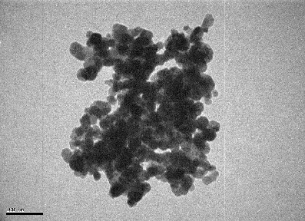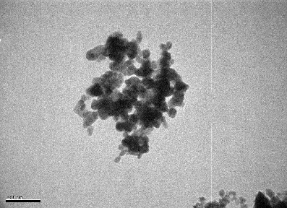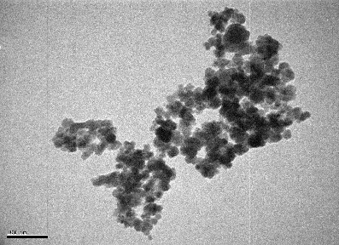
(a) （b） (c)
Fig. S1 TEM images of (a) MF-NPs, (b) M-NPs, and (c) F-NPs.

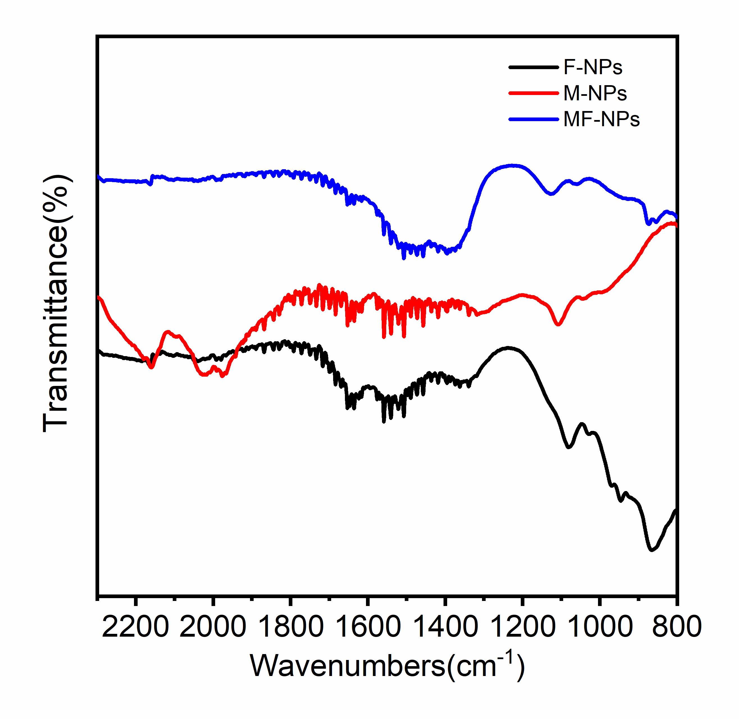
Fig. S2 Fourier transform infrared (FTIR) spectra of F-NPs, M-NPs and MF-NPs.

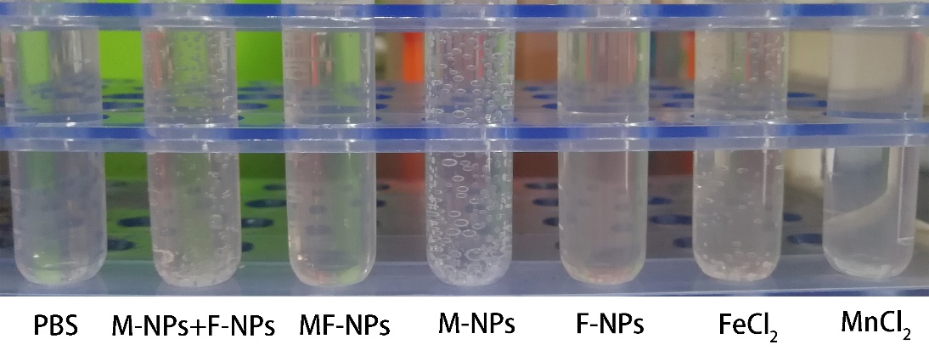

Fig. S3 Comparison of the efficiency of oxygen production induced by different materials.

Fig.S4 Ultraviolet scan curve of MB fading at different reaction time points in the presence of NPs and CMs.

Fig. S5 Aboveground phenotypic images of soybean matrix treated with different NPs.

Fig. S6 Plant height of soybean under exposure to different materials. The significance levels were determined at *P < 0.05, **P < 0.01, and ***P < 0.001.
Fig. S7 Stem diameter of soybean under exposure to different materials. The significance levels were determined at *P < 0.05, **P < 0.01, and ***P < 0.001.
Fig. S8 Phenotypic image of root system of soybean matrix treated with different NPs.

Fig. S9 Root length of soybean matrix treated with different NPs. The significance levels were determined at *P < 0.05, **P < 0.01, and ***P < 0.001.

Fig. S10 Total biomass of soybean under exposure to different NPs. The significance levels were determined at *P < 0.05, **P < 0.01, and ***P < 0.001.
Fig. S11 Number of soybean nodules under exposure to different NPs. The significance levels were determined at *P < 0.05, **P < 0.01, and ***P < 0.001.
Fig. S12 Weight of soybean nodules under exposure to different NPs. The significance levels were determined at *P < 0.05, **P < 0.01, and ***P < 0.001.
Fig.S13 Quantitative analysis of total ROS in root (n=5).

Fig. S14 Numbers of differentially expressed genes (DEGs) detected in the three developmental stages; red indicates genes with significant up-regulation; green indicates genes with significant down-regulation; blue indicates genes with no significant change in expression.
a b c
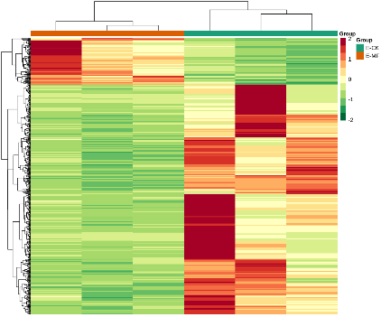 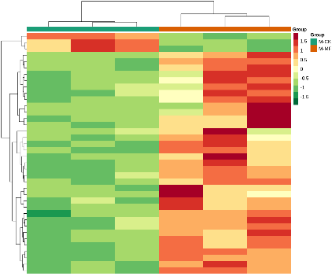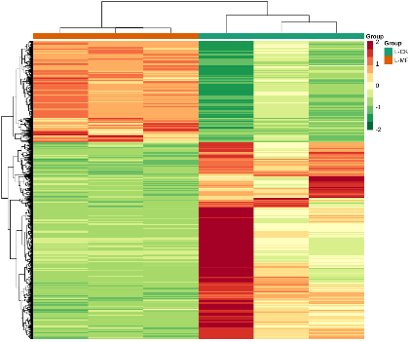 Early Middle Late
Fig. S15 Heat map of cluster analysis of differentially expressed genes in the three different developmental stages.

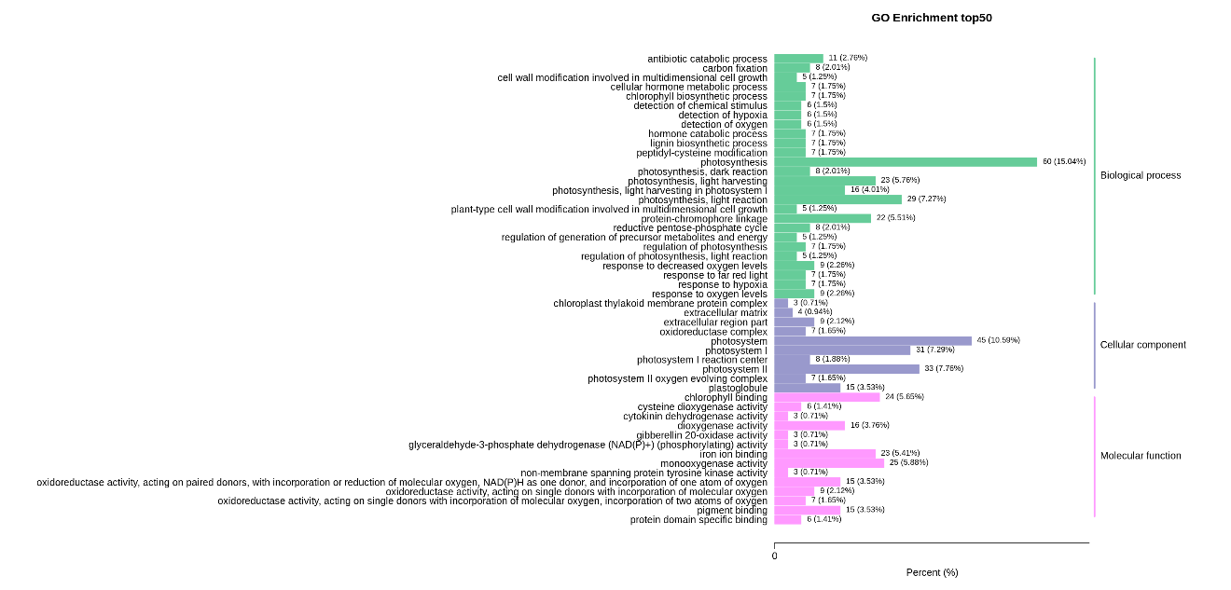
Fig. S16 GO enrichment histogram of differentially expressed genes (early stage)

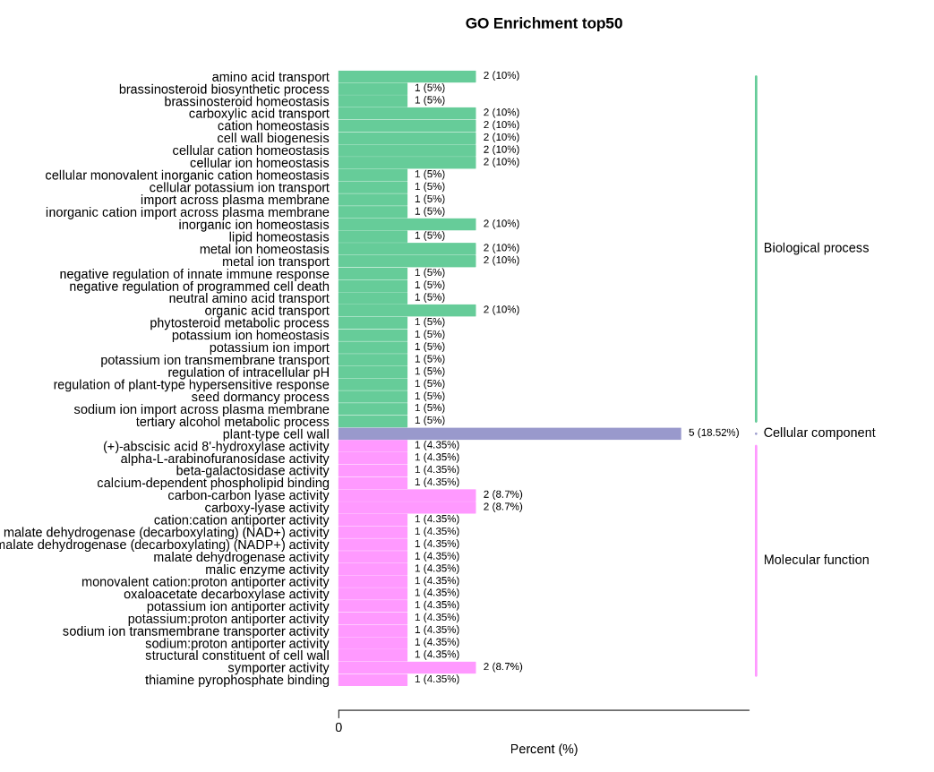
Fig. S17 GO enrichment histogram of differentially expressed genes (middle stage)

Fig. S18 Directed acyclic graph (DAG) of enriched GO entries (late stage).
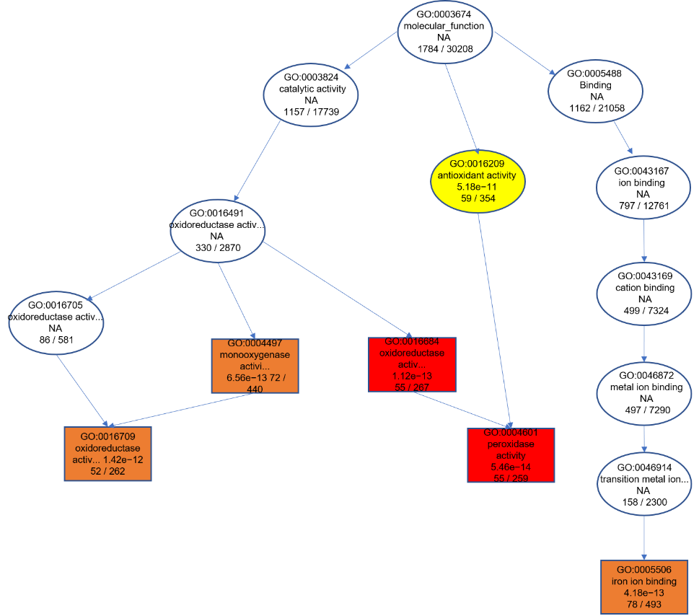

Fig. S19 Directed acyclic graph (DAG) of enriched GO entries for changes in the ROS metabolism (late stage).

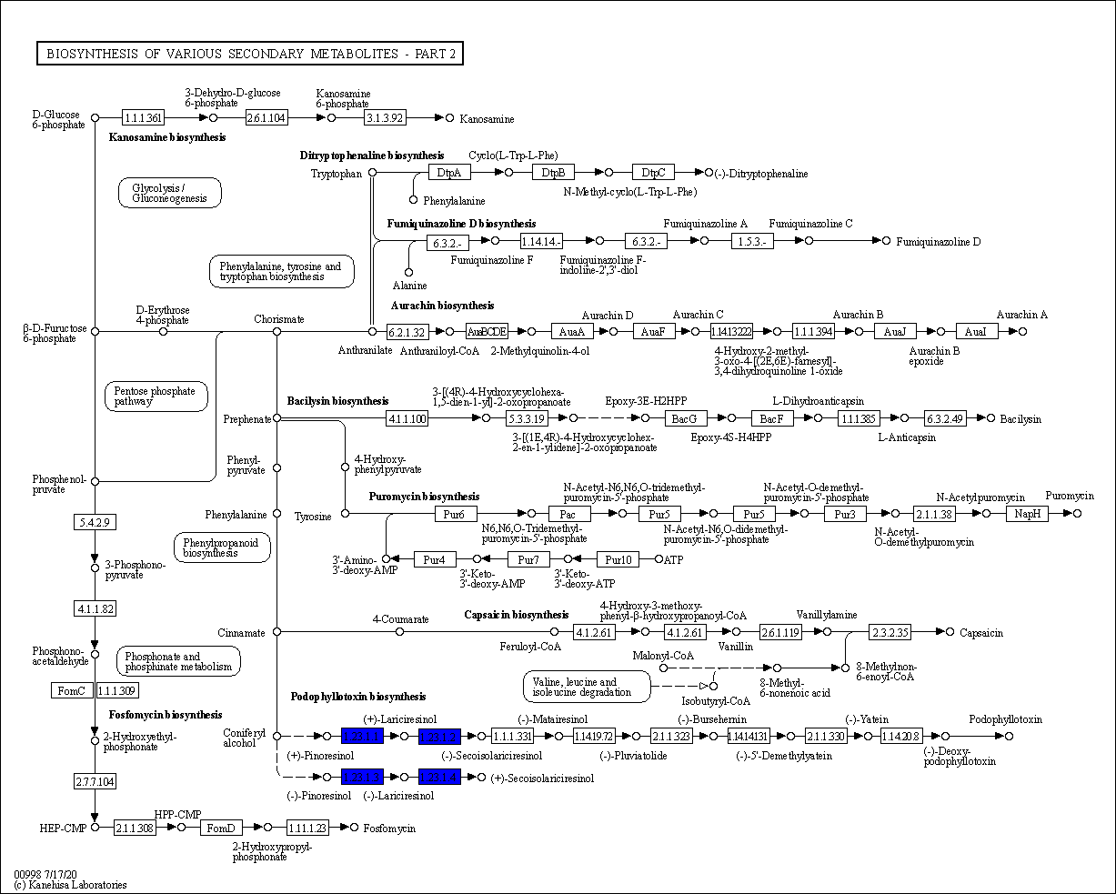

Fig. S20 KEGG pathway of biosynthesis of various secondary metabolites - part 2 in response to MF-NPs treatment.

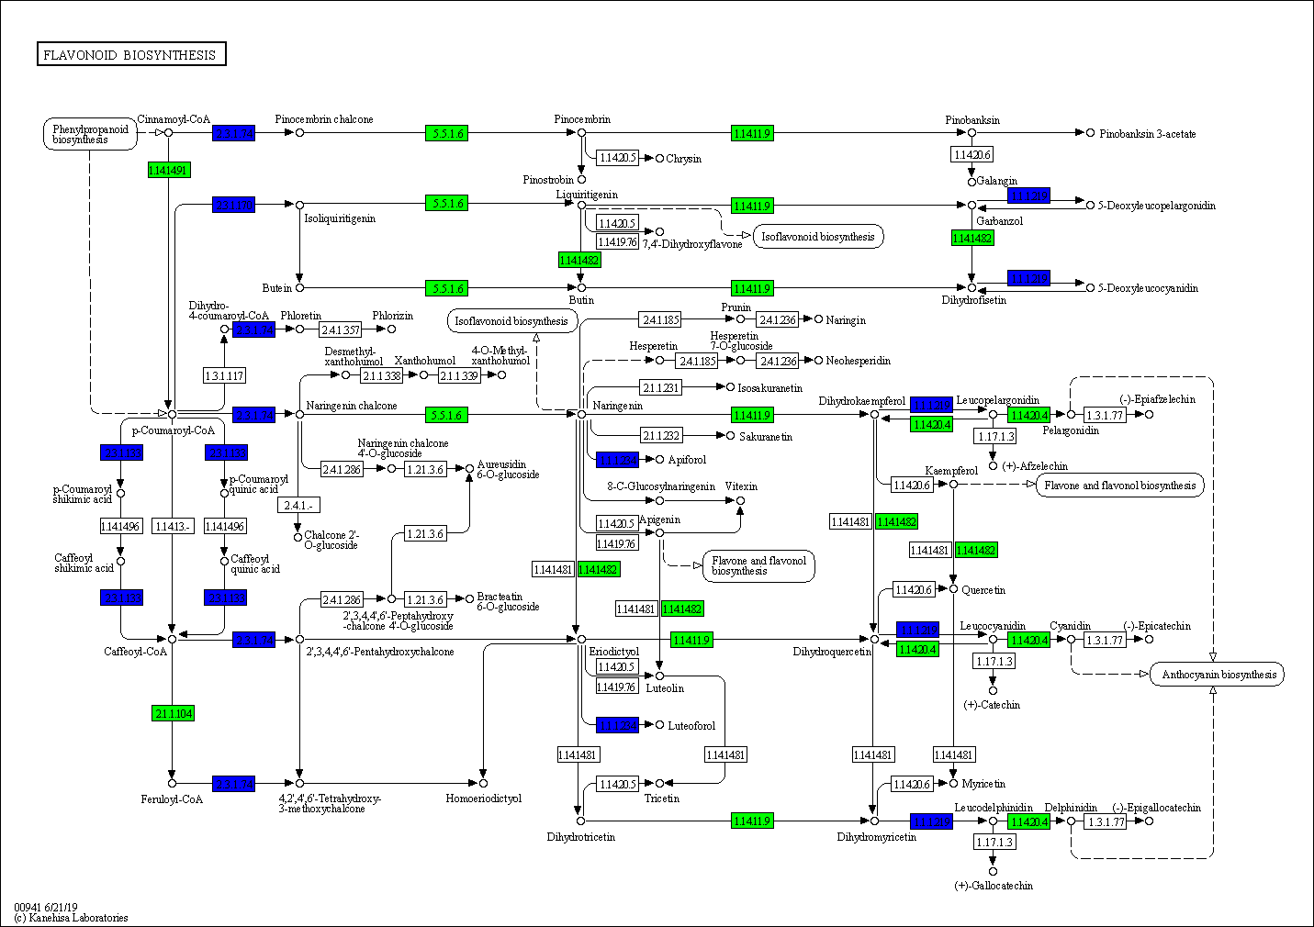
Fig. S21 KEGG pathway of flavonoid biosynthesis in response to MF-NPs treatment.

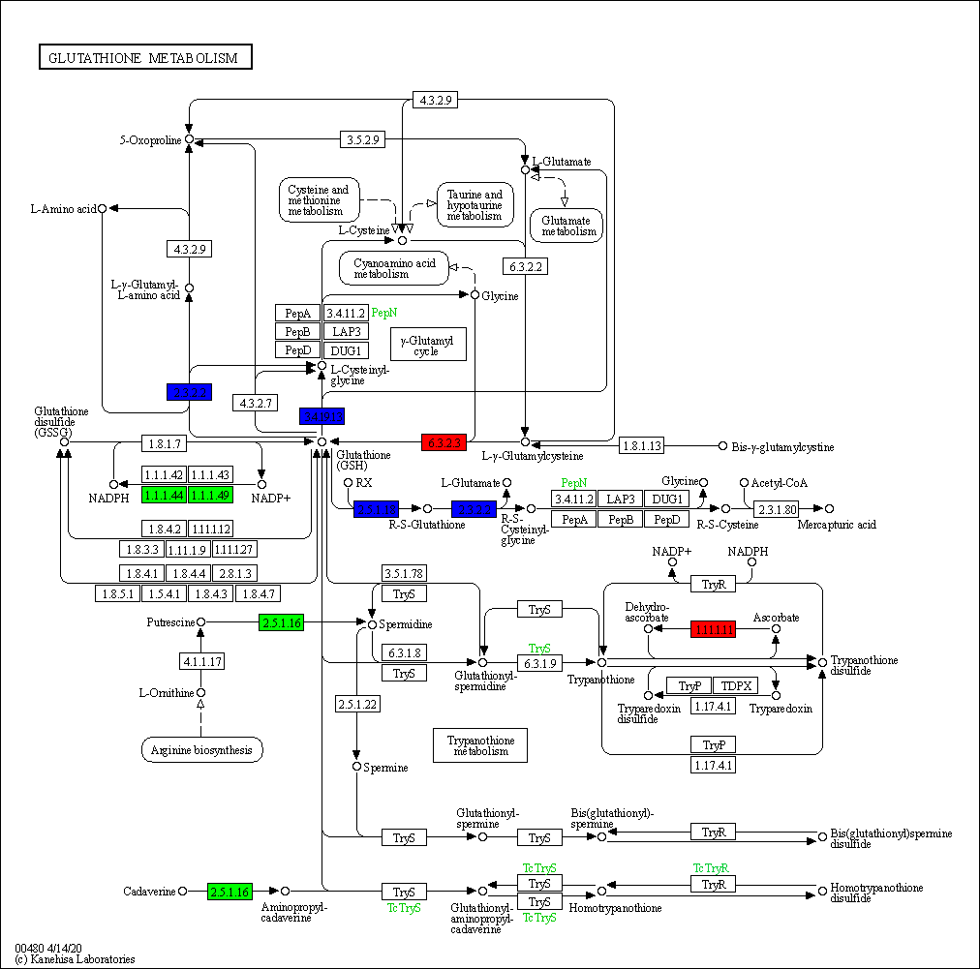

Fig. S22 KEGG pathway of glutathione metabolism in response to MF-NPs treatment.
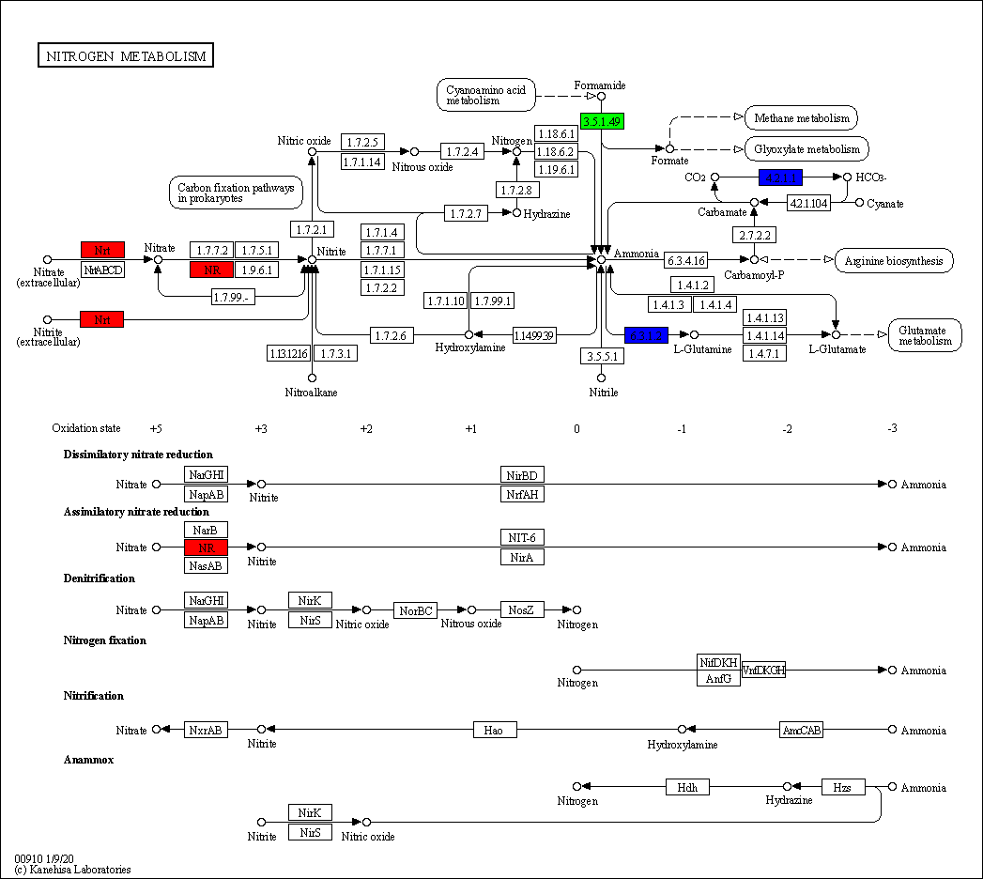

Fig. S23 Kyoto Encyclopedia of Genes and Genomes (KEGG) pathway of nitrogen metabolism in response to MF-NPs treatment.

Fig. S24 Standard curve of nitrogenase activity detection.

Supplementary Table S1. The elemental content of NPs
NPs | Element | Atomic percentage
MnO₂ | O K | 59.88
MnO₂ | Mn K | 40.12
Fe₂O₃ | O K | 47.86
Fe₂O₃ | Fe K | 50.14
MnFe₂O₄ | O K | 59.52
MnFe₂O₄ | Mn K | 10.84
MnFe₂O₄ | Fe K | 29.64

Supplementary Table S2 Expression of nodulation related (Nod-R) genes in the roots in response to MF-NPs treatment.
Gene ID | Symbol | Up/Down Regulation
ENOD55-2 | hypothetical protein GLYMA-17G073400 | up
ENOD93 | early nodulin-93 | up
LBA | leghemoglobin A | up
LBC1 | leghemoglobin C1 | up
LBC2 | leghemoglobin C2 | up
LBC3 | leghemoglobin C3 | up
LOC100306363 | uncharacterized protein LOC100306363 | down
LOC100527563 | uncharacterized protein LOC100527563 isoform X1 | up
LOC100776166 | probable 2-isopropylmalate synthase | up
LOC100778148 | probable 2-isopropylmalate synthase | up
LOC100784860 | early nodulin-55-1 precursor | up
LOC100791523 | nodulin-21-like | up
LOC100792407 | nodulation-signaling pathway 2 protein-like | up
LOC100803042 | chitin elicitor receptor kinase 1-like isoform X1 | up
LOC100807538 | probable 2-isopropylmalate synthase | up
LOC100816317 | nodulation-signaling pathway 2 protein-like | down
LOC100817841 | early nodulin-70-like | up
LOC100819730 | sucrose synthase-like | down
LOC100820292 | uncharacterized protein LOC100820292 | down
LOC100820501 | putative E3 ubiquitin-protein ligase LIN-1 isoform X1 | down
LOC106795450 | probable 2-isopropylmalate synthase | up
LOC106796780 | nodulin-16-like isoform X2 | up
LOC547522 | hypothetical protein GLYMA-06G065600 | up
LOC547914 | nodulin-24-like | up
N-20 | hypothetical protein GLYMA-13G328800 | up
N-21 | nodulin-21 | up
N-22 | nodulin-22 precursor | up
N-23 | nodulin-C51 precursor | up
N-24 | nodulin-24 precursor | up
N-26 | nodulin-26 | up
N-26B | nodulin-26B precursor | up
N-36A | early nodulin-36A | up
N-44 | nodulin-44 | up
N-70 | early nodulin-70 isoform X1 | up
NGM-16 | nodulin-16 isoform X1 | up
UR9 | uricase-2 isozyme 1 | up

Supplementary Table S3 Expression of flavonoid related (Fla-R) genes in the roots in response to MF-NPs treatment.
Gene ID | Symbol | Up/Down Regulation
CHI1A | chalcone--flavonone isomerase 1A | down
CHI1B2 | chalcone--flavonone isomerase 1B-2 | down
CHS3 | chalcone synthase 3 | down
CHS5 | chalcone synthase 5 | down
CHS6 | chalcone synthase 6 | down
CHS7 | chalcone synthase 7 | down
CHS8 | chalcone synthase | down
CHS9 | chalcone synthase 1 | down
GMACHS1 | chalcone synthase 1 | down
GMCHI4A | chalcone isomerase 4-like | down
GMCHR | NAD(P)H-dependent 6'-deoxychalcone synthase isoform X1 | down
HIDH | 2-hydroxyisoflavanone dehydratase | down
LOC100194416 | vestitone reductase | down
LOC100500657 | uncharacterized protein LOC100500657 | down
LOC100527374 | uncharacterized protein LOC100527374 precursor | down
LOC100527469 | uncharacterized protein LOC100527469 | up
LOC100775264 | chalcone synthase J-like | up
LOC100778253 | uncharacterized protein LOC100778253 | down
LOC100779649 | chalcone synthase 5-like | down
LOC100783009 | 1-aminocyclopropane-1-carboxylate oxidase 1-like | down
LOC100784518 | leucoanthocyanidin dioxygenase-like | down
LOC100785409 | alpha/beta-hydrolases superfamily protein | down
LOC100785554 | chalcone synthase 6-like | down
LOC100788048 | chalcone synthase 6-like | down
LOC100789075 | chalcone synthase 3 | down
LOC100790480 | flavonoid 3'-monooxygenase-like | down
LOC100792581 | chalcone synthase 5-like | down
LOC100793687 | uncharacterized protein LOC100793687 | down
LOC100794125 | flavonol synthase/flavanone 3-hydroxylase-like | down
LOC100794209 | uncharacterized protein LOC100794209 | down
LOC100795616 | HXXXD-type acyl-transferase family protein | down
LOC100798122 | transcription factor EGL1 isoform X1 | up
LOC100800931 | NAD(P)H-dependent 6'-deoxychalcone synthase-like | down
LOC100803345 | myb-related protein Myb4-like | down
LOC100805464 | 1-aminocyclopropane-1-carboxylate oxidase 5-like | down
LOC100805689 | cytochrome P450 711A1-like | down
LOC100807814 | pathogenesis-related protein 5-like | up
LOC100808297 | cytochrome P450 711A1-like | down
LOC100809662 | leucoanthocyanidin dioxygenase | down
LOC100815855 | ribonuclease S-2-like | down
LOC100816155 | anthocyanidin 3-O-glucosyltransferase 7-like | up
LOC100816546 | hypothetical protein GLYMA-09G107100, partial | down
LOC100817818 | ribonuclease 1-like isoform X1 | down
LOC100820161 | NAD(P)H-dependent 6'-deoxychalcone synthase-like | down
LOC106794283 | chalcone synthase 3 | down
LOC547660 | hypothetical protein GLYMA-18G220600 | down
MYB92 | MYB transcription factor MYB92 | down

Supplementary Table S4 Expression of reactive oxygen species related (ROS-R) genes in the roots in response to MF-NPs treatment.
Gene ID | Symbol | Up/Down Regulation
GMIPER1 | peroxidase, pathogen-induced precursor | down
INR2 | inducible nitrate reductase [NADH] | up
LOC100527587 | peroxidase 7-like protein precursor | down
LOC100775837 | peroxidase 12-like | down
LOC100775970 | peroxidase 3-like | down
LOC100776019 | peroxidase superfamily protein | down
LOC100777390 | peroxidase 12-like, partial | down
LOC100777463 | peroxidase 19 | up
LOC100782791 | putative L-ascorbate peroxidase 6 | up
LOC100785662 | peroxidase 3-like | down
LOC100786765 | peroxidase 10-like | down
LOC100787073 | uncharacterized protein LOC100787073 precursor | down
LOC100790188 | peroxidase 5-like | down
LOC100790910 | cationic peroxidase 1-like | down
LOC100791014 | peroxidase 66-like | down
LOC100792351 | peroxidase 5-like | down
LOC100794128 | cationic peroxidase 1-like | up
LOC100796311 | peroxidase 5-like | down
LOC100797524 | aspartic proteinase CDR1-like | up
LOC100797875 | probable peroxidase 26 | down
LOC100798064 | aspartic proteinase CDR1-like | down
LOC100799162 | cationic peroxidase 1-like | down
LOC100806595 | peroxidase 3-like | down
LOC100799691 | peroxidase 3-like | down
LOC100799894 | cationic peroxidase 1-like | down
LOC100800520 | hypothetical protein GLYMA-08G097300 | up
LOC100802035 | peroxidase P7-like | down
LOC100803619 | peroxidase P7-like | down
LOC100804126 | peroxidase 12 | down
LOC100804765 | uncharacterized protein LOC100804765 precursor | down
LOC100804829 | unknown | down
LOC100805171 | peroxidase 10-like | up
LOC100806700 | uncharacterized protein LOC100806700 precursor | down
LOC100808542 | peroxidase 16-like | down
LOC100810392 | peroxidase P7 | down
LOC100811634 | cationic peroxidase 1-like | down
LOC100811634 | cationic peroxidase 1-like | down
LOC100812082 | peroxidase 55-like | down
LOC100812309 | uncharacterized protein LOC100812309 precursor | down
LOC100812820 | peroxidase P7-like | down
LOC100812961 | peroxidase 10-like | down
LOC100813471 | putative nitrate reductase 1 | down
LOC100814067 | peroxidase P7 | down
LOC100814964 | peroxidase N-like | down
LOC100815142 | cationic peroxidase 1-like | down
LOC100815350 | peroxidase 5-like | down
LOC100815671 | uncharacterized protein LOC100815671 precursor | down
LOC100815708 | peroxidase 10 | down
LOC100817540 | uncharacterized protein LOC100817540 precursor | down
LOC100817743 | L-type lectin-domain containing receptor kinase IX.1-like | down
LOC100818176 | cationic peroxidase 1-like | down
LOC100819100 | probable arabinosyltransferase ARAD1 | up
LOC100820410 | probable peroxidase 26 | down
LOC102663236 | peroxidase P7-like | down
LOC102668893 | L-type lectin-domain containing receptor kinase IX.2-like isoform X1 | up
LOC102670034 | peroxisomal (S)-2-hydroxy-acid oxidase GLO1-like | up
LOC106796332 | peroxidase A2-like | down
LOC111064645 | peroxidase family protein precursor | down
LOC112997600 | hypothetical protein GLYMA-15G128800 | down
LOC112997743 | uncharacterized protein LOC100814455 | down
PRX4 | peroxidase precursor | down
References
1. Kim J, Kim HY, Song SY, Go SH, Sohn HS, Baik S, Soh M, Kim K, Kim D, Kim HC. Synergistic oxygen generation and reactive oxygen species scavenging by manganese ferrite/ceria co-decorated nanoparticles for rheumatoid arthritis treatment. ACS Nano. 2019;13:3206-3217.
2. Kanehisa M, Goto S. KEGG: kyoto encyclopedia of genes and genomes. Nucleic acids res. 2000;28:27-30.
3. Bagheri H, Dyer R, Severin A, Rajan H. Comprehensive analysis of non redundant protein database. 2020.
4. Boeckmann B, Bairoch A, Apweiler R, Blatter MC, Estreicher A, Gasteiger E, Martin MJ, Michoud K, O'Donovan C, Phan I. The SWISS-PROT protein knowledgebase and its supplement TrEMBL in 2003. Nucleic acids res. 2003; 31:365-370.
5. Li L, Stoeckert CJ, Roos DS. OrthoMCL: identification of ortholog groups for eukaryotic genomes. Genome res. 2003;13:2178-2189.
6. Consortium GO.The Gene Ontology (GO) database and informatics resource. Nucleic acids res. 2004;32:D258-D261.
7. Finn RD, Bateman A, Clements J, Coggill P, Eberhardt RY, Eddy SR, Heger A, Hetherington K, Holm L, Mistry J. Pfam: the protein families database. Nucleic acids res. 2014;42:D222-D230.

