[Additional Information]
Structure based innovative approach to Analyze
Aptaprobe-GPC3 complexes in Hepatocellular Carcinoma

Woo-Ri Shin^{1,‡}, Dae-Young Park^{1,‡}, Ji Hun Kim^{2,‡}, Jin-Pyo Lee¹, Nguyen Quang Thai¹, In-Hwan Oh¹, Simranjeet Singh Sekhon¹, Wooil Choi³, Sung Yeon Kim⁴, Byung-Kwan Cho², Sun Chang Kim², Jiho Min^{3,*}, Ji-Young Ahn^{1,*} and Yang-Hoon Kim^{1,*}

¹Department of Microbiology, Chungbuk National University
1 Chungdae-Ro, Seowon-Gu, Cheongju 28644, South Korea
²Department of Biological Sciences, Korea Advanced Institute of Science and Technology, 291 Daehak-ro, Yuseong-gu, Daejeon 34141, Republic of Korea
³Graduate School of Semiconductor and Chemical Engineering,
Jeonbuk National University, Jeonju 54896, Korea
⁴College of Pharmacy, Wonkwang University, Shinyoung-dong 344-2,
Iksan Jeonbuk 570-749, Republic of Korea

*Corresponding author:
(Phone) +82-43-261-3575
(Fax) +82-43-264-9600
(E-mail) kyh@chungbuk.ac.kr

*Co-corresponding author:
(Phone) +82-43-261-2301
(Fax) +82-43-264-9600
(E-mail) jyahn@chungbuk.ac.kr

*Co-corresponding author
(Phone) +82-63-270-2436
(Fax) +82-63-270-2306
(E-mail) jihomin@jbnu.ac.kr

*Correspondence s
hould be addressed to
Yang-Hoon Kim kyh@chungbuk.ac.kr
or Ji-Young Ahn jyahn@chungbuk.ac.kr
or Jiho Min jihomin@jbnu.ac.kr

Supplementary materials
SELEX procedure
GPC3 binding aptaprobes were selected as previously described [1]. Simply, a 100-base oligonucleotide ssDNA consisted of a 40-base randomized sequence flanked by defined primer-binding sites, a 42-base forward primer, and a 18-base reverse primer (5’-biotin-GGT AAT ACG ACT CAC TAT AGG GAG ATA CCA GCT TAT TCA ATT - random sequence - AGA TAG TAA GTG CAA TCT-3’). The initial ssDNA library and primers used to amplify were designed and prepared by Bioneer (South Korea). The starting point of each SELEX process was a synthetic random ssDNA oligonucleotide library consisting of a multitude of ssDNA fragments with different sequences.
Ten selection rounds and a negative round were performed using filter membranes. For the first round of SELEX, 40 μL (64.8 pmol) of GPC3 in 1 × PBS buffer and 60 μL of 1 × PBS buffer were mixed to make 100 μL. ssDNA aptamer pool (648 pmol) was added to 100 μL 1 × PBS buffer and denatured by heating at 85°C for 5 min. It was then structured slowly by renaturating at room temperature for 2 hours. Structured ssDNA aptamers were incubated with GPC3 at 4°C for 2 hours. GPC3 and ssDNA aptamer complexes were then filtered using a wet nitrocellulose filter (0.45 μm HA; Millipore, Billerica, MA, USA) fitted in a filter apparatus (Millipore, Billerica, MA, USA). Structured ssDNA aptamers that bound to GPC3 protein were held on the filter membrane while aptamers that failed to bind to GPC3 protein were removed with washing buffer (1 × PBS buffer). Finally, ssDNA-GPC3 complexes were recovered with 200 μL 1 × PBS by heating at 85°C for 5 min. To retrieve the binding aptamers, the binding complexes were treated with PCI followed by ethanol precipitation. Purified DNA aptamers were amplified by PCR, asymmetric PCR, and then separated by streptavidin agarose resin (Thermo scientific, USA) for the next selection round. Along with ten rounds of SELEX process, a negative selection process of ssDNA aptamers eluted from the 7th round pass through of wet nitrocellulose filter was employed to avoid selection and amplification of nonbinding ssDNA aptamers. To monitor the progression of SELEX, amounts of eluted ssDNAs were quantified with a nanodrop spectrophotometer (Thermo scientific, USA). Concentrations (ng/μL) of ssDNAs were confirmed by reading 1 μL ssDNA of each round on the sensor at 260 nm.
To further demonstrate the difference of binding ability round by round, we employed the post-SELEX and real-time PCR (RT-PCR) analysis that provided a valuable tool for validating the optimal status of ssDNA aptamer enrichment. The specific ssDNA ligands bound in each round were monitored by post-SELEX analysis of the eluted sample. The eluted ssDNA bound from 7th, 8th, 9th and 10th rounds were normalized with the same concentration and reintroduced to GPC3 for post-SELEX incubating. The recovered DNA samples from 7th, 8th, and 9th round were amplified using an optimized RT-PCR cycle and the fluorescence signal was monitored by MiniOpticonTM Real-time PCR fluorescence signal detection system (Bio-Rad, USA). PCR experiment was independently triplicated and data was analyzed to obtain the average C(t) values.

Sequencing of GPC3 protein binding ssDNA aptamers
The aptamer pool from SELEX at the 9th round which eluted the highest amount of GPC3 binding ssDNAs was amplified subsequently by PCR with unmodified primers and cloned into T-Blunt vector (T-Blunt PCR Cloning Kit, Solgent, South Korea). Ligation of amplified PCR fragments and T-Blunt vector was performed at room temperature. Ligated product was then transformed into Escherichia coli DH5α and incubated at 37°C for 1 hour. Then 200 μL aliquot of cultured product was spread onto LB agar plate containing ampicillin (100 μg/mL), IPTG (25 μg/mL), kanamycin (50 μg/mL), and X-gal (40 μg/mL) and incubated at 37°C overnight. White colonies were selected and sequenced by Solgent (Deajeon, South Korea) using appropriate primers (M13F and M13R). Sequence analysis and alignments were performed using Clustal X software.

Affinity of ssDNA aptamers to GPC3 target
Binding affinities of 12 aptamer candidates from the 9th round of selection for their target GPC3 protein were analyzed by SPR using a Biacore X100 (Biacore, AB, Sweden). To immobilize the GPC3 protein on the CM5 sensor chip (GE Healthcare, Sweden), GPC3 protein was covalently bound to activated carboxyl groups of dextran molecules via amine coupling. First, the dextran matrix was activated with 100 μL of equal mixture of 0.1 M N-hydroxysuccinimide (NHS; GE Healthcare, Sweden) and 0.4 M N-Ethyl-N’-dimethylamonipropyl carbodiimide (EDC; GE Healthcare, Sweden). The GPC3 protein was diluted 1:100 in 10 mM sodium acetate buffer (pH 3.5) and injected at 10 μL/min for 7 min. After immobilization of the GPC3 protein, any unreacted NHS esters were deactivated by injecting an excess of ethanolamine hydrochloride (pH 8.5) to remove any non-specific adsorption. Flow rate was kept at 10 μL/min throughout the experiment. HBS-EP buffer (0.01 M HEPES pH 7.4, 0.15 M NaCl, 3 mM EDTA, 0.005% v/v surfactant P20) was used as running buffer. After baseline stabilization, structured ssDNA aptamer candidates were injected to sensor surface to measure their binding affinity (KD values) of GPC3 protein binding ssDNA aptamer interaction by serially dilution at various concentrations ranging from 0 nM to 1500 nM. To elute bound aptamers from immobilized GPC3 and regenerate the chip surface using regeneration buffer (1 M NaCl, 50 mM NaOH). Following each binding experiment, the surface was regenerated with 5-25 μL of regeneration buffer until the signal reached baseline level. BIA evaluation software (GE Healthcare, USA) was used for the SPR experiments to determine the binding affinity.

Figure S1.
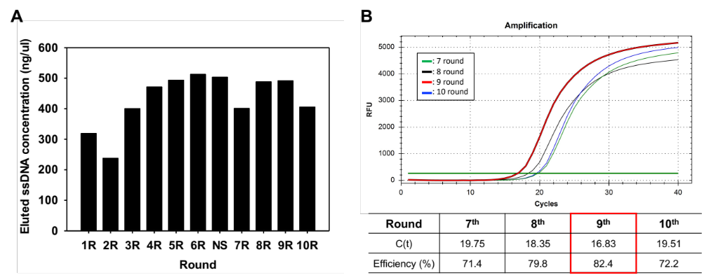
Figure S1. SELEX round eluted aptamer concentration. (A) Nano-drop results for selecting the optimal SELEX round are shown. The eluted aptamer concentration from each round was checked to select the best round. NS: negative selection step. (B) Real-time PCR amplification of post-SELEX analysis of the eluted sample for each round. Recovered aptamer pools from 7th, 8th, 9th and 10th round were amplified using an optimized RT-PCR round. Reactions and signal determination are shown. C(t) difference as a function of GPC3 aptamer concentration was analyzed.
Figure S2
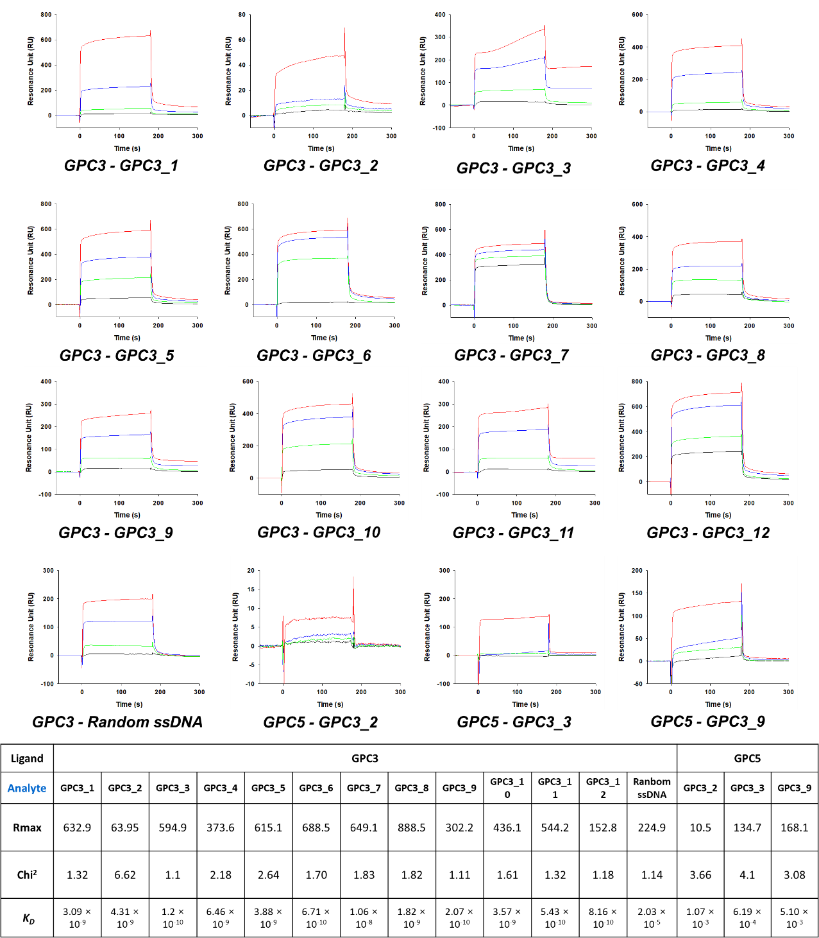

Figure S2. Surface plasmon resonance (SPR) analysis of the interaction of GPC3 and GPC3 aptamer candidates (GPC3_1 to GPC3_12) using a Biacore X100. SPR signals were detected for association (180 seconds) and dissociation (360 seconds) of aptamer candidates to GPC3. The graph shows the kinetic data for 4 aptamer concentrations with data for the lowest (100 nM) to the highest (1500 nM) aptamer concentration displayed from bottom to top. The resulting binding constant (K_{D}) was determined as shown in Table 1.
Figures S3
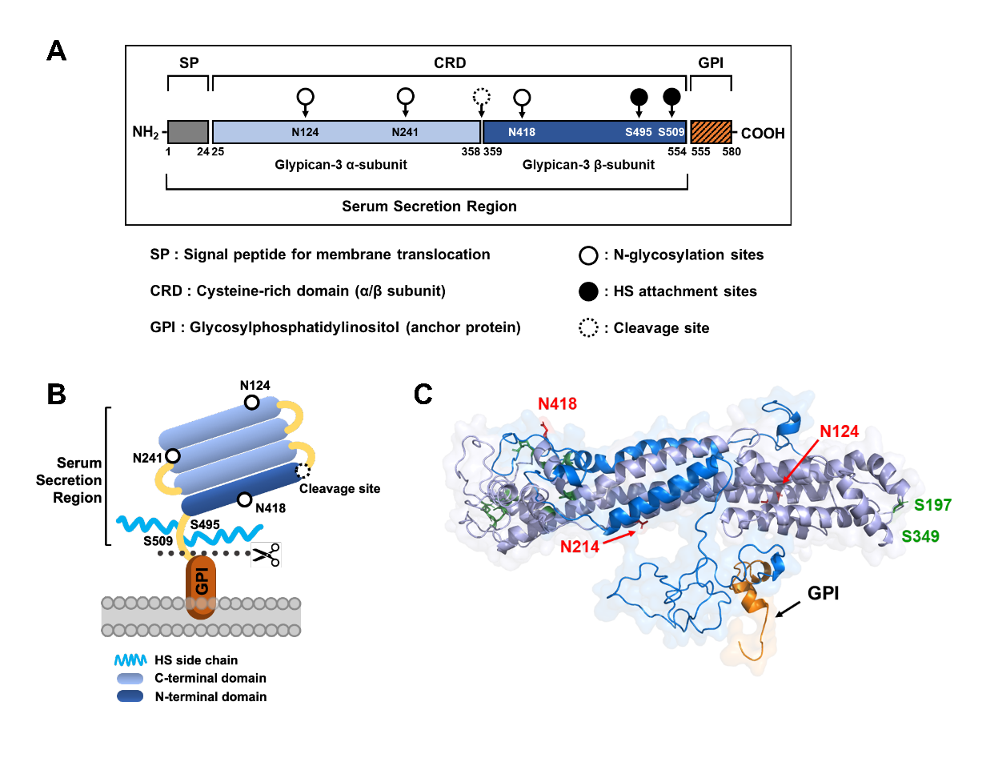
Figure S3. Schematic of the GPC3 protein. (A) Schematic diagram of GPC3 protein structure and domains. GPC3 comprises signal peptide (SP), cysteine-rich domain (CRD), and glycosylphospatidylinositol domain (GPI, anchor protein). Among these, two N-glycosylation sites are present in the CRD. The cleavage between the CRD and GPI secretes GPC3 core protein into serum. (B) Diagram illustration of GPC3 protein structure. The GPC3 protein consists of α-subunit (light blue), β-subunit (blue), and GPI region (orange). (C) The three-dimensional 3D predicted structure model of GPC3 protein (light blue and blue) and 555–580 amino acid domain (orange).

Figures S4
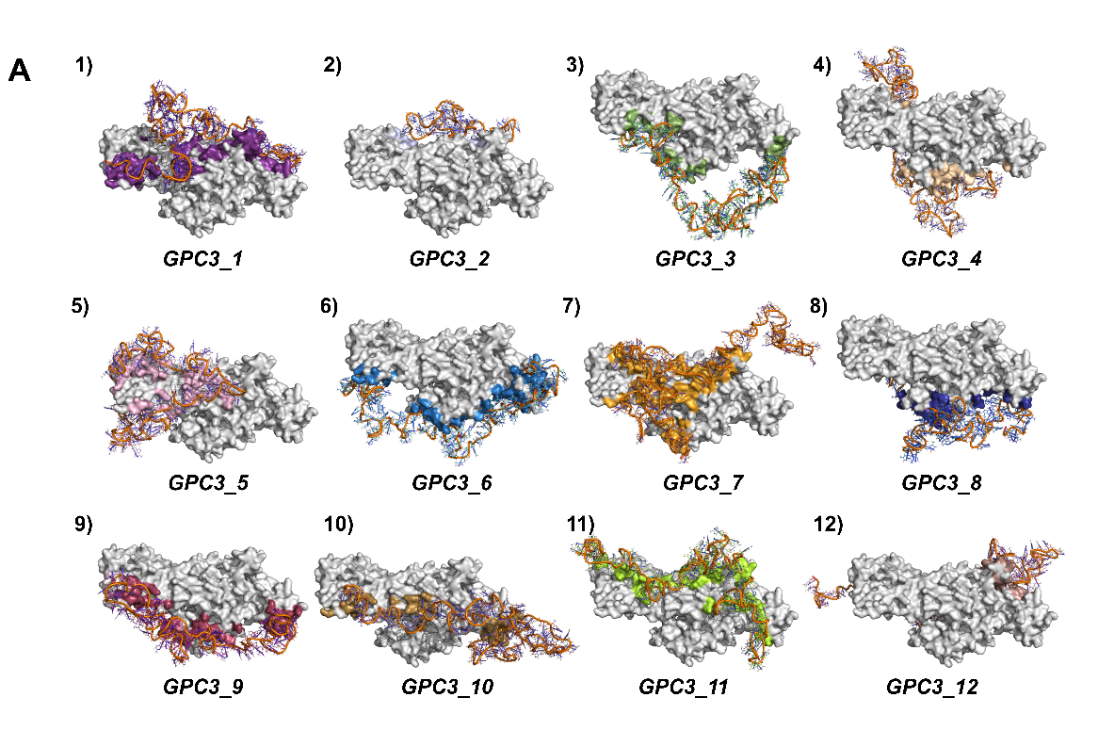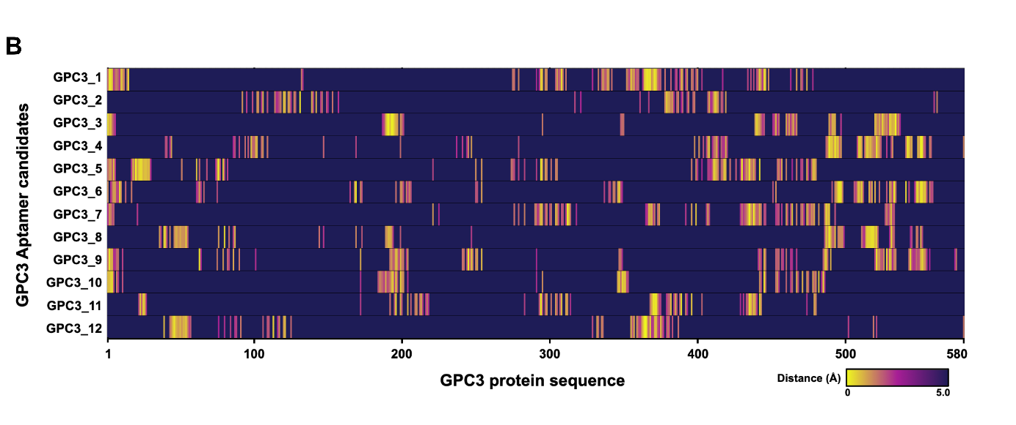
Figure S4. Comparing the GPC3 protein and aptamer complex conformation by docking simulation. (A) The GPC3 is indicated in white and aptamers in different colors. 1) GPC3_1, 2) GPC3_2, 3) GPC3_3, 4) GPC3_4, 5) GPC3_5, 6) GPC3_6, 7) GPC3_7, 8) GPC3_8, 9) GPC3_9, 10) GPC3_10, 11) GPC3_11, and 12) GPC3_12. (B) Heatmap of the binding distance between GPC3 amino acid and aptamer candidates. Dark purple indicates > 4 Å distance, while the bright color indicates < 4 Å distance or closer.

Figures S5
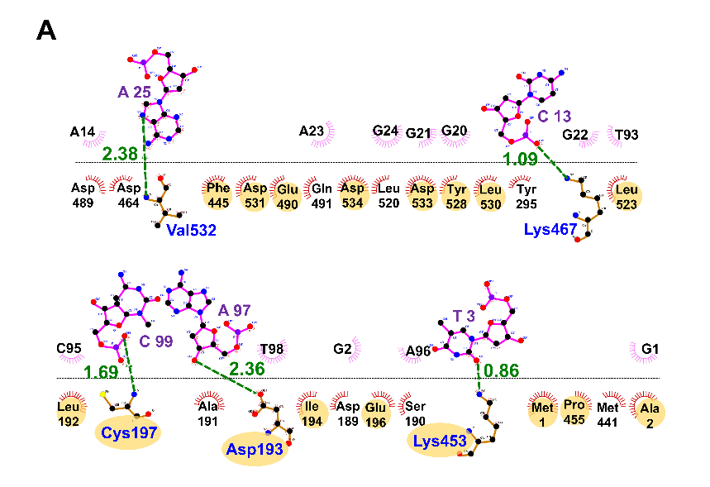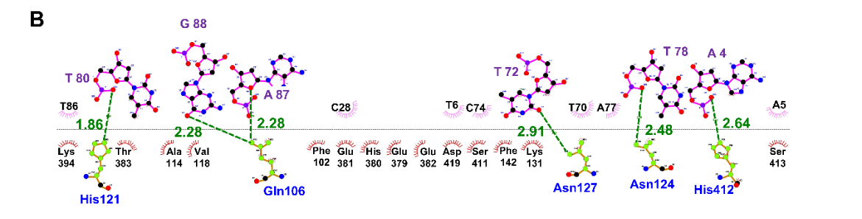
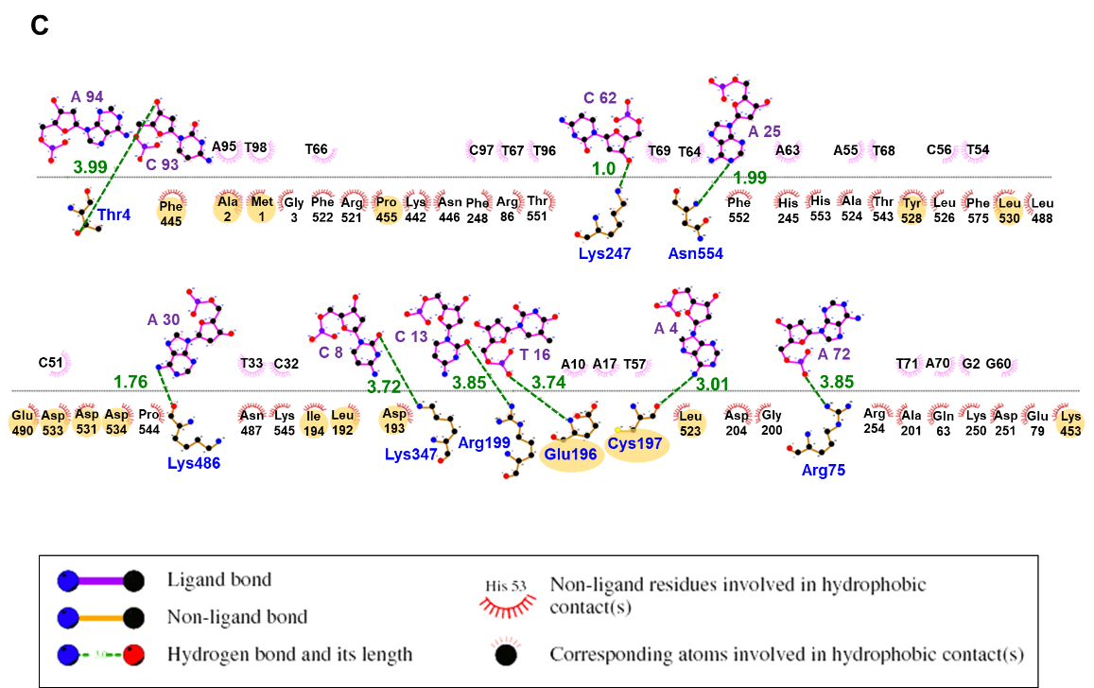
Figures S5. Ligplot+ molecular interaction analysis of aptaprobes with the GPC3. Involved hydrophobic interactions are shown in the combs in pink (aptaprobes) and red (GPC3 protein), and hydrogen bonds are shown in green color. (A) GPC3_3, (B) GPC3_2, and (C) GPC3_9. T-rich aptaprobe sites (GPC3_3 aptaprobe: T3 and Lys453, GPC3_2 aptaprobe: T72 and Asn127, T78 and Asn124, T80 and His121, GPC3_9 aptaprobe: T16 and Glu196) bind to an aptatope site on the GPC3. The interaction of hydrogen bond may affect to enhance the stability and binding affinity of the aptaprobes.

Figures S6
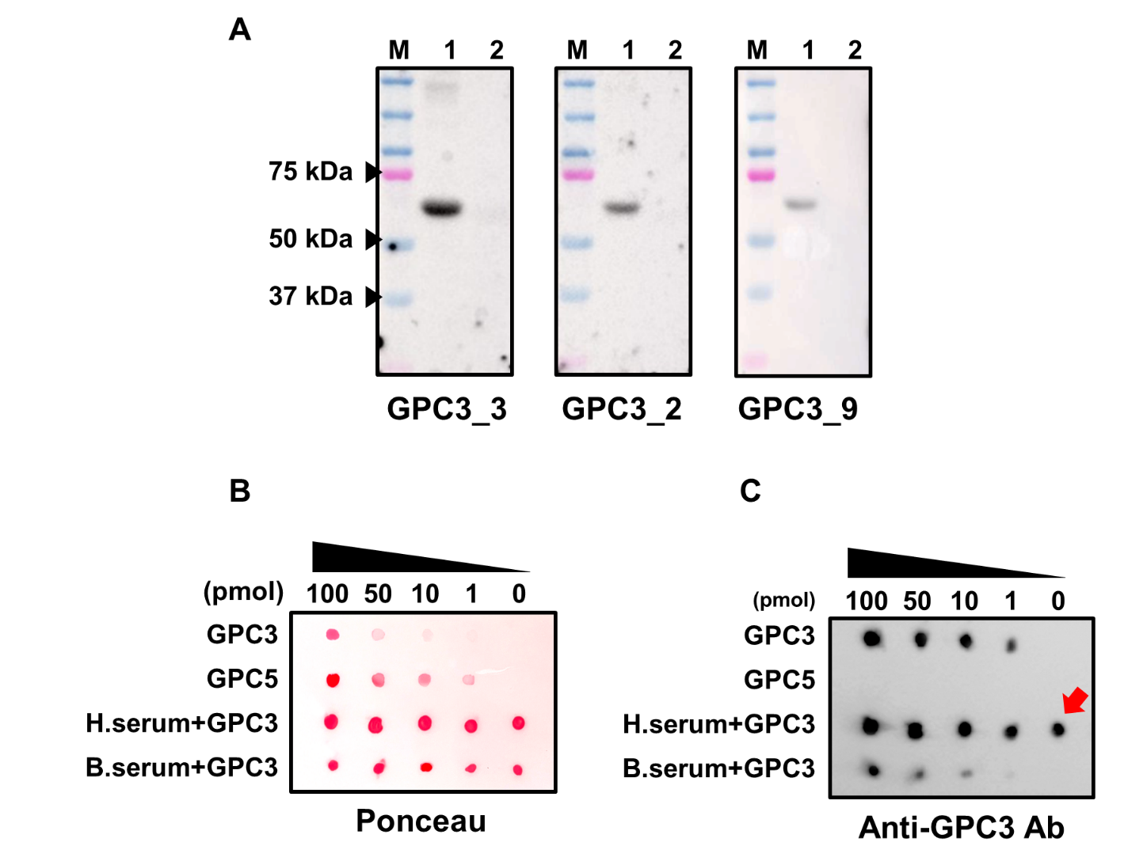
Figures S6. Aptablotting assay and immunodot blot assay (A) Whole gel image of aptablotting assay with GPC3 (lane 1) and GPC5 (lane 2). (B) Ponceau S protein stain of blots was used as loading. Serially diluted GPC3 and GPC5 protein (100, 50, 10, 1, 0 pmol) were immobilized on nitrocellulose (NC) membrane. H.serum+GPC3 and B.serum+GPC3 were mixed with the serial diluted GPC3 protein and serum samples (10 µg). (H.serum: human serum and B.serum: bovine serum). (C) Immunodot blot assay using anti-GPC3 antibody. Red arrow, non-specific dot-blot signal.

Figures S7
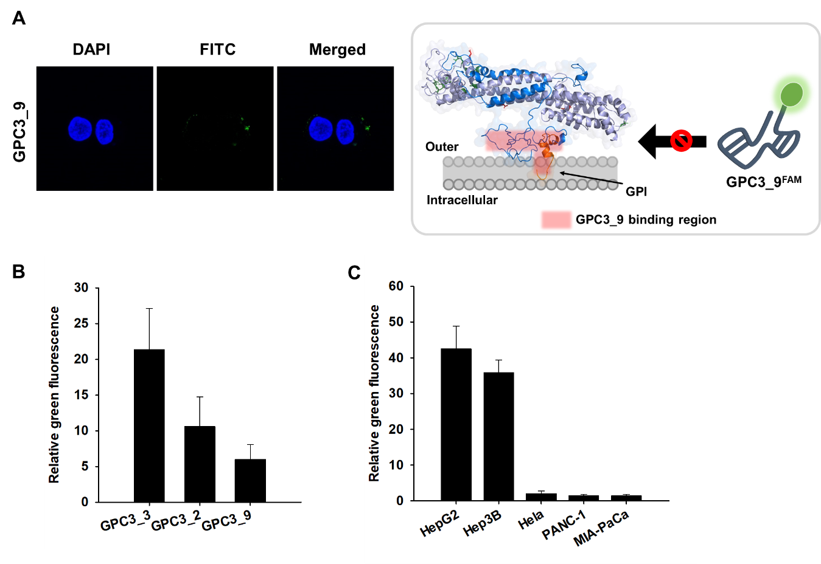
Figures S7. Confocal imaging and fluorescence intensity quantification of FAM-labeled GPC3 aptaprobes in cell line. (A) Confocal imaging of FAM-labeled GPC3_9 aptaprobe in HepG2 cells. The reduced fluorescence signal indicated that the GPC3_9 aptaprobes did not bind to their potential binding site by the cell membrane-bound region. (B) Fluorescence intensity quantification of GPC3_3, GPC3_2, and GPC3_9 aptaprobes in HepG2 cell (C) Fluorescence intensity quantification of GPC3_3 aptaprobe in various cancer cell lines

Figures S8
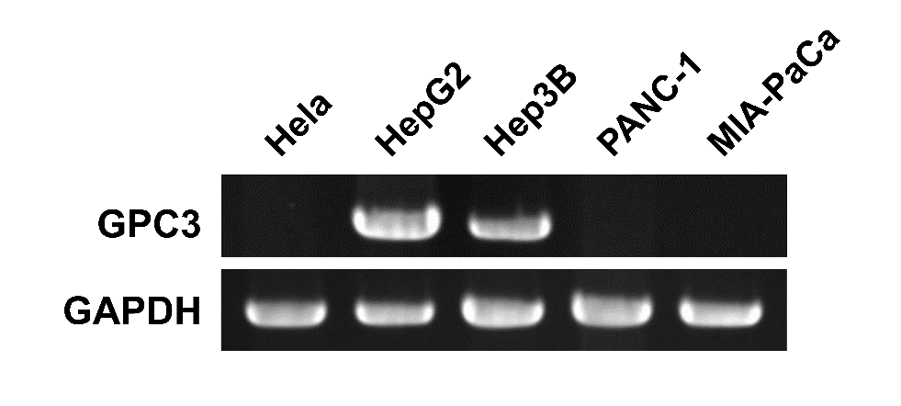
Figures S8. mRNA expression test to confirm GPC3 expression of in Hela cells, liver cancer cells (HepG2 and Hep3B), and pancreatic cancer cells (PANC-1 and MIA-PaCa).

Figures S9
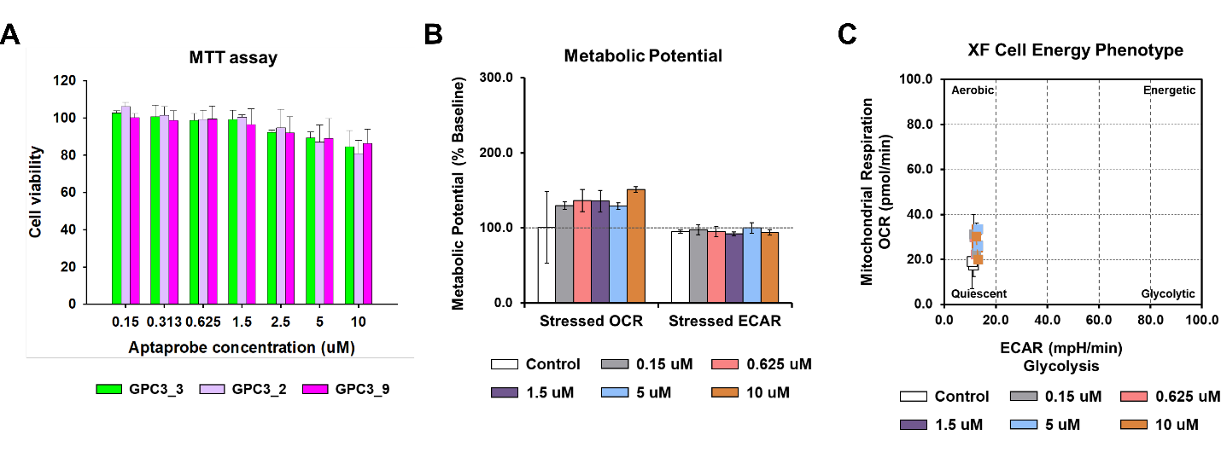
Figures S9. Cell viability using 3-(4,5-dimethylthiazol-2-yl)-2,5-diphenyl tetrazolium bromide salt (MTT) assay and Seahorse analysis for HepG2 cells treated with different aptaprobe concentrations. (A) Detection of cytotoxicity of the selected aptaprobes by MTT assay. After incubating HepG2 cells for 24 h with 0.15, 0.313, 0.625, 1.5, 2.5, 5, and 10 μM aptaprobe, cell viabilities were measured by an MTT kit. The green is GPC3_3; light purple is GPC3_2; and magenta is GPC3_9. (B) and (C) indicate the basal oxygen consumption rate (OCR) and extracellular acidification rate (ECAR) of GPC3_3 aptaprobe-treated HepG2 cells. HepG2 cells (18,000 cells/well) were plated in XF96 cell culture plates 24 h prior to the assays. Upon completion of an assay, the total protein concentration of the cells was measured with bicinchoninic acid (BCA) assay for normalization. The OCR and ECAR values were normalized to pmoles/min or mpH/min. The results are expressed as the mean ± standard deviation of three independent experiments. (B) The effects of the GPC3_3 aptaprobe treatment on metabolic potential in HepG2 cells. GPC3_3 aptaprobe treatment increased the aerobic potential of HepG2 cells as shown by the difference in stressed OCR between the control (white) and treated (gray, 0.15 μM; pink 0.625 μM; purple, 1.5 μM; light blue, 5 μM; and brown, 10 μM) values. (C) Plot of baseline and stressed conditions in control and GPC3_3-treated cells. The GPC3_3-treated cells have a small increase in OCR at baseline.

Figures S10
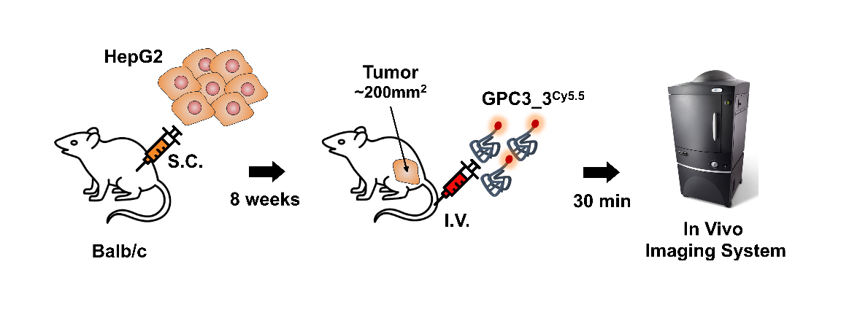
Figures S10. Schematic demonstrating the experimental workflow of in vivo GPC3_3 labeling in an intravenously hepatocellular carcinoma (HCC) xenograft model.

Figures S11
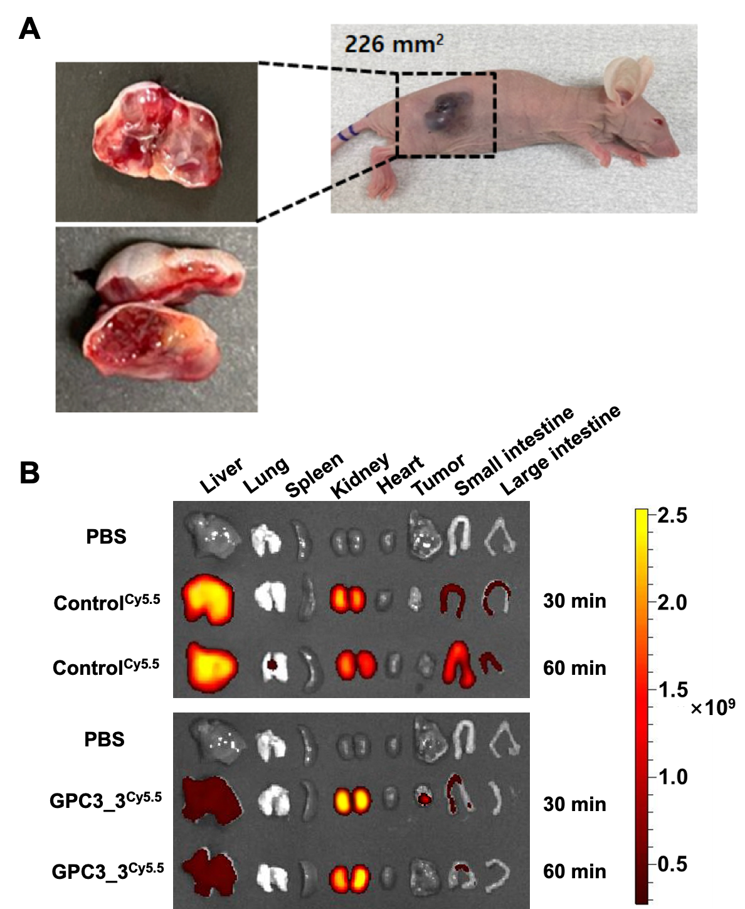
Figures S11. Representative images of HCC xenograft model. (A) 1×10⁷ HepG2 cells were injected subcutaneously into the right flank of 6-week-old BALB/c nude mice. The tumor was allowed to grow till 100–200 mm³. (B) Representative image showing organs with Cy5.5 fluorescence signals. The color scales show total fluorescence signal values ranging from 0.3×10⁹ (red) to 2.5×10⁹ (yellow).

Table S1. Amino acid residue involved in hydrophobic contact of the between GPC3 protein and aptamer candidate.
Aptamer candicates | Possible amino acid residues involved in molecular contact of GPC3 protein |  | Distance of hydrogen bond (Å)
GPC3_3 | Met1, Ala2, Asp189, Ser190, Ala191, Leu192, Asp193, Ile194, Glu196, Cys197, Tyr295, Cys349, Ala350, Met441, Phe445, Lys453, Pro455, Ser460, Asp464, Lys467, Asp489, Glu490, Glu491, Gly492, Phe493, Leu520, Leu523, Tyr528, Leu530, Asp531, Val532, Asp533, Asp534 | Asp193-A97 : 2.36  Cys197-C99 : 1.69  Lys453-T3 : 0.86  Asp464-A14 : 1.51  Lys467-C13 : 1.09  Asp531-A25 : 3.24  Val532-A25 : 2.38  Asp533-G24 : 2.86
GPC3_1 | Met1, Ala2, Gly3, Thr4, Arg6, Thr7, Ala8, Leu10, Val11, Val12, Met14, Leu15, Asn132, Gly275, Gly276, Asn278, Lys294, Tyr295, Arg297, Glu298, Glu304, Glu305, Leu306, Val307, Asn308, Gly309, Tyr311, Tyr333, Gln335, Lys336, Asn337, Ala338, Gly339, Lys340, Thr342, Ser352, Gly353, Arg355, Gln356, Tyr357, Ser359, Ala360, Glu364, Asp365, Leu366, Phe367, Ile368, Asp369, Lys370, Lys371, Val372, Leu373, Val375, Val378, Glu382, Arg389, Glu390, Gln393, Lys396, Ser397, Ile399, Ser400, Met441, Lys442, Asn443, Phe445, Asn446, His448, Lys467, Asn470, Arg474 | Thr7-A96 : 3.01  Asn308-A25 : 1.57  Tyr333-T16 : 3.02  Arg355-C8 : 2.35  Asp369-A19 : 3.31  Lys371-A17 : 2.49  Gln393-A39 : 3.05  Arg474-A86 : 2.1
GPC3_2 | Leu92, Phe102, Leu103, Gln106, Ala109, Ala114, Ile117, Val118, Arg120, Phe121, Lys123, Asn124, Asn127, Ala128, Lys131, Pro139, Phe142, Gly146, Phe149, Ser153, Val378, Glu379, His380, Glu381, Glu382, Thr383, Ser386, Arg387, Glu390, Lys384, Ser397, Phe398, Gly407, Tyr408, Ser411, His412, Ser413, Pro414, Ser416, Glu417, Asp419, Leu562 | Gln106-A87 : 2.28  Gln106-G88 : 2.28  His121-T80 : 1.86  Asn124-T78 : 2.48  Asn127-T72 : 2.91  Lys131-T72 : 2.36  Glu379-C28 : 2.24  His412-A4 : 2.64  Asp419-T6 : 3.03
GPC3_4 | Arg44, Gln94, Ala96, Met98, Glu99, Leu100, Lys101, Phe102, Ile105, Gln106, Ala109, Glu147, Arg199, His245, Lys247, Phe398, Phe401, Ala404, Gly407, Tyr408, Ser411, His412, Ser413, Ala416, Asp419, Asn487, Leu488, Asp489, Glu490, Glu491, Gly492, Phe493, Glu494, Ser495, Gly496, Asp497, Ser509, Gly510, Asp511, Met513, Ile514, Lys515, Val516, Lys517, Asn518, Gln519, Leu520, Arg521, Phe522, Leu523, Ala524, Val532, Gln541, Ala542, Thr543, Pro544, Lys545, Ile549, Ser550, Thr551, Phe552, His553, Asn554, Asn557, Val558, His580 | Arg44-C63 : 2.79  Lys101-T54 : 2.81  Lys247-T46 : 2.31  Asp489-A17 : 1.58  Ser509-A19 : 2.47  Ala542-T12 : 2.79  Thr551-A4 : 2.61
GPC3_5 | Met1, Ala2, Gly3, Thr4, Val5, Leu18, Asp19, Phe20, Pro21, Gly22, Gln23, Ala24, Pro25, Pro26, Pro27, Pro28, Trp51, Asp61, Gln63, Lys68, Arg75, Lys76, Glu79, Lys250, Arg254, Cys264, Gly275, Lys294, Tyr295, Arg297, Glu298, Leu301, Glu304, Glu305, Lys396, Ile399, Cys410, Ser411, His412, Ser413, Pro414, Ala416, Glu417, Asn418, Asp419, Cys422, Gln426, Glu430, Tyr432, Ser433, Gln434, Lys435, Ala436, Ala437, Arg438, Asn439, Lys442, Gly454, Pro455, Pro457, Ser460, Lys467, Arg474, Ser477, Met478, Pro479, Lys480 | Pro26-T98 : 2.24  Tyr295-A49 : 2.27  Glu305-A54 : 3.25  Asn418-G84 : 2.95  Glu430-T79 : 1.47  Arg438-T71 : 2.39  Lys442-A46 : 2.6  Lys480-T55 : 2.57
GPC3_6 | Met1, Thr4, Val5, Arg6, Cys9, Leu10, Ser17, Gln63, Leu66, Asn168, Glu169, Asp172, Ser173, Glu196, Arg199, Gly200, Arg203, Leu205, Lys206, Lys250, Asp251, Arg254, Lys340, Thr343, Thr344, Gly346, Lys347, Leu348, Lys451, Lys453, Glu491, Phe493, Glu494, Ser495, Gly496, Asp497, Cys498, Ile506, Gly508, Ser509, Gly510, Asp511, Gly512, Val516, Lys517, Asn518, Leu520, Leu523, Tyr528, Leu530, Asp531, Asp533, Asp534, Gln541, Glu548, Ile549, Ser550, Thr551, Phe552, His553, Asn554, Leu555, Asn557, His559 | Val5-A4 : 2.13  Asn168-T75 : 2.44  Gly200-T77 : 3.44  Arg254-T16 : 2.38  Lys453-G20 : 2.69  Ser495-C48 : 2.12  Asp533-T42 : 1.27  Gln541-A53 : 1.91  Asn554-C70 : 3.06
GPC3_7 | Ala2, Gly3, Val5, Lys221, Gly276, Asn279, Gln283, Val290, Glu291, Asp293, Lys294, Tyr295, Glu298, Leu301, Glu304, Glu305, Asn308, Gly309, Arg312, Ile313, Tyr314, Phe367, Ile368, Asp369, Lys371, Leu373, Lys374, Lys396, Ile399, Gly407, Glu430, Tyr432, Ser433, Gln434, Lys435, Ala436, Ala437, Arg438, Asn439, Gly440, Met441, Lys442, Asn443, Pro455, Ser460, Asp464, Lys467, Asn470, Gln471, Arg474, Thr475, Ser477, Met478, Pro479, Arg482, Lys486, Asn487, Leu488, Asp489, Phe493, Ala527, Tyr528, Leu530, Asp531, Asp533 | Lys221-T41 : 2.56  Arg438-T61 : 2.8  Asp464-G92 : 2.84  Lys467-T76 : 3.23  Gln471-T74 : 3.25  Ser477-T43 : 2.91  Asp489-C95 : 1.27
GPC3_8 | His36, Arg39, Phe40, Gln43, Gln46, Pro47, Gly48, Leu49, Lys50, Trp51, Val52, Pro53, Glu54, Thr55, Lys76, Lys80, Leu83, Leu87, Phe144, Glu169, Ser173, Asp189, Ser190, Ala191, Leu192, Asp193, Arg199, Lys486, Asn487, Leu488, Asp489, Glu490, Glu491, Gly492, Phe493, Ser495, Gly496, Asp497, Cys498, Asp511, Ile514, Lys515, Val516, Lys517, Asn518, Gln519, Leu520, Arg521, Phe522, Asp531, Val532, Asp533, Glu548, Ile549, Thr551 | Val52-A97 : 2.75  Lys76-T86 : 2.6  Glu169-A14 : 3.35  Asn518-T70 : 3.06  Arg521-C71 : 2.76  Asp531-G55 : 1.6
GPC3_9 | Met1, Ala2, Gly3, Thr4, Thr7, Ala8, Gln63, Arg75, Glu79, Gln82, Arg86, Glu90, Asp172, Leu192, Asp193, Ile194, Glu196, Cys197, Arg199, Gly200, Ala201, Asp204, Asn241, Thr242, Asp244, His245, Leu246, Lys247, Phe248, Lys250, Asp251, Arg254, Lys347, Leu348, Lys442, Phe445, Asn446, Lys453, Gly454, Pro455, Ser460, Asp485, Lys486, Asn487, Leu488, Glu490, Arg521, Phe522, Leu523, Ala524, Leu526, Tyr528, Leu530, Asp531, Asp533, Asp534, Thr543, Pro544, Lys545, Glu548, Ser550, Thr551, Phe552, His553, Asn554, Phe575 | Thr4-C93 : 3.99  Gln63-A72 : 0.44  Arg75-A72 : 3.85  Arg86-T68 : 0.88  Glu196-T16 : 3.74  Cys197-A4 : 3.01  Arg199-C13 : 3.85  Lys247-C62 : 1.00  Lys347-C8 : 3.72  Lys486-A30 : 1.76  Asn554-A25 : 1.99
GPC3_10 | Met1, Ala2, Gly3, Thr4, Thr7, Asn184, Pro185, Gly186, Leu187, Asp189, Ala191, Leu192, Asp193, Ile194, Glu196, Cys197, Arg199, Gly200, Ala201, Tyr295, Gly346, Lys347, Leu348, Cys349, Ala350, His351, Lys442, Phe445, Asn446, Lys453, Gly454, Ser460, Asp464, Lys469, Gln471, Arg474, Thr475, Met478, Pro478, Lys480, Arg482, Asp485 | Ala2-A4 : 2.02  Thr4-G2 : 1.78  Asp189-T98 : 2.9  Arg199-G62 : 2.62  Tyr295-C13 : 2.65  His351-T75 : 2.91  Asp485-T18 : 2.67
GPC3_11 | Gln23, Ala24, Gln25, Pro26, Leu192, Asn195, Glu196, Arg199, Gly200, Asp204, Lys206, Gly209, Asn210, Pro212, Lys213, Thr217, Asp293, Lys294, Tyr295, Arg297, Glu298, Leu301, Glu304, Glu305, Val307, Asn308, Tyr311, Arg312, Ile368, Asp369, Lys370, Lys371, Val372, Leu373, His380, Glu381, Glu382, Ser385, Ser386, Arg388, Arg389, Ile392, Lys396, Ser403, Ser433, Gln434, Lys435, Ala436, Ala437, Arg438, Asn439, Lys442, Asn443, Pro479, Lys480 | Arg199-T3 : 1.94  Lys294-T65 : 2.17  Glu304-A53 : 2.41  Lys371-C29 : 2.53  Glu382-T49 : 2.35  Arg389-A51 : 1.8  Lys396-T52 : 2.97  Lys480-G21 : 2.77
GPC3_12 | Arg39, Gln43, Arg44, Leu45, Gln46, Pro47, Gly48, Leu49, Lys50, Trp51, Val52, Pro53, Glu54, Thr55, Val57, Gln91, Gln106, Ala109, Val110, Glu113, Ile117, Arg120, His121, Tyr125, Gln332, Tyr333, Gln335, Lys336, Arg355, Gln356, Tyr357, Ser359, Ala360, Tyr362, Pro363, Glu364, Asp365, Leu366, Phe367, Ile368, Lys371, Val372, Leu373, Val375, Ala376, His380, Thr383, Arg387, Gln519, Leu520, Leu523, Tyr528, Leu530, His580 | Arg39-T84 : 1.88  Glu113-A39 : 2.09  His121-C38 : 3.05  Arg355-T6 : 2.33  Asp365-A25 : 2.58  Ile368-C29 : 2.8  His380-T34 : 2.9
* Participants of hydrophobic interaction with aptamers were highlighted in yellow.

Table S2. Features of biomolecules for interventional fluorescence imaging of tumors in preclinical studies.
Material (Name) | Target cancer | Detection target | Detection time | Reference
Nanoparticle (Luminescence Ce6-luminol-PEG) | lung cancer | - | 72 hr | [2]
Nanoparticle (ICG/Fe3O4@PLGA-ZOL) | breast cancer | Zoledronate and SPIO | 24 hr | [3]
Nanoparticle (ALNPs) | breast cancer | - | 1 hr | [4]
Nanoparticle  (Ag2S Quantum Dot) | mammary carcinoma | - | 2 hr | [5]
Peptide (NEW) | breast tumor | CD44v6 | 1 hr | [6]
Peptide (HMNPWSD-KLA) | Pancreatic Cancer | PANC-1 cell | 2 hr | [7]
Aptamer (TD05) | Ramos tumor | Ramos cell | 3.5 hr | [8]
Aptamer (S6) | lung cancer | A549 lung carcinoma cell | 3 hr | [9]
Aptamer (A9g) | prostate cancer | prostate-specific membrane antigen (PSMA) | 24 hr | [10]
Aptaprobe (GPC3_3) | Hepatocellular Carcinoma | GPC3 | < 1 hr | In this study

References
1. Bayat P, Nosrati R, Alibolandi M, Rafatpanah H, Abnous K, Khedri M, Ramezani M: SELEX methods on the road to protein targeting with nucleic acid aptamers. Biochimie 2018, 154:132-155.
2. Xu X, An H, Zhang D, Tao H, Dou Y, Li X, Huang J, Zhang J: A self-illuminating nanoparticle for inflammation imaging and cancer therapy. Science advances 2019, 5:eaat2953.
3. Jiang Z, Li J, Chen S, Guo Q, Jing Z, Huang B, Pan Y, Wang L, Hu Y: Zoledronate and SPIO dual-targeting nanoparticles loaded with ICG for photothermal therapy of breast cancer tibial metastasis. Scientific Reports 2020, 10:1-16.
4. Jiang Y, Huang J, Zhen X, Zeng Z, Li J, Xie C, Miao Q, Chen J, Chen P, Pu K: A generic approach towards afterglow luminescent nanoparticles for ultrasensitive in vivo imaging. Nature communications 2019, 10:1-10.
5. Hong G, Robinson JT, Zhang Y, Diao S, Antaris AL, Wang Q, Dai H: In vivo fluorescence imaging with Ag2S quantum dots in the second near‐infrared region. Angewandte Chemie International Edition 2012, 51:9818-9821.
6. Khan F, Gurung S, Gunassekaran GR, Vadevoo SMP, Chi L, Permpoon U, Haque ME, Lee Y-K, Lee S-W, Kim S: Identification of novel CD44v6-binding peptides that block CD44v6 and deliver a pro-apoptotic peptide to tumors to inhibit tumor growth and metastasis in mice. Theranostics 2021, 11:1326.
7. Zheng L, Zhang B, He X, Cao G, Li Y, Cai K, Yang B, Wu Y: A New Fusion Peptide Targeting Pancreatic Cancer and Inhibiting Tumor Growth. OncoTargets and therapy 2020, 13:7865.
8. Shi H, Tang Z, Kim Y, Nie H, Huang YF, He X, Deng K, Wang K, Tan W: In vivo fluorescence imaging of tumors using molecular aptamers generated by cell‐SELEX. Chemistry–An Asian Journal 2010, 5:2209-2213.
9. Shi H, Cui W, He X, Guo Q, Wang K, Ye X, Tang J: Whole cell-SELEX aptamers for highly specific fluorescence molecular imaging of carcinomas in vivo. PloS one 2013, 8:e70476.
10. Dassie JP, Hernandez LI, Thomas GS, Long ME, Rockey WM, Howell CA, Chen Y, Hernandez FJ, Liu XY, Wilson ME: Targeted inhibition of prostate cancer metastases with an RNA aptamer to prostate-specific membrane antigen. Molecular therapy 2014, 22:1910-1922.

